Database System Engineering and Distributed Backend Development
Course Code: 25CS1302E
WEEK-3
Name: V. Charishma
Roll no: 2520030140
INSERT SAMPLE DOCUMENTS
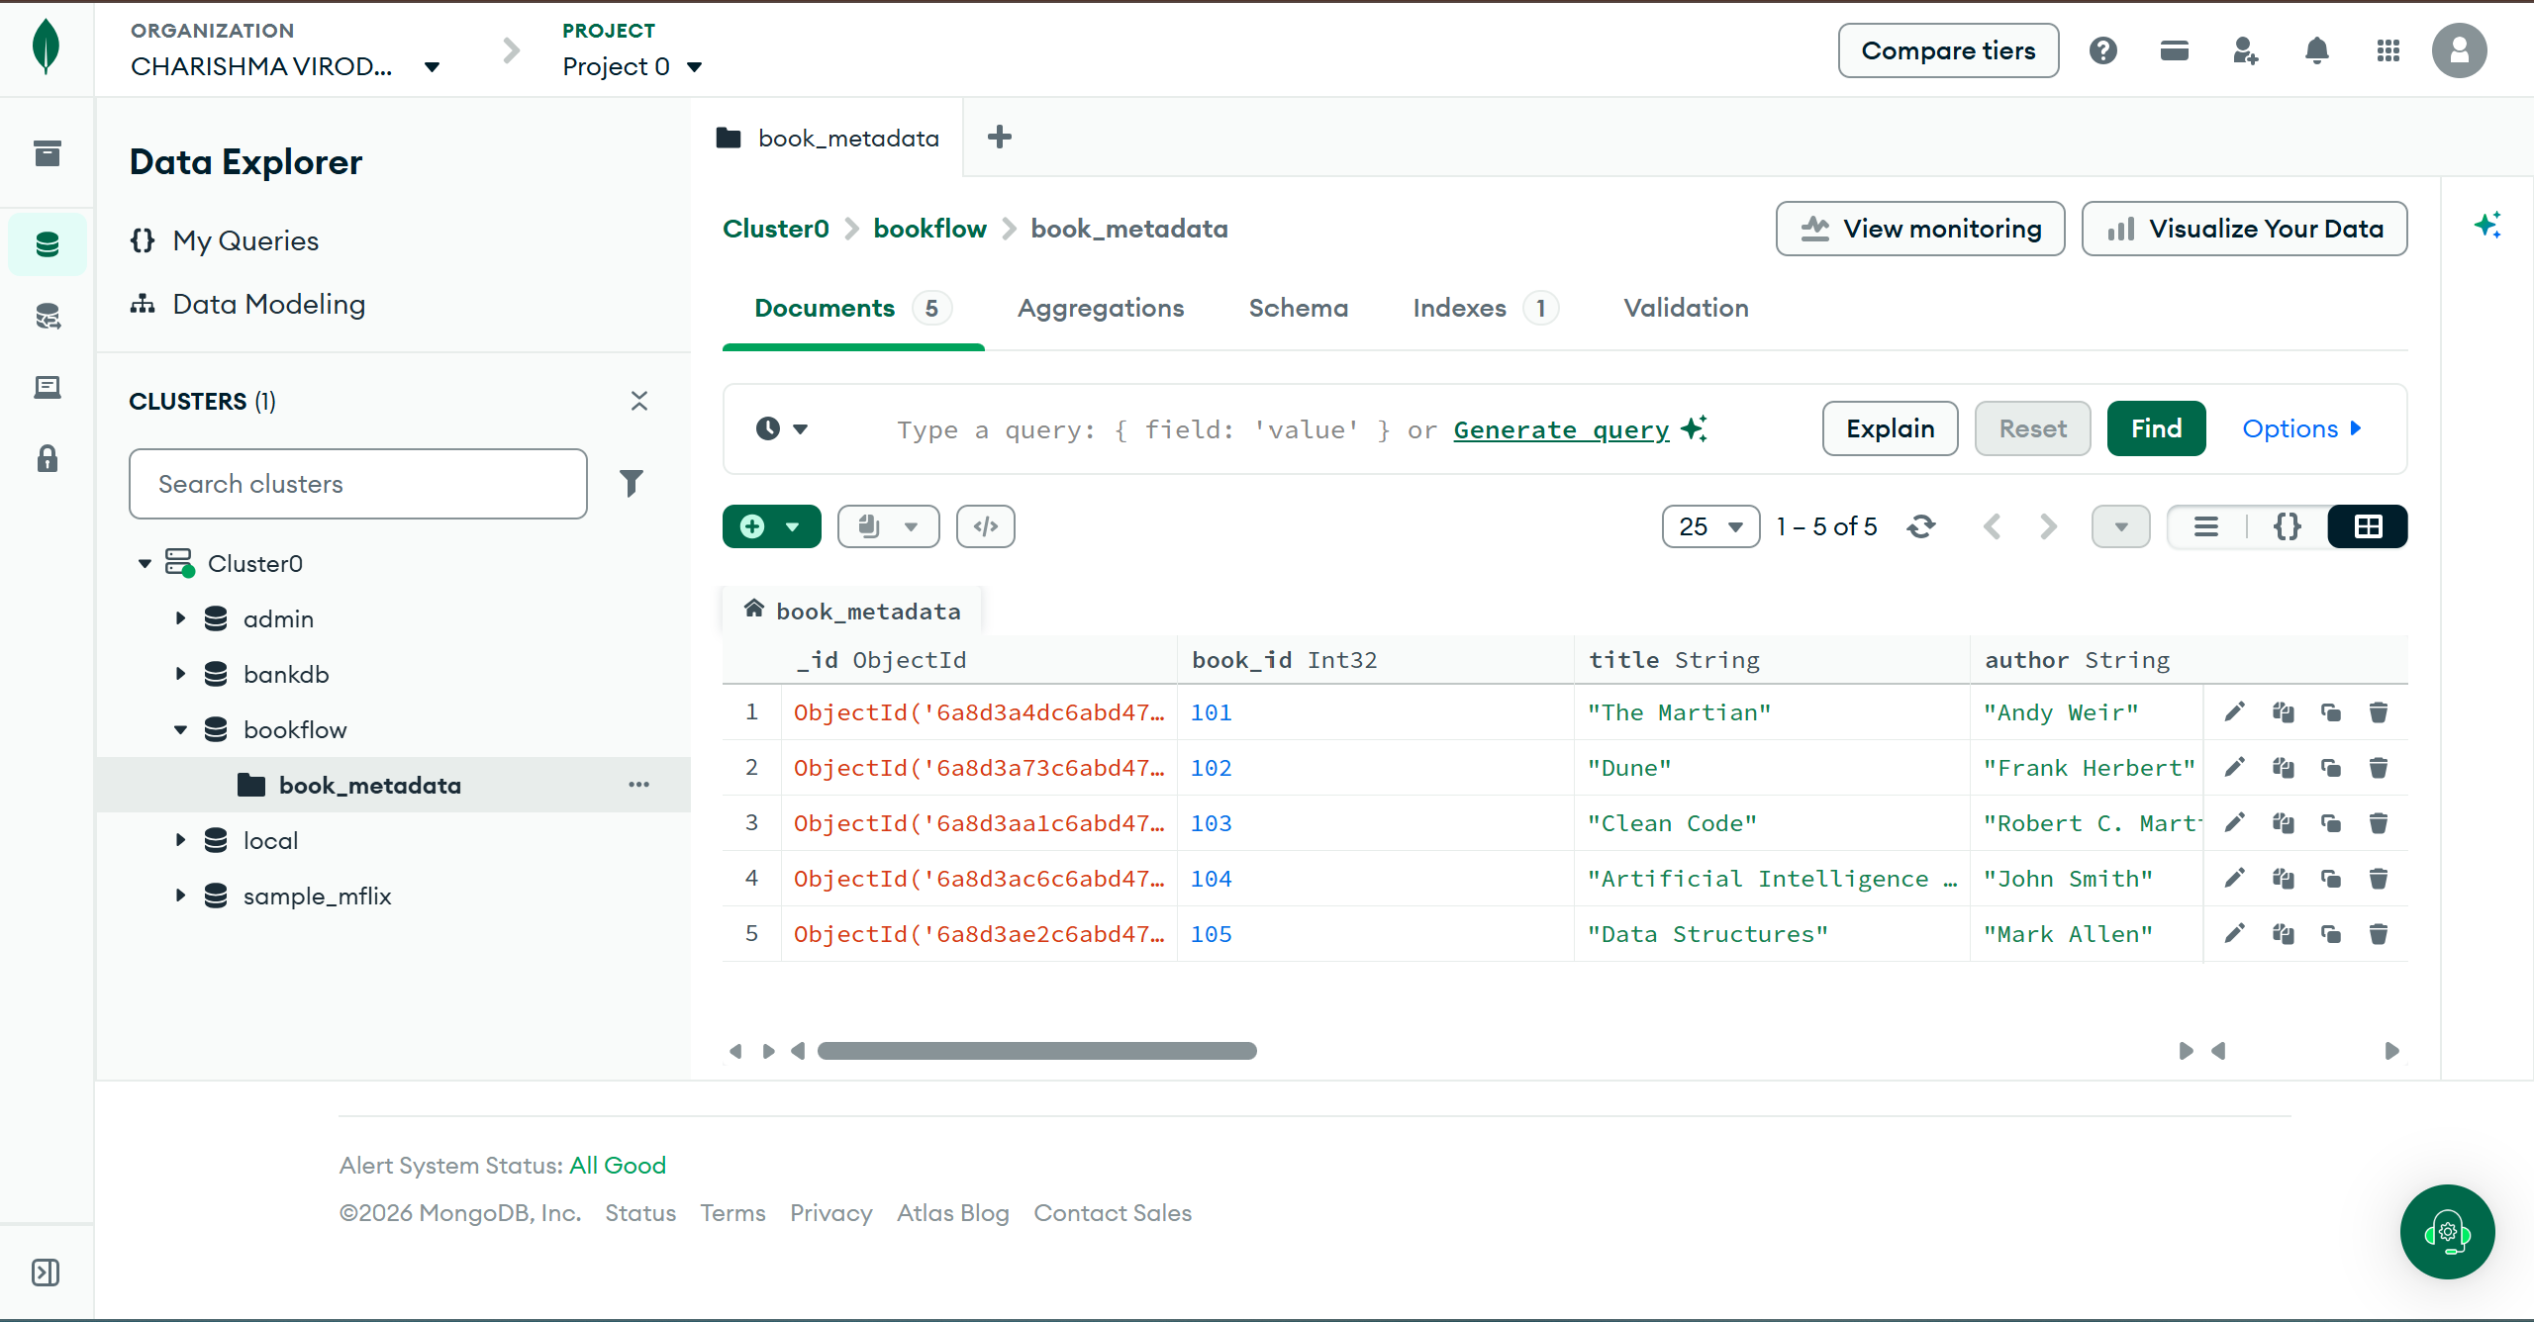
COMPARISON OPERATOR $gt
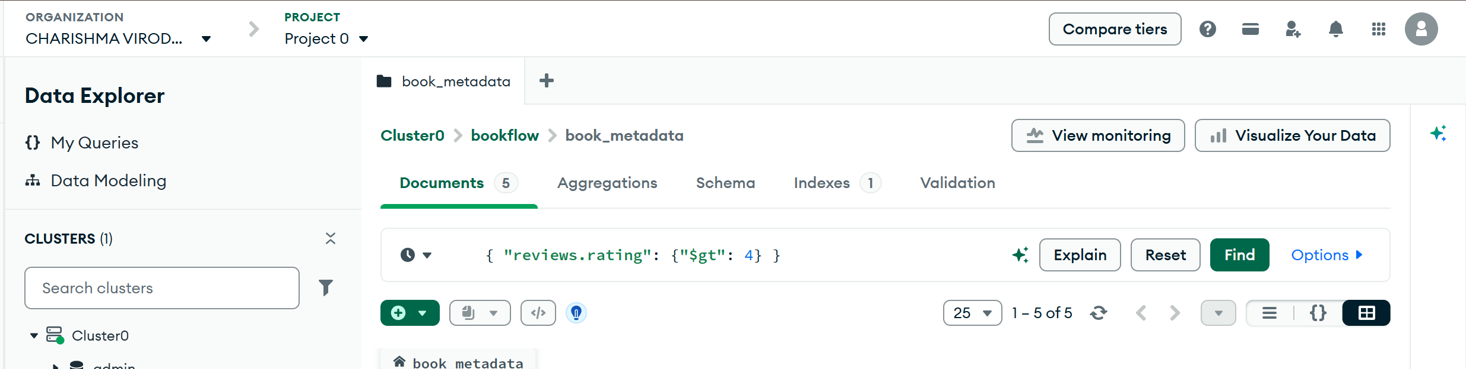
Output
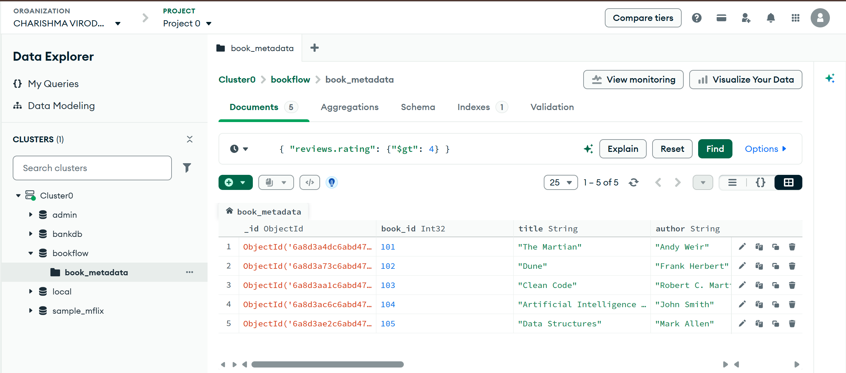

USING $IN
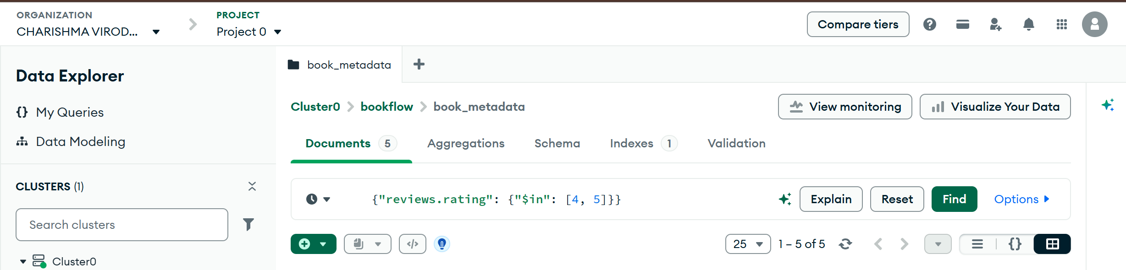
Output:
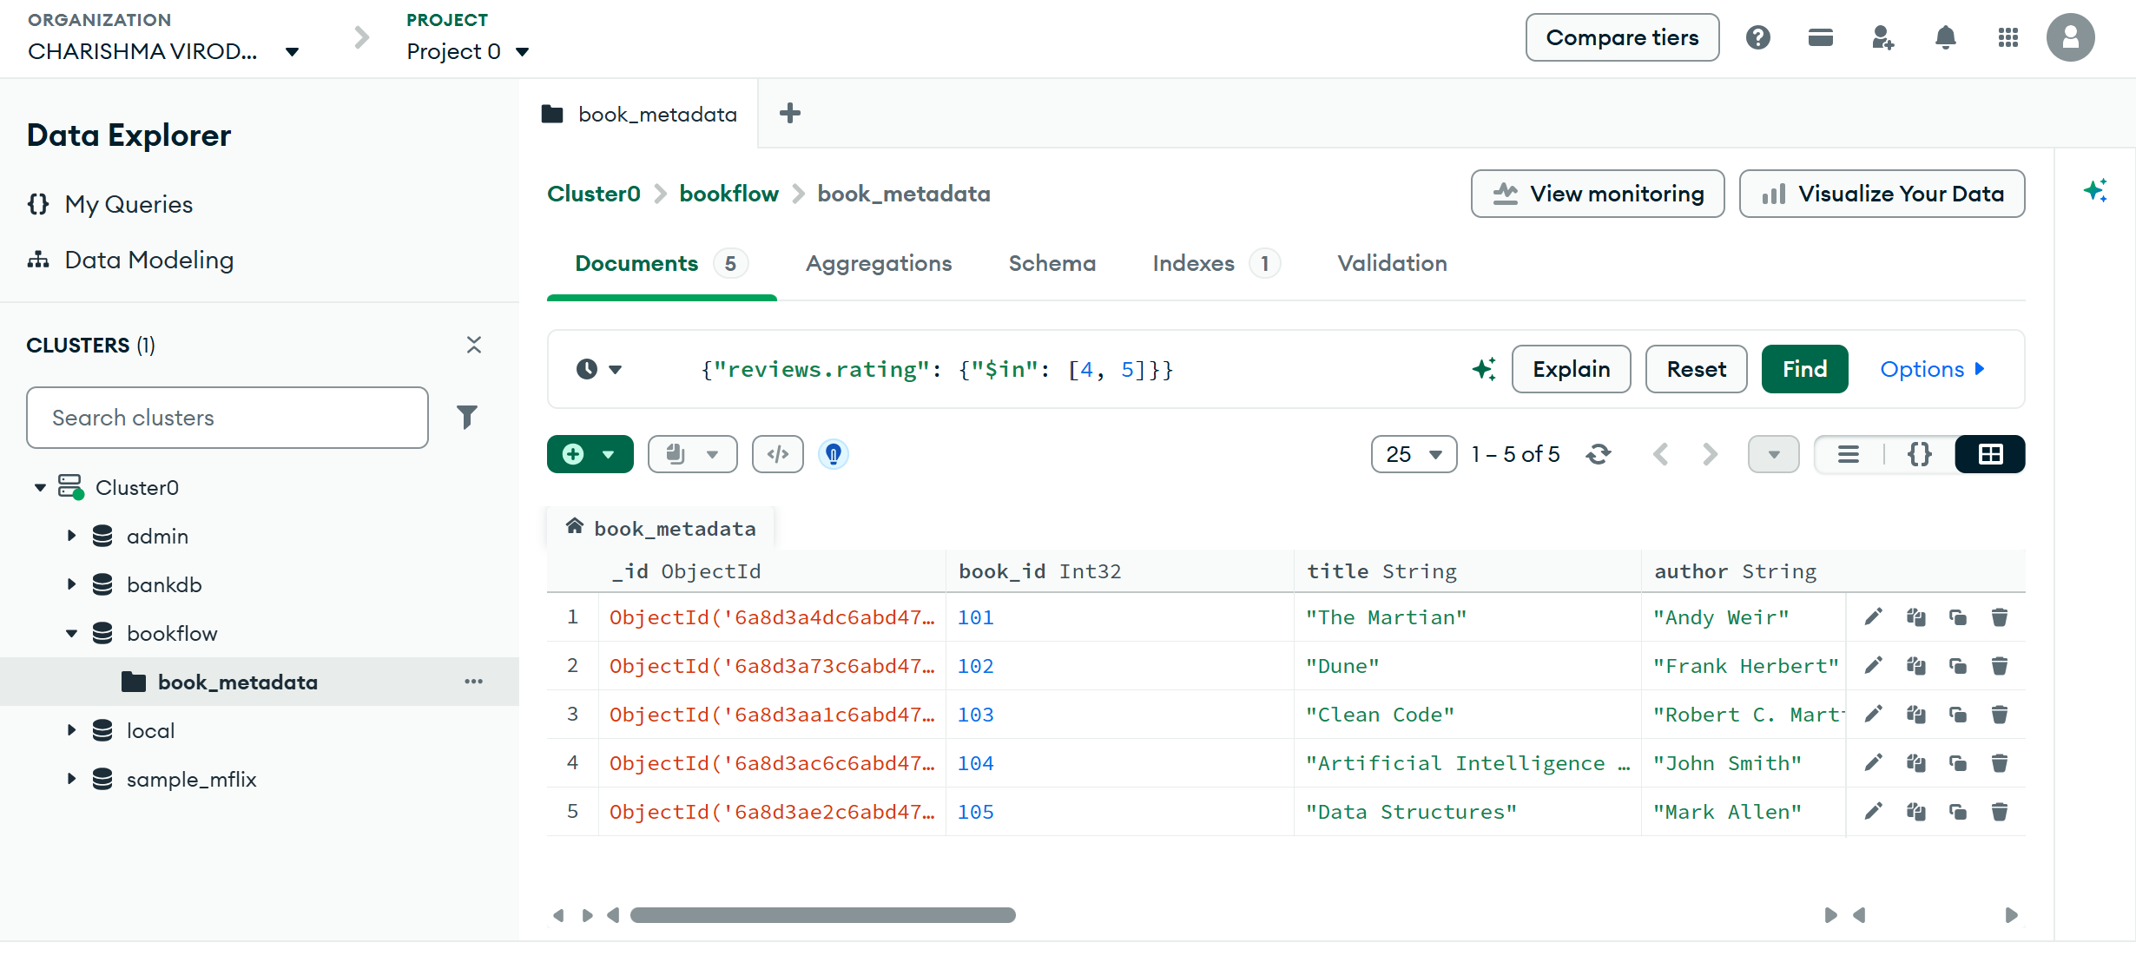
REGEX QUERY
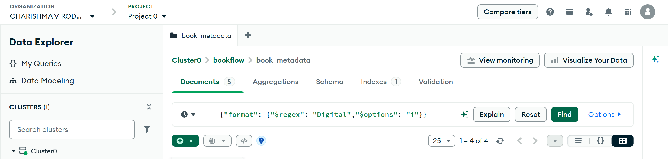
Output
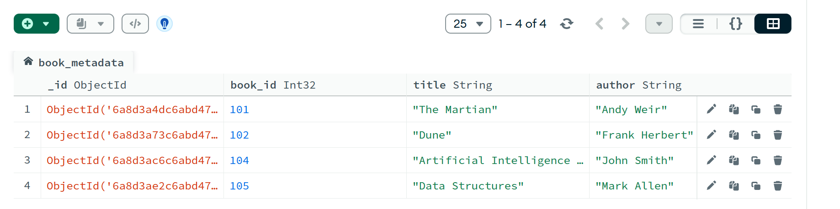
Aggregations:
$MATCH
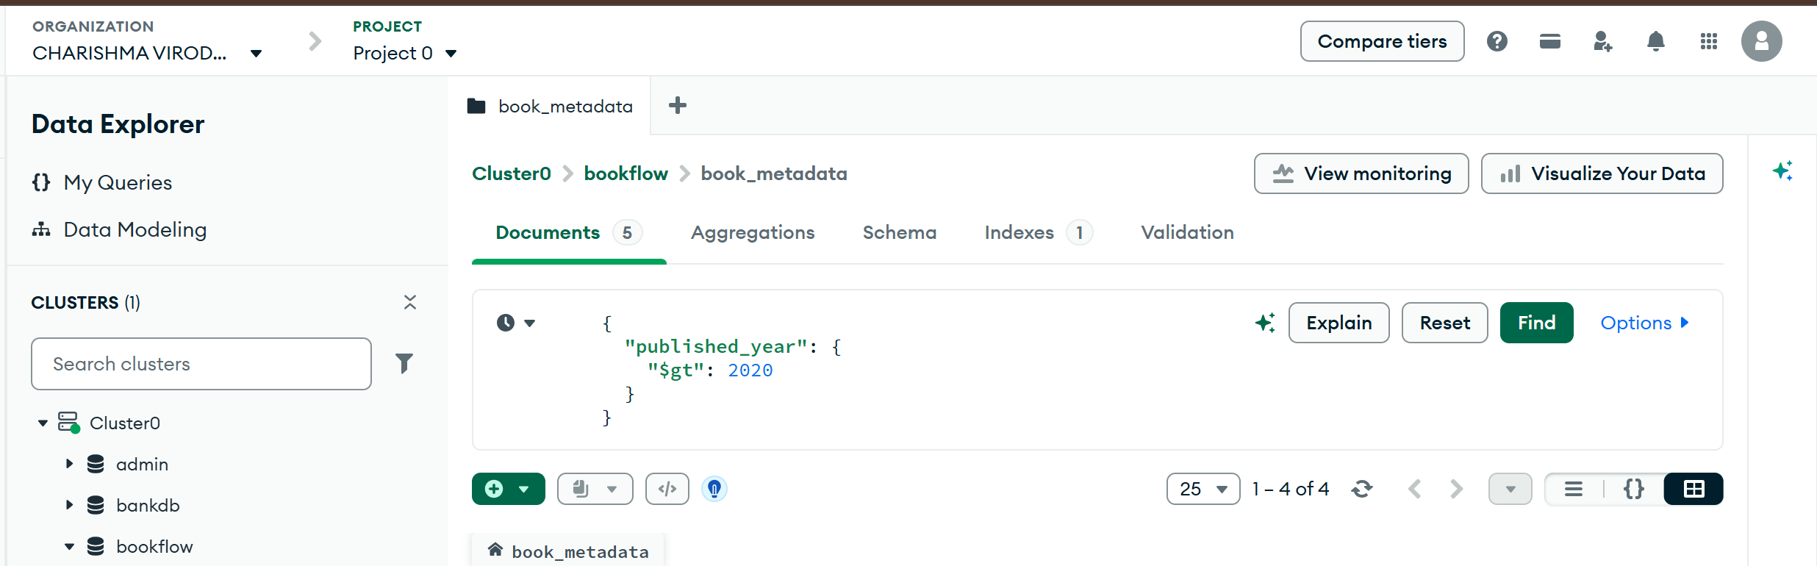
Output
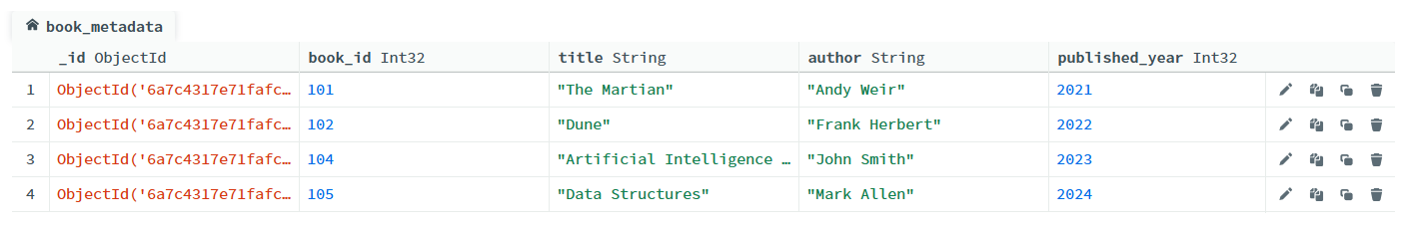
$MATCH
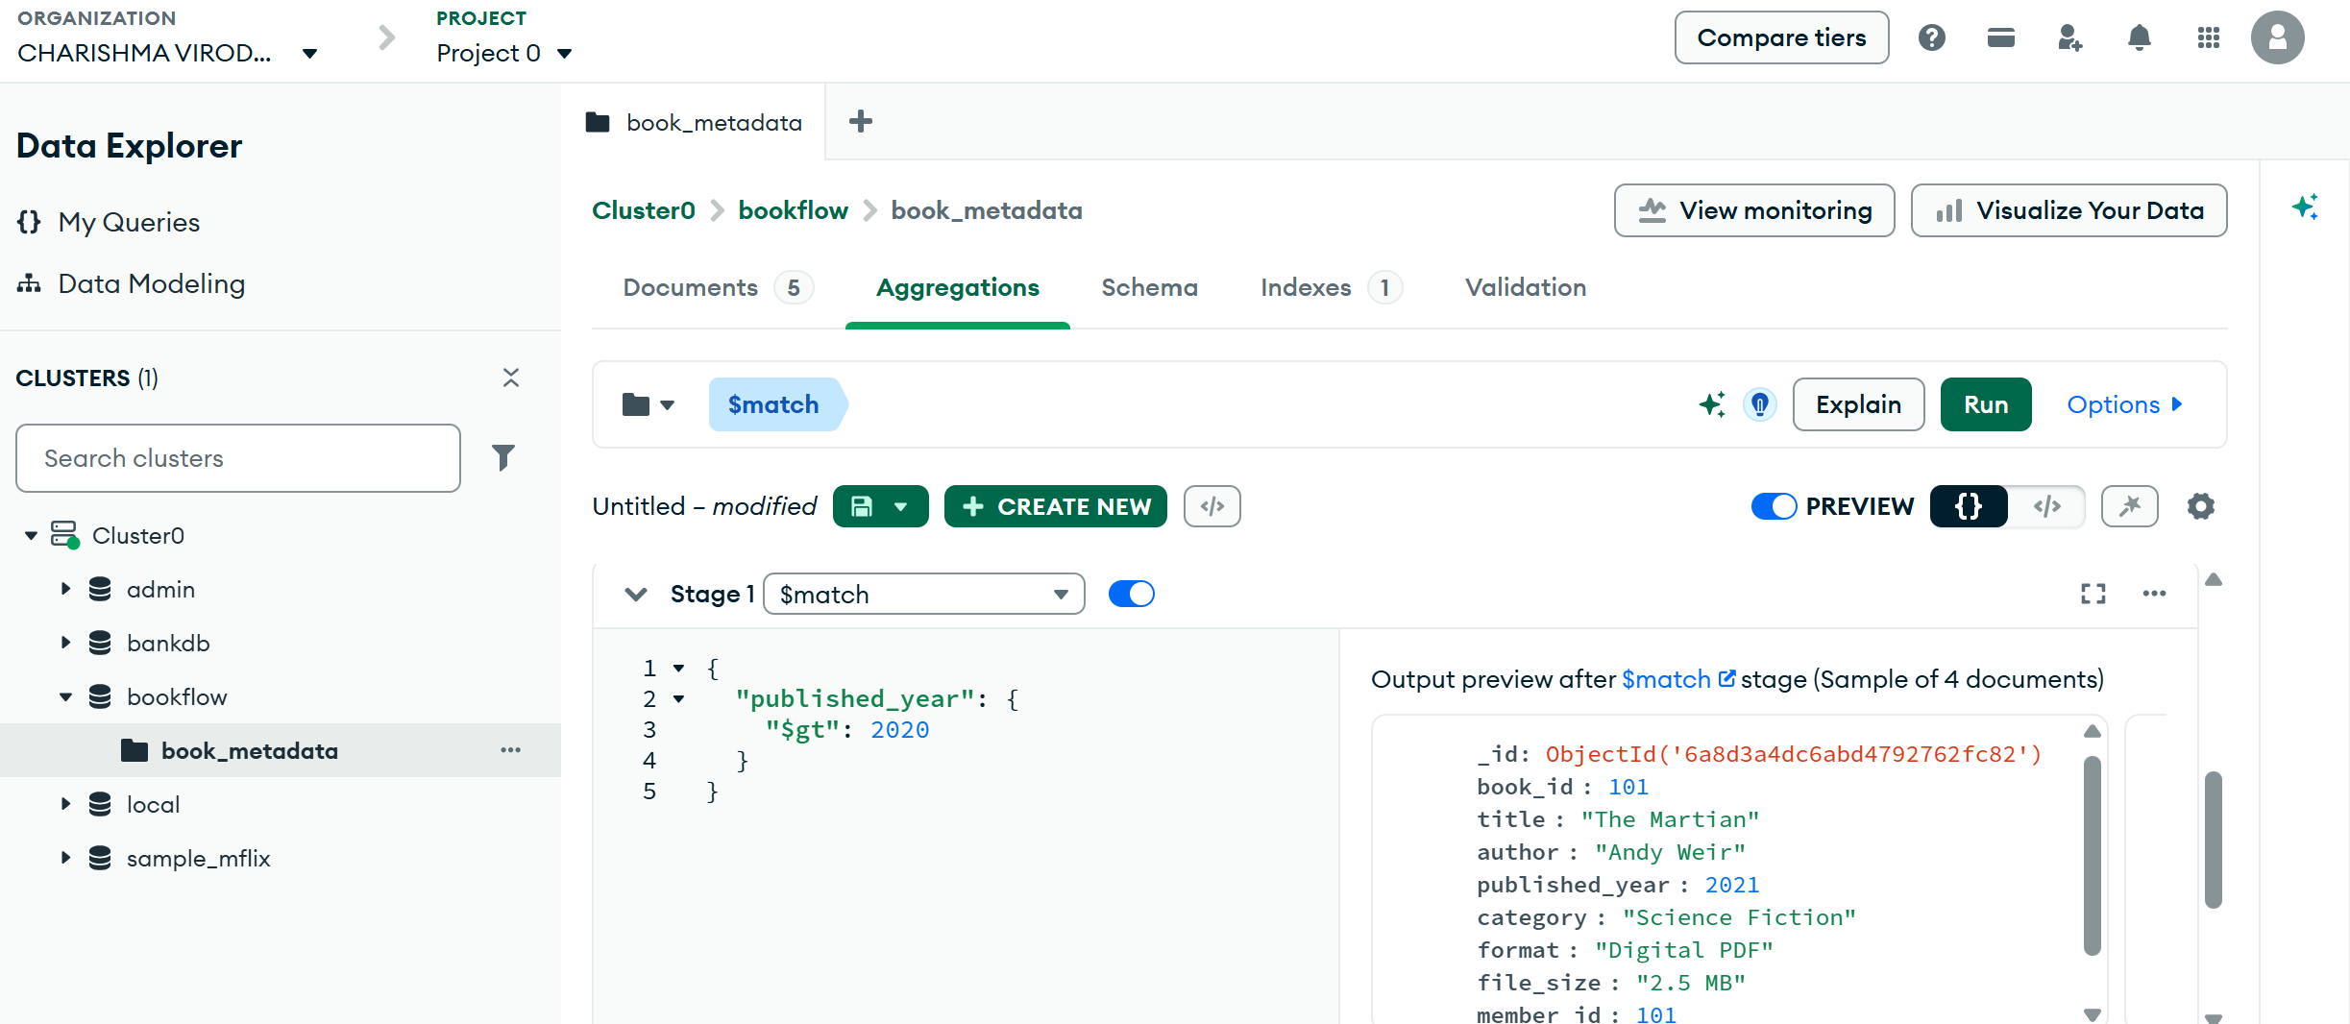

$UNWIND
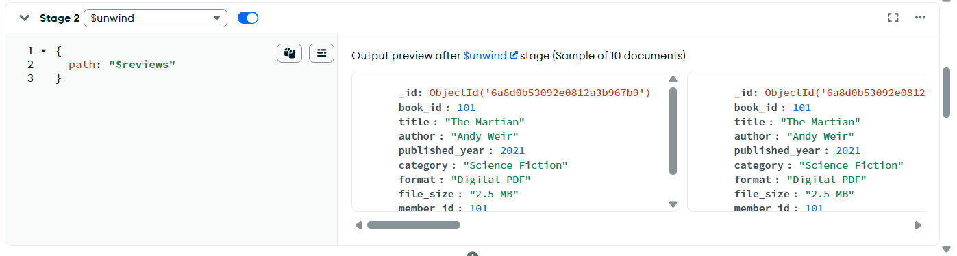
$GROUP
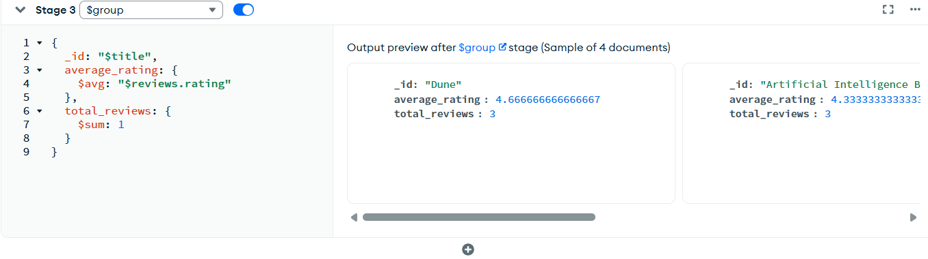
$SORT
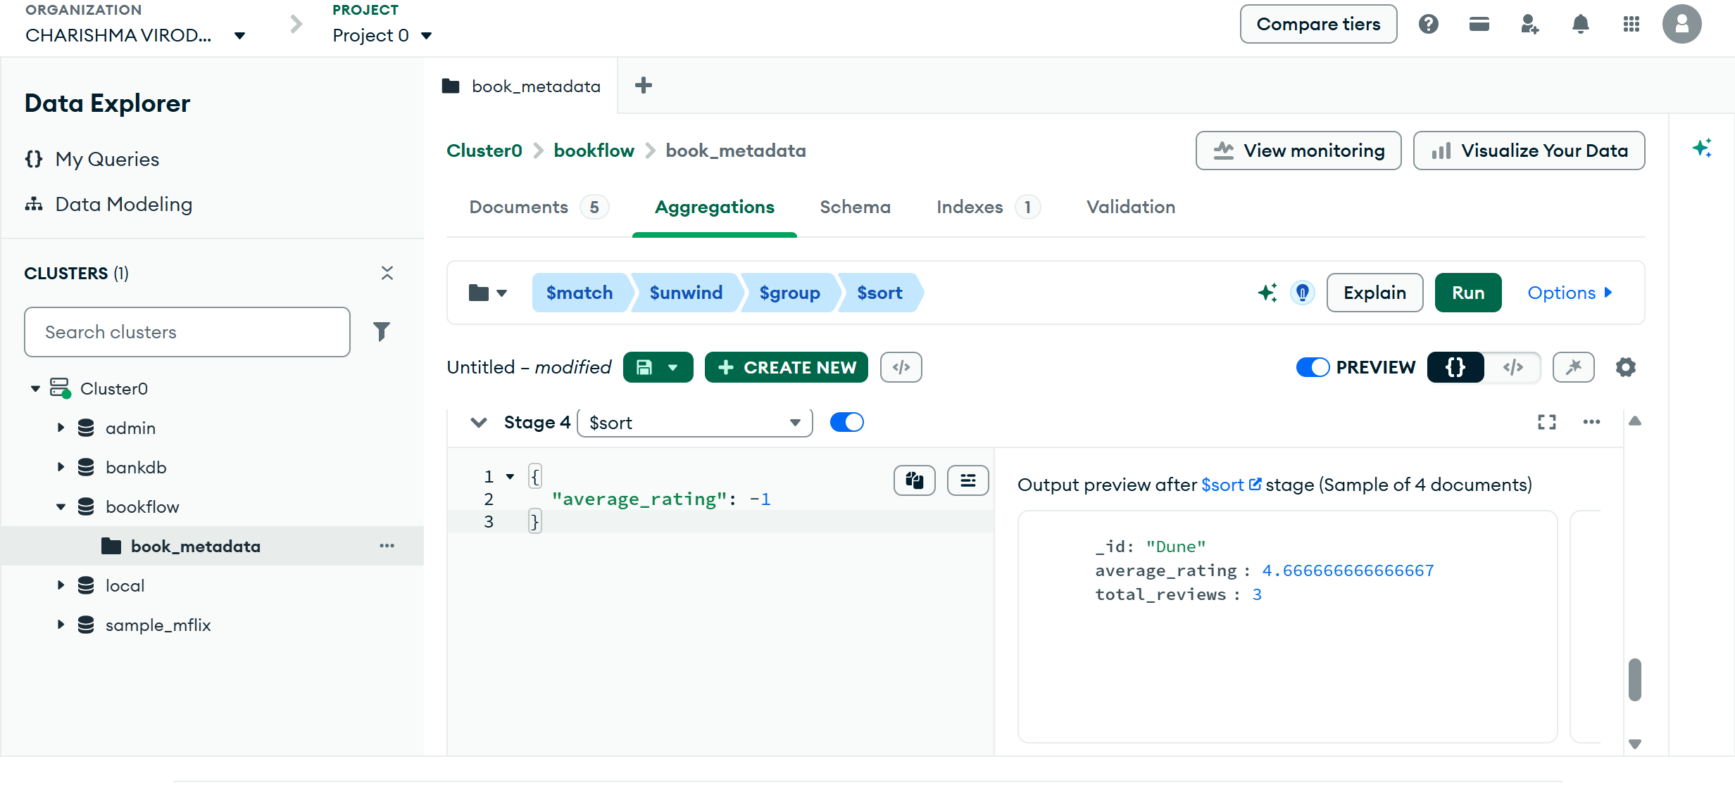
ALL RESULTS
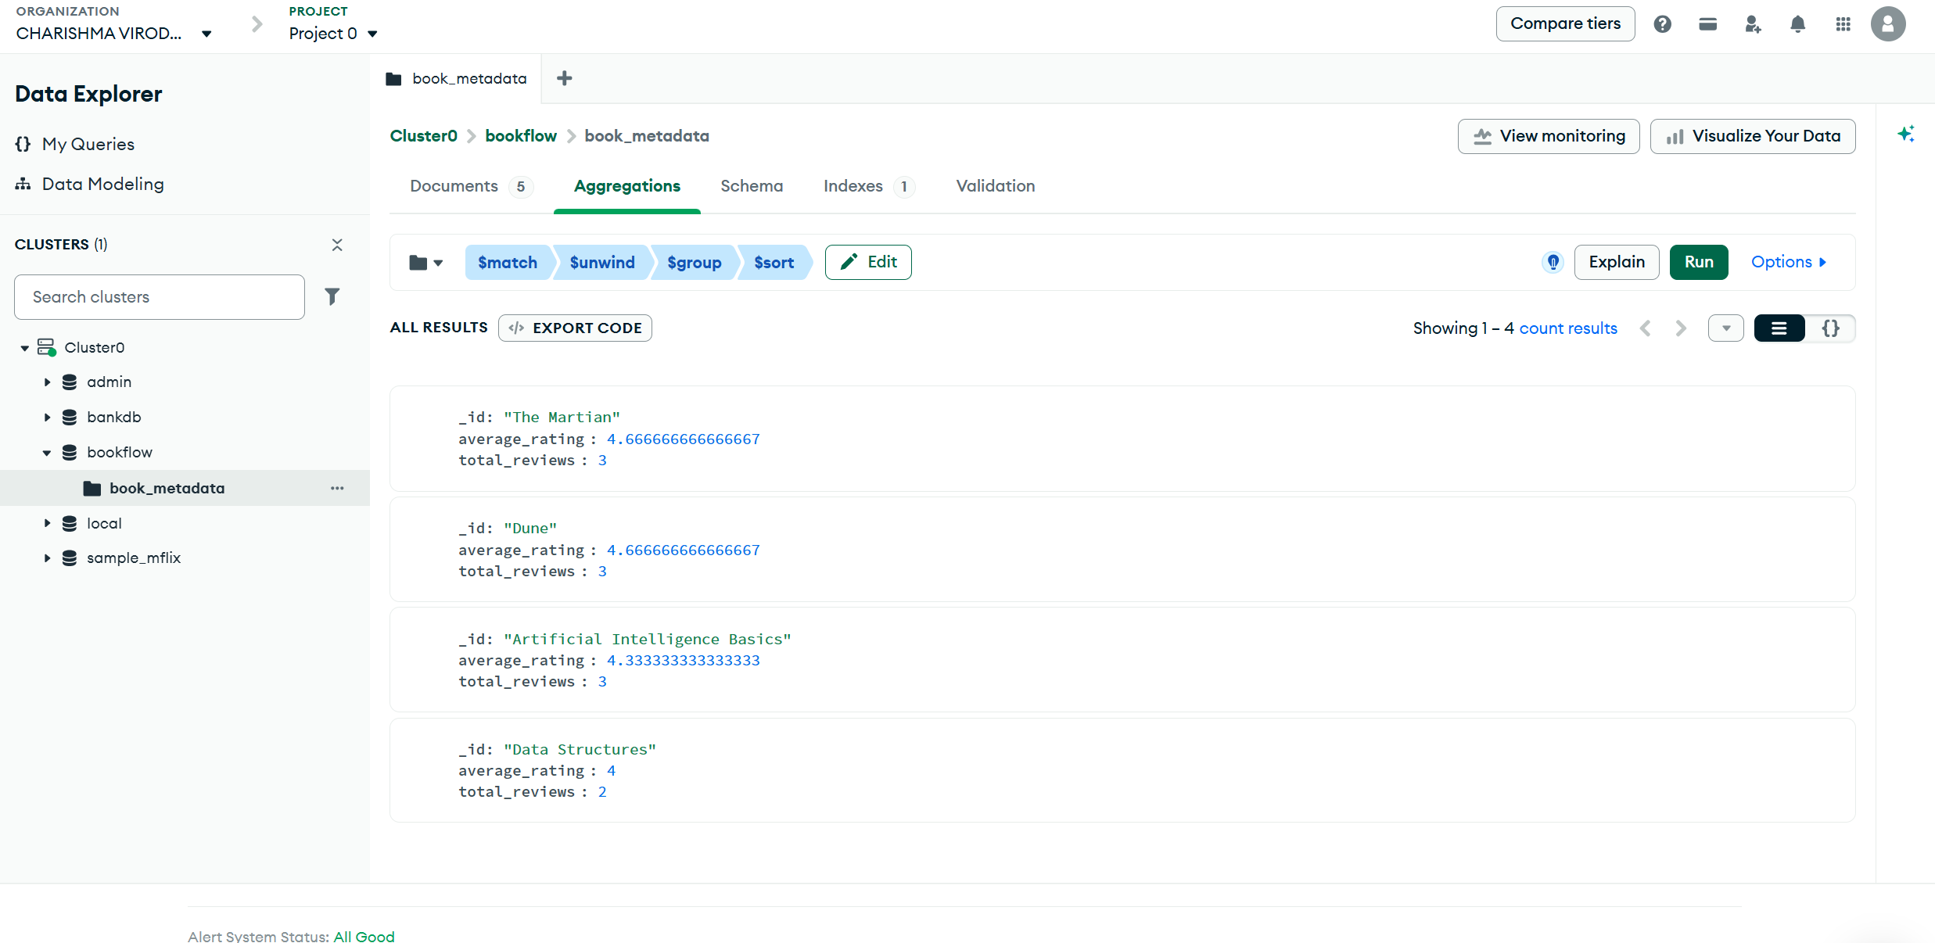
Create index text
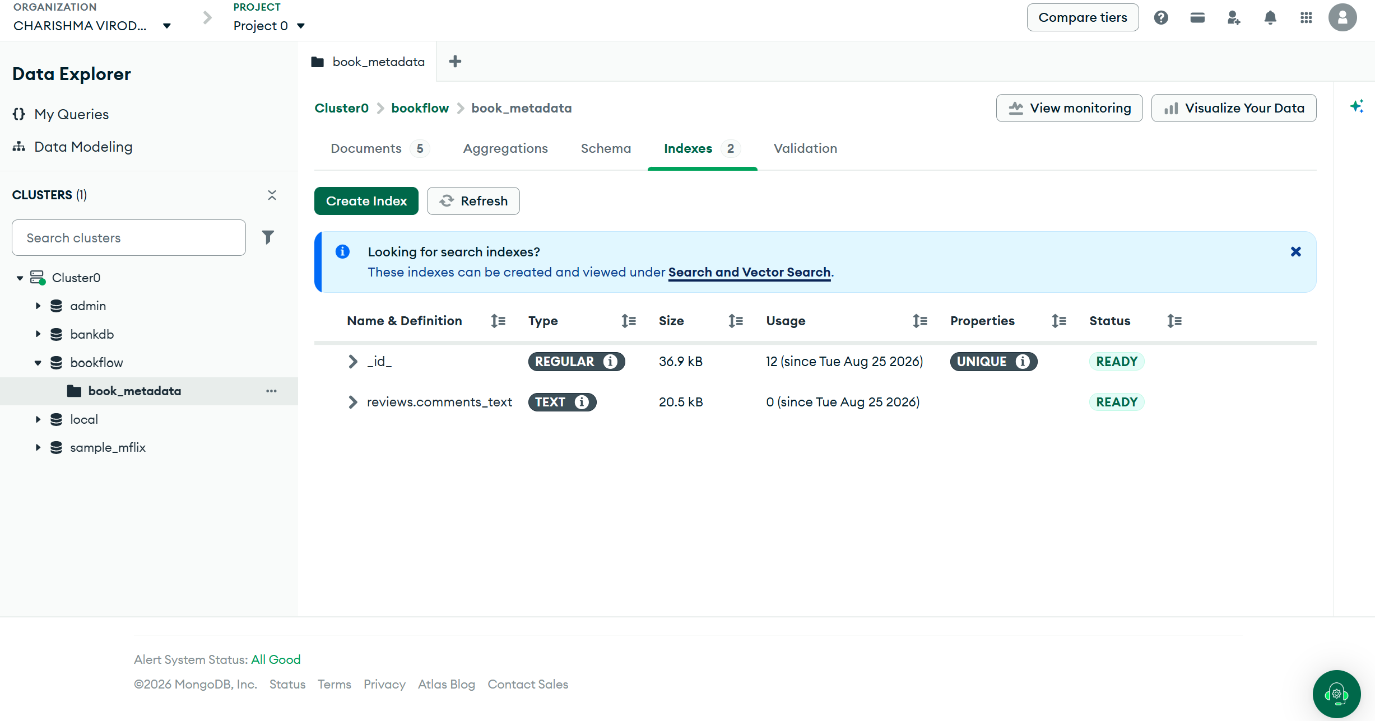
SEARCH USING TEXT INDEX
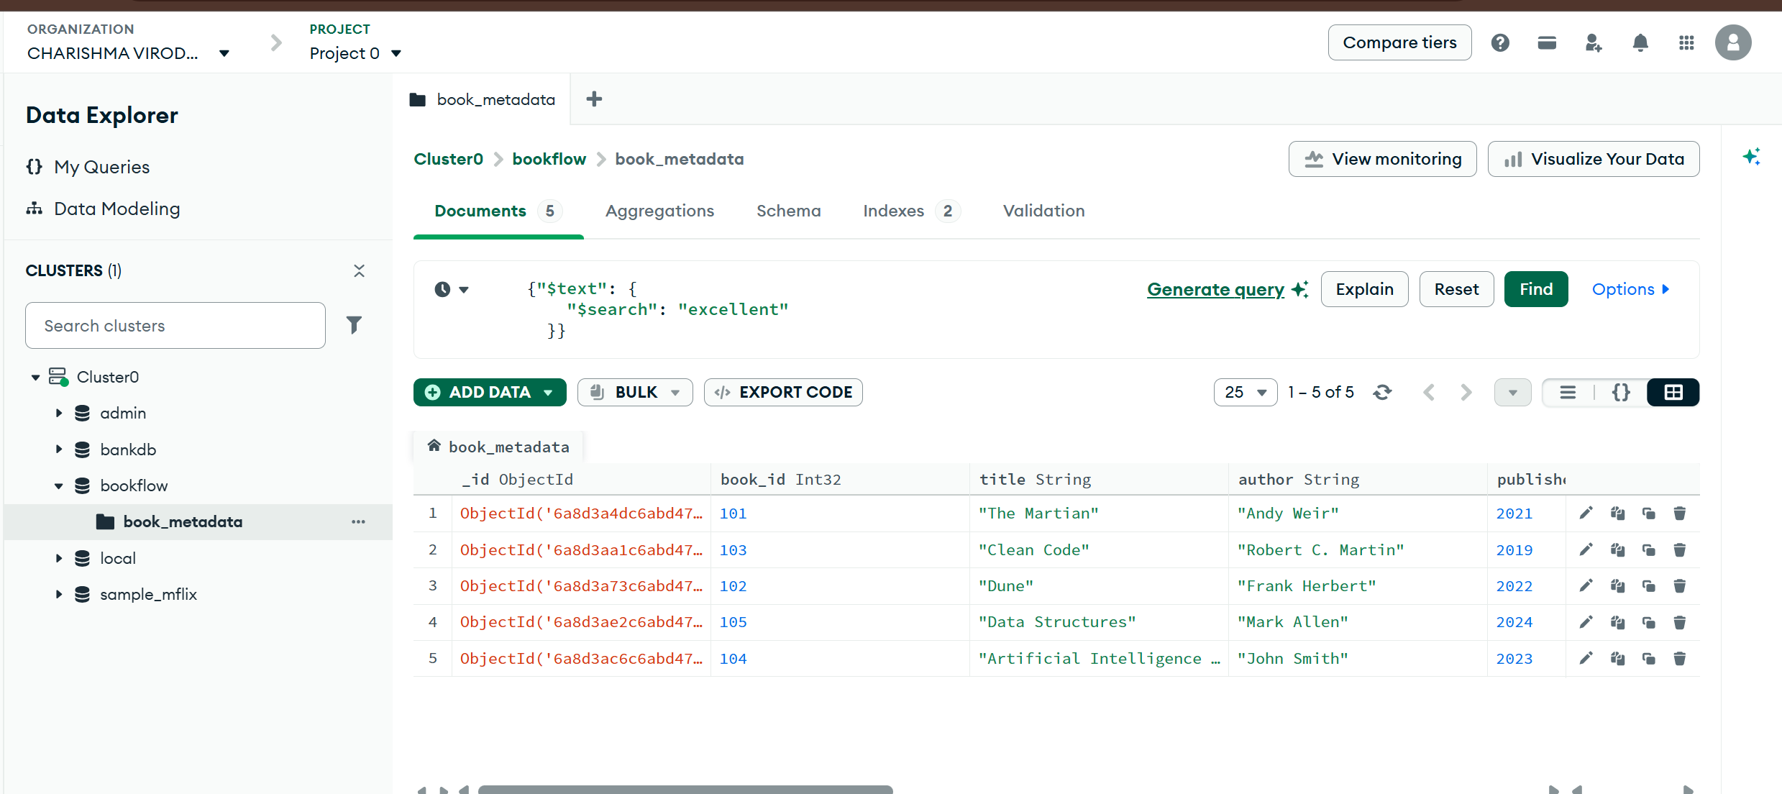

USE explain()
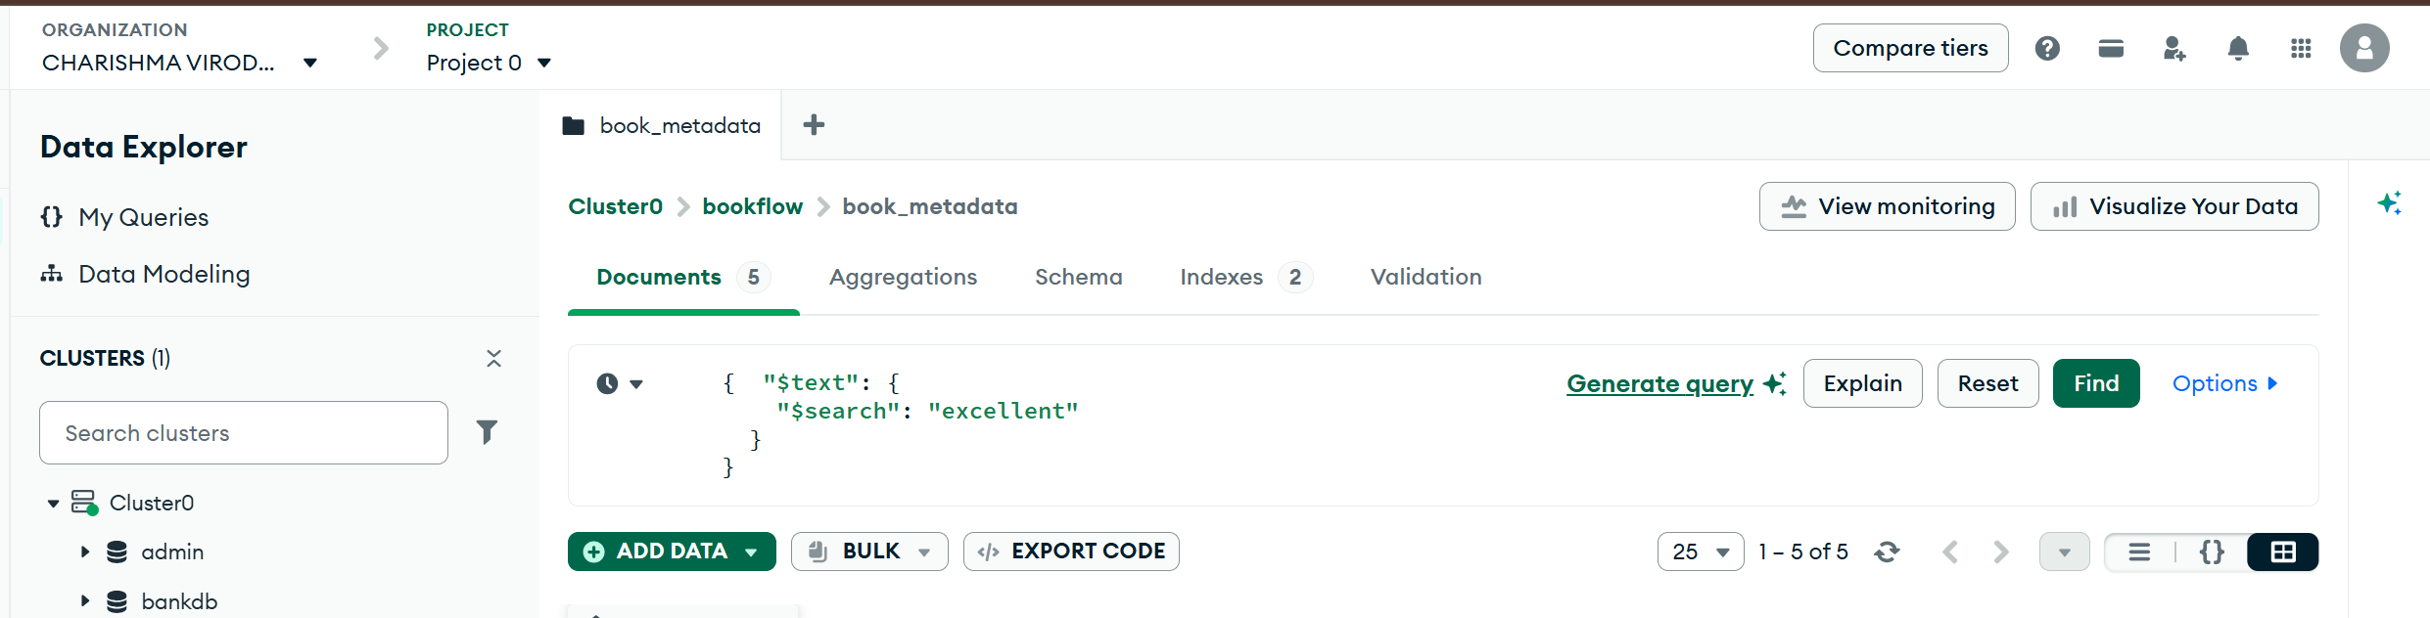
Output
