2520030140
V.Charishma
Skill-09
Title: Implementing the cd Built-in Command and Built-in Dispatch Table in a Custom Shell.
Aim:
To develop a C program that implements the cd built-in command with path validation, working-directory update, error handling and previous-directory support (cd -).
Also, to create a dispatch table that identifies built-in commands, executes them in-process, and reports invalid commands.

Objective:
- To change directories using chdir().
- To validate paths and handle errors using perror().
- To update and display the current working directory with getcwd().
- To maintain the previous directory for cd -.
- To identify built-ins and create a dispatch table of function pointers.
- To execute in-process commands and handle invalid commands.
Theory
1. Why cd must be a built-in
A child process has its own working directory. If cd were run through fork() and exec(), the directory change would be lost when the child exits. Hence cd must be executed inside the shell process itself.
2. chdir() and getcwd()
chdir(path) changes the working directory of the calling process and returns -1 on failure. getcwd() returns the absolute path of the current directory.
3. Dispatch table
A table of (name, function pointer) pairs. The shell searches the table for the first word of the command. If found, the function is called directly; otherwise the command is reported as not found (or executed as an external program).
Algorithm
- Start the program.
- Define the built-in functions cd, pwd and help.
- Create a dispatch table of command names and function pointers.
- Read a command and split it into arguments.
- Search the dispatch table for args[0].
- For cd: save the current directory, call chdir(), and update the previous directory on success.
- If chdir() fails, print the error using perror().
- If the command is not in the table, display 'command not found'.
- Repeat for all test commands and stop.
System Calls / Linux Commands Used
System Call / Command | Purpose
chdir() | Changes the current working directory
getcwd() | Returns the current working directory
getenv() | Reads the HOME environment variable
perror() | Prints the system error message
strtok() | Splits a command into tokens

C Program
#include <stdio.h>
#include <stdlib.h>
#include <string.h>
#include <unistd.h>
#include <limits.h>

char prev_dir[PATH_MAX] = "";

int do_cd(char **a)
{
char cur[PATH_MAX], target[PATH_MAX];
getcwd(cur, sizeof(cur));
if (a[1] == NULL) strcpy(target, getenv("HOME") ? getenv("HOME") : "/");
else if (strcmp(a[1], "-") == 0) {
if (prev_dir[0] == '\0') { printf("cd: no previous directory\n"); return 1; }
strcpy(target, prev_dir);
} else strcpy(target, a[1]);
if (chdir(target) != 0) { perror("cd"); return 1; }
strcpy(prev_dir, cur);
getcwd(cur, sizeof(cur));
printf("Directory changed to: %s\n", cur);
return 0;
}
int do_pwd(char **a) { char c[PATH_MAX]; getcwd(c, sizeof(c)); printf("%s\n", c); return 0; }
int do_help(char **a) { printf("Built-ins: cd pwd help\n"); return 0; }

struct builtin { const char *name; int (*fn)(char **); };
struct builtin table[] = { {"cd", do_cd}, {"pwd", do_pwd}, {"help", do_help} };
#define NB (int)(sizeof(table)/sizeof(table[0]))

int dispatch(char *line)
{
char *args[16]; int n = 0;
for (char *t = strtok(line, " "); t && n < 15; t = strtok(NULL, " ")) args[n++] = t;
args[n] = NULL;
if (n == 0) return 0;
for (int i = 0; i < NB; i++)
if (strcmp(args[0], table[i].name) == 0) return table[i].fn(args);
printf("%s: command not found\n", args[0]);
return 127;
}
int main()
{
const char *cmds[] = {"pwd", "cd /tmp", "pwd", "cd /usr", "cd -", "cd /nonexistent", "help", "hello"};
for (int i = 0; i < 8; i++) {
char buf[128]; strcpy(buf, cmds[i]);
printf("myshell> %s\n", cmds[i]);
dispatch(buf);
}
return 0;
}

OUTPUT:
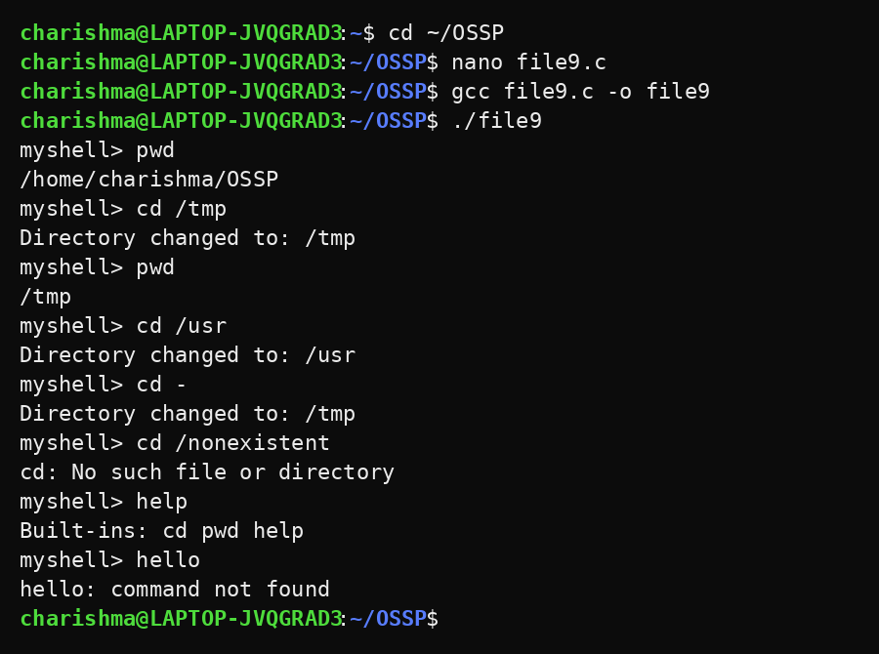
Observation
- cd changed the working directory of the shell process itself.
- cd - returned to the previously visited directory.
- An invalid path produced the error message 'No such file or directory'.
- pwd and help were executed in-process through the dispatch table.
- An unknown command (hello) was reported as 'command not found'.
Result
The cd built-in and the built-in dispatch table were implemented successfully. Directory navigation, path validation, previous-directory tracking and dispatch of valid and invalid commands were tested and verified.

