2520030140
V.Charishma
Skill-13
Title: Implementing Input Redirection (<) and Output Redirection (>).
Aim:
To develop a C program that parses input redirection (<), opens files, redirects stdin, and handles missing files.
Also, to implement output redirection (>) that creates output files, redirects stdout, handles permissions and verifies the data written.

Objective:
- To parse the < and > operators.
- To open files using open().
- To redirect stdin and stdout using dup2().
- To handle missing files and permission errors.
- To restore the standard streams in the shell.
- To verify the redirected data.
Theory
1. File descriptors
Descriptor 0 is stdin, 1 is stdout and 2 is stderr. Redirection replaces one of these with a file.
2. Input redirection
The file is opened with O_RDONLY and duplicated onto descriptor 0, so the command reads from the file instead of the keyboard.
3. Output redirection
The file is opened with O_WRONLY | O_CREAT | O_TRUNC (mode 0644) and duplicated onto descriptor 1. An existing file is overwritten.
4. Where it is done
Redirection is performed in the child after fork() and before exec(), so the shell's own streams stay unchanged.
Algorithm
- Start the program.
- Create a test file input.txt.
- Fork a child process.
- In the child, open the input file; if it fails, print the error and exit.
- Redirect stdin using dup2().
- Open the output file with O_CREAT | O_TRUNC and redirect stdout.
- Execute the command using execvp().
- The parent waits for the child.
- Display the output file contents and stop.
System Calls / Linux Commands Used
System Call / Command | Purpose
open() | Opens a file and returns a descriptor
dup2() | Redirects stdin/stdout
O_RDONLY, O_CREAT, O_TRUNC | File open flags
execvp() | Runs the command
perror() | Reports missing file or permission errors

C Program
#include <stdio.h>
#include <stdlib.h>
#include <string.h>
#include <fcntl.h>
#include <unistd.h>
#include <sys/wait.h>

void run(char *argv[], const char *infile, const char *outfile)
{
fflush(stdout);
if (fork() == 0) {
if (infile) {
int fd = open(infile, O_RDONLY);
if (fd < 0) { perror(infile); exit(1); }
dup2(fd, 0); close(fd);
}
if (outfile) {
int fd = open(outfile, O_WRONLY | O_CREAT | O_TRUNC, 0644);
if (fd < 0) { perror(outfile); exit(1); }
dup2(fd, 1); close(fd);
}
execvp(argv[0], argv); perror(argv[0]); exit(127);
}
wait(NULL);
}
int main()
{
FILE *f = fopen("input.txt", "w"); fprintf(f, "banana\napple\ncherry\n"); fclose(f);
char *sort[] = {"sort", NULL}, *cat[] = {"cat", NULL}, *wc[] = {"wc", "-l", NULL};

printf("--- Part 1: Input redirection ( < ) ---\n");
printf("myshell> sort < input.txt\n"); run(sort, "input.txt", NULL);
printf("myshell> wc -l < input.txt\n"); run(wc, "input.txt", NULL);
printf("myshell> sort < missing.txt\n"); run(sort, "missing.txt", NULL);

printf("\n--- Part 2: Output redirection ( > ) ---\n");
printf("myshell> sort < input.txt > sorted.txt\n"); run(sort, "input.txt", "sorted.txt");
printf("myshell> cat sorted.txt\n"); run(cat, "sorted.txt", NULL);
printf("myshell> cat input.txt > /root/x/out.txt\n"); run(cat, "input.txt", "/root/x/out.txt");
printf("Original stdin/stdout restored in the shell process.\n");
return 0;
}

OUTPUT:
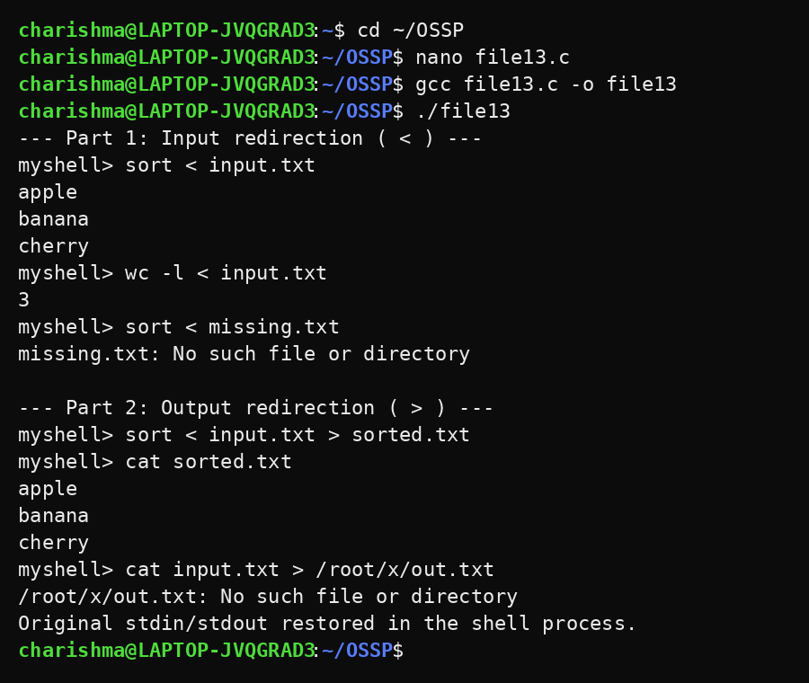
Observation
- sort < input.txt read its data from the file and printed it sorted.
- wc -l < input.txt counted the lines of the file.
- A missing input file produced the error message without crashing the shell.
- sort < input.txt > sorted.txt wrote the result into sorted.txt.
- Writing to an inaccessible path displayed an error.
Result
Input and output redirection were implemented successfully. Files were opened, streams were redirected for the child process, errors were handled and the output data was verified.

