2520030140
V.Charishma
Skill-16
Title: Implementing Background Job Execution and a Job Table.
Aim:
To develop a C program that detects the & operator, launches non-blocking background processes, returns the prompt immediately and stores job information.
Also, to create a job table that stores process groups, tracks states, updates the status and removes completed jobs.

Objective:
- To detect background jobs using the & operator.
- To launch non-blocking processes.
- To return the prompt immediately.
- To create a job table and store process IDs and group IDs.
- To track and update job states using waitpid() with WNOHANG.
- To remove completed jobs and validate the job records.
Theory
1. Foreground and background
A foreground job is waited for with waitpid(). A background job is started with & and the shell does not wait for it, so the prompt returns immediately.
2. Process groups
Every job is placed in its own process group using setpgid(0, 0), so that signals can be sent to the whole job.
3. Job table
An array of structures stores the job ID, PID, command and state. The shell checks the jobs with waitpid(pid, NULL, WNOHANG), which returns immediately and reports whether the child has finished.
4. Cleanup
Finished jobs are removed from the table to avoid zombie processes and stale entries.
Algorithm
- Start the program.
- Read a command and check whether it ends with &.
- Fork a child, put it in a new process group and exec the command.
- For a background job, add it to the job table, print [id] pid and return the prompt without waiting.
- For a foreground job, call waitpid() and wait.
- Periodically call waitpid(WNOHANG) for every job to update its state.
- Print 'Done' for completed jobs.
- Remove completed jobs from the table and stop.
System Calls / Linux Commands Used
System Call / Command | Purpose
fork() | Creates the job process
setpgid() | Assigns the process group
waitpid(..., WNOHANG) | Checks job status without blocking
sleep | Test command for background jobs
struct job | Stores the job table entries

C Program
#include <stdio.h>
#include <stdlib.h>
#include <string.h>
#include <unistd.h>
#include <sys/types.h>
#include <sys/wait.h>
#define MAXJ 16

struct job { int id; pid_t pid; char cmd[64]; int running; };
struct job jobs[MAXJ]; int njobs = 0, next_id = 1;

void add_job(pid_t pid, const char *cmd)
{
jobs[njobs].id = next_id++; jobs[njobs].pid = pid; jobs[njobs].running = 1;
strncpy(jobs[njobs].cmd, cmd, 63); njobs++;
}
void print_table(void)
{
printf("%-5s %-8s %-10s %s\n", "ID", "PID", "STATE", "COMMAND");
for (int i = 0; i < njobs; i++)
printf("[%d] %-8d %-10s %s\n", jobs[i].id, jobs[i].pid, jobs[i].running ? "Running" : "Done", jobs[i].cmd);
}
void update_jobs(void)
{
for (int i = 0; i < njobs; i++)
if (jobs[i].running && waitpid(jobs[i].pid, NULL, WNOHANG) > 0) {
jobs[i].running = 0;
printf("[%d]+ Done %s\n", jobs[i].id, jobs[i].cmd);
}
}
void remove_done(void)
{
int k = 0;
for (int i = 0; i < njobs; i++) if (jobs[i].running) jobs[k++] = jobs[i];
njobs = k;
}
void launch(char *argv[], const char *text, int bg)
{
pid_t pid = fork();
if (pid == 0) { setpgid(0, 0); execvp(argv[0], argv); exit(127); }
setpgid(pid, pid);
if (bg) { add_job(pid, text); printf("[%d] %d\n", jobs[njobs - 1].id, pid); }
else waitpid(pid, NULL, 0);
}
int main()
{
char *s1[] = {"sleep", "2", NULL}, *s2[] = {"sleep", "4", NULL}, *e[] = {"echo", "foreground done", NULL};
printf("myshell> sleep 2 &\n"); launch(s1, "sleep 2 &", 1);
printf("myshell> sleep 4 &\n"); launch(s2, "sleep 4 &", 1);
printf("(prompt returned immediately)\nmyshell> echo foreground done\n"); fflush(stdout);
launch(e, "echo", 0);
printf("\nJob table:\n"); print_table();
sleep(3); printf("\n[after 3 seconds]\n"); update_jobs(); print_table();
remove_done(); printf("\n[completed jobs removed]\n"); print_table();
sleep(2); printf("\n[after 5 seconds]\n"); update_jobs(); remove_done(); print_table();
return 0;
}

OUTPUT:
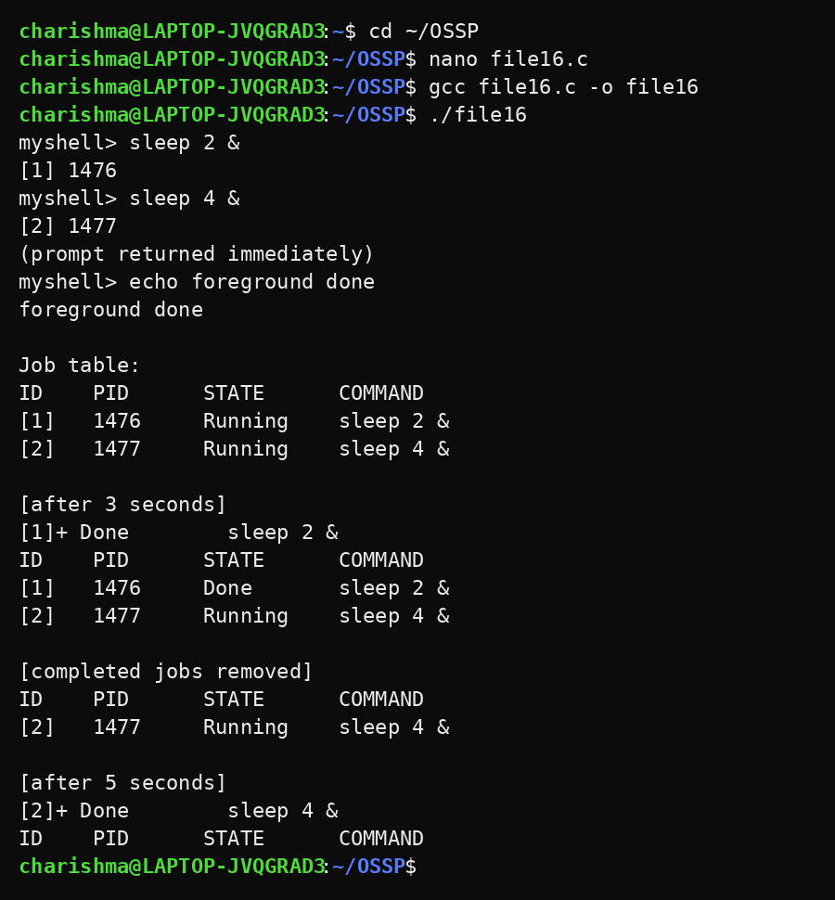
Observation
- The prompt returned immediately after starting a background job.
- Each job received a job ID and PID ([1] and [2]).
- The foreground command completed while the background jobs were running.
- After 3 seconds the shorter job was reported as Done.
- Completed jobs were removed and the table became empty at the end.
Result
Background execution and the job table were implemented successfully. Jobs were launched without blocking the shell, their states were tracked and completed jobs were removed.

