Experiment: Practical-03
Course: Operating Systems and Systems Programming (OSSP)
Name: T.Hansini
Roll No.: 2520030095
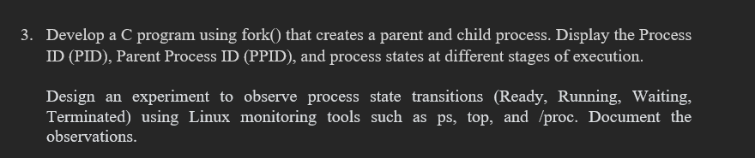
Step 1: Navigate to the Working Directory
Command:
Observation: The working directory fork_process_lab was successfully opened.

Step 2: Execute the Fork Process Program
Command:
Observation: The program was executed successfully and created two processes: a parent process and a child process.

Step 3: Observe the Parent and Child Process IDs
Output:
Both processes started
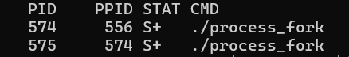
Observation: The program successfully displayed the Process ID (PID) of the parent process and the child process.

Step 4: Observe the Parent Process
Output:
--- PARENT PROCESS ---
Parent PID : 574
Child PID : 575
Parent is RUNNING...
Parent is WAITING for child to terminate...
Observation: The parent process entered the RUNNING state and then waited for the child process to complete its execution.

Step 5: Observe the Child Process
Output:
--- CHILD PROCESS ---
Child PID : 575
Child PPID : 574
Child is RUNNING...
Child is WAITING for 10 seconds...
Child is RUNNING again...
Child is TERMINATING...
Observation: The child process successfully demonstrated different process states. It entered the RUNNING state, waited for 10 seconds, resumed execution, and then terminated.

Step 6: Observe Parent Process After Child Termination
Output:
Child terminated.
Parent is RUNNING again.
Parent is TERMINATING...
Observation: After the child process terminated, the parent process resumed execution and then terminated successfully.

Step 7: Display Process Information Using ps
Command:
Observation: The ps command was used to display the PID, Parent PID, process state, and command name of the running process_fork program.

Step 8: Observe Parent and Child Process Details
Output:
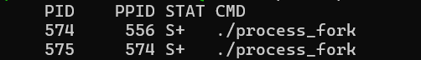
Observation: The output showed two processes. Process 574 was the parent process, and process 575 was created as its child process with PPID 574.

Step 9: Check Process Status Using the /proc File System
Command:
Observation: The /proc file system was used to obtain detailed information about the process name, state, PID, and PPID.

Step 10: Monitor Running Processes Using top
Command:
Observation: The top command was used to monitor active processes, their process IDs, CPU usage, memory usage, and current execution status.

Step 11: Observe Process States in top
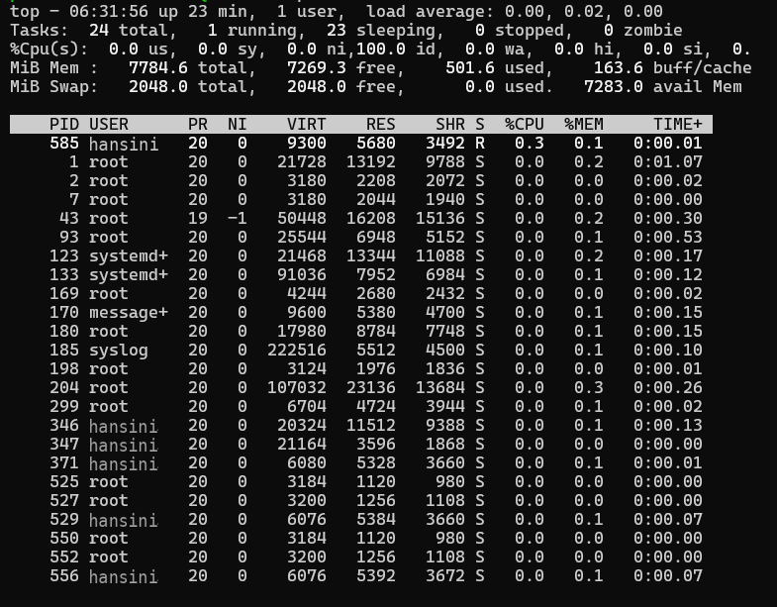
Observation: The process monitoring screen displayed the currently running processes and their states. This was used to observe system process activity during the fork process experiment.

Step 12: Exit the top Command
Command:
Observation: The q key was used to exit the top process monitoring screen.

Result
Observation: The program successfully demonstrated process creation using fork(). A parent process and a child process were created with different PIDs.

