Experiment: Practical-04
Course: Operating Systems and Systems Programming (OSSP)
Name: T. Hansini
Roll No.: 2520030095
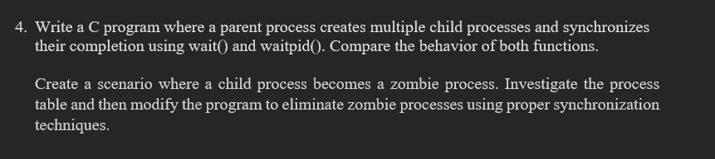
Step 1: Navigate to the Downloads Directory
Command:
Observation: The Downloads directory was successfully opened.

Step 2: Create and Navigate to the Working Directory
Command:
Observation: The process_sync_lab directory was already present. The directory was opened successfully.

Step 3: Verify the Current Working Directory
Command:
Observation: The current working directory was successfully verified.

Step 4: Display the Files in the Working Directory
Command:
Output:
Observation: The programs for demonstrating wait(), waitpid(), and zombie processes were successfully present in the working directory.

Step 5: Execute the wait() Demonstration Program
Command:
Output:
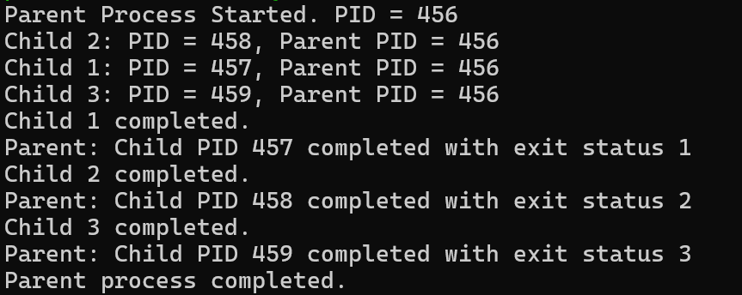
Observation: The parent process successfully created three child processes. The parent used wait() to wait for each child process to complete before finishing its execution.

Step 6: Observe Child Process Completion Using wait()
Observation: Each child process completed its execution and returned a different exit status. The parent process collected the terminated child processes one by one using wait().

PART-B: Process Synchronization Using waitpid()
Step 7: Execute the waitpid() Demonstration Program
Command:
Output:
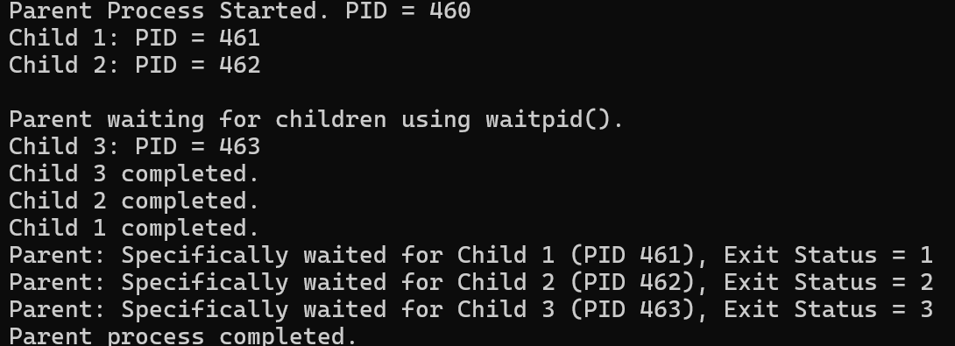
Observation: The parent process successfully used waitpid() to wait for specific child processes and collected their exit statuses individually.

Step 8: Observe Specific Child Process Synchronization
Observation: Unlike wait(), the waitpid() system call allowed the parent process to wait for a particular child process by specifying its PID.

PART-C: Zombie Process Demonstration
Step 9: Execute the Zombie Process Program
Command:
Output:
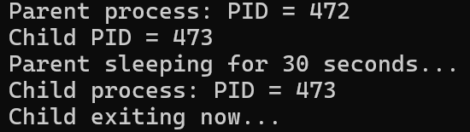
Observation: The child process terminated while the parent process continued sleeping. This situation was used to demonstrate the creation of a zombie process.

Step 10: Check the Zombie Process
Command:
Output:
Observation: The output showed the child process as [zombie] <defunct>, confirming that the child had terminated but had not yet been collected by its parent process.

Step 11: Observe the Zombie Process After Parent Termination
Command:
Observation: After the parent process completed, the zombie process was no longer present in the process list.

Step 12: Monitor Process Information Using ps
Command:
Observation: The ps command was used to monitor the PID, PPID, process state, and command of the active processes.

PART-D: Preventing Zombie Process Using wait()
Step 13: Edit the Zombie Program
Command:
Observation: The zombie process program was modified so that the parent process uses wait() to collect the terminated child process.

Step 14: Compile the Modified Program
Command:
Observation: The modified zombie.c program was compiled successfully without errors.

Step 15: Execute the Modified Zombie Program
Command:
Output:
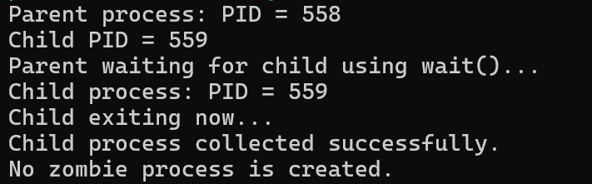
Observation: The parent process successfully used wait() to collect the child process after it terminated. Therefore, no zombie process was created.

Step 16: Verify That No Zombie Process Exists
Command:
Output:
Observation: Only the grep zombie command appeared in the output. No [zombie] <defunct> process was found, confirming that the child process was successfully collected.

Result
Observation: The experiment was successfully performed to demonstrate process synchronization using wait() and waitpid.A zombie process was also successfully demonstrated when a child terminated before its parent collected its exit status.

