SKILL - 10

Name: V.Charishma
Rollno: 2520030140

Experiment No. 10
Title: Implementing pwd, exit and export Built-in Commands in a Custom Shell.
Aim:
To develop a C program that implements the pwd and exit built-ins, including cleanup of resources and saving of shell state.
Also, to implement the export built-in that parses NAME=VALUE syntax, validates names, updates environment variables and passes them to child processes.

Objective:
- To retrieve and display the current directory.
- To process exit requests and release resources.
- To save the shell state to a file before exiting.
- To parse export syntax (NAME=VALUE).
- To validate variable names and handle existing variables.
- To export variables to child processes and test the functionality.
Theory
1. pwd
pwd calls getcwd() and prints the absolute path of the current working directory.
2. exit
The exit built-in frees allocated memory, closes open files, saves the state (such as the last directory) and then calls exit(0).
3. export and the environment
Every process has an environment (a list of NAME=VALUE strings). setenv() adds or modifies a variable. A child created by fork() inherits the environment of the parent, so exported variables are visible to child programs.
4. Valid names
A name must start with a letter or underscore and may contain only letters, digits and underscores.
Algorithm
- Start the program.
- Display the current directory using getcwd() for pwd.
- Read the export argument and locate '='.
- Validate the variable name.
- If the variable already exists, report the old value.
- Store the variable using setenv().
- Create a child using fork() and run a command that prints the variable.
- For exit: save the state to a file, release resources and call exit(0).
- Stop the program.
System Calls / Linux Commands Used
System Call / Command | Purpose
getcwd() | Retrieves the current directory
setenv() | Adds or updates an environment variable
getenv() | Reads an environment variable
fork() / execlp() | Creates a child that inherits the environment
fopen() / fprintf() | Saves the shell state to a file
exit() | Terminates the shell

C Program
#include <stdio.h>
#include <stdlib.h>
#include <string.h>
#include <unistd.h>
#include <limits.h>
#include <sys/wait.h>

int is_valid_name(const char *s)
{
if (!(s[0] == '_' || (s[0] >= 'A' && s[0] <= 'Z') || (s[0] >= 'a' && s[0] <= 'z'))) return 0;
for (int i = 1; s[i]; i++)
if (!(s[i] == '_' || (s[i] >= '0' && s[i] <= '9') || (s[i] >= 'A' && s[i] <= 'Z') || (s[i] >= 'a' && s[i] <= 'z'))) return 0;
return 1;
}
void do_export(char *arg)
{
char *eq = strchr(arg, '=');
if (!eq) { printf("export: usage: export NAME=VALUE\n"); return; }
*eq = '\0';
if (!is_valid_name(arg)) { printf("export: '%s': not a valid identifier\n", arg); return; }
if (getenv(arg)) printf("Variable %s already exists. Old value: %s\n", arg, getenv(arg));
setenv(arg, eq + 1, 1);
printf("Exported %s=%s\n", arg, getenv(arg));
}
void do_pwd(void) { char c[PATH_MAX]; getcwd(c, sizeof(c)); printf("%s\n", c); }
void do_exit(void)
{
FILE *fp = fopen("/tmp/shell_state.txt", "w");
char c[PATH_MAX]; getcwd(c, sizeof(c));
if (fp) { fprintf(fp, "last_dir=%s\n", c); fclose(fp); printf("State saved to /tmp/shell_state.txt\n"); }
printf("Resources released. Exiting shell...\n");
exit(0);
}
int main()
{
char a1[] = "MYVAR=hello", a2[] = "MYVAR=world", a3[] = "1BAD=x", a4[] = "NOVALUE";
printf("myshell> pwd\n"); do_pwd();
printf("myshell> export MYVAR=hello\n"); do_export(a1);
printf("myshell> export MYVAR=world\n"); do_export(a2);
printf("myshell> export 1BAD=x\n"); do_export(a3);
printf("myshell> export NOVALUE\n"); do_export(a4);
printf("myshell> sh -c 'echo child sees MYVAR=$MYVAR'\n"); fflush(stdout);
if (fork() == 0) { execlp("sh", "sh", "-c", "echo child sees MYVAR=$MYVAR", NULL); exit(1); }
wait(NULL);
printf("myshell> exit\n"); do_exit();
}

OUTPUT:
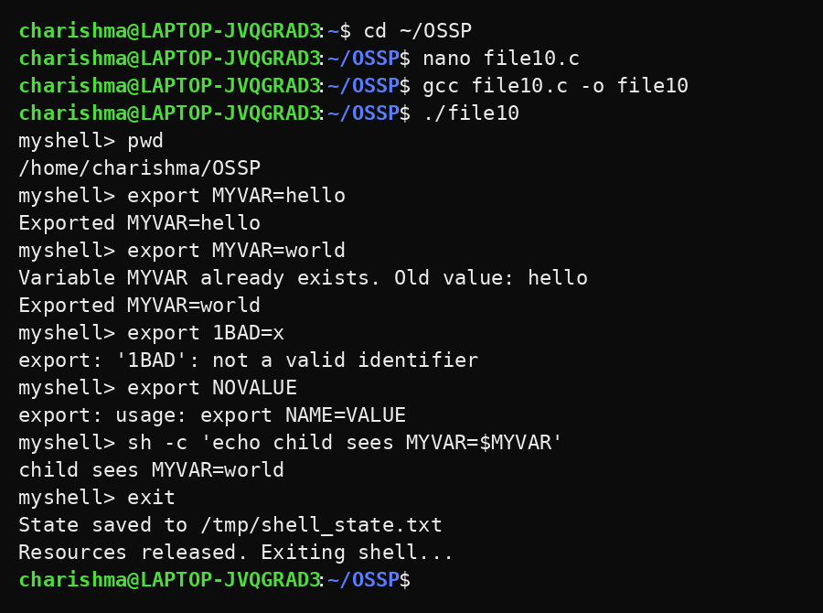
Observation
- pwd displayed the current working directory.
- export created the variable MYVAR and updated it when it already existed.
- An invalid name (1BAD) and a missing value were rejected with messages.
- The child process printed the value of the exported variable.
- exit saved the state to /tmp/shell_state.txt and released resources before terminating.
Result
The pwd, exit and export built-ins were implemented successfully. Environment variables were validated, updated and inherited by child processes, and the shell exited after saving its state.

