SKILL - 14

Name: V.Charishma
Rollno: 2520030140

Experiment No. 14
Title: Implementing Append Redirection (>>) and Standard Error Redirection (2>).
Aim:
To develop a C program that parses the append operator (>>), opens files in append mode and preserves existing data.
Also, to implement stderr redirection (2>) that captures error output into a file.

Objective:
- To parse the >> operator.
- To open files in append mode using O_APPEND.
- To preserve existing file data.
- To parse the 2> operator.
- To redirect descriptor 2 (stderr) to a file.
- To verify file contents and test error cases.
Theory
1. Append mode
With O_APPEND every write goes to the end of the file, so earlier content is kept. With > (O_TRUNC) the file is emptied first.
2. stderr
Descriptor 2 is used for error messages. It is separate from stdout, so errors can be redirected independently using 2>.
3. Implementation
The file is opened with the proper flags and dup2(fd, 1) (for >>) or dup2(fd, 2) (for 2>) is called before exec().
Algorithm
- Start the program.
- Run echo with > to create log.txt.
- Run echo twice with >> using O_APPEND.
- Display log.txt to verify that all lines are preserved.
- Run a failing command (ls no_such_file) with descriptor 2 redirected to err.txt.
- Observe that nothing is printed on the terminal.
- Display err.txt to verify the captured error message.
- Stop the program.
System Calls / Linux Commands Used
System Call / Command | Purpose
open() with O_APPEND | Appends data to a file
dup2(fd, 1) | Redirects stdout
dup2(fd, 2) | Redirects stderr
fork() / execvp() | Run the command
cat | Displays file contents

C Program
#include <stdio.h>
#include <stdlib.h>
#include <fcntl.h>
#include <unistd.h>
#include <sys/wait.h>

void run(char *argv[], const char *outfile, const char *errfile, int append)
{
fflush(stdout);
if (fork() == 0) {
if (outfile) {
int fd = open(outfile, O_WRONLY | O_CREAT | (append ? O_APPEND : O_TRUNC), 0644);
dup2(fd, 1); close(fd);
}
if (errfile) {
int fd = open(errfile, O_WRONLY | O_CREAT | O_TRUNC, 0644);
dup2(fd, 2); close(fd);
}
execvp(argv[0], argv); exit(127);
}
wait(NULL);
}
int main()
{
char *e1[] = {"echo", "first line", NULL}, *e2[] = {"echo", "second line", NULL};
char *e3[] = {"echo", "third line", NULL}, *cat[] = {"cat", "log.txt", NULL};
char *bad[] = {"ls", "no_such_file", NULL}, *cate[] = {"cat", "err.txt", NULL};

printf("--- Part 1: Append operator ( >> ) ---\n");
printf("myshell> echo first line > log.txt\n"); run(e1, "log.txt", NULL, 0);
printf("myshell> echo second line >> log.txt\n"); run(e2, "log.txt", NULL, 1);
printf("myshell> echo third line >> log.txt\n"); run(e3, "log.txt", NULL, 1);
printf("myshell> cat log.txt\n"); run(cat, NULL, NULL, 0);

printf("\n--- Part 2: stderr redirection ( 2> ) ---\n");
printf("myshell> ls no_such_file 2> err.txt\n"); run(bad, NULL, "err.txt", 0);
printf("(nothing printed on terminal - error went to file)\n");
printf("myshell> cat err.txt\n"); run(cate, NULL, NULL, 0);
return 0;
}

OUTPUT:
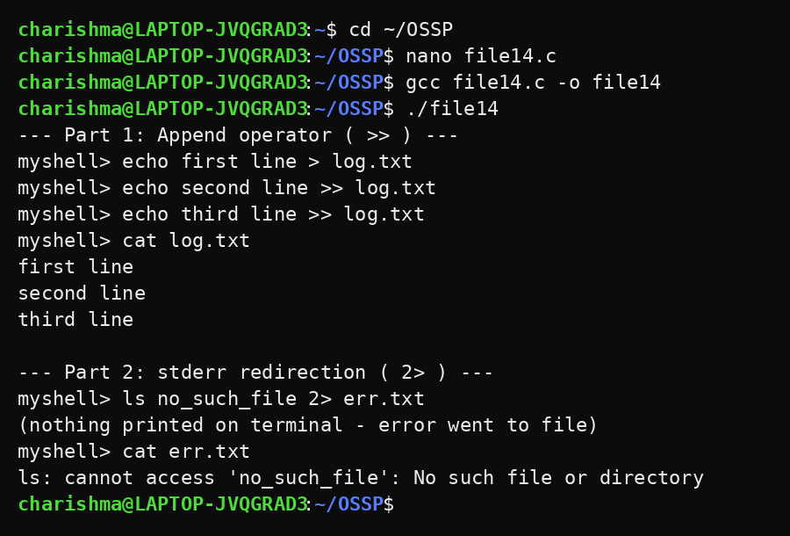
Observation
- The first command created log.txt and the next two commands appended to it.
- Existing data was preserved and all three lines appeared in order.
- The error message of ls was not displayed on the terminal.
- The error message was stored in err.txt.
- stdout and stderr were redirected independently.
Result
Append redirection and stderr redirection were implemented successfully. Existing data was preserved in append mode and error output was captured in a file.

