SKILL - 17

Name: V.Charishma
Rollno: 2520030140

Experiment No. 17
Title: Implementing the jobs and fg Built-in Commands.
Aim:
To develop a C program that implements the jobs command to list active jobs, display status information and job IDs.
Also, to implement the fg command that identifies the target job, transfers terminal control, resumes the process and waits for its completion.

Objective:
- To list active jobs and retrieve job IDs.
- To display status information in a formatted way.
- To update job states before listing.
- To identify the target job for fg.
- To transfer terminal control using tcsetpgrp().
- To resume the process, wait for completion and update the job state.
Theory
1. jobs
jobs prints every entry of the job table in the form [id]+ State PID Command. The + sign marks the most recent job.
2. fg
fg %n brings background job n to the foreground. The shell gives the terminal to the job's process group with tcsetpgrp(), sends SIGCONT, and waits using waitpid().
3. Terminal control
Only the foreground process group can read from the terminal. After the job finishes, the shell takes the terminal back with tcsetpgrp(tty, getpgrp()). SIGTTOU is ignored so that the shell is not stopped while doing this.
Algorithm
- Start the program.
- Start two background jobs and add them to the job table.
- jobs: update the states using waitpid(WNOHANG) and print every entry.
- fg %n: search the table for job n.
- If not found, print 'no such job'.
- Ignore SIGTTOU and give terminal control to the job's process group.
- Send SIGCONT and wait for the job with waitpid().
- Restore terminal control to the shell, update the job state and stop.
System Calls / Linux Commands Used
System Call / Command | Purpose
tcsetpgrp() | Transfers terminal control
kill(-pgid, SIGCONT) | Resumes the job's process group
waitpid() | Waits for completion
signal(SIGTTOU, SIG_IGN) | Prevents the shell from being stopped
jobs, fg | Built-in commands implemented

C Program
#include <stdio.h>
#include <stdlib.h>
#include <string.h>
#include <unistd.h>
#include <signal.h>
#include <sys/types.h>
#include <sys/wait.h>
#define MAXJ 16
struct job { int id; pid_t pid; char cmd[64]; int running; };
struct job jobs[MAXJ]; int njobs = 0;

void start_bg(char *argv[], const char *text)
{
pid_t pid = fork();
if (pid == 0) { setpgid(0, 0); execvp(argv[0], argv); exit(127); }
setpgid(pid, pid);
jobs[njobs].id = njobs + 1; jobs[njobs].pid = pid; jobs[njobs].running = 1;
strcpy(jobs[njobs].cmd, text); njobs++;
printf("[%d] %d\n", njobs, pid);
}
void do_jobs(void)
{
for (int i = 0; i < njobs; i++) {
if (jobs[i].running && waitpid(jobs[i].pid, NULL, WNOHANG) > 0) jobs[i].running = 0;
printf("[%d]%c %-8s PID=%-6d %s\n", jobs[i].id, i == njobs - 1 ? '+' : '-',
jobs[i].running ? "Running" : "Done", jobs[i].pid, jobs[i].cmd);
}
}
void do_fg(int id)
{
struct job *j = NULL;
for (int i = 0; i < njobs; i++) if (jobs[i].id == id && jobs[i].running) j = &jobs[i];
if (!j) { printf("fg: %%%d: no such job\n", id); return; }
printf("%s\n", j->cmd);
signal(SIGTTOU, SIG_IGN);
tcsetpgrp(STDIN_FILENO, j->pid);
kill(-j->pid, SIGCONT);
waitpid(j->pid, NULL, 0);
tcsetpgrp(STDIN_FILENO, getpgrp());
j->running = 0;
printf("Job [%d] completed in foreground\n", id);
}
int main()
{
char *a[] = {"sleep", "6", NULL}, *b[] = {"sleep", "3", NULL};
printf("myshell> sleep 6 &\n"); start_bg(a, "sleep 6");
printf("myshell> sleep 3 &\n"); start_bg(b, "sleep 3");
printf("myshell> jobs\n"); do_jobs();
printf("myshell> fg %%2\n"); fflush(stdout); do_fg(2);
printf("myshell> fg %%9\n"); do_fg(9);
printf("myshell> jobs\n"); do_jobs();
kill(jobs[0].pid, SIGTERM); waitpid(jobs[0].pid, NULL, 0);
printf("myshell> jobs\n"); jobs[0].running = 0; do_jobs();
return 0;
}

OUTPUT:
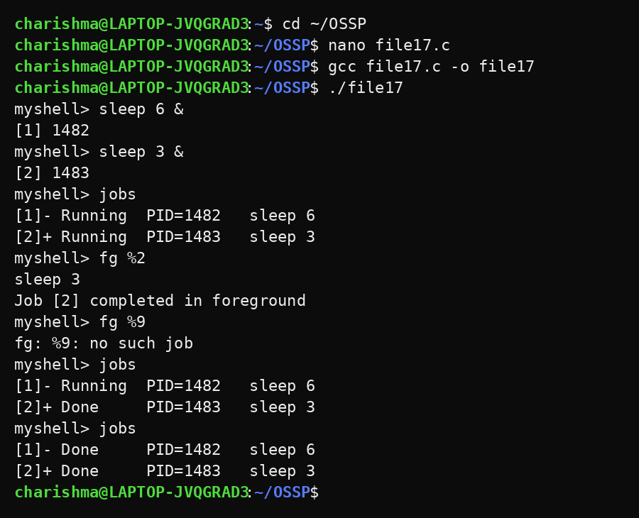
Observation
- jobs listed both jobs with ID, state, PID and command.
- fg %2 brought the job to the foreground and waited until it completed.
- fg %9 reported that the job does not exist.
- The state of job 2 changed from Running to Done.
- The terminal control was returned to the shell after fg.
Result
The jobs and fg commands were implemented successfully. Active jobs were listed correctly and a background job was moved to the foreground and completed.

