SKILL - 18

Name: V.Charishma
Rollno: 2520030140

Experiment No. 18
Title: Analysis of Signal Delivery and Resuming Stopped Jobs (bg / SIGCONT).
Aim:
To analyze signal delivery, signal masks, process groups and terminal signals in Linux.
Also, to implement how to resume stopped jobs by sending SIGCONT, update the job status and verify the execution.

Objective:
- To understand signal delivery to a process.
- To understand signal masks (blocking and pending signals).
- To review process groups and sessions.
- To explore terminal signals such as SIGINT and SIGTSTP.
- To resume a stopped job using SIGCONT.
- To update the job status and test background recovery.
Theory
1. Signals
A signal is an asynchronous notification sent to a process. Examples: SIGINT (Ctrl+C), SIGTSTP (Ctrl+Z), SIGSTOP, SIGCONT, SIGTERM.
2. Signal mask
sigprocmask() blocks selected signals. A blocked signal becomes pending and is delivered only after it is unblocked. sigpending() shows the pending signals.
3. Process groups and sessions
Terminal signals are sent to the whole foreground process group. Every process has a PID, a PGID and a session ID (SID).
4. Stop and continue
SIGSTOP suspends a process (state T). SIGCONT resumes it. waitpid() with WUNTRACED reports a stopped child, checked using WIFSTOPPED().
Algorithm
- Start the program.
- Display the PID, PGID and SID of the shell.
- Block SIGUSR1, send it to the process and check that it is pending.
- Ignore the signal and unblock it to show that the process survives.
- Fork a child running sleep 5 in its own process group.
- Send SIGSTOP and confirm the stop using waitpid(WUNTRACED).
- Check the state using ps (T = stopped).
- Send SIGCONT to the group (bg), check the state again and update the job status.
- Terminate the job and stop.
System Calls / Linux Commands Used
System Call / Command | Purpose
sigprocmask() | Blocks or unblocks signals
sigpending() | Shows pending signals
kill() | Sends a signal
waitpid(WUNTRACED) | Detects a stopped child
ps -o pid,stat,cmd | Shows the process state
getpgrp(), getsid() | Show group and session IDs

C Program
#include <stdio.h>
#include <stdlib.h>
#include <unistd.h>
#include <signal.h>
#include <sys/wait.h>

int main()
{
sigset_t block, pending;
printf("--- Part 1: Signal analysis ---\n");
printf("Shell PID = %d, Process Group = %d, Session = %d\n", getpid(), getpgrp(), getsid(0));
sigemptyset(&block); sigaddset(&block, SIGUSR1);
sigprocmask(SIG_BLOCK, &block, NULL);
printf("SIGUSR1 blocked using signal mask\n");
kill(getpid(), SIGUSR1);
sigpending(&pending);
printf("SIGUSR1 pending after kill(): %s\n", sigismember(&pending, SIGUSR1) ? "YES" : "NO");
signal(SIGUSR1, SIG_IGN);
sigprocmask(SIG_UNBLOCK, &block, NULL);
printf("Unblocked with SIG_IGN -> process survived\n");

printf("\n--- Part 2: Resume stopped job (SIGSTOP / SIGCONT) ---\n"); fflush(stdout);
pid_t pid = fork();
if (pid == 0) { setpgid(0, 0); execlp("sleep", "sleep", "5", NULL); exit(1); }
setpgid(pid, pid);
char cmd[64]; int st;
sleep(1);
kill(pid, SIGSTOP); waitpid(pid, &st, WUNTRACED);
printf("Job PID %d stopped : WIFSTOPPED = %d\n", pid, WIFSTOPPED(st));
snprintf(cmd, sizeof cmd, "ps -o pid,stat,cmd -p %d", pid); system(cmd);
printf("myshell> bg %%1 (sending SIGCONT)\n");
kill(-pid, SIGCONT);
sleep(1);
snprintf(cmd, sizeof cmd, "ps -o pid,stat,cmd -p %d", pid); system(cmd);
printf("Job state updated: Stopped -> Running (background)\n");
kill(pid, SIGTERM); waitpid(pid, &st, 0);
printf("Job terminated by signal %d (SIGTERM)\n", WTERMSIG(st));
return 0;
}

OUTPUT:
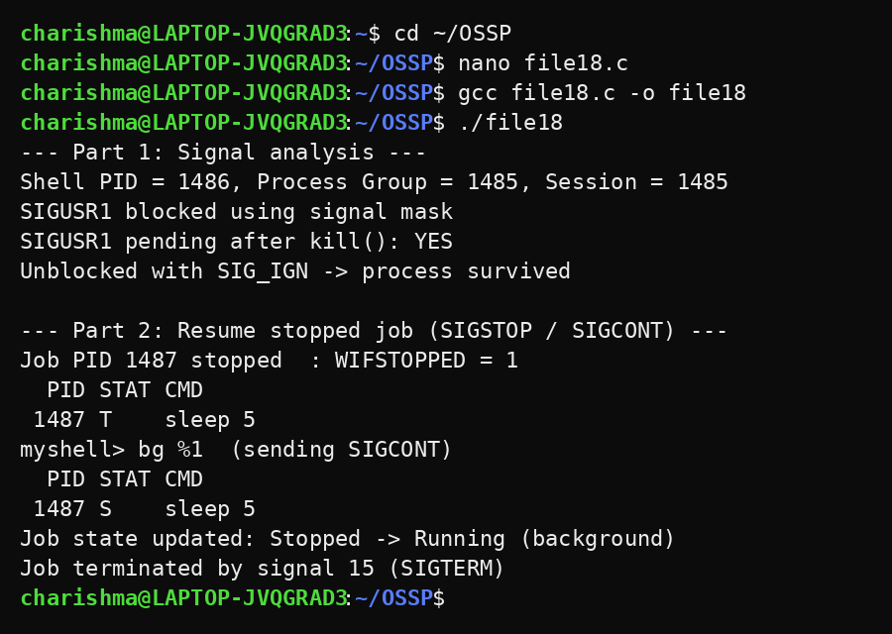
Observation
- The blocked signal stayed pending until it was handled.
- The shell, its process group and its session were displayed.
- After SIGSTOP the job state was T (stopped) and WIFSTOPPED was true.
- After SIGCONT the job state changed to S/R (running).
- The job table status changed from Stopped to Running and the job was terminated normally.
Result
Signal delivery, signal masks and process groups were analysed, and a stopped job was resumed with SIGCONT. The job status was updated and the background recovery was verified.

