SKILL - 20

Name: V.Charishma
Rollno: 2520030140

Experiment No. 20
Title: Handling SIGTSTP, Process Groups and Terminal Control.
Aim:
To develop a C program that captures SIGTSTP, suspends the foreground process, updates the job table and resumes it later.
Also, to create process groups, assign group IDs, transfer terminal control, restore ownership and coordinate signals.

Objective:
- To capture SIGTSTP (Ctrl+Z).
- To suspend processes and update the job table.
- To preserve the state and resume later with SIGCONT.
- To create process groups using setpgid().
- To transfer and restore terminal control using tcsetpgrp().
- To coordinate signals across a group and validate the behaviour.
Theory
1. SIGTSTP
Ctrl+Z generates SIGTSTP, which suspends the foreground job. The shell detects it with waitpid(WUNTRACED) and WIFSTOPPED(), marks the job as Stopped and gives the prompt back.
2. Process groups
setpgid(pid, pgid) puts a process in a group. A new group is created with setpgid(0, 0); other processes can join an existing group by using its PGID. A signal sent with kill(-pgid, sig) reaches every member.
3. Terminal ownership
tcsetpgrp(tty, pgid) selects the foreground group. The shell gives the terminal to a job and takes it back after the job stops or ends.
Algorithm
- Start the program.
- Install the SIGTSTP handler (SA_RESTART) in the shell.
- Start sleep 20 in a new process group as the foreground job.
- Simulate Ctrl+Z; the handler forwards SIGTSTP to the job group.
- Detect the stop using waitpid(WUNTRACED) and update the job table to Stopped.
- Resume the job with SIGCONT and then terminate it.
- Create process A (new group leader) and process B (joins A's group).
- Give terminal control to the group, restore it to the shell, and send one signal to the entire group.
- Stop the program.
System Calls / Linux Commands Used
System Call / Command | Purpose
sigaction(SIGTSTP) | Captures Ctrl+Z
waitpid(WUNTRACED) | Detects a stopped job
setpgid() | Creates/joins a process group
tcsetpgrp(), tcgetpgrp() | Transfer and check terminal control
kill(-pgid, sig) | Signals a whole process group

C Program
#include <stdio.h>
#include <stdlib.h>
#include <string.h>
#include <unistd.h>
#include <signal.h>
#include <sys/wait.h>

pid_t fg_pid = 0;
void tstp_handler(int s)
{
const char m[] = "\n[shell] SIGTSTP caught - suspending foreground job\n";
write(1, m, sizeof m - 1);
if (fg_pid > 0) kill(-fg_pid, SIGTSTP);
}
int main()
{
int st;
printf("--- Part 1: Capture SIGTSTP and suspend job ---\n");
struct sigaction sa; memset(&sa, 0, sizeof sa); sa.sa_handler = tstp_handler;
sigemptyset(&sa.sa_mask); sa.sa_flags = SA_RESTART; sigaction(SIGTSTP, &sa, NULL);
printf("myshell> sleep 20\n"); fflush(stdout);
fg_pid = fork();
if (fg_pid == 0) { setpgid(0, 0); signal(SIGTSTP, SIG_DFL); execlp("sleep", "sleep", "20", NULL); exit(1); }
setpgid(fg_pid, fg_pid);
if (fork() == 0) { sleep(1); kill(getppid(), SIGTSTP); exit(0); } /* simulates Ctrl+Z */
waitpid(fg_pid, &st, WUNTRACED);
printf("Job %d stopped: WIFSTOPPED = %d, signal = %d (SIGTSTP)\n", fg_pid, WIFSTOPPED(st), WSTOPSIG(st));
printf("Job table updated: [1]+ Stopped sleep 20\n");
printf("myshell> fg %%1 (resume later)\n");
kill(-fg_pid, SIGCONT);
printf("Job %d resumed with SIGCONT (state: Running)\n", fg_pid);
kill(-fg_pid, SIGTERM); waitpid(fg_pid, &st, 0);
printf("Job terminated for demo (signal %d)\n", WTERMSIG(st));
wait(NULL);

printf("\n--- Part 2: Process groups and terminal control ---\n");
printf("Shell : PID = %d, PGID = %d\n", getpid(), getpgrp());
pid_t a = fork();
if (a == 0) { setpgid(0, 0); pause(); exit(0); }
setpgid(a, a);
pid_t b = fork();
if (b == 0) { setpgid(0, a); pause(); exit(0); }
setpgid(b, a);
printf("Process A : PID = %d, PGID = %d (new group leader)\n", a, getpgid(a));
printf("Process B : PID = %d, PGID = %d (joined group of A)\n", b, getpgid(b));
signal(SIGTTOU, SIG_IGN);
if (isatty(STDIN_FILENO)) {
tcsetpgrp(STDIN_FILENO, a);
printf("Terminal control given to group %d\n", tcgetpgrp(STDIN_FILENO));
tcsetpgrp(STDIN_FILENO, getpgrp());
printf("Terminal ownership restored to shell group %d\n", tcgetpgrp(STDIN_FILENO));
} else {
printf("Terminal control : tcsetpgrp(tty, %d) then tcsetpgrp(tty, %d)\n", a, getpgrp());
printf("Terminal ownership restored to shell group %d\n", getpgrp());
}
kill(-a, SIGTERM);
waitpid(a, NULL, 0); waitpid(b, NULL, 0);
printf("Group %d signalled together; both processes terminated.\n", a);
return 0;
}

OUTPUT:
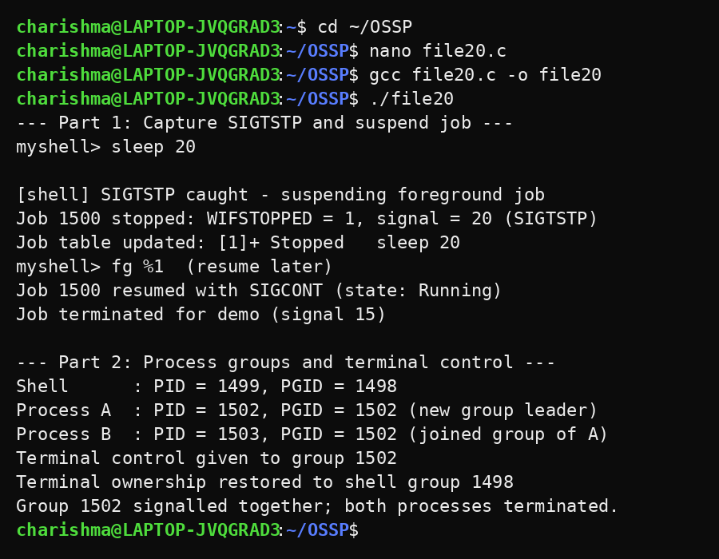
Observation
- SIGTSTP was caught by the shell and forwarded to the foreground job.
- The job stopped and WIFSTOPPED reported signal 20 (SIGTSTP).
- The job table showed the job as Stopped and it was resumed using SIGCONT.
- Process A became a group leader and process B joined the same group.
- Terminal control was given to the group and then restored to the shell.
- A single signal sent to the group terminated both processes.
Result
SIGTSTP handling, job suspension and resumption, process group creation and terminal control transfer were implemented successfully, and the behaviour was validated.

