Experiment: Skill-12
Course: Operating Systems and Systems Programming (OSSP)
Name: B. Pranavi
Roll No.: 2520030026

Title: Implementing Single and Multiple Pipes using pipe(), dup2() and fork().
Aim:
To develop a C program that creates a pipe, redirects streams using dup2(), executes two connected commands and synchronizes the processes.
Also, to extend the program to support multiple pipes using a descriptor array and launch several processes in a pipeline.

Objective:
- To create pipes using pipe().
- To redirect standard streams using dup2().
- To execute connected commands using fork() and exec().
- To close unused descriptors correctly.
- To synchronize processes using wait().
- To support long pipelines using descriptor arrays.
Theory
1. pipe()
pipe(fd) creates a unidirectional channel. fd[0] is the read end and fd[1] is the write end.
2. dup2()
dup2(old, new) duplicates a descriptor. dup2(fd[1], 1) makes standard output write into the pipe, and dup2(fd[0], 0) makes standard input read from the pipe.
3. Closing descriptors
Every unused end of the pipe must be closed. If a write end remains open, the reading process never receives end-of-file and may wait forever.
4. Multiple pipes
A pipeline of N commands needs N-1 pipes. Command i reads from pipe i-1 and writes to pipe i.
Algorithm
- Start the program.
- Create a pipe using pipe(fd).
- Fork the first child: redirect stdout to fd[1], close both ends and exec the first command.
- Fork the second child: redirect stdin to fd[0], close both ends and exec the second command.
- Close both ends in the parent and call wait() for both children.
- For multiple pipes, create an array of N-1 pipes.
- For each command, redirect stdin/stdout to the proper pipes and close all pipe descriptors.
- Wait for all children and stop the program.
System Calls / Linux Commands Used
System Call / Command | Purpose
pipe() | Creates a pipe
dup2() | Redirects a standard stream
fork() | Creates a process for each command
execvp() | Runs the command
close() | Closes unused descriptors
wait() | Waits for the children

C Program
#include <stdio.h>
#include <stdlib.h>
#include <unistd.h>
#include <sys/wait.h>

void single_pipe(void)
{
int fd[2]; pipe(fd);
if (fork() == 0) { dup2(fd[1], 1); close(fd[0]); close(fd[1]); execlp("echo", "echo", "apple\nbanana\ncherry", NULL); exit(1); }
if (fork() == 0) { dup2(fd[0], 0); close(fd[0]); close(fd[1]); execlp("wc", "wc", "-l", NULL); exit(1); }
close(fd[0]); close(fd[1]);
wait(NULL); wait(NULL);
}
void multi_pipe(char *cmds[][4], int n)
{
int fds[8][2];
for (int i = 0; i < n - 1; i++) pipe(fds[i]);
for (int i = 0; i < n; i++) {
if (fork() == 0) {
if (i > 0) dup2(fds[i - 1][0], 0);
if (i < n - 1) dup2(fds[i][1], 1);
for (int j = 0; j < n - 1; j++) { close(fds[j][0]); close(fds[j][1]); }
execvp(cmds[i][0], cmds[i]); exit(1);
}
}
for (int j = 0; j < n - 1; j++) { close(fds[j][0]); close(fds[j][1]); }
for (int i = 0; i < n; i++) wait(NULL);
}
int main()
{
printf("--- Part 1: Single pipe (echo ... | wc -l) ---\n"); fflush(stdout);
single_pipe();
printf("\n--- Part 2: Multiple pipes (printf | sort | uniq -c | sort -rn) ---\n"); fflush(stdout);
char *c[][4] = {
{"printf", "b\\na\\nb\\nc\\nb\\na\\n", NULL, NULL},
{"sort", NULL, NULL, NULL},
{"uniq", "-c", NULL, NULL},
{"sort", "-rn", NULL, NULL}};
multi_pipe(c, 4);
printf("All pipeline processes finished, descriptors closed.\n");
return 0;
}

OUTPUT:
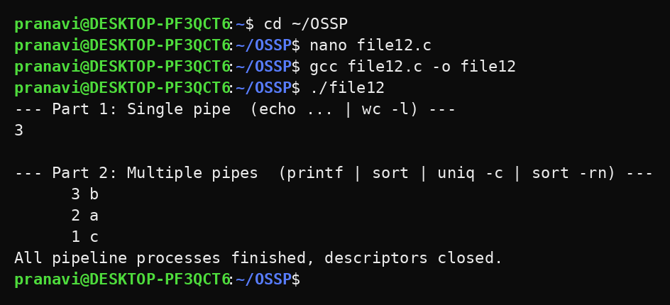
Observation
- The output of the first command was delivered to the second through the pipe (wc -l printed 3).
- The multi-stage pipeline printf | sort | uniq -c | sort -rn produced counted and sorted output.
- All descriptors were closed so every process terminated normally.
- The parent waited for every child before continuing.
Result
Single and multiple pipes were implemented successfully. Data flowed correctly between processes and long pipelines were executed and cleaned up without errors.

