Experiment: Skill-15
Course: Operating Systems and Systems Programming (OSSP)
Name: B. Pranavi
Roll No.: 2520030026

Title: Implementing Combined Redirection (2>&1) and Complex Commands with Pipes and Redirections.
Aim:
To develop a C program that parses combined redirection, duplicates file descriptors and merges stdout and stderr into one file.
Also, to parse complex commands that combine pipes and redirections and to resolve their execution order.

Objective:
- To parse the > file 2>&1 syntax.
- To duplicate file descriptors using dup2().
- To merge stdout and stderr and verify ordering.
- To combine pipes and redirections in one command.
- To resolve the execution order and generate an execution plan.
- To validate the syntax and test integrated outputs.
Theory
1. 2>&1
It makes descriptor 2 a duplicate of descriptor 1. When stdout has already been redirected to a file, both streams are written to the same file in the order in which they are produced.
2. Order matters
The redirections are applied from left to right. 'cmd > f 2>&1' sends both to f, but 'cmd 2>&1 > f' sends only stdout to f.
3. Complex commands
In sort < data.txt | uniq -c > result.txt, the first stage reads from a file and writes to a pipe, and the last stage reads from the pipe and writes to a file. Redirections are applied after the pipe connections for each stage.
Algorithm
- Start the program.
- Open both.txt and duplicate it onto descriptors 1 and 2.
- Execute a command that writes to stdout and stderr and display the file.
- Parse the command sort < data.txt | uniq -c > result.txt into stages.
- Create a pipe between the two stages.
- Stage 1: redirect stdin from data.txt and stdout to the pipe.
- Stage 2: redirect stdin from the pipe and stdout to result.txt.
- Wait for both stages, display result.txt and stop.
System Calls / Linux Commands Used
System Call / Command | Purpose
dup2(fd,1); dup2(fd,2) | Merges stdout and stderr
pipe() | Connects the stages
open() | Opens input and output files
fork() / execlp() | Run each stage
sort, uniq -c | Commands used in the pipeline

C Program
#include <stdio.h>
#include <stdlib.h>
#include <string.h>
#include <fcntl.h>
#include <unistd.h>
#include <sys/wait.h>

void combined(void)
{
fflush(stdout);
if (fork() == 0) {
int fd = open("both.txt", O_WRONLY | O_CREAT | O_TRUNC, 0644);
dup2(fd, 1); dup2(fd, 2); close(fd);
execlp("sh", "sh", "-c", "echo to-stdout; ls missing_file; echo end", NULL); exit(1);
}
wait(NULL);
}
void complex_cmd(void)
{
int fd[2]; pipe(fd); fflush(stdout);
if (fork() == 0) {
dup2(fd[1], 1); close(fd[0]); close(fd[1]);
int in = open("data.txt", O_RDONLY); dup2(in, 0); close(in);
execlp("sort", "sort", NULL); exit(1);
}
if (fork() == 0) {
dup2(fd[0], 0); close(fd[0]); close(fd[1]);
int out = open("result.txt", O_WRONLY | O_CREAT | O_TRUNC, 0644); dup2(out, 1); close(out);
execlp("uniq", "uniq", "-c", NULL); exit(1);
}
close(fd[0]); close(fd[1]); wait(NULL); wait(NULL);
}
int main()
{
FILE *f = fopen("data.txt", "w"); fprintf(f, "dog\ncat\ndog\nbird\ncat\ndog\n"); fclose(f);
printf("--- Part 1: Combined redirection ( > file 2>&1 ) ---\n");
printf("myshell> sh -c \"echo to-stdout; ls missing_file; echo end\" > both.txt 2>&1\n");
combined();
printf("myshell> cat both.txt\n"); fflush(stdout);
if (fork() == 0) { execlp("cat", "cat", "both.txt", NULL); exit(1); } wait(NULL);

printf("\n--- Part 2: Pipe + redirection ---\n");
printf("Parsed plan:\n Stage 1: sort stdin <- data.txt stdout -> pipe\n");
printf(" Stage 2: uniq -c stdin <- pipe stdout -> result.txt\n");
printf("myshell> sort < data.txt | uniq -c > result.txt\n");
complex_cmd();
printf("myshell> cat result.txt\n"); fflush(stdout);
if (fork() == 0) { execlp("cat", "cat", "result.txt", NULL); exit(1); } wait(NULL);
return 0;
}

OUTPUT:
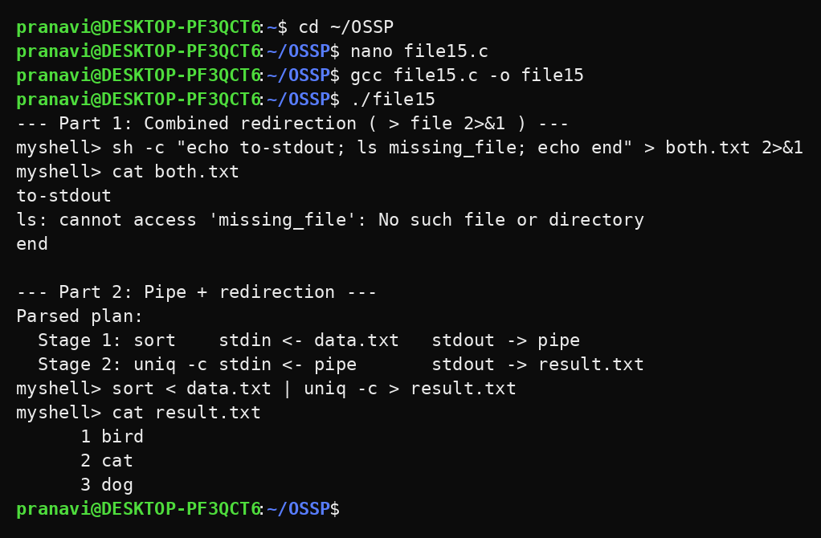
Observation
- Both normal output and the error message were stored in the same file in the correct order.
- The execution plan showed the redirections of every stage.
- The first stage read from the file and wrote into the pipe.
- The last stage wrote the counted result into result.txt.
- The integrated command produced the correct output.
Result
Combined redirection and complex commands containing pipes and redirections were implemented successfully. Streams were merged correctly and the execution order was resolved and verified.

