Course: Operating Systems and Systems Programming (OSSP)
Name: B. Hansini
Roll No.: 2520030026
Date: 01/08/2026
Experiment: Skill-04
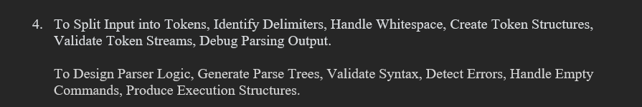
Step 1: Navigate to the Downloads Directory
Observation: The Downloads directory was successfully opened.

Step 2: Create the Parser Project Directory
Observation: A new directory named parser_lab was created successfully.

Step 3: Navigate to the Parser Project Directory
Observation: The parser_lab directory was successfully opened.

Step 4: Create the Parser Program
Observation: A C program named parser.c was created successfully to tokenize commands, identify token types, validate syntax, and display the parser structure.

Step 5: Compile the Parser Program
Observation: The parser.c program was compiled successfully and the executable file parser was generated.

Step 6: Test a Simple Command with an Argument
Command:
Input:
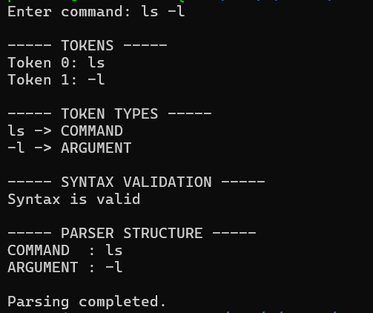
Observation: The parser correctly identified ls as the COMMAND and -l as an ARGUMENT. The syntax was validated successfully.

Step 7: Test an Invalid PIPE Position
Command:
Input:
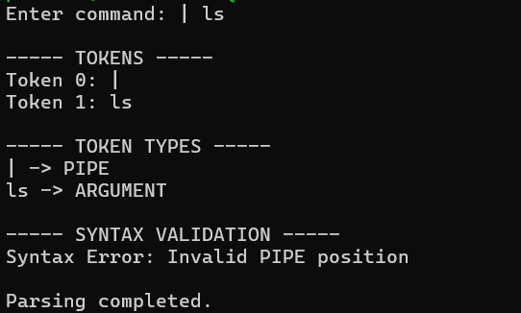
Observation: The parser detected that the PIPE operator was placed at an invalid position and displayed the error "Syntax Error: Invalid PIPE position".

Step 8: Test a Valid PIPE Command
Command:
Input:
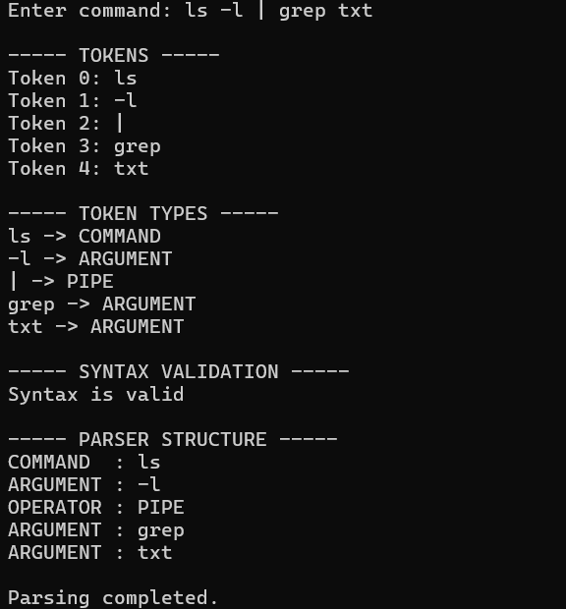
Observation: The parser successfully tokenized the command and identified the PIPE operator. The syntax was validated successfully.

Step 9: Test Missing Output Filename
Command:
Input:
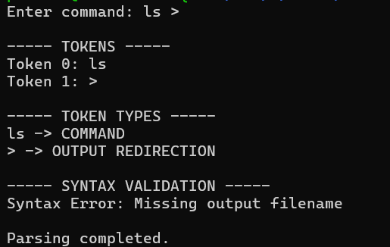
Observation: The parser detected the missing output filename after the output redirection operator and displayed "Syntax Error: Missing output filename".

Step 10: Test Valid Input Redirection
Command:
Input:
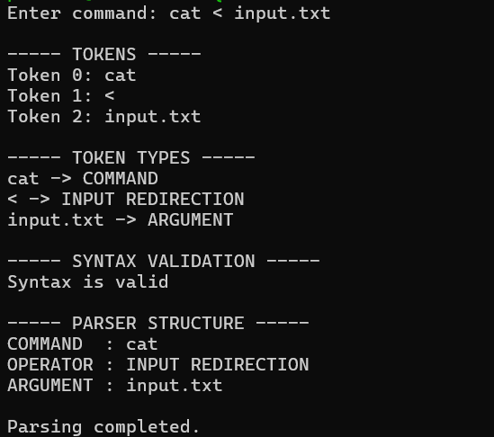
Observation: The parser correctly identified cat as the command, < as the INPUT REDIRECTION operator, and input.txt as the argument. The syntax was valid.

Step 11: Test Missing Input Filename
Command:
Input:
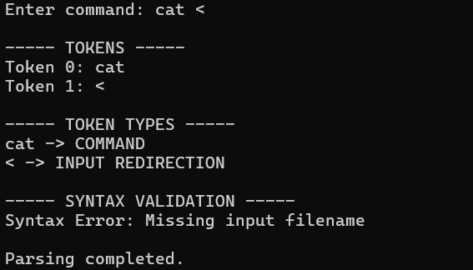
Observation: The parser detected the missing input filename and displayed "Syntax Error: Missing input filename".

Step 12: Test Command with Multiple Spaces
Command:
Input:
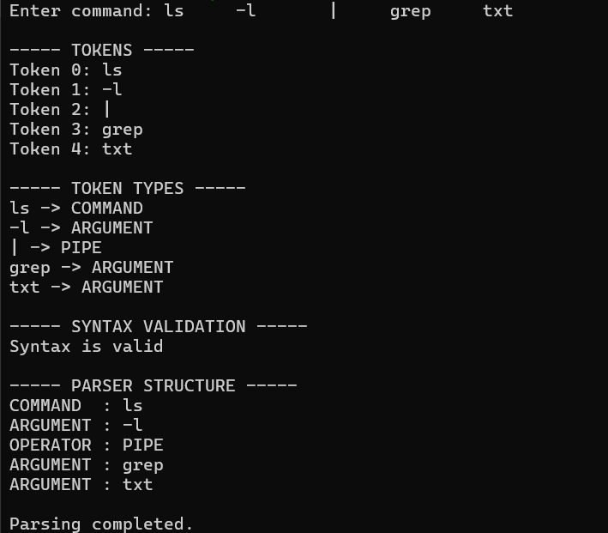
Observation: The parser successfully handled multiple spaces between tokens and correctly parsed the command. The syntax was valid.

Step 13: Test Consecutive PIPE Operators
Command:
Input:
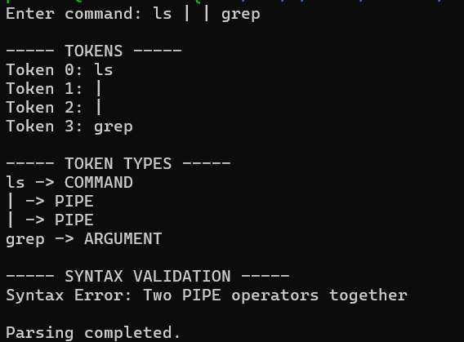
Observation: The parser detected two consecutive PIPE operators and displayed "Syntax Error: Two PIPE operators together".

Step 14: Test a Normal Multiword Command
Command:
Input:
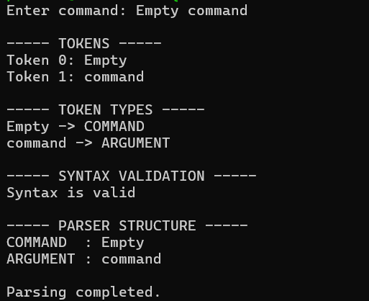
Observation: The parser treated Empty as the COMMAND and command as an ARGUMENT and validated the syntax successfully.

Step 15: Test an Empty Command
Command:
Input:
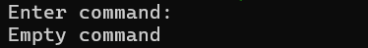
Observation: The parser correctly identified that no command was entered and displayed "Empty command".

Result
Observation: The command parser program was successfully implemented and tested. It correctly performed tokenization, token classification, syntax validation, and parser structure generation. Valid commands were accepted, while invalid PIPE positions, consecutive PIPE operators, missing input filenames, and missing output filenames were successfully detected.

