2520030095
T.Hansini
Skill-11
Title: Implementing a Command History Buffer and Pipeline Data Structure.
Aim:
To develop a C program that stores commands in a history buffer with a fixed capacity, retrieves entries and displays the history.
Also, to create a pipeline structure that stores the commands of a pipeline in execution order.

Objective:
- To store commands in a history buffer.
- To handle capacity limits by discarding the oldest entry.
- To retrieve and display history entries with numbers.
- To validate the consistency of the history.
Theory
1. History buffer
The shell remembers previously entered commands. A fixed-size array of strings is used. When the array is full, the oldest entry is removed and the remaining entries are shifted, so that only the most recent commands are kept.
2. Pipeline
A pipeline such as cmd1 | cmd2 | cmd3 connects the output of one command to the input of the next. The shell splits the line at '|' and stores each command as a stage in a structure, in the order of execution.
3. Structure used
struct pipeline { int n; char *cmd[MAXSEG]; } stores the number of stages and the command text of every stage.
Algorithm
- Start the program.
- Create an array of CAP string pointers for the history.
- For every new command, append it; if the buffer is full, remove the oldest entry.
- Display the history with serial numbers.
- Read a pipeline string and split it at '|' using strtok().
- Trim leading spaces and store every stage in the pipeline structure.
- Display the number of stages and their order.
- Stop the program.
System Calls / Linux Commands Used
System Call / Command | Purpose
strdup() | Copies a command string into memory
memmove() | Shifts history entries when the buffer is full
strtok() | Splits the pipeline at '|'
free() | Releases the removed entry
printf() | Displays history and stages

C Program
#include <stdio.h>
#include <stdlib.h>
#include <string.h>
#define CAP 5
#define MAXSEG 8

char *hist[CAP]; int count = 0, total = 0;

void add_history(const char *cmd)
{
if (count == CAP) { free(hist[0]); memmove(hist, hist + 1, (CAP - 1) * sizeof(char *)); count--; }
hist[count++] = strdup(cmd); total++;
}
void show_history(void)
{
for (int i = 0; i < count; i++) printf("%5d %s\n", total - count + i + 1, hist[i]);
}
struct pipeline { int n; char *cmd[MAXSEG]; };

void build_pipeline(char *line, struct pipeline *p)
{
p->n = 0;
for (char *s = strtok(line, "|"); s && p->n < MAXSEG; s = strtok(NULL, "|")) {
while (*s == ' ') s++;
p->cmd[p->n++] = s;
}
}
int main()
{
const char *in[] = {"ls", "pwd", "date", "echo hi", "cat a.txt", "ls -l", "whoami"};
printf("--- Part 1: History buffer (capacity = %d) ---\n", CAP);
for (int i = 0; i < 7; i++) { printf("myshell> %s\n", in[i]); add_history(in[i]); }
printf("myshell> history\n"); show_history();
printf("Entries stored: %d, oldest retained: %s\n", count, hist[0]);

printf("\n--- Part 2: Pipeline structure ---\n");
char l1[] = "cat file.txt | grep error | sort | uniq", l2[] = "ls -l | wc -l";
struct pipeline p; char *tests[] = {l1, l2};
for (int t = 0; t < 2; t++) {
printf("Input: %s\n", tests[t]);
build_pipeline(tests[t], &p);
printf("Number of commands : %d\n", p.n);
for (int i = 0; i < p.n; i++) printf(" Stage %d -> %-14s %s\n", i + 1, p.cmd[i], i < p.n - 1 ? "(output piped to next stage)" : "(last stage)");
}
return 0;
}

OUTPUT:
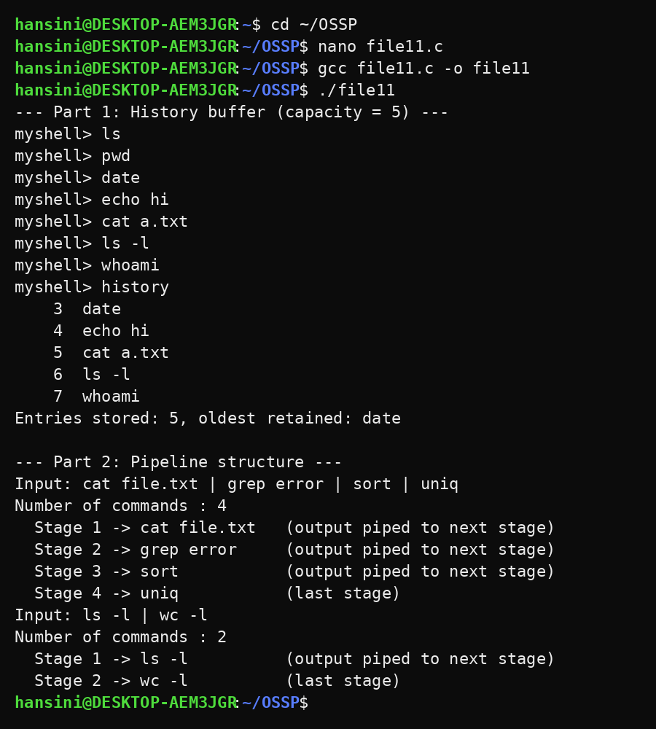
Observation
- Seven commands were entered but only the latest five were retained (capacity = 5).
- History numbering continued correctly (entries 3 to 7).
- The oldest entries (ls and pwd) were discarded automatically.
- The pipeline with four commands was split into four ordered stages.
- The last stage was identified separately from the intermediate stages.
Result
The history buffer with capacity handling and the pipeline structure were implemented successfully. Commands were stored, displayed and validated in the correct order.

