2520030095
T.Hansini
Skill-19
Title: Registering Signal Handlers and Handling SIGINT in a Shell.
Aim:
To develop a C program that registers signal handlers using sigaction(), configures signal actions and verifies the stability of the process.
Also, to capture SIGINT, forward it to the foreground job, protect the shell process and update the job state.

Objective:
- To register handlers using sigaction().
- To configure signal actions and flags (SA_RESTART).
- To handle interrupts safely.
- To manage the signal context (async-safe functions).
- To forward SIGINT to the foreground job.
Theory
1. sigaction()
sigaction() installs a handler for a signal with additional control over the signal mask and flags. SA_RESTART restarts interrupted system calls such as waitpid().
2. Safe handlers
A handler must be short and use only async-signal-safe functions such as write(). A volatile sig_atomic_t variable is used to pass information to the main program.
3. SIGINT in a shell
When Ctrl+C is pressed, the shell must not terminate. Its handler forwards SIGINT to the foreground process group using kill(-pgid, SIGINT), while the child restores the default action with SIG_DFL.
Algorithm
- Start the program.
- Install handlers for SIGUSR1 and SIGUSR2 using sigaction().
- Raise the signals and display which signal was handled.
- Install the SIGINT handler in the shell.
- Fork a foreground job (sleep 30) in its own process group with default SIGINT action.
- Simulate Ctrl+C by sending SIGINT to the shell.
- The handler prints a message and forwards the signal to the job.
- The shell waits for the job, displays that it was terminated by SIGINT, updates the job state and continues.
System Calls / Linux Commands Used
System Call / Command | Purpose
sigaction() | Registers a signal handler
raise() | Sends a signal to itself
kill(-pgid, SIGINT) | Forwards a signal to a process group
write() | Async-signal-safe output
waitpid(), WTERMSIG() | Retrieve the termination signal

C Program
#include <stdio.h>
#include <stdlib.h>
#include <string.h>
#include <unistd.h>
#include <signal.h>
#include <sys/wait.h>

volatile sig_atomic_t got_sig = 0;
pid_t fg_pid = 0;

void handler(int s) { got_sig = s; }
void sigint_handler(int s)
{
const char m[] = "\n[shell] SIGINT caught - shell protected\n";
write(1, m, sizeof m - 1);
if (fg_pid > 0) kill(-fg_pid, SIGINT);
}
int main()
{
struct sigaction sa;
printf("--- Part 1: Register handlers (sigaction) ---\n");
memset(&sa, 0, sizeof sa); sa.sa_handler = handler; sigemptyset(&sa.sa_mask);
sa.sa_flags = SA_RESTART;
sigaction(SIGUSR1, &sa, NULL); sigaction(SIGUSR2, &sa, NULL);
raise(SIGUSR1); printf("Handler ran for signal %d (SIGUSR1)\n", got_sig);
raise(SIGUSR2); printf("Handler ran for signal %d (SIGUSR2)\n", got_sig);
printf("Shell still stable after handling signals.\n");

printf("\n--- Part 2: SIGINT forwarding to foreground job ---\n");
sa.sa_handler = sigint_handler; sigaction(SIGINT, &sa, NULL);
printf("myshell> sleep 30\n"); fflush(stdout);
fg_pid = fork();
if (fg_pid == 0) {
setpgid(0, 0); signal(SIGINT, SIG_DFL); execlp("sleep", "sleep", "30", NULL); exit(1);
}
setpgid(fg_pid, fg_pid);
if (fork() == 0) { sleep(1); kill(getppid(), SIGINT); exit(0); } /* simulates Ctrl+C */
int st; waitpid(fg_pid, &st, 0);
printf("Foreground job %d terminated by signal %d (SIGINT)\n", fg_pid, WTERMSIG(st));
fg_pid = 0;
printf("Job state updated: Terminated. Shell (PID %d) is still alive.\n", getpid());
wait(NULL);
return 0;
}

OUTPUT:
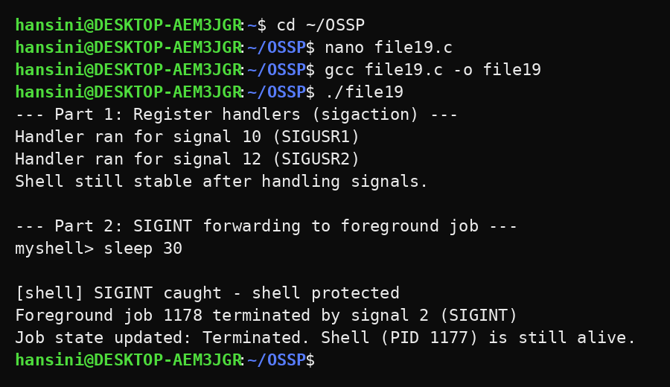
Observation
- The handlers were executed for SIGUSR1 (10) and SIGUSR2 (12).
- The shell remained stable after handling the signals.
- The SIGINT handler caught the interrupt instead of terminating the shell.
- The foreground job was terminated by signal 2 (SIGINT).
- The job state was updated and the shell continued running.
Result
Signal handlers were registered and SIGINT was captured and forwarded to the foreground job. The shell was protected from termination and the job state was updated successfully.

