Course: Operating Systems and Systems Programming (OSSP)
Name: B. Pranavi
Roll No.: 2520030026
Date: 01/08/2026
OSSP LAB – Week 1 (Part-A)
Experiment No: 1(A)
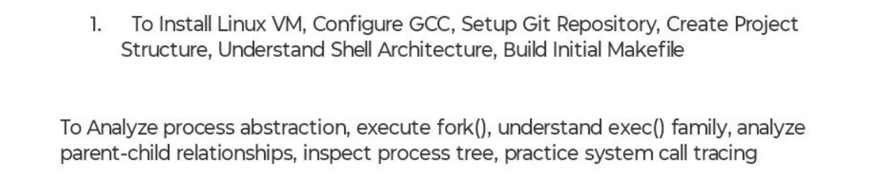
Step 1- Verify GCC Installation:
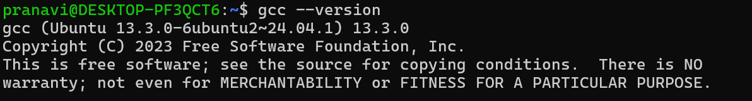
Observation: GCC compiler was successfully installed and its version was verified.
Step 2 - Verify Git Installation:
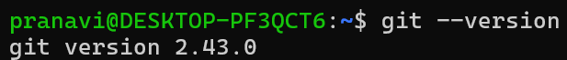
Observation: Git was successfully installed and its version was verified.
Step 3: Configure Git
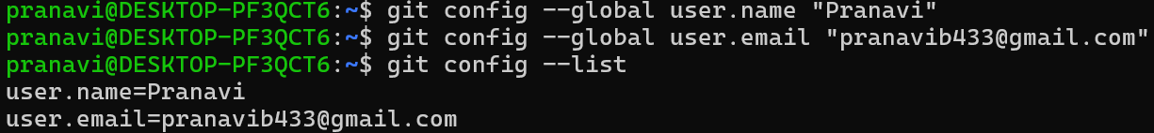
Observation: Git username and email were configured successfully.
Step 4: Create Project Directory
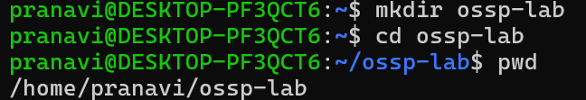
Observation: A new project directory named ossp -lab was created successfully.
Step 5: Initialize Git Repository
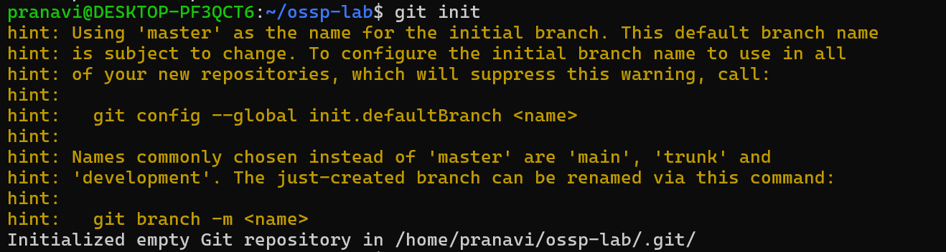
Observation: A Git repository was initialized successfully in the project directory.
Step 6: Create Project Structure
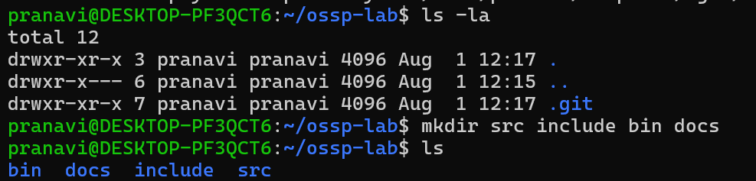
Observation: The project directory structure containing src, include, bin, and docs folders was created successfully.
Step 7: Create C Program
Observation: A simple C program (hello.c) was created and saved successfully.
Step 8: Compile the Program
Observation: The C program was compiled successfully without any errors.
Step 9: Execute the Program
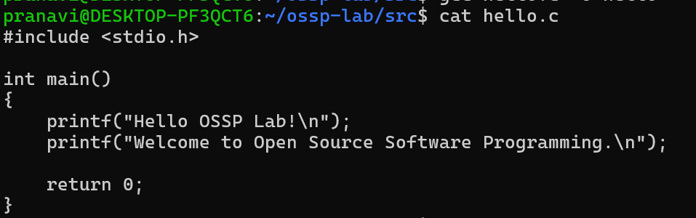
Observation: The program executed successfully and displayed the expected output.
Step 10: Create Makefile
Observation: A Makefile was created successfully to automate the build process.
Step 11: Build Using Make
Observation: The Makefile compiled the program successfully and generated the executable.
Step 12: Execute Using Make
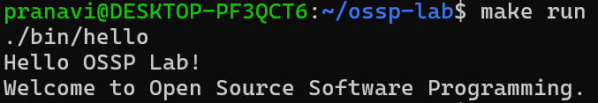
Observation: The program was executed successfully using the make run command.(
Step 13: Clean Build Files
Observation: The make clean command removed the generated executable successfully while preserving the source files.
Experiment No: 1(B)
PART-B: Process Abstraction using fork() and exec()
Step 1: Create the forkdemo.c Program
Observation: The forkdemo.c program was created successfully to demonstrate the creation of parent and child processes using the fork() system call.
Step 2: Compile and Execute forkdemo.c
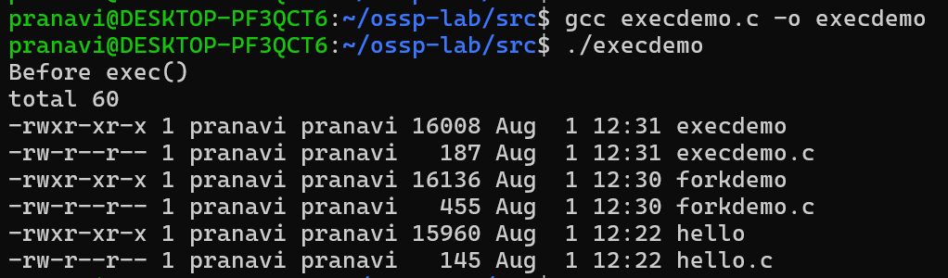
Observation: The program compiled successfully and executed correctly, displaying separate parent and child process IDs.
Step 3: Create the execdemo.c Program
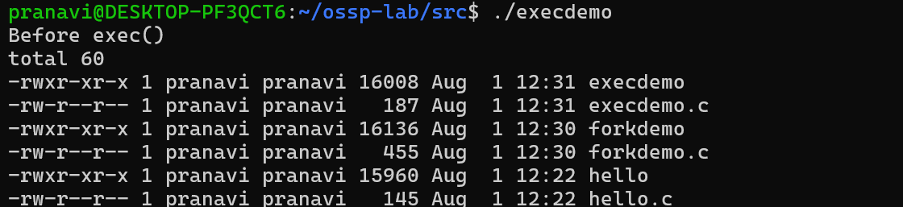
Observation: The program compiled and executed successfully, replacing the current process with the ls command and displaying the directory contents.
Step 5: Display the Process Tree
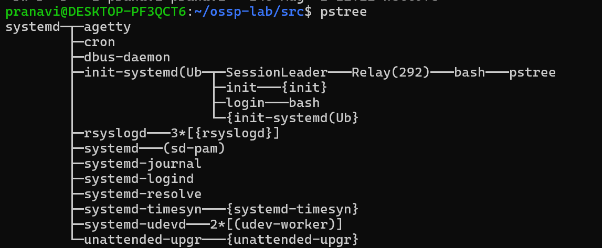
Observation: The pstree command displayed the hierarchical relationship among the running processes.
Step 6: Install strace Utility
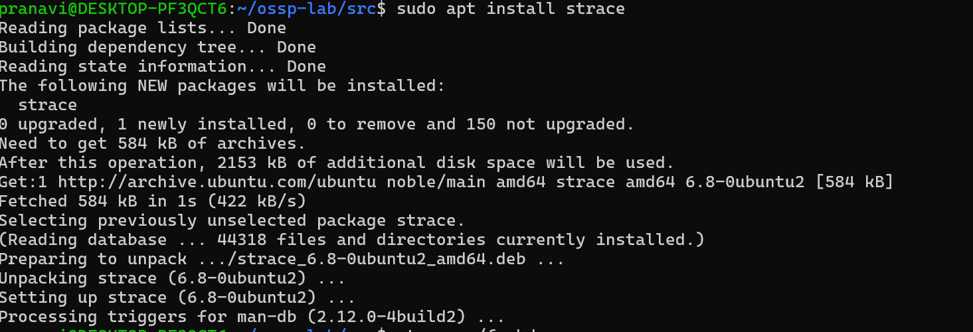 Observation: The strace utility was installed successfully for tracing system calls.
Step 7: Trace System Calls
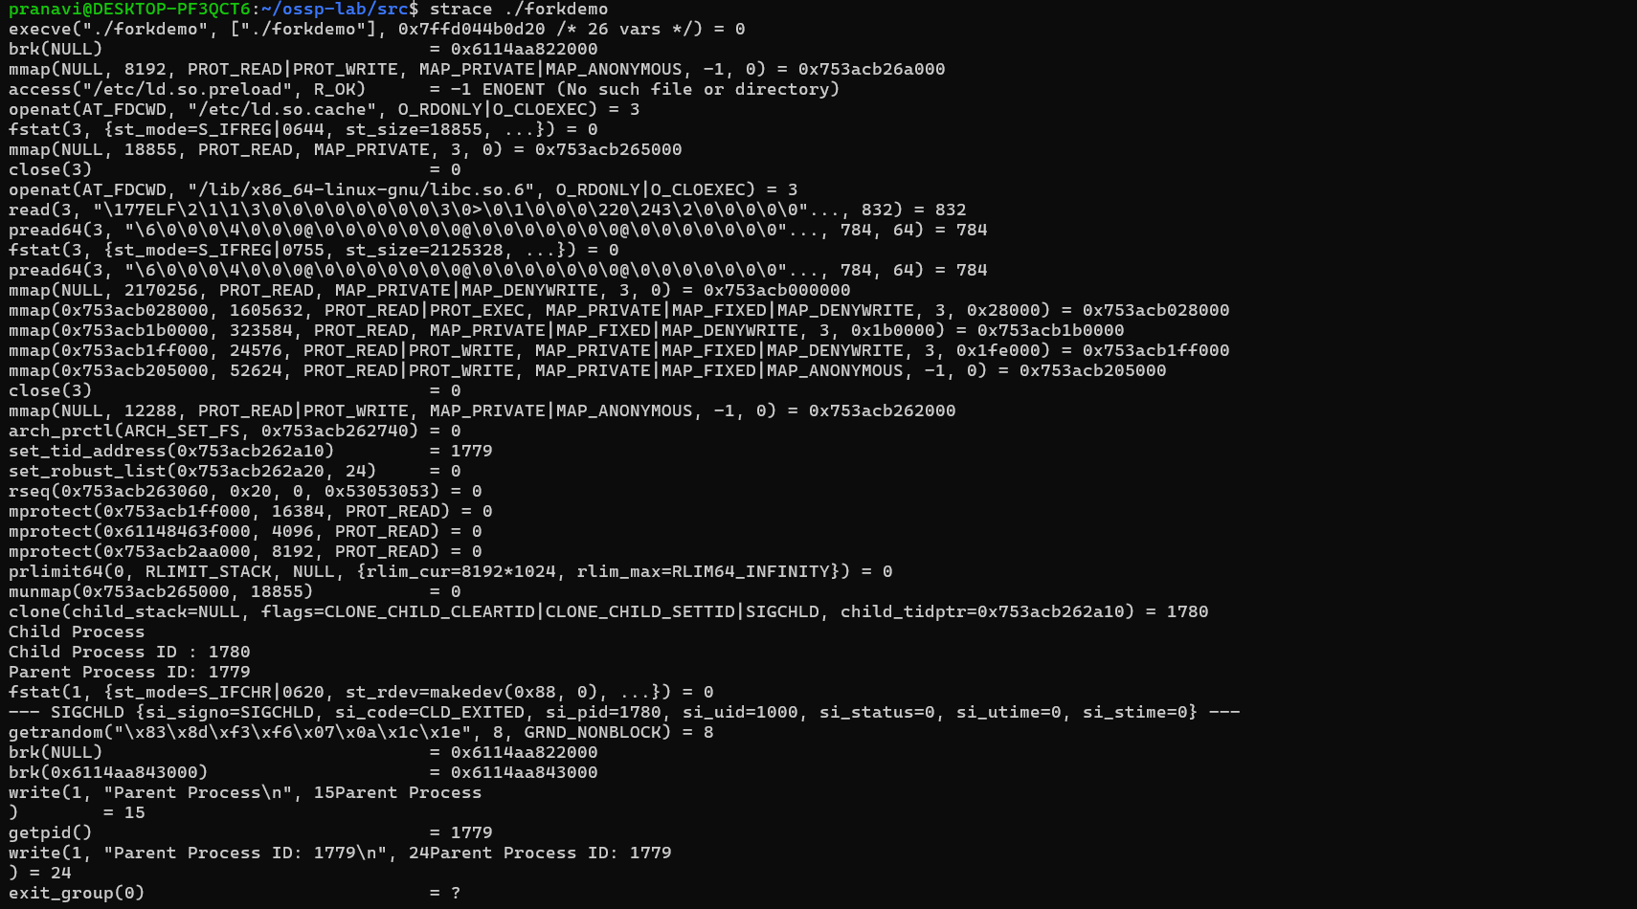
Observation: The system calls executed by the forkdemo program were successfully traced and displayed on the terminal.

