Course: Operating Systems and Systems Programming (OSSP)
Name: B. Pranavi
Roll No.: 2520030026
Date: 01/08/2026
Experiment 2 – Part A:
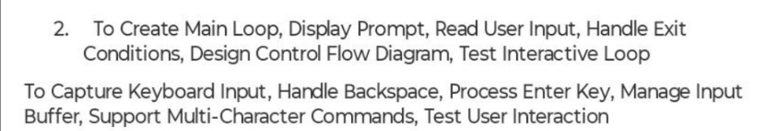
Step 1: Navigate to the Working Directory
Open the Ubuntu terminal and move to the experiment folder.
Observation:
The terminal successfully changed to the experiment directory where the source code file was stored.
Step 2: Verify the Current Working Directory
Observation:
The current working directory was verified successfully.
Step 3: Create/Open the Source File
Action Performed:
- Opened the Nano text editor by executing the nano exp2.c command.
- Entered the C program for implementing the main loop.
- Pressed Ctrl + O to save the file.
- Pressed Enter to confirm the filename (exp2.c).
- Pressed Ctrl + X to exit the Nano editor.
Observation:
The source file exp2.c was created successfully, and the program was saved without any errors.
Step 4: Compile the Program
Observation:
The program compiled successfully without any errors, and the executable file exp2 was created.
Step 5: Execute the Program
Observation:
The program started successfully and displayed:
shell>
indicating that it was ready to accept user input.
Step 6: Test the Interactive Loop
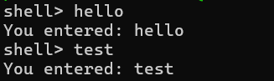
The program accepted the input and displayed it correctly.
Observation:
The program continued to execute in the loop and accepted another command successfully.
Step 12: Test the Exit Condition
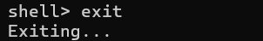
Observation:
The program detected the exit command, terminated the loop, and exited successfully.

Experiment 2 – Part B:
Experiment Steps:
Step 1: Open Ubuntu Terminal
Action Performed:
- Opened the Ubuntu terminal.
Observation:
The Ubuntu terminal opened successfully and displayed the command prompt.
Step 2: Navigate to the Working Directory
Observation:
The terminal successfully navigated to the experiment directory.
Step 3: Create the Source File
Action Performed:
- Opened the Nano text editor.
- Entered the C program for keyboard input handling.
Observation:
The source file exp2b.c was created successfully.
Step 4: Save the Source File
Action Performed:
- Pressed Ctrl + O to save the file.
- Pressed Enter to confirm the filename (exp2b.c).
- Pressed Ctrl + X to exit the Nano editor.
Observation:
The source file was saved successfully and the Nano editor was closed.
Step 5: Compile the Program
Observation:
The program compiled successfully without any compilation errors, and the executable file exp2b was created.
Step 6: Execute the Program
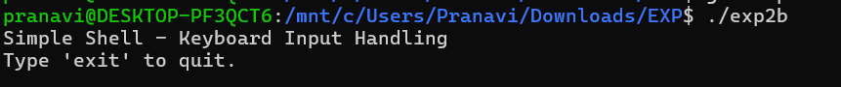Observation:
The program executed successfully and displayed the following message
Step 7: Test Keyboard Input
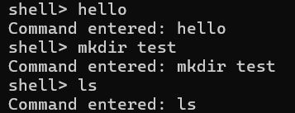
Observation:
The program successfully captured keyboard input and displayed the entered command.
Step 8: Test the Exit Condition
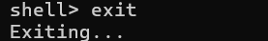
Observation:
The program detected the exit command and terminated successfully.

