PRACTICAL - 5

Name: T.Hansini Reddy
Rollno: 252003095

Experiment No. 5
Title: Implementation of a Producer-Consumer Communication System and a Shell Pipeline Emulator using Anonymous Pipes, fork(), dup2(), and exec() System Calls.
Aim:
To develop C programs that (i) implement a producer-consumer system using anonymous pipes where a parent process produces data and a child process consumes it, measuring the communication efficiency, and (ii) emulate the shell command ls -l | grep ".c" using fork(), pipe(), dup2() and exec() system calls.

Objective:
- To understand inter-process communication (IPC) using anonymous pipes.
- To implement a producer-consumer relationship between a parent and a child process.
- To measure the communication efficiency (throughput) of pipe-based IPC.
- To understand file descriptor duplication using dup2().
- To emulate shell command piping between two processes using pipe(), fork(), dup2() and exec().
Theory:
1. Anonymous pipe
A pipe is a unidirectional communication channel in the kernel. pipe(fd) creates two descriptors: fd[0] for reading and fd[1] for writing. Data written at one end is read from the other end in FIFO order. Anonymous pipes can be used only between related processes (parent and child) because the descriptors are inherited through fork().
2. Producer-consumer
The producer writes data into the pipe and the consumer reads it. If the pipe is empty the consumer blocks, and if it is full the producer blocks, so the pipe also provides synchronization. The consumer sees end-of-file only after all write ends are closed.
3. dup2()
dup2(oldfd, newfd) makes newfd a copy of oldfd. dup2(fd[1], 1) sends the standard output of a process into the pipe, and dup2(fd[0], 0) makes the standard input come from the pipe.
4. exec()
The exec family replaces the current process image with a new program (ls, grep). The redirected descriptors remain open across exec, so the new program reads and writes through the pipe without knowing it.
5. Communication efficiency
Throughput = data transferred (MB) / time taken (seconds). The time is measured using clock_gettime(CLOCK_MONOTONIC).
Algorithm (Part 1 – Producer-Consumer)
- Start the program and create a pipe using pipe(fd).
- Create a child process using fork().
- Child (consumer): close the write end, read integers from the pipe until end-of-file and compute their sum.
- Parent (producer): close the read end, record the start time and write the integers 1 to N into the pipe.
- Close the write end so that the consumer receives end-of-file.
- Wait for the child using wait() and record the end time.
- Calculate and display the time taken and the throughput in MB/s.
- Stop the program.
Algorithm (Part 2 – ls -l | grep ".c" Emulation)
- Start the program and create a pipe.
- Fork child 1: dup2(fd[1], 1), close both pipe ends and exec ls -l.
- Fork child 2: dup2(fd[0], 0), close both pipe ends and exec grep ".c".
- The parent closes both ends of the pipe.
- The parent waits for both children using wait().
- Display the completion message and stop.
System Calls / Linux Commands Used:
System Call / Command | Purpose
pipe() | Creates an anonymous pipe
fork() | Creates the producer/consumer and pipeline processes
read() / write() | Reads from and writes to the pipe
dup2() | Redirects stdin/stdout to the pipe
execlp() | Runs ls and grep
wait() | Waits for child processes
clock_gettime() | Measures the elapsed time
close() | Closes unused descriptors

Program 1: Producer-Consumer with Communication Efficiency Measurement
#include <stdio.h>
#include <stdlib.h>
#include <unistd.h>
#include <time.h>
#include <sys/wait.h>
#define COUNT 200000

int main()
{
int fd[2];
if (pipe(fd) == -1) { perror("pipe"); return 1; }
pid_t pid = fork();
if (pid < 0) { perror("fork"); return 1; }

if (pid == 0) { /* Consumer (child) */
close(fd[1]);
int value, n = 0; long sum = 0;
while (read(fd[0], &value, sizeof(int)) > 0) { sum += value; n++; }
close(fd[0]);
printf("Consumer: received %d integers, sum = %ld\n", n, sum);
exit(0);
}
/* Producer (parent) */
close(fd[0]);
struct timespec t1, t2;
clock_gettime(CLOCK_MONOTONIC, &t1);
for (int i = 1; i <= COUNT; i++) write(fd[1], &i, sizeof(int));
close(fd[1]);
wait(NULL);
clock_gettime(CLOCK_MONOTONIC, &t2);
double sec = (t2.tv_sec - t1.tv_sec) + (t2.tv_nsec - t1.tv_nsec) / 1e9;
double mb = COUNT * sizeof(int) / (1024.0 * 1024.0);
printf("Producer: sent %d integers (%.2f MB)\n", COUNT, mb);
printf("Time taken : %.4f seconds\n", sec);
printf("Throughput : %.2f MB/s\n", mb / sec);
return 0;
}

OUTPUT:
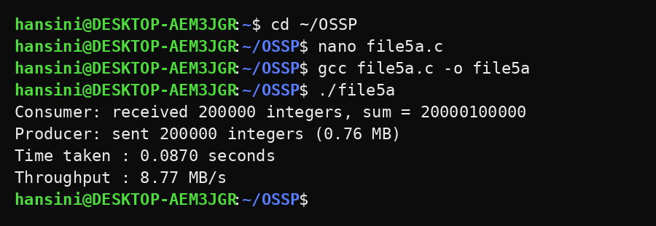
Program 2: Emulating ls -l | grep ".c" using pipe(), fork(), dup2() and exec()
#include <stdio.h>
#include <stdlib.h>
#include <unistd.h>
#include <sys/wait.h>

int main()
{
int fd[2];
pipe(fd);
printf("Emulating: ls -l | grep \".c\"\n\n");
fflush(stdout);

if (fork() == 0) { /* child 1 : ls -l */
dup2(fd[1], STDOUT_FILENO);
close(fd[0]); close(fd[1]);
execlp("ls", "ls", "-l", NULL);
perror("exec ls"); exit(1);
}
if (fork() == 0) { /* child 2 : grep ".c" */
dup2(fd[0], STDIN_FILENO);
close(fd[0]); close(fd[1]);
execlp("grep", "grep", ".c", NULL);
perror("exec grep"); exit(1);
}
close(fd[0]); close(fd[1]);
wait(NULL); wait(NULL);
printf("\nPipeline completed.\n");
return 0;
}

OUTPUT:
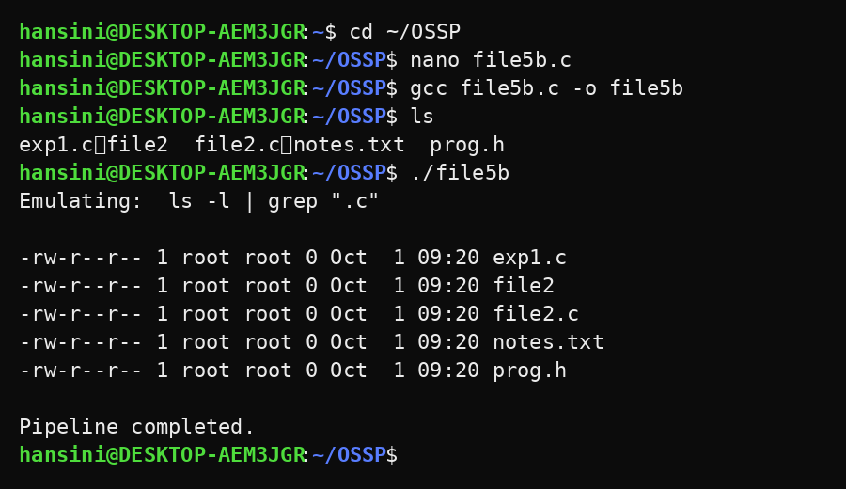
Observation:
- The parent (producer) wrote 200000 integers and the child (consumer) received all of them; the sum matched the expected value 20000100000.
- The consumer detected end-of-file only after the producer closed the write end of the pipe.
- The time taken and the throughput of the pipe were calculated and displayed.
- In the emulation, the output of ls -l was delivered to grep through the pipe, and only lines containing the pattern were displayed.
- In the grep pattern ".c" the dot matches any character, so lines such as 'Oct' in the date also match; use "\.c" to match only .c files.
- Closing the unused descriptors in every process was necessary for the pipeline to terminate.
Result:
The producer-consumer system using an anonymous pipe and the shell pipeline emulator for ls -l | grep ".c" were implemented successfully. The communication efficiency of pipe-based IPC was measured and the use of pipe(), fork(), dup2() and exec() was verified.

