PRACTICAL - 6

Name: T.Hansini Reddy
Rollno: 252003095

Experiment No. 6
Title: Client-Server Communication Using Named Pipes (FIFOs) and POSIX Signal Handling.
Aim:
Part A: To create a client-server application using Named Pipes (FIFOs) where the client sends messages to the server and the server processes them and responds to the client.
Part B: To demonstrate POSIX signal handling by registering handlers with sigaction() for SIGINT, SIGUSR1, SIGALRM and SIGTERM.

Objective:
- To understand IPC using Named Pipes (FIFOs).
- To implement client-server communication using two FIFOs.
- To observe the blocking behaviour of FIFOs with several clients.
- To understand the concept of signals in Linux.
- To register signal handlers using sigaction().
- To send signals using kill(), raise() and alarm().
Theory:
1. Named pipe (FIFO)
A FIFO is a pipe that has a name in the file system, created with mkfifo(). Unlike an anonymous pipe, it can be used by unrelated processes. Opening a FIFO for reading blocks until a writer opens it, and vice versa.
2. Client-server using FIFOs
Client → server_fifo → Server (request)
Server → response_fifo → Client (response)
Two FIFOs are used because each FIFO is one-directional.
3. Signals
A signal is an asynchronous notification sent to a process. Common signals: SIGINT (Ctrl+C), SIGTERM (termination request), SIGALRM (timer expiry from alarm()), SIGUSR1 (user-defined).
4. sigaction()
sigaction() installs a handler for a signal and is more reliable and portable than signal(). The handler should be short and should only set a flag of type volatile sig_atomic_t.
Algorithm (Part A – FIFO Client-Server)
- Start the program and create the request and response FIFOs using mkfifo().
- Fork a child process to act as the server.
- Server: open the request FIFO for reading, read the message and display it.
- Server: convert the message to upper case, open the response FIFO for writing and send an acknowledgement.
- Client (parent): open the request FIFO for writing and send a message.
- Client: open the response FIFO for reading and display the reply.
- Repeat for three clients, wait for the server and remove the FIFOs using unlink().
- Stop the program.
Algorithm (Part B – Signal Handling)
- Start the program and display its PID.
- Fill a sigaction structure with the handler and register SIGINT, SIGUSR1, SIGALRM and SIGTERM.
- Send SIGINT twice with kill() and show that the process continues.
- Send SIGUSR1 using raise() and check the flag set by the handler.
- Call alarm(2) and pause() and wait for SIGALRM.
- Send SIGTERM, perform a graceful exit and stop.
System Calls / Linux Commands Used:
System Call / Command | Purpose
mkfifo() | Creates a named pipe
open() / read() / write() | Communicate through the FIFO
unlink() | Removes the FIFO
sigaction() | Registers a signal handler
kill() / raise() | Send a signal
alarm() / pause() | Timer signal and waiting for a signal

Part A – Program: Client-Server Communication using FIFOs
#include <stdio.h>
#include <stdlib.h>
#include <string.h>
#include <ctype.h>
#include <fcntl.h>
#include <unistd.h>
#include <sys/stat.h>
#include <sys/wait.h>
#define REQ "/tmp/server_fifo"
#define RES "/tmp/response_fifo"

void server(int nmsg)
{
char buf[100];
for (int i = 0; i < nmsg; i++) {
int rf = open(REQ, O_RDONLY);
int n = read(rf, buf, sizeof buf - 1); buf[n] = '\0'; close(rf);
printf("Server : received \"%s\"\n", buf);
for (int k = 0; buf[k]; k++) buf[k] = toupper(buf[k]);
char reply[140]; snprintf(reply, sizeof reply, "ACK: %s", buf);
int wf = open(RES, O_WRONLY);
write(wf, reply, strlen(reply)); close(wf);
}
}
void client(const char *msg, int id)
{
char buf[140];
printf("Client %d: sending \"%s\"\n", id, msg); fflush(stdout);
int wf = open(REQ, O_WRONLY); write(wf, msg, strlen(msg)); close(wf);
int rf = open(RES, O_RDONLY);
int n = read(rf, buf, sizeof buf - 1); buf[n] = '\0'; close(rf);
printf("Client %d: response \"%s\"\n", id, buf); fflush(stdout);
}
int main()
{
unlink(REQ); unlink(RES);
mkfifo(REQ, 0666); mkfifo(RES, 0666);
printf("FIFOs created: %s, %s\n\n", REQ, RES); fflush(stdout);
pid_t s = fork();
if (s == 0) { server(3); exit(0); }
const char *msgs[] = {"hello server", "operating systems", "named pipes work"};
for (int i = 0; i < 3; i++) { client(msgs[i], i + 1); printf("\n"); fflush(stdout); }
waitpid(s, NULL, 0);
unlink(REQ); unlink(RES);
printf("Server stopped, FIFOs removed.\n");
return 0;
}

OUTPUT:
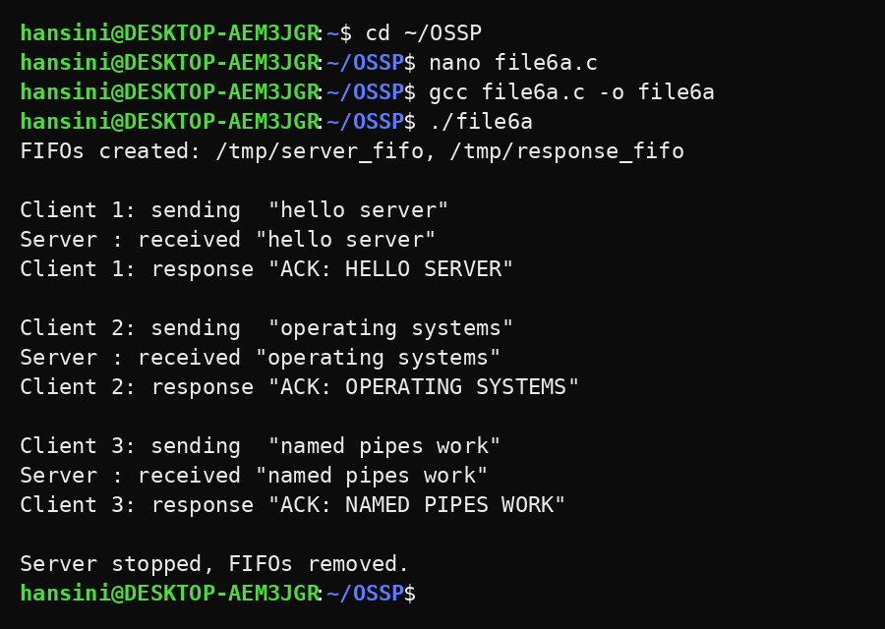
Part B – Program: POSIX Signal Handling
#include <stdio.h>
#include <stdlib.h>
#include <string.h>
#include <unistd.h>
#include <signal.h>

volatile sig_atomic_t sigint_count = 0, alarm_flag = 0, usr1_flag = 0, stop = 0;

void handler(int sig)
{
if (sig == SIGINT) sigint_count++;
if (sig == SIGALRM) alarm_flag = 1;
if (sig == SIGUSR1) usr1_flag = 1;
if (sig == SIGTERM) stop = 1;
}
int main()
{
struct sigaction sa;
memset(&sa, 0, sizeof sa);
sa.sa_handler = handler; sigemptyset(&sa.sa_mask); sa.sa_flags = SA_RESTART;
sigaction(SIGINT, &sa, NULL); sigaction(SIGALRM, &sa, NULL);
sigaction(SIGUSR1, &sa, NULL); sigaction(SIGTERM, &sa, NULL);

printf("Process PID = %d, handlers registered for SIGINT, SIGALRM, SIGUSR1, SIGTERM\n\n", getpid());

printf("1. Sending SIGINT (like Ctrl+C) twice\n");
kill(getpid(), SIGINT); kill(getpid(), SIGINT);
printf(" SIGINT handled %d times - process was NOT terminated\n\n", (int)sigint_count);

printf("2. Sending SIGUSR1 (user-defined signal)\n");
raise(SIGUSR1);
printf(" SIGUSR1 handler executed: %s\n\n", usr1_flag ? "YES" : "NO");

printf("3. Setting alarm(2) and waiting with pause()\n");
alarm(2); pause();
printf(" SIGALRM received after 2 seconds: %s\n\n", alarm_flag ? "YES" : "NO");

printf("4. Sending SIGTERM for graceful shutdown\n");
kill(getpid(), SIGTERM);
if (stop) printf(" SIGTERM caught - cleaning up and exiting normally\n");
return 0;
}

OUTPUT:
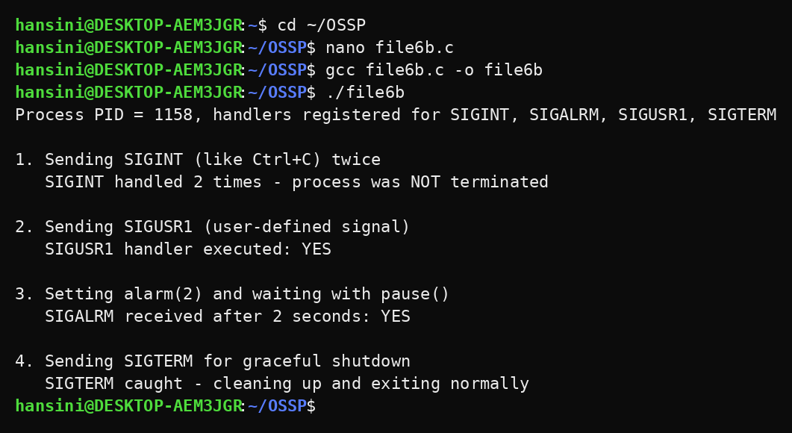
Observation:
- Two FIFOs were created in /tmp and used for the request and the response.
- The server received every client message, converted it to upper case and returned an acknowledgement.
- The clients were served one after another and each client received its own response.
- The FIFOs were removed after the communication was completed.
- SIGINT was handled twice and the process was not terminated.
- SIGUSR1 and SIGALRM invoked their handlers, and SIGTERM allowed the process to exit gracefully.
Result:
The client-server application using named pipes and the POSIX signal handling program were implemented and executed successfully. Messages were exchanged correctly through FIFOs and the registered handlers were called for the signals.

