PRACTICAL - 7

Name: T.Hansini Reddy
Rollno: 252003095

Experiment No. 7
Title: Memory Address Space of a Process and /proc/<PID>/maps.
Aim:
To write a C program that prints the addresses of code, global, static, heap and stack variables, and to analyse the Linux process address-space layout using /proc/<PID>/maps.

Objective:
- To understand the memory layout of a Linux process.
- To identify the code, global, static, heap and stack regions.
- To print the virtual addresses of different kinds of variables.
- To read and interpret /proc/<PID>/maps.
- To understand the permissions (r, w, x, p) of memory regions.
Theory:
1. Process address space
Every process has its own virtual address space containing: Text (code, read-only and executable), Data (initialised global and static variables), BSS (uninitialised globals and statics), Heap (dynamic memory from malloc, grows upward) and Stack (local variables and function calls, grows downward).
2. /proc/<PID>/maps
This file lists every memory region of a process with its address range, permissions (r, w, x, p = private), offset, device, inode and mapped file name or a label such as [heap] and [stack].
3. Address space layout randomization (ASLR)
Linux randomizes the base addresses of the stack, heap and libraries on every run, so the addresses change each time the program is executed, but their relative order stays the same.
Algorithm
- Start the program.
- Declare an initialised global, an uninitialised global, a static variable and a local variable.
- Allocate an integer on the heap using malloc().
- Print the addresses of main, a function, a string literal and all the variables.
- Open /proc/<PID>/maps for the current process.
- Read the file line by line and print the regions of the program, [heap] and [stack].
- Free the heap memory and stop.
System Calls / Linux Commands Used:
System Call / Command | Purpose
getpid() | Returns the process ID
malloc() / free() | Allocate and release heap memory
fopen() / fgets() | Read /proc/<PID>/maps
sscanf() | Extracts the address, permissions and name
printf("%p") | Prints addresses

Program: Printing Addresses and Reading /proc/<PID>/maps
#include <stdio.h>
#include <stdlib.h>
#include <string.h>
#include <unistd.h>

int global_init = 10; /* .data */
int global_uninit; /* .bss */
const char *msg = "literal"; /* pointer in .data, string in .rodata */

void show_function(void) { }

int main()
{
static int static_var = 5;
int local_var = 1;
int *heap_var = (int *)malloc(sizeof(int));
*heap_var = 99;

printf("Process ID : %d\n\n", getpid());
printf("Code (main function) : %p\n", (void *)main);
printf("Code (show_function) : %p\n", (void *)show_function);
printf("Read-only string literal : %p\n", (void *)msg);
printf("Global (initialised) : %p\n", (void *)&global_init);
printf("Global (uninitialised, bss) : %p\n", (void *)&global_uninit);
printf("Static variable : %p\n", (void *)&static_var);
printf("Heap (malloc) : %p\n", (void *)heap_var);
printf("Stack (local variable) : %p\n\n", (void *)&local_var);

printf("---- /proc/%d/maps (selected regions) ----\n", getpid());
char path[64], line[512];
snprintf(path, sizeof path, "/proc/%d/maps", getpid());
FILE *fp = fopen(path, "r");
while (fgets(line, sizeof line, fp)) {
char range[64], perms[8], name[200] = "";
sscanf(line, "%63s %7s %*s %*s %*s %199s", range, perms, name);
if (strstr(name, "file7") || strstr(name, "[heap]") || strstr(name, "[stack]"))
printf("%-26s %s %s\n", range, perms, name);
}
fclose(fp);
free(heap_var);
return 0;
}

OUTPUT:
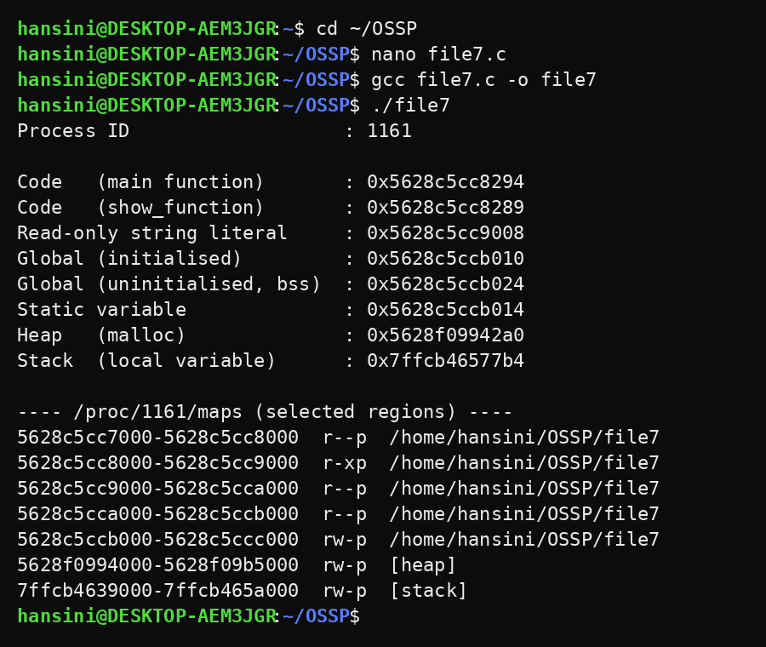
Observation:
- The code (main, show_function) lies at the lowest addresses, in the r-xp (read-execute) region of the executable.
- The string literal is stored in the read-only (r--p) region.
- The initialised global, the static variable and the uninitialised global (bss) lie in the rw-p data region just after the code.
- The heap address belongs to the [heap] region, at a higher address than the data segment.
- The stack variable has a very high address and lies inside [stack].
- Running the program again gives different addresses because of ASLR, but the order code < data < heap < stack remains the same.
Result:
The addresses of code, global, static, heap and stack variables were printed, and the process address-space layout was analysed using /proc/<PID>/maps. Every variable was matched with its memory region and permissions.
Conclusion:
The experiment showed that a Linux process is divided into separate regions with different permissions, and that /proc/<PID>/maps can be used to inspect them.

