PRACTICAL - 8

Name: T.Hansini Reddy
Rollno: 252003095

Experiment No. 8
Title: Dynamic Memory Allocation and Copy-on-Write.
Aim:
Part A: To develop a C program using malloc(), calloc(), realloc() and free(), and to identify memory leaks using Valgrind.
Part B: To demonstrate Copy-on-Write (COW) behaviour after fork() and to show that the parent and the child get separate copies of a page only when one of them modifies it.

Objective:
- To understand dynamic memory allocation on the heap.
- To use malloc(), calloc(), realloc() and free().
- To detect memory leaks using Valgrind.
- To understand the Copy-on-Write mechanism.
- To observe the behaviour of memory after fork().
Theory:
1. Dynamic memory
Dynamic memory is allocated from the heap at run time. malloc(size) allocates uninitialised memory, calloc(n, size) allocates zero-initialised memory, realloc(ptr, size) changes the size of a block and free(ptr) releases it. Memory that is not freed causes a memory leak.
2. Valgrind
Valgrind (Memcheck) runs a program and reports invalid memory accesses and leaks. 'definitely lost' means the pointer to the block was lost without freeing it.
3. Copy-on-Write
After fork() the parent and the child do not get physical copies of memory. Both map the same physical pages marked read-only. When either process writes to a page, the kernel makes a private copy for that process. This makes fork() fast and saves memory.
4. Illustration
Before fork: Parent → Page A
After fork: Parent and Child → Shared Page A
After child modifies: Parent → Page A, Child → Page B (copy)
Algorithm (Part A – Dynamic Memory)
- Start the program.
- Allocate an integer array using malloc() and another using calloc().
- Fill the first array and display both arrays (calloc gives zeros).
- Resize the first array using realloc() and fill the new elements.
- Display the resized array and release it using free().
- Leave the calloc memory unfreed to create a leak.
- Compile with -g and run with valgrind --leak-check=full to detect the leak.
Algorithm (Part B – Copy-on-Write)
- Start the program and declare a variable with the value 100.
- Display its value and address, then call fork().
- In the child, display the value and address, modify the value to 500 and display it again.
- The parent waits for the child using wait().
- The parent displays its value and address.
- Compare the values and the addresses and stop.
System Calls / Linux Commands Used:
System Call / Command | Purpose
malloc() / calloc() | Allocate heap memory
realloc() | Resizes a memory block
free() | Releases memory
valgrind --leak-check=full | Detects memory leaks
fork() / wait() | Create and wait for the child
gcc -g | Compiles with debug information

Part A – Program: malloc(), calloc(), realloc() and free()
#include <stdio.h>
#include <stdlib.h>
#include <string.h>

int main()
{
int n = 5;
int *a = (int *)malloc(n * sizeof(int));
int *b = (int *)calloc(n, sizeof(int));
if (!a || !b) { printf("Memory allocation failed\n"); return 1; }

printf("malloc : block at %p allocated for %d integers\n", (void *)a, n);
printf("calloc : block at %p allocated for %d integers\n", (void *)b, n);
for (int i = 0; i < n; i++) a[i] = (i + 1) * 10;
printf("a[] after filling : "); for (int i = 0; i < n; i++) printf("%d ", a[i]); printf("\n");
printf("b[] (calloc zero-initialised) : "); for (int i = 0; i < n; i++) printf("%d ", b[i]); printf("\n\n");

a = (int *)realloc(a, 8 * sizeof(int));
for (int i = n; i < 8; i++) a[i] = (i + 1) * 10;
printf("realloc: a resized to 8 integers (block at %p)\n", (void *)a);
printf("a[] after realloc : "); for (int i = 0; i < 8; i++) printf("%d ", a[i]); printf("\n\n");

free(a);
/* b is intentionally NOT freed to demonstrate a memory leak */
printf("a freed. b was not freed (deliberate leak for Valgrind)\n");
return 0;
}

OUTPUT:
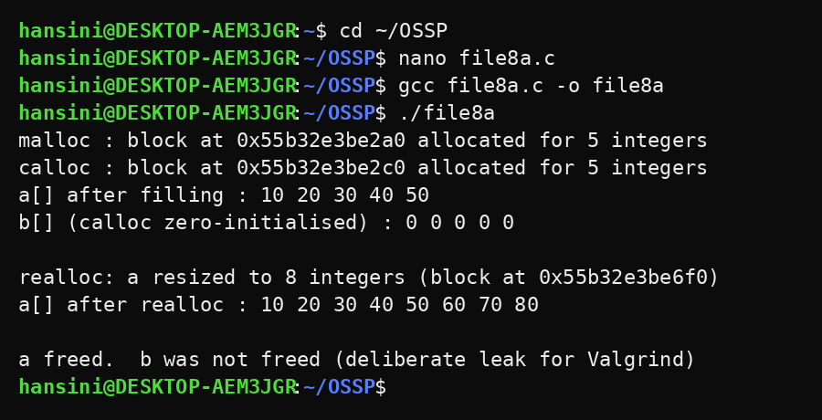
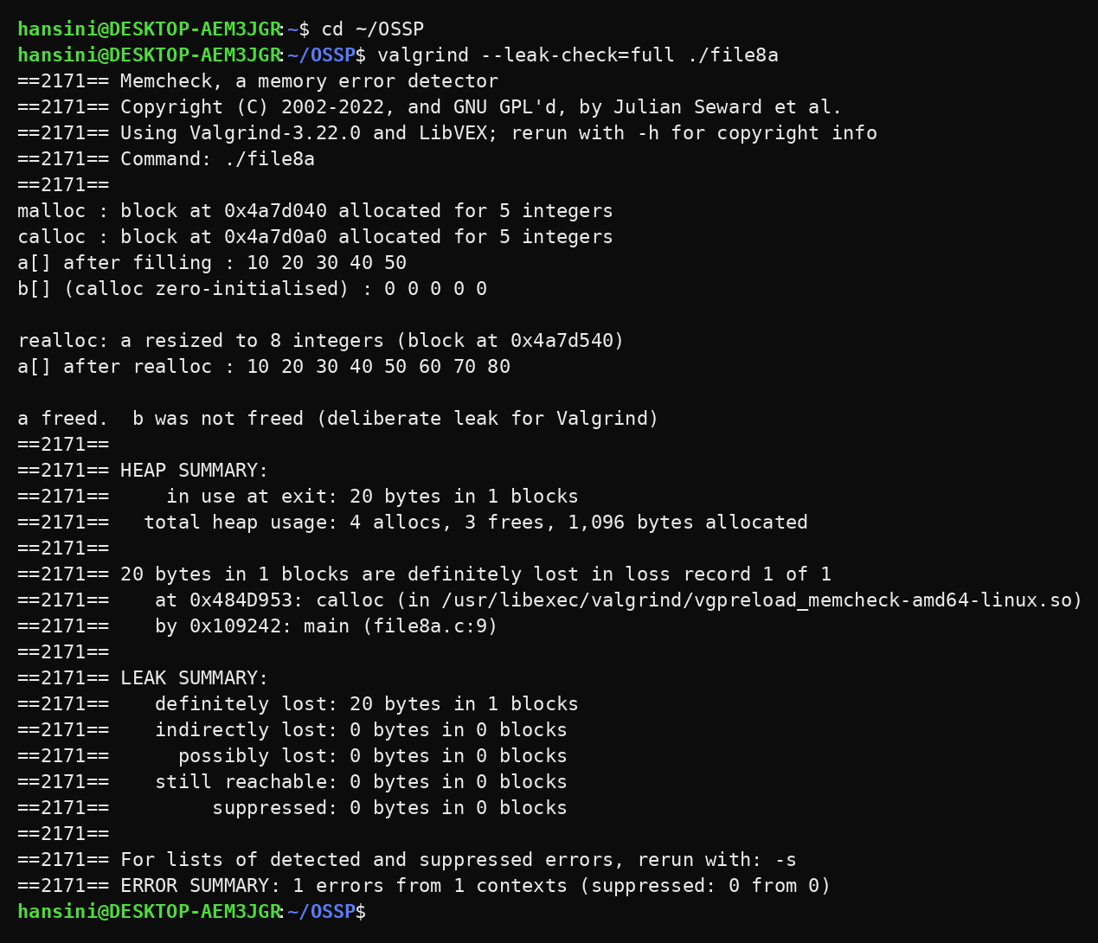
Part B – Program: Copy-on-Write using fork()
#include <stdio.h>
#include <stdlib.h>
#include <unistd.h>
#include <sys/wait.h>

int main()
{
int value = 100;
printf("Before fork : value = %d, address = %p\n\n", value, (void *)&value);
pid_t pid = fork();
if (pid == 0) {
printf("Child (before modification): value = %d, address = %p\n", value, (void *)&value);
value = 500;
printf("Child (after modification): value = %d, address = %p\n", value, (void *)&value);
exit(0);
}
wait(NULL);
printf("Parent (after child finished): value = %d, address = %p\n\n", value, (void *)&value);
printf("Same virtual address, different values -> pages were copied on write.\n");
return 0;
}

OUTPUT:
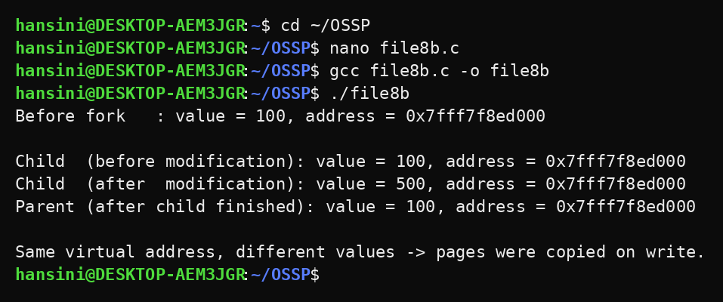
Observation:
- malloc() returned uninitialised memory, calloc() returned memory initialised with zeros and realloc() preserved the old values while enlarging the array.
- Valgrind reported 20 bytes in 1 block as definitely lost, pointing to the calloc() call at line 9, because that memory was never freed.
- The block freed with free() was not reported by Valgrind.
- Before modification, the child saw the same value (100) as the parent.
- After the child changed the value to 500, the parent still had 100.
- The virtual address was the same in both processes, but they used different physical pages after the write, which shows Copy-on-Write.
Result:
The program using malloc(), calloc(), realloc() and free() was implemented and the memory leak was identified using Valgrind. The Copy-on-Write behaviour of fork() was also demonstrated successfully.
Conclusion:
The experiment demonstrated two important Linux memory concepts: dynamic memory must always be released to avoid leaks, and fork() uses Copy-on-Write so that memory is copied only when it is modified.

