Experiment: Practical-03
Course: Operating Systems and Systems Programming (OSSP)
Name: B. Pranavi
Roll No.: 2520030026
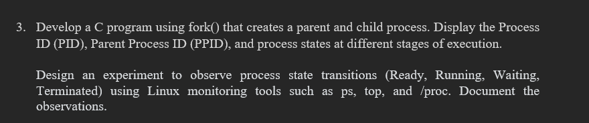
Step 1: Navigate to the Working Directory
Command:
Observation: The working directory fork_process_lab was successfully opened.

Step 2: Execute the Fork Process Program
Command:
Observation: The program was executed successfully and created two processes: a parent process and a child process.

Step 3: Observe the Parent and Child Process IDs
Output:
Both processes started
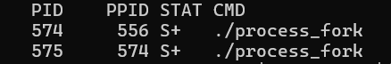
Observation: The program successfully displayed the Process ID (PID) of the parent process and the child process.

Step 4: Observe the Parent Process
Output:
--- PARENT PROCESS ---
Parent PID : 574
Child PID : 575
Parent is RUNNING...
Parent is WAITING for child to terminate...
Observation: The parent process entered the RUNNING state and then waited for the child process to complete its execution.

Step 5: Observe the Child Process
Output:
--- CHILD PROCESS ---
Child PID : 575
Child PPID : 574
Child is RUNNING...
Child is WAITING for 10 seconds...
Child is RUNNING again...
Child is TERMINATING...
Observation: The child process successfully demonstrated different process states. It entered the RUNNING state, waited for 10 seconds, resumed execution, and then terminated.

Step 6: Observe Parent Process After Child Termination
Output:
Child terminated.
Parent is RUNNING again.
Parent is TERMINATING...
Observation: After the child process terminated, the parent process resumed execution and then terminated successfully.

Step 7: Display Process Information Using ps
Command:
Observation: The ps command was used to display the PID, Parent PID, process state, and command name of the running process_fork program.

Step 8: Observe Parent and Child Process Details
Output:
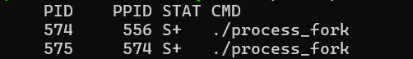
Observation: The output showed two processes. Process 574 was the parent process, and process 575 was created as its child process with PPID 574.

Step 9: Check Process Status Using the /proc File System
Command:
Observation: The /proc file system was used to obtain detailed information about the process name, state, PID, and PPID.

Step 10: Monitor Running Processes Using top
Command:
Observation: The top command was used to monitor active processes, their process IDs, CPU usage, memory usage, and current execution status.

Step 11: Observe Process States in top
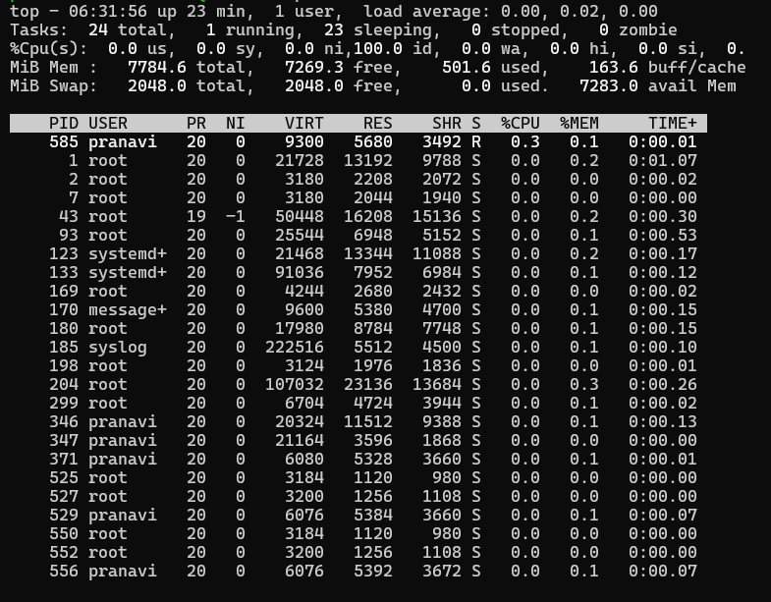
Observation: The process monitoring screen displayed the currently running processes and their states. This was used to observe system process activity during the fork process experiment.

Step 12: Exit the top Command
Command:
Observation: The q key was used to exit the top process monitoring screen.

Result
Observation: The program successfully demonstrated process creation using fork(). A parent process and a child process were created with different PIDs. The child process demonstrated RUNNING, WAITING, and TERMINATING states, while the parent process waited for the child to terminate and then resumed execution. Process information was successfully monitored using the ps, /proc, and top commands.

