Experiment 1: Linux Command Execution Using fork() and exec()
Course: Operating Systems and Systems Programming (OSSP)
Name: B. Pranavi
Roll No.: 2520030026
Date: 31/7/2026
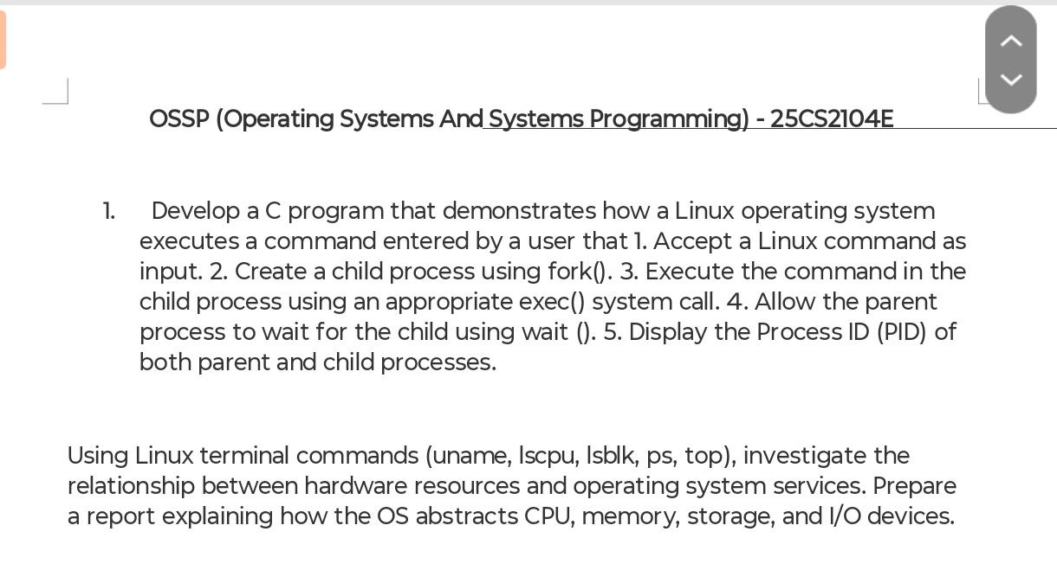
Experiment Steps:

Step 1: Check Whether GCC is Installed
To check if the GNU C Compiler (GCC) was installed, I executed the following command:
gcc --version
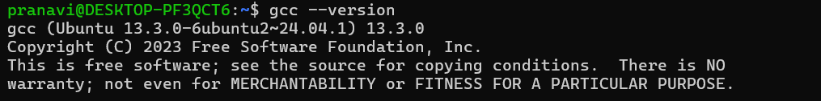
Observation:
The GCC compiler was successfully installed on the system. The command displayed the installed GCC version as 13.3.0, confirming that the compiler is ready to compile C programs.

Step 2: Navigate to the Program Directory
The directory containing the C program was opened using:
To verify the file, the following command was executed:
Observation:
The terminal displayed:
This confirmed that the source file was present in the directory.

Step 3: Compile the Program
The C program was compiled using the GCC compiler with the following command:
Observation:
The program compiled successfully without any errors, and an executable file named exp1 was created.

Step 4: Execute the Program
The compiled program was executed using:
./exp1
When prompted:
Enter Linux Command
a Linux command was entered, and the program executed it successfully using the system() function.

Step 5: Execute Different Linux Commands Step
- Ls
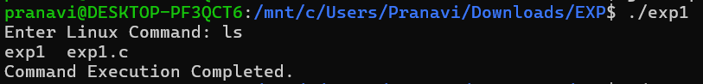

- pwd
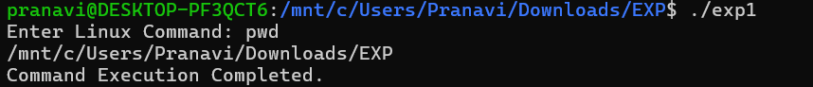

- date

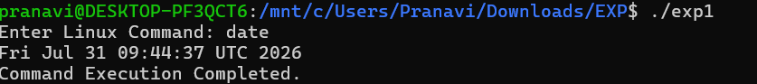
- Uname

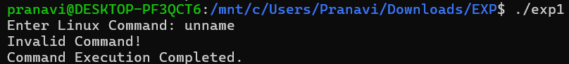
- Lscpu

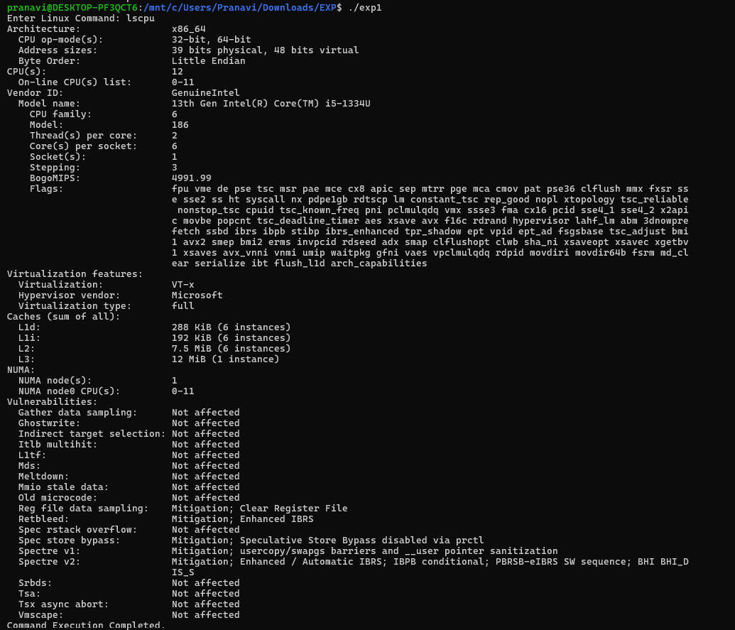

- Lsblk

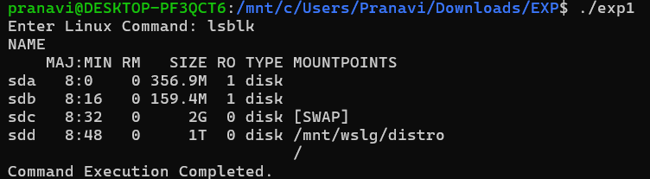
- Ps

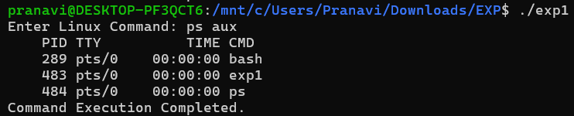
- Top

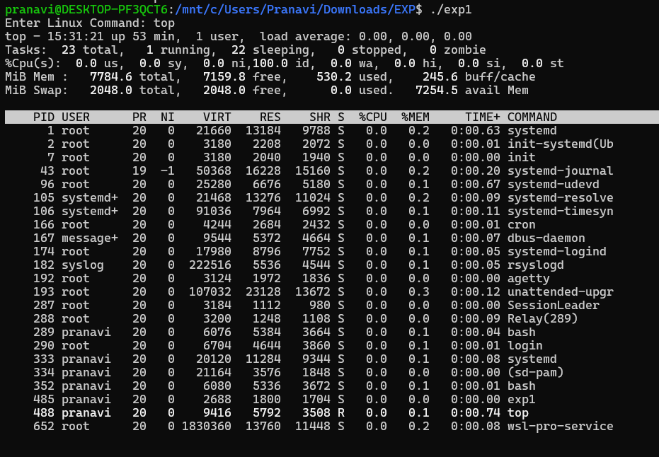

9)whoami

