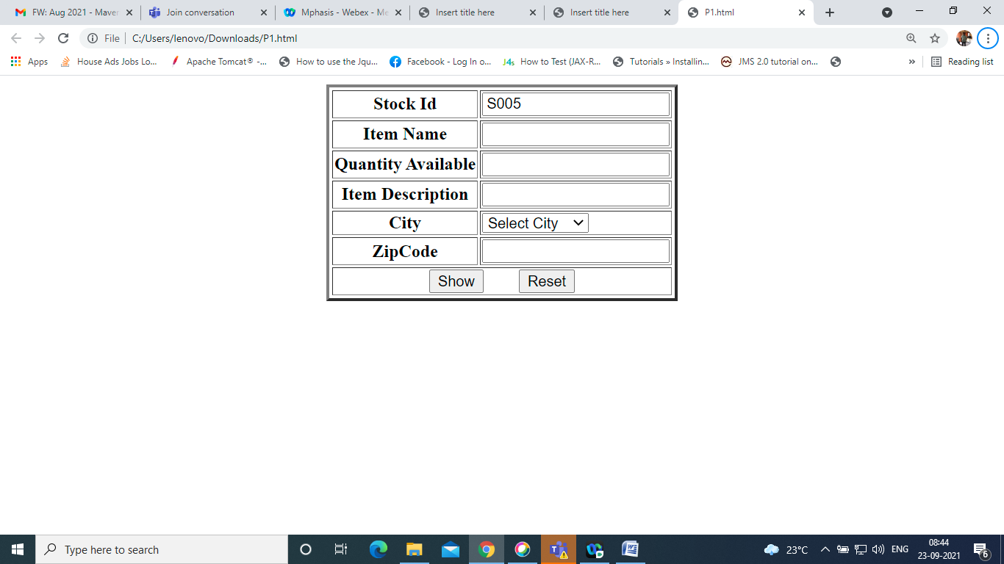

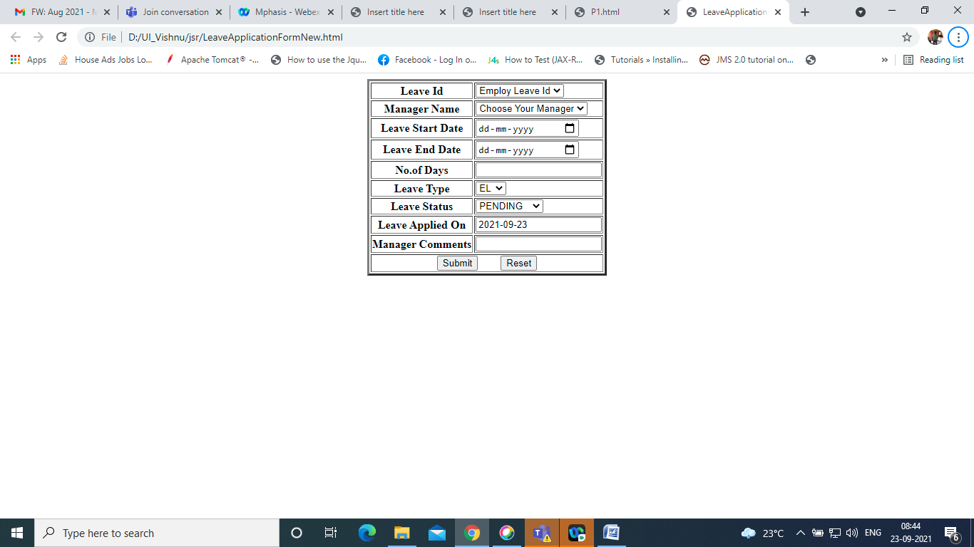

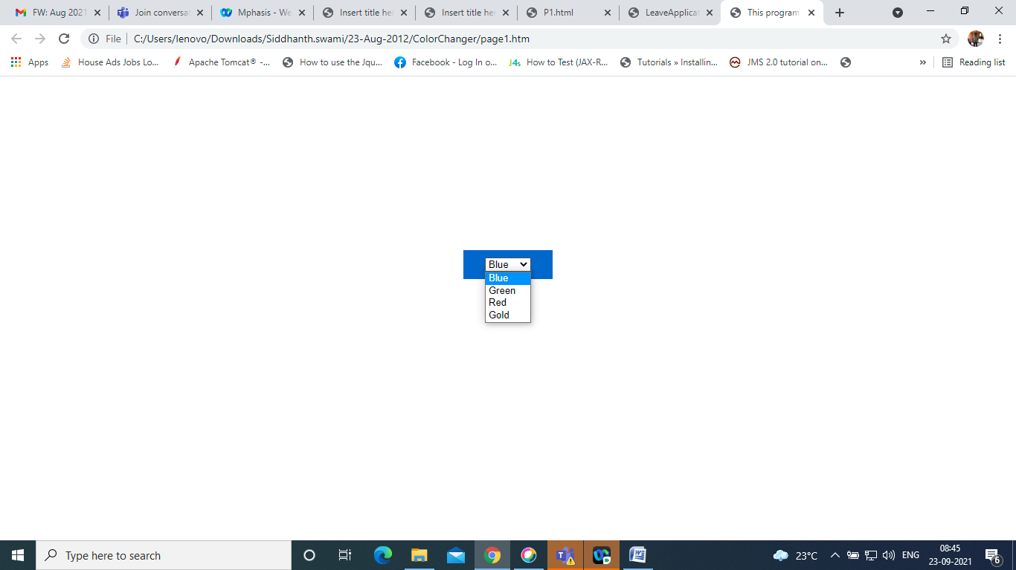

Design this page and appy colors

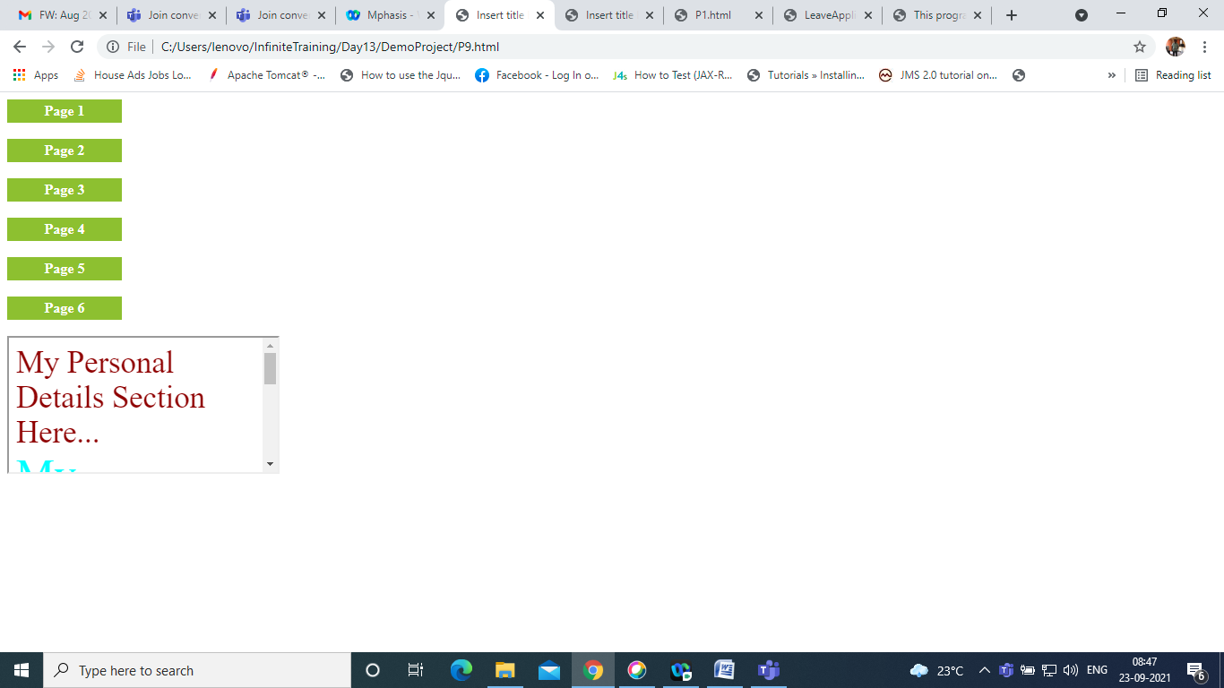

Create page with actions.

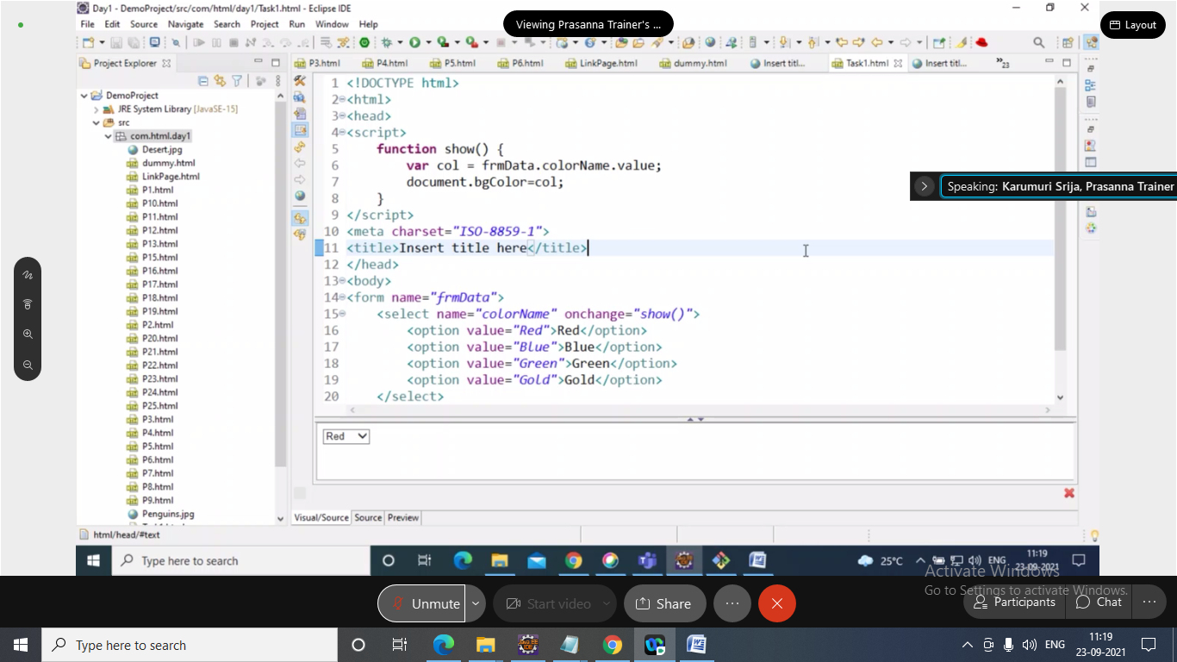

<https://github.com/PrasananTrainer03/Mphasis_New/blob/master/Day3_Solutions.zip>

<https://github.com/PrasananTrainer03/Mphasis_New/blob/master/P25.html>

<https://github.com/PrasananTrainer03/Mphasis_New/blob/master/Day3_Solutions.zip>