PSP0 Project Plan Summary

Student | José Javier Virviescas Toledo | Date | 24/01/2015
Program | Conceptos Avanzados de Ing. de Software | Program # | 1
Instructor | Luis Daniel Benavides Navarro | Language | JAVA

Time in Phase (min.) | Plan |  | Actual |  | To Date |  | To Date %
Planning |  |  | 5 |  | 5 |  | 2.9
Design |  |  | 10 |  | 10 |  | 5.8
Code |  |  | 105 |  | 105 |  | 61.4
Compile |  |  | 0 |  | 0 |  | 0.0
Test |  |  | 28 |  | 28 |  | 16.4
Postmortem |  |  | 23 |  | 23 |  | 13.5
Total | 180 |  | 171 |  | 171 |  | 100.0
Defects Injected |  |  | Actual |  | To Date |  | To Date %
Planning |  |  | 0 |  | 0 |  | 0.0
Design |  |  | 1 |  | 1 |  | 16.7
Code |  |  | 3 |  | 3 |  | 50.0
Compile |  |  | 0 |  | 0 |  | 0.0
Test |  |  | 2 |  | 2 |  | 33.3
Total Development |  |  | 6 |  | 6 |  | 100.0
Defects Removed |  |  | Actual |  | To Date |  | To Date %
Planning |  |  | 0 |  | 0 |  | 0.0
Design |  |  | 0 |  | 0 |  | 0.0
Code |  |  | 4 |  | 4 |  | 66.7
Compile |  |  | 0 |  | 0 |  | 0
Test |  |  | 2 |  | 2 |  | 33.3
Total Development |  |  | 6 |  | 6 |  | 100
After Development |  |  | 0 |  | 0

PSP Time Recording Log
Student | José Javier Virviescas Toledo | Date | 24/01/2015
Program | Conceptos Avanzados de Ing. de Software | Program # | 1
Instructor | Luis Daniel Benavides Navarro | Language | JAVA

Project | Phase | Start Date and Time | Int. Time | Stop Date and Time | Delta  Time | Comments
PSP0 | Planning | 24/01/2015  11:35 am |  | 24/01/2015  11:40 am | 5
 | Design | 24/01/2015  11:40 am | 3 | 24/01/2015  11:53 am | 10
 | Code | 24/01/2015  11:59 am | 10 | 24/01/2015  01:03 pm | 54
 | Code | 25/01/2015  9:26 am | 20 | 25/01/2015  10:37 am | 51
 | Test | 25/01/2015  10:55 am | 5 | 25/01/2015  11:28 am | 28
 | Postmortem | 26/01/2015  9:25 pm | 7 | 26/01/2015  9:55 pm | 23

PSP Defect Recording Log
Defect Types
10 Documentation | 60 Checking
20 Syntax | 70 Data
30 Build, Package | 80 Function
40 Assignment | 90 System
50 Interface | 100 Environment
Student | José Javier Virviescas Toledo | Date | 24/01/2015
Program | Conceptos Avanzados de Ing. de Software | Program # | 1
Instructor | Luis Daniel Benavides Navarro | Language | JAVA

 | Project |  |  | Date |  | Number |  | Type |  | Inject |  | Remove |  | Fix Time |  | Fix Ref.
 | PSP0 |  |  | 24/01/2015 |  | 1 |  | 20 |  | Design |  | Code |  | 3
Description: |  |  | Inicialmente se planteó trabajar un LinkedList con elementos de tipo float. Finalmente en
el código se paso a trabajar con un LinkedList con elementos String, para realizar la conversión a double.
 | Project |  |  | Date |  | Number |  | Type |  | Inject |  | Remove |  | Fix Time |  | Fix Ref.
 | PSP0 |  |  | 24/01/2015 |  | 2 |  | 20 |  | Code |  | Code |  | 5 |  | 1
Description: |  |  | Error intentando tomar y operar los valores de un LinkedList con elementos tipo flat.
 | Project |  |  | Date |  | Number |  | Type |  | Inject |  | Remove |  | Fix Time |  | Fix Ref.
 | PSP0 |  |  | 25/01/2015 |  | 3 |  | 80 |  | Code |  | Code |  | 15
Description: |  |  | El valor que estaba retornando el método desviacionEstandar no era el correcto.
 | Project |  |  | Date |  | Number |  | Type |  | Inject |  | Remove |  | Fix Time |  | Fix Ref.
 | PSP0 |  |  | 25/01/2015 |  | 4 |  | 70 |  | Code |  | Code |  | 5
Description: |  |  | La precisión que se estaba imprimiendo en los métodos no era la adecuada
 | Project |  |  | Date |  | Number |  | Type |  | Inject |  | Remove |  | Fix Time |  | Fix Ref.
 | PSP0 |  |  | 25/01/2015 |  | 5 |  | 80 |  | Test |  | Test |  | 5
Description: |  |  | Error comparando el resultado del método testDesviaciónEstandar con una valor
 | Project |  |  | Date |  | Number |  | Type |  | Inject |  | Remove |  | Fix Time |  | Fix Ref.
 | PSP0 |  |  | 25/01/2015 |  | 6 |  | 20 |  | Test |  | Test |  | 4
Description: |  |  | Pasando el valor de retorno del método desviacionEstandar a String y comparando con
otro String.

PSP Defect Type Standard
Type Number | Type Name | Description
10 | Documentation | Comments, messages
20 | Syntax | Spelling, punctuation, typos, instruction formats
30 | Build, Package | Change management, library, version control
40 | Assignment | Declaration, duplicate names, scope, limits
50 | Interface | Procedure calls and references, I/O, user formats
60 | Checking | Error messages, inadequate checks
70 | Data | Structure, content
80 | Function | Logic, pointers, loops, recursion, computation, function defects
90 | System | Configuration, timing, memory
100 | Environment | Design, compile, test, or other support system problems

Test Results
Prueba local:

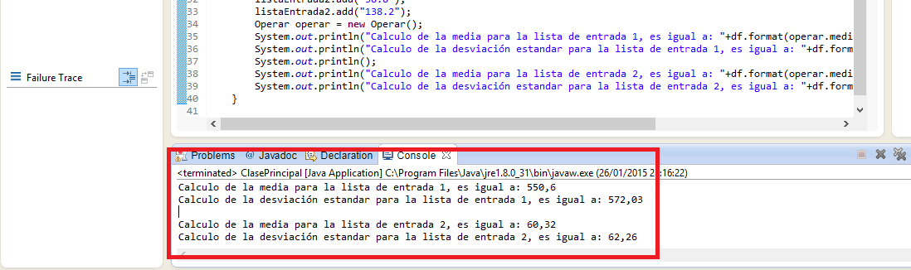

Pruebas unitarias:

