Simulation

// Metadata

Name | Simulation
Keywords | Simulation
Creation date | September, 2011
Has contributor | Bernard Gibaud, Germain Forestier
Used ontology engineering methodology | OntoSpec
Is of type | Domain ontology
Natural language | English
Has ontology language | OntoSpec
Has formality level | Semi informal
Has reference
Ressource locator
Version | 1.0
Number of concepts (classes) | 19
Number of relations (properties) | 0

// Concepts

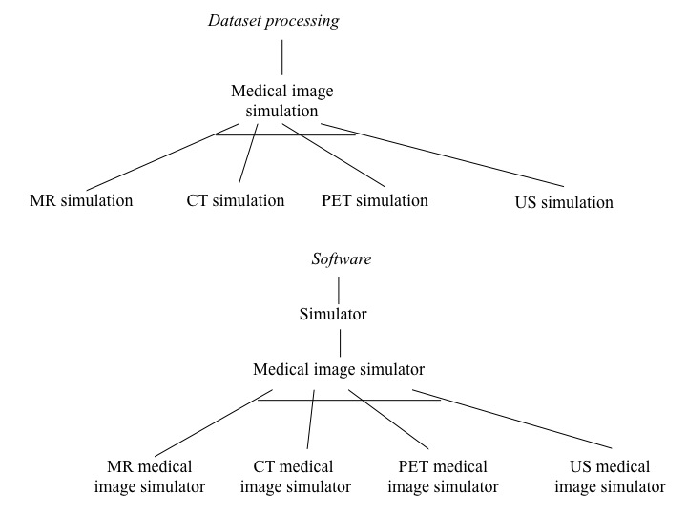

Medical image simulation, simulation
Meta Properties
MR SIMULATION, CT SIMULATION, PET SIMULATION and US SIMULATION and is a disjunctive sub-division of MEDICAL IMAGE SIMULATION.
Properties
[EP/SL] A MEDICAL IMAGE SIMULATION is a DATASET PROCESSING. [EP/ER] A MEDICAL IMAGE SIMULATION has for data exactly one MEDICAL IMAGE SIMULATION OBJECT MODEL at a TIME INTERVAL. [EP/ER] A MEDICAL IMAGE SIMULATION has for result some SIMULATED DATA at a TIME INTERVAL. A MEDICAL IMAGE SIMULATION has for instrument some MEDICAL IMAGE SIMULATOR at a TIME INTERVAL.
Comment
[DEF] A medical image simulation is a dataset processing consisting in calculating medical images representing an object (usually a biological object, but it can also be a geometric phantom) from a model of this object. The calculations involved in this process include the simulation of the physical phenomena that occur during a real image image acquisition using an imaging equipment (e.g. emission of photons and interactions with the imaged object and the detector).

MR simulation
Meta Properties
Properties
[EP/SL] An MR SIMULATION is a MEDICAL IMAGE SIMULATION. [EP/ER] A MR SIMULATION has for result some MR SIMULATED DATA at a TIME INTERVAL. A MR SIMULATION has for instrument some MR MEDICAL IMAGE SIMULATOR at a TIME INTERVAL.
Comment
[DEF] MR simulations are Medical image simulations aiming at creating MR simulated data.

CT simulation
Meta Properties
Properties
[EP/SL] A CT SIMULATION is a MEDICAL IMAGE SIMULATION. [EP/ER] A CT SIMULATION has for result some CT SIMULATED DATA at a TIME INTERVAL. A CT SIMULATION has for instrument some CT MEDICAL IMAGE SIMULATOR at a TIME INTERVAL.
Comment
[DEF] CT simulations are Medical image simulations aiming at creating CT simulated data.

PET simulation
Meta Properties
Properties
[EP/SL] A PET SIMULATION is a MEDICAL IMAGE SIMULATION. [EP/ER] A PET SIMULATION has for result some PET SIMULATED DATA at a TIME INTERVAL. A PET SIMULATION has for instrument some PET MEDICAL IMAGE SIMULATOR at a TIME INTERVAL.
Comment
[DEF] PET simulations are Medical image simulations aiming at creating PET simulated data.

US simulation
Meta Properties
Properties
[EP/SL] An US SIMULATION is a MEDICAL IMAGE SIMULATION. [EP/ER] An US SIMULATION has for result some US SIMULATED DATA at a TIME INTERVAL. An US SIMULATION has for instrument some US MEDICAL IMAGE SIMULATOR at a TIME INTERVAL.
Comment
[DEF] US simulations are Medical image simulations aiming at creating US simulated data.

Simulator
Meta Properties
Properties
[EP/SL] A SIMULATOR is a SOFTWARE.
Comment
[DEF] A simulator is a software dedicated to simulation.

Medical image simulator
Meta Properties
MR MEDICAL IMAGE SIMULATOR, CT MEDICAL IMAGE SIMULATOR, PET MEDICAL IMAGE SIMULATOR and US MEDICAL IMAGE SIMULATOR and is a disjunctive sub-division of MEDICAL IMAGE SIMULATOR.
Properties
[EP/SL] A MEDICAL IMAGE SIMULATOR is a SIMULATOR.
Comment
[DEF] A medical image simulator is a simulator dedicated to the simulation of Medical images.

MR Medical image simulator
Meta Properties
Properties
[EP/SL] An MR MEDICAL IMAGE SIMULATOR is a MEDICAL IMAGE SIMULATOR.
Comment
[DEF] An MR medical image simulator is a simulator dedicated to the simulation of MR simulated data.

CT Medical image simulator
Meta Properties
Properties
[EP/SL] A CT MEDICAL IMAGE SIMULATOR is a MEDICAL IMAGE SIMULATOR.
Comment
[DEF] A CT medical image simulator is a simulator dedicated to the simulation of CT simulated data.

PET Medical image simulator
Meta Properties
Properties
[EP/SL] A PET MEDICAL IMAGE SIMULATOR is a MEDICAL IMAGE SIMULATOR.
Comment
[DEF] A PET medical image simulator is a simulator dedicated to the simulation of PET simulated data.

US Medical image simulator
Meta Properties
Properties
[EP/SL] An US MEDICAL IMAGE SIMULATOR is a MEDICAL IMAGE SIMULATOR.
Comment
[DEF] An US medical image simulator is a simulator dedicated to the simulation of US simulated data.
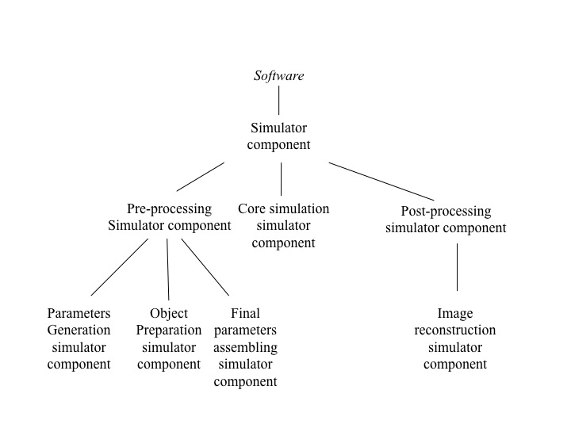
Simulator component
Meta Properties
Properties
[EP/SL] A SIMULATOR COMPONENT is a SOFTWARE. [EP/ER] A SIMULATOR COMPONENT is a part of some SIMULATOR during a TIME INTERVAL.
Comment
[DEF] A simulator component is a software achieving some of the processing involved in simulation.

Pre-processing simulator component
Meta Properties
Properties
[EP/SL] A PRE-PROCESSING SIMULATOR COMPONENT is a SIMULATOR COMPONENT.
Comment
[DEF] A pre-processing simulator component is a simulator component achieving some pre-processing of simulation.

Core simulation simulator component
Meta Properties
Properties
[EP/SL] A CORE SIMULATION SIMULATOR COMPONENT is a SIMULATOR COMPONENT.
Comment
[DEF] A core simulation simulator component is a simulator component achieving some core simulation.

Post-processing simulator component
Meta Properties
Properties
[EP/SL] A POST-PROCESSING SIMULATOR COMPONENT is a SIMULATOR COMPONENT.
Comment
[DEF] A post-processing simulator component is a simulator component achieving some post-processing of simulation.

Parameters generation simulator component
Meta Properties
Properties
[EP/SL] A PARAMETERS GENERATION SIMULATOR COMPONENT is a PRE-PROCESSING SIMULATOR COMPONENT.
Comment
[DEF] A parameters generation simulator component is a pre-processing simulator component achieving some generation of simulation parameters.

Object preparation simulator component
Meta Properties
Properties
[EP/SL] An OBJECT PREPARATION SIMULATOR COMPONENT is a PRE-PROCESSING SIMULATOR COMPONENT.
Comment
[DEF] An object preparation simulator component is a pre-processing simulator component achieving some object preparation.

Final parameters assembling simulator component
Meta Properties
Properties
[EP/SL] A FINAL PARAMETERS ASSEMBLING SIMULATOR COMPONENT is a PRE-PROCESSING SIMULATOR COMPONENT.
Comment
[DEF] A final parameters assembling simulator component is a pre-processing simulator component achieving some final assembling of simulation parameters.

Image reconstruction simulator component
Meta Properties
Properties
[EP/SL] An IMAGE RECONSTRUCTION SIMULATOR COMPONENT is a POST-PROCESSING SIMULATOR COMPONENT.
Comment
[DEF] An image reconstruction simulator component is a post-processing simulator component achieving some image reconstruction.

