Design, Simulation and Testing of a High Performance 15-4 Compressor

Authors: Shubhajit Roy Chowdhury, Aniruddha Roy²,
Aritra Banerjee³, Hiranmay Saha⁴

Abstract

The current trend in the development of digital signal processing circuits characterized by high speed and low power dissipation has motivated the design of compressors characterized by optimization of power and delay. The paper presents a novel high speed and low power 15-4 compressor for high speed and low power multiplication applications. The proposed compressor uses bit sliced adder architecture to exploit the parallelism in the computation of sum of 15 input bits by five full adders. The newly proposed compressor is also centered around the design of a novel 5-3 compressor that attempts to minimize the stage delays of a conventional 5-3 compressor that is designed using single bit full adder and half adder architectures. The proposed 15-4 compressor uses the minimum number of hardware resources so far as the logic level architecture of the design is concerned. The proposed compressor is tested using 10 transistor adder and 14 transistor adder designs reported in literature. The power dissipation of the proposed compressor is found to be equal to as low as 0.98fJ using 10- transistor adder and as low as 0.46fJ using 14- transistor adder.

Keywords: Compressor, bit sliced adder, high speed, low power

- Introduction:

Ever since its very inception, the semiconductor industry has overseen a radical growth in the integration of diversified circuit components over a limited area of silicon. The continuous surge in the integration of more and more components on the same area of silicon has motivated the scientists to explore well engineered technologies to address the challenging criteria of these emerging low voltage low power and high speed technologies. Multiplication being a salient prerequisite for general purpose processors, digital signal processors, digital filters, etc [1, 2], deserves ultimate attention for power efficient design. At the circuit design level, considerable potential for power savings and voltage scaling exists through the use of contemporary and new logic styles for the implementation of its embraced combinational circuits. Compressor constitutes a very fundamental block.

A survey of contemporary literature reveals a huge development of multiplier over the past few decades. The earliest reported multiplier was an array multiplier that uses a chain of ripple carry adders to compute the product by means of repetitive addition [3]. Multiplier architecture is essentially divisible into three stages: a partial product generation stage, a partial product addition stage and final addition stage. A fast array or tree multiplier is composed of three sub-circuits: a Booth encoder for generation of partial products, a carry save structured accumulator for summing up the partial products and a final carry propagation adder to compute the final binary result from its stored carry representation [4]. The second stage requires the use of adders or compressors and this stage mainly contribute to delay and power. Therefore speeding up the second stage and lowering its power dissipation are the most eminent means of achieving performance improvement of the multiplier [5]. In high speed multipliers, 4-2 compressors are widely used to lower the latency of the partial product accumulation stage. Owing to its regular interconnection, 4-2 compression is ideal for constructing regularly structured Wallace tree with low complexity [1]. However, for the compression of a larger number of bits, higher order compressors are needed.

The current work presents the novel design of a 15 to 4 compressor with logic level interconnection suitably modified as to minimize the stage delay. The proposed compressor uses bit sliced adder architecture to exploit the parallelism in the computation of sum of 15 input bits by five full adders. The newly proposed compressor is also centered around the design of a novel 5-3 compressor that attempts to minimize the stage delays of a conventional 5-3 compressor that is designed using single bit full adder and half adder architectures. The proposed 15-4 compressor uses the minimum number of hardware resources so far as the logic level architecture of the design is concerned. The proposed compressor is tested using 14 transistor and 10 transistor adder designs reported in literature.

The paper is organized as follows. Section 2 focuses on the design of a novel 5-3 compressor that attempts to minimize the computational delay with respect to the conventional 5-3 compressor. Section 3 discusses on the design of the 15-4 compressor using the proposed 5-3 compressor. Section 4 shows the detailed circuit design of the 15-4 compressor. The performance evaluation of the proposed circuit is presented in section 5 and we conclude in section 6.

- 5-3 Compressor Architecture:

A 5-3 compressor essentially comprises of a combinational logic circuit with five inputs and three outputs. It accepts a five bit input string as input, and produces its sum as output. Obviously, the maximum output of a 5-3 compressor can be 101, when all its input bits are at logic 1. The conventional architecture of a 5-3 compressor is based on the extended design of a conventional 4-2 compressor [6, 7, 8]. The architecture of a conventional 5-3 compressor is shown in figure 1.
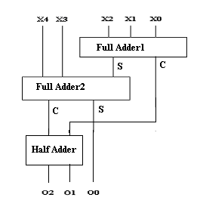
Figure 1. Architecture of a conventional 5-3 compressor

As evident from the figure 1, the straightforward implementation of the 5-3 compressor entails for 5 gate delays. Moreover the least significant bit of the output requires 4 gate delays (delay imposed by four XOR gates). As a result, there can be a problem of synchronization of the output bits when the input bits change leading to static hazards. The current work proposes a novel architecture of a 5-3 compressor that can produce output with only three gate delays. The architecture of the compressor has been obtained by suitably rewriting the Boolean equations of a 5-3 compressor as:
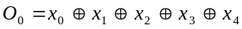…………………….……………………......……(1)
...(2)
..(3)
Using equations (1), (2) and (3), we propose to design a multiplexer based architecture of a 5-3 compressor as shown in figure 2.
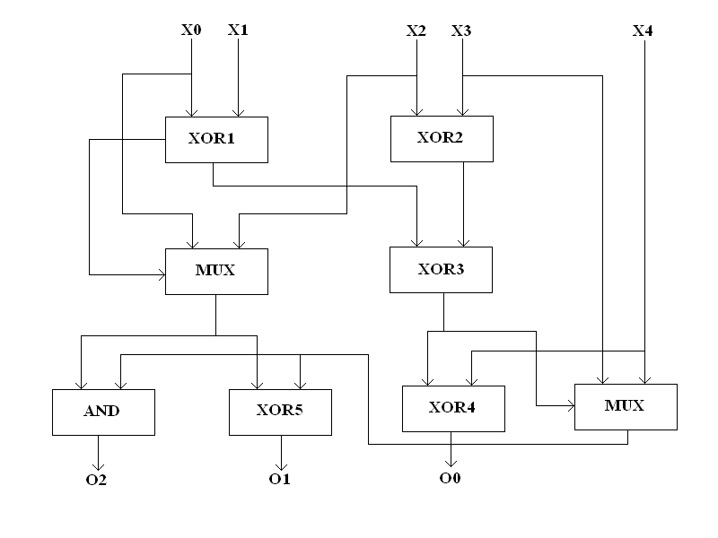
Figure 2. Architecture of the proposed 5-3 Compressor

From figure 2, it is evident that the output of the compressor requires 3 gate delays. It is therefore obvious that the proposed 5-3 compressor computes the compressed output with a much lesser delay than the conventional 5-3 compressor.
The power and delay of the proposed 5-3 compressor has been compared with that of the standard 5-3 compressor found in literature. Table I shows the comparative study of power and delay of the proposed 5-3 compressor and the standard 5-3 compressor found in literature.

Table I
Comparative study of Power Delay Product of 5-3 compressors
Compressor Type | Average Power (μW) | Average Delay (ns) | Power-Delay Product (fJ)
Proposed 5-3 Compressor | 0.17 | 0.04 | 0.0068
Conventional 5-3 Compressor (Fig.1) | 0.23 | 0.07 | 0.0161

A comparative study of the simulation results presented in table 1 indicates that the proposed 5-3 compressor is more efficient in terms of power, delay and power-delay product than its peer design.

Moreover, the straightforward implementation of the 5-3 compressor requires the use 5 XOR gates, 5 AND gates and 2 OR gates. However, the proposed 5-3 compressor requires the use of 5 XOR gates, 2 AND gates and 2 multiplexers. Since multiplexers can be implemented with only two transistors using pass transistor logic, therefore the proposed 5-3 compressor uses much hardware resources than the conventional 5-3 compressor. With 10T adders, the conventional 5-3 compressor requires 27 transistors to implement. However, the proposed 5-3 compressor can be implemented with only 25 transistors.

- 15-4 Compressor Architecture:

Using the proposed 5-3 compressor, a 15-4 compressor has been designed. The architectural design of the proposed 15-4 compressor is shown in figure 3.
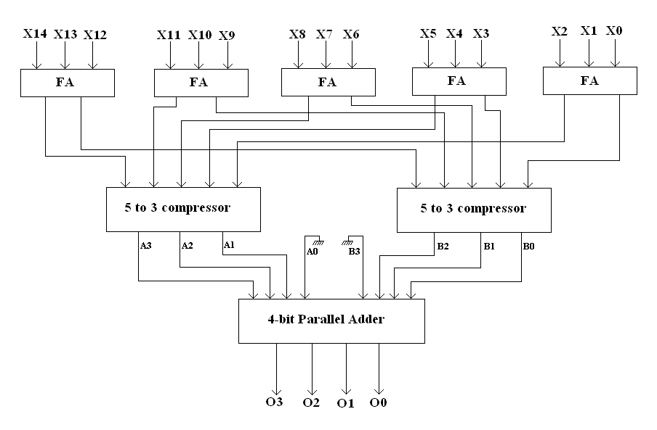
Figure 3. Architecture of the proposed 15-4 Compressor

As discussed, the architecture is based on a bit sliced addition technique. The 15 input bits are divided five groups of three bits each. The 3 input bits in each group are compressed into 2 bits in the first stage using a full adder. The sum and carry outputs of each adder are thereafter sent to two 5-3 compressors whose design has been discussed in section 2. The outputs of the compressor are sent to a 4 bit parallel adder that has been suitably optimized according to the design requirements.

Since the 5-3 compressor that computes the sum of the carry outputs of the full adders in the first stage produces a result that has twice the weight of the output of the other compressor, hence the compressor output is sent to the parallel adder after being appropriately left shifted. Since least significant bit of the one set of 4 bits is zero and the most significant bit of the other set of 4 bits is zero, hence the adder design is suitably optimized as shown in figure 4.
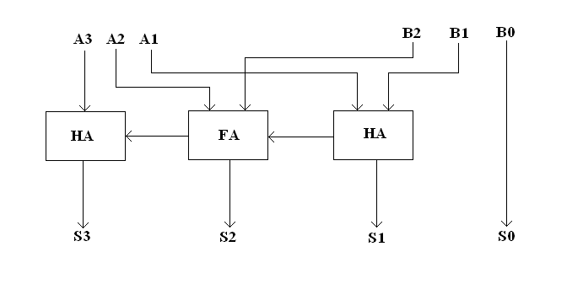
Figure 4. Optimal design of the parallel adder

- Circuit Design of the 15-4 Compressor:
The circuit has been designed, simulated and tested using 10 transistor and 14 transistor adder circuits. The design of the 14 transistor adder [11] is shown in figure 5 (a).
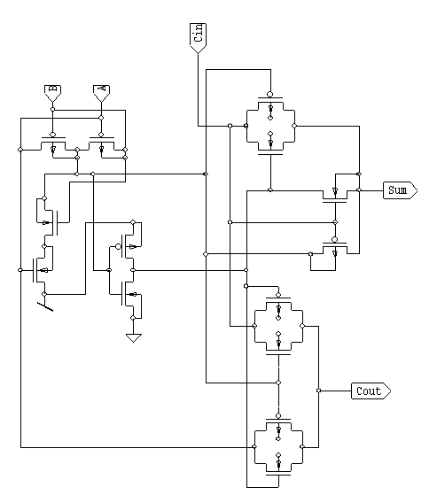
Figure 5 (a) Design of 14T adder.

It contains a 4T XOR circuit, an inverter and two transmission gate based multiplexer designs for Sum and Cout signals. Despite the threshold voltage loss in internal nodes, this design maintains a full output voltage swing. The design of the 10T full adder [12] is shown in figure 5(b).

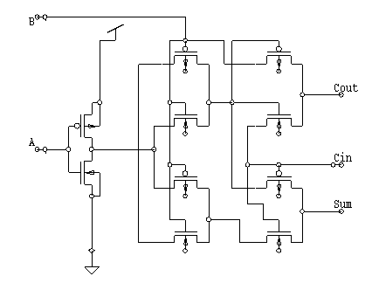
Figure 5 (b) Design of 10T adder.

In the 10T adder cell, the implementation of XOR and XNOR of A and B is done using pass transistor logic. An inverter is used to complement the input signal A. This implementation results in faster XOR and XNOR outputs and also ensures that there is a balance of delays at the outputs of these gates. This leads to less spurious sum and cout outputs. The capacitance at the outputs of XOR and XNOR gates is also reduced as they are not loaded with inverter.

Using the adders, the 15-4 compressor has been designed and the circuits are shown in figure 6(a) and (b) respectively. The architecture of the 15-4 compressor has already been shown in figure 3.
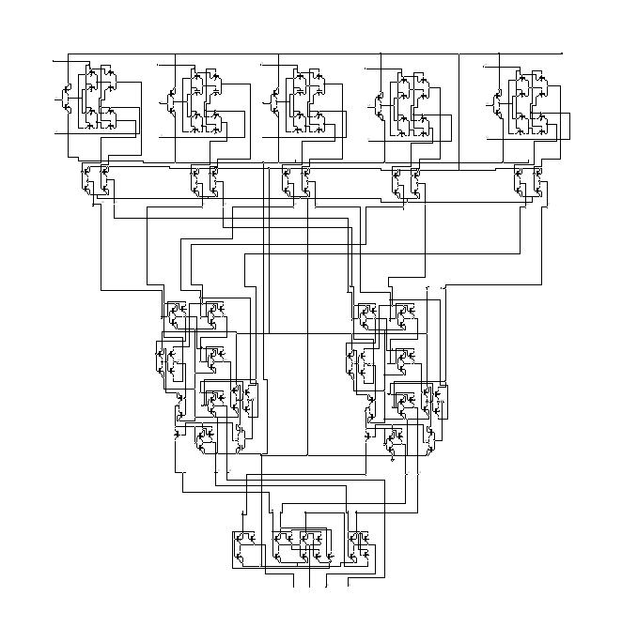
Figure 6 (a)

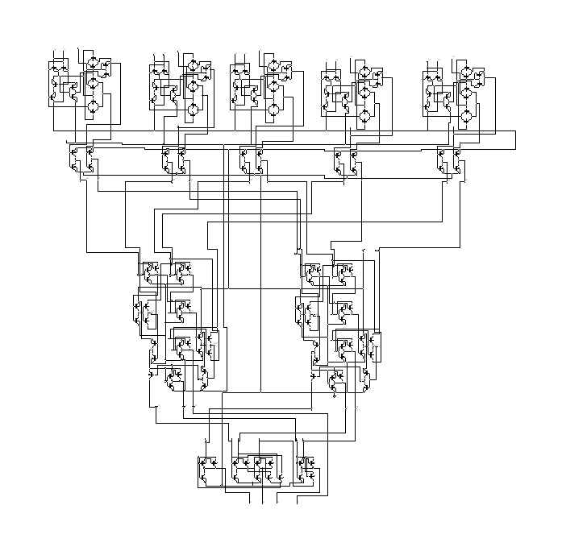
Figure 6(b)

Figure 6. Design of 15-4 Compressors using (a) 10T and (b) 14T adders

- Simulation and results:
The whole circuit has been designed and simulated using T-Spice. The circuit has been found to satisfy the truth table of a 15-4 compressor. The circuit has been extensively simulated and power, delay and power-delay product has been found out. The results are shown in table II.
Table II.
Simulation results of the proposed 15-4 compressor
Type of circuit | Power (μW) | Delay (ns) | PDP (fJ)
10T adder based design | 7.35 | 0.13 | 0.98
14T adder based design | 4.12 | 0.11 | 0.46

A comparative study of the simulation results presented in table 1 indicates that the 14T adder based design is more efficient in terms of power, delay and power-delay product, although the circuit area becomes somewhat more compared to its 10T adder based counterpart. The layout of the proposed 15-4 compressor using 14 transistor adder architecture is shown in figure 7.

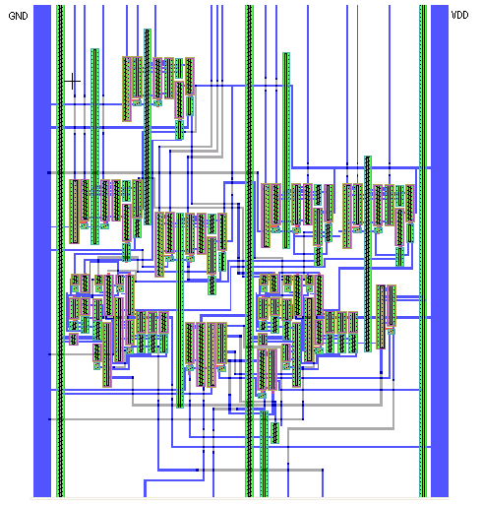
Figure 7. Layout of the proposed 15-4 Compressor
- Conclusion:

The current work investigates the design, simulation and testing of a 15-4 compressor. The proposed compressor uses bit sliced adder architecture to exploit the parallelism in the computation of sum of 15 input bits by five full adders. The newly proposed compressor is also centered around the design of a novel 5-3 compressor that attempts to minimize the stage delays of a conventional 5-3 compressor that is designed using single bit full adder and half adder architectures. The proposed 15-4 compressor uses the minimum number of hardware resources so far as the logic level architecture of the design is concerned. The proposed compressor is tested using 14 transistor and 10 transistor adder designs reported in literature.

- References:

[1] D. Radhakrishnan, A.P. Preethy (2000), “Low Power CMOS pass logic 4-2 compressor for high speed multiplication”, Proceedings of 43rd IEEE Midwest Symposium on Circuits and Systems, Vol. 3, pp. 1296-1298.
[2] S.F. Hsiao, M.R. Jiang, J.S. Yeh, (1998) “Design of high low power 3-2 counter and 4-2 compressor for fast multipliers”, Electronic Letters, Vol. 34, No. 4, pp. 341-343.
[3] C. Baugh, B. Wooley (1973), “A two’s complement parallel array multiplication algorithm”, IEEE Transactions on Computers, Vol. C-22, No. 12, pp. 1045-1047.
[4] J. Gu, C. Chang (2003), “Ultra low voltage low power 4-2 compressor for high speed multiplications”, Proceedings of IEEE International Symposium on Circuits and Systems”, Vol. 5, pp. 321-324.
[5] K. Prasad, K.K. Parhi (2001), “Low power 4-2 and 5-2 compressors”, Proceedings of 35th Asilomar Conference on Signals, Systems and Computers, Vol. 1, pp. 129-133.
[6] V.G. Oklobdzija, D. Villeger, S.S. Liu (1996), “A method for speed optimized partial product reduction and generation of fast parallel multipliers using an algorithmic approach”, IEEE Transactions on Computers, Vol. 45, No. 3.
[7] P. Stelling, C. Martel, V.G. Oklobdzija, R. Ravi (1998), “Optimal circuit for parallel multipliers”, IEEE Transactions on Computers, Vol. 47, No. 3.
[8] V.G. Oklobdzija (2000), “High speed VLSI arithmetic unit: Adders and Multipliers”, in Design of High Performance Microprocessor Circuits”, Editor A. Chandrakasan, IEEE Press.
[9] L. Junming, S. Yan, L. Zhengui, W. Ling (2001), “A novel 10 transistor low power high speed full adder cell“, Proceedings of 6th International Conference on Solid State and Integrated Circuit Technology, Vol. 1, pp. 1155-1158.
[10] A. M. Shams, M. Bayoumi (2000), “A novel high performance CMOS 1 bit full adder cell”, IEEE Transactions on Circuits and Systems II, Analog and Digital Signal Processing, Vol. 47, No. 5, pp. 478-481.
[11] E. Abu-Shama and M. Bayoumi (1995), “A new cell for low power adders,” in Proc. Int. Midwest Symp. Circuits Syst., pp. 1014–1017.
[12] L.Junming, S.Y an, L.Zhenghui, and W.Ling (2001), “A novel 10-transistor low-power high-speed full adder cell”, Proceedings of 6th International Conference on Solid-State and Integrated-Circuit Technology, pp.1155–1158.

^{,2,3,4}IC Design and Fabrication Centre, Department of Electronics and Telecommunication Engineering, Jadavpur University, Kolkata-700032. Emails: ¹shubhajit@juiccentre.res.in, ²anietce@gmail.com, ³aritraetce@gmail.com, ⁴hsaha@juiccentre.res.in.

