POLARIMETERS
in
College
Chemistry
Courses

TABLE OF CONTENTS

DESCRIPTION OF POLARIMETRY

Introduction . . . . . . . page 3

Optical Activity . . . . . . . page 3

Polarized Light . . . . . . . page 3

Polarimeter . . . . . . . page 4

Accuracy vs Complexity – Polarimeter Design . . . page 5

A Polarimeter of Simplified Design . . . . . page 5

Use of Polarimeter: Qualitative . . . . . page 7

Quantitative Measurements: Specific Rotation . . . page 7

Optical Activity – Isomers and Stereoisomers . . . page 8

SUGGESTED EXPERIMENTS

Which Liquid Cell Should You Use? . . . . page 9

The Relationship of Optical Activity to Path Length (Gladstone) . page 11

The Relationship between Optical Activity and Concentration (Decon) . page 12

The Rate if Hydrolysis of Sucrose when Catalyzed by Acid (Decon) . page 13

Eagle Point, Oregon Experiments (Marsh)
Introduction . . . . . . . page 15
Qualitative Polarimetry: Carbohydrates . . . . page 16
Qualitative Polarimetry: Amino Acids . . . . page 17
Qualitative Polarimetry . . . . . . page 18
Additional Notes on the Above Experiments . . . page 19

Published Experiments:
A Polarimeter Experiment for Introductory Courses (Gibas) . . page 20
Resolution of Racemic – Phenylethylamine (Moore & Dalrymble) . page 24
Resolution of Racemic – Phenylethylamine (Roberts et al) . . page 28
Optical Isomers of Co (en)3+3(Angelici) . . . . page 34

INTRODUCTION

Optical activity is an intriguing property of certain molecules. In this booklet we discuss optical activity and its measurement. We also suggest several experiments, using the GLAS-COL polarimeter, which fit into any basic course in chemistry.

OPTICAL ACTIVITY

The study of optical activity of liquids began in the early 19th century with Biot and other scientists. They found that solutions of sugar and certain other naturally occurring chemicals would rotate a beam of polarized light passing through the solution. They called such substances optically active, a term which is still used. The instrument used to demonstrate or to measure this rotation was given the name polarimeter.

Many scientists, including Pasteur, made important contributions to the field of chemistry by studying optically active molecules. In fact, the whole field of stereo-chemistry, which is concerned with the structural arrangements of isomers, grew out of these studies of optical activity – using polarimeters.

This is, therefore, a particularly appropriate field for laboratory experimentation. The reader is referred to textbooks on organic chemistry – such as Gilman, Organic Chemistry, Vol. 1 - for a general discussion over significance of optical activitiy. Since physicists as well as chemists, have been interested in these subjects, you will also find discussions in most physics texts in the chapters on light.

POLARIZED LIGHT

Since polarized light is the basis for all studies of optical activity, it is well to review its nature and formation. As you will find in the physics textbooks: polarized light is considered to be light in which the electromagnetic waves are vibrating only in parallel planes.

Ordinary light, by way on contrast, is made up of waves vibrating in all directions (perpendicular to the direction of travel). To create polarized light from ordinary light,
one used a polarizing filter on prism, which will transmit the light vibrating in planes parallel to each other and will absorb, or divert light vibrating in other planes. Such polarized light is often referred to as plane-polarized light. (There is also elliptical light.)

POLARIMETER: BASIC DESIGN

A polarimeter consists of a light source, two polarizing prisms or filters, a liquid cell placed between the two polarizers, an eyepiece and a protractor for measuring the angular rotation of light by the solution.
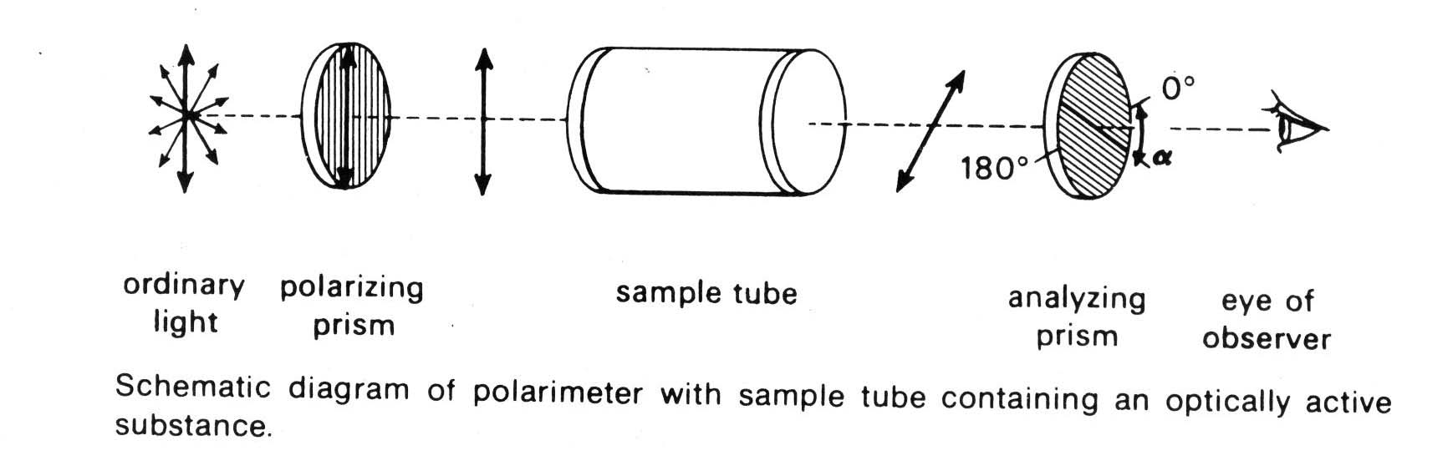

Historically, polarimeters have been based on very carefully cut prisms made of Iceland Spar (calcite). Such prisms, known as Nicol prisms, are often shown as ___ in diagrams of polarimeters. The classical polarimeter, based on Nicol prisms, is a familiar
instrument in advanced chemistry courses. Usually it is regarded as a very special instrument that is to be used only by the faculty and a few special students. (This may be reasonable since such polarimeters are inexpensive, difficult for an inexperienced person to use, and the cells can be easily damaged.)

ACCURACY vs COMPLEXITY – Polarimeter Design

For many years, all of the development work on polarimeters was concerned with making instruments that were more and more precise. Thus, the 360° measuring scales, which are the most conspicuous part of the polarimeters, are often equipped with special eyepieces and verniers so that the scales can be read to the nearest 0.05° or even 0.01°.
The liquid cells also underwent a similar development so that the length of cell through which the polarized light passes can be read to the nearest 0.01 mm.

A consideration of the accuracy required in making polarimetry measurements is important; to a large extent, the complications encountered in polarimetry are a factor of the accuracy desired. Thus, if you want to make very accurate polarimetric measurements – say, to 0.01° of rotation – then the measurements must be made at a specified and carefully controlled temperature, usually 25° C; the cell length must be measured to 0.01 mm; you should use a monochromatic light of specified wave length – usually the sodium “D” line (589.3 nm); and finally, the angle measuring scale on the polarimeter must be equipped with a vernier so that it can be read to a fraction of 0.01° .

A POLARIMETER OF SIMPLIFIED DESIGN

There are many applications of polarimetry in which the ultimate in accuracy is not required, and in which a simplified polarimeter would be a very useful tool. Some applications are industrial and the others are academic. Even in research, there are applications where an accuracy of 1° would be satisfactory – for example, in making quick checks of whether or not certain compounds or mixtures are optically active.

In academic courses, the real need is for an inexpensive, rugged polarimeter that students can use for experiments in their introductory lab courses. In many such experiments a precision of 0.01° is not needed. In fact if a precision of 1° is acceptable a rugged and simple instrument can be designed and certain simplifications follow:

1. The temperature may be held to the nearest 5° C.
- Instead of an expensive sodium light, a yellow filter and an incandescent or tungsten light with an exposed filament may be used.
- The length of the light path through the solution being studied need only be estimated to the nearest mm.

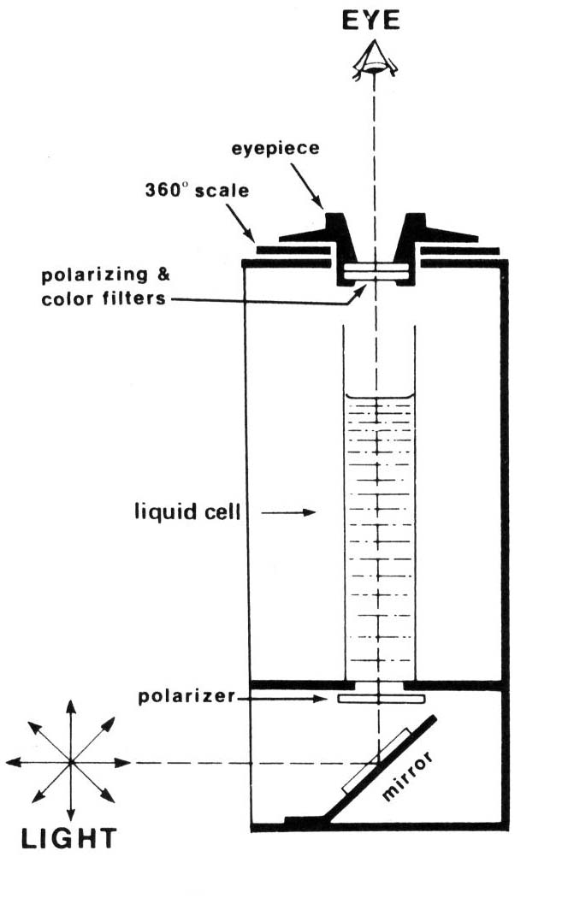
The simplifications listed above are
the basis for the design of the Glas-Col polarimeter.
Incidentally, a precision of 1° presupposes that the
polarimeter will be used with solution that are
sufficiently concentrated and optically active so that
optical rotations of 5 to 15° are expected.

The Glas-Col polarimeter has optics similar
to those of conventional polarimeter except for these
differences:

- The light path is vertical rather than
horizontal or inclined.

- The measurements are made at the
point of optical extinction rather than
the point of maximum brightness.

Note: If you compare the Glas-Col polarimeter with a conventional polarimeter, you will find that the 0° and 180° positions on a conventional polarimeter corresponds to maximum brightness, rather than to extinction points. Under certain conditions, the positions of maximum brightness can be determined more accurately than to the extinction points. Under certain conditions, the positions of maximum brightness can be determined more accurately than the extinction point. Usually, however, operation with the fields at maximum brightness is more tedious since eye fatigue becomes quite evident.)

A final point of difference between the Glas-Col polarimeter and the traditional polarimeter is the use of Polaroid sheet in the optics instead of the very expensive crystal prisms. This material was developed by E.H. Land, the founder of the Polaroid Corporation.

Having thus considered the nature of polarimeters in general, and the Glas-Col polarimeter in particular, let us consider ways in which these devices can be used in the laboratory.

USE OF POLARIMETER: QUALITATIVE

Once you have a polarimeter available, it is delightfully easy to demonstrate the phenomena of optical rotation. First, you should look through the eyepiece when the light source is turned on and the cell is empty. If it is a traditional polarimeter, rotate the eyepiece to the point at which the light, or the image of the filament, is almost completely extinct. Note the scale reading. Then pour into the cell a water solution of ordinary sugar. A solution of 10 grams of sugar in 50 ml of water will be suitable.

You will immediately notice that something has changed – the view through the eyepiece is quite different. Now, try rotating the eyepiece, clockwise or counterclockwise. You will find that it will be necessary turn the eyepiece 10° or more clockwise to regain the condition that existed when no solution was in the cell. Thus, you have demonstrated that the solution you poured into the cell rotated the beam of polarized light passing through the cell. *

- Remembering this rotational basis for polarimetry, an interesting question for students to consider is: what other optical phenomena are the basis of other laboratory instruments, spectrometers, etc?

QUANTATIVE MEASUREMENTS: SPECIFIC ROTATION

In making the above exploratory use of the polarimeter, using the sugar solution, you doubtless had to turn the eyepiece clockwise rather than counterclockwise to reach the new extinction point. It is on this basis that sucrose is considered to be dextrorotatory, often shortened to dextrorotary, dextro or d+. You may well experiment with other compounds having the opposite rotational effect. These are called levorotatory, which is often shortened to levorotary and abbreviated as levo or 1-.

Assuming that you are now ready to make quantitative measurements, proceed as above, using a sugar solution of known composition. Carefully check the “O” point when the liquid cell is empty and again when it contains your solution. The difference between these two readings is called the “observed rotation.” It is a physical property of the particular solution in the cell; it is dependent on the concentration, on the solvent used, the temperature, the length of the light path, and the wavelength of the light.

A standard formula is used to convert observed rotations into “specific rotations”
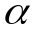 a physical property that can be found in tables of physical properties of chemical compounds.

θ = measured rotation in angular degrees
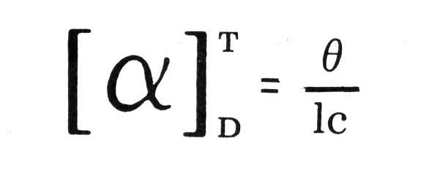
c = concentration in grams per milliliter of solution

l = cell length in decimeters

D = wavelength of light, usually the D* line of a sodium lamp

T = temperature of measurement, usually 25° C
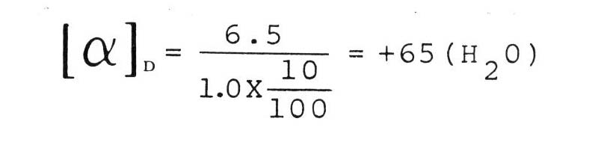
As an example, the observed rotation of 10 grams sucrose in 100 ml of solution (water) was measured as: 6.5 when 1 was 1.0 decimeter.

This compares with a value of 66.5 in the literature.

OPTICAL ACTIVITY – ISOMERS and STEREOISOMERS

One of the favorite stories of early chemistry has to do with Pasteur who studied the crystals of tartaric acid growing in the sediment from wine making. Pasteur noticed two different types of crystals and upon careful study found that although they looked different – both types of crystals were chemically identical. Pasteur was so concerned with the differences between the two types of crystals that he painstakingly picked over the crystals until he had enough of each to study. He found that the two types when put into solution gave optical rotations of opposite direction. One was dextrorotary and the other was levorotary. How could this be? The explanation came from Van’t Hoff in Germany and Le Bel in France. Molecules such as tartaric acid may well exist in two isomeric forms – a right-handed and a left-handed form, depending on the relative orientation of the atoms making up the molecule.

For further discussion of stereochemistry see the various textbooks on organic chemistry – also the various encyclopedia.

* * * *
References:

Organic Chemistry, Morrison, Robert Thornton and Boyd, Robert; Allyn and Bacon, Inc., 1966

Organic Chemistry – Methane to Macromolecules, Roberts, Stewart and Caserio; W.A. Benjamin, Inc., 1971

Introduction to Organic and Biochemistry, William Brown; Willard Grant Press, Boston, Mass., 1972
SUGGESTED EXPERIMENTS – What Size Cell Should You Use?

Before you start the experiments on the following pages, consider: “What is the best size liquid cell to use?” The choice will depend on the cost and availability of the chemicals you intend to work with. In your initial experiments, you’ll probably find that sucrose is ideal; it’s optically active, readily available, and cheap. We suggest that you use the 30 ml cells we currently ship with the polarimeter. These are more convenient and easier to use than the smaller cells.
However, when you consider experiments with more expensive chemicals, you may want to try smaller cells. In general, cells you can use in the Glas-Col polarimeter are:

“50 ml Nessler tubes”: Some laboratories may still have some of the cells that were provided when the polarimeter was first introduced back in 1972. The 1972 polarimeters used the “50 ml Nessler tubes,” made in England by the E-MIL Works of J.A. Joblings. These cells are approximately 16 cm tall, 25 mm in O.D., and when full, hold 50 ml of liquid. They require about 38 ml to fill them to a height of 10 cm.

30 ml cells: In 1974, cells of 21 mm O.D., requiring about 28 ml of liquid for a height of 10 cm became available. Now, these cells are available in two grades, a “standard” and a “deluxe” cell. The 30ml cells are probably the most convenient cells to use.

10 ml cells: When the cost of chemicals is important, consider the suggestion that a 10 ml graduated cylinder can be used as a liquid cell.

Make your own cell, small or large: We have been told that some labs make their own cells by epoxy-cementing a flat glass disk onto the end of piece of glass tubing, cut off and ground-square. If you try this, be sure to keep the cement away from the center of the disk.

Use a beaker as a cell: We have also been told that if the bottom clips of the polarimeter are removed, you can use a glass beaker directly as the “cell”. Presumably, the chemical being studied would be quite inexpensive and available in quantity.

NOTES:

1. A fixed cell length of 10 cm is traditional for conventional polarimeters. However, since the Glas-Col polarimeter is vertical and you will be using open cells, you can fill them to a lesser or greater height. With a liquid height of 13 cm, for example, you will obtain larger rotations and greater accuracy than if you filled the cells only 10.0 cm.

2. Since the experiments listed on the following pages were written for various size cells, you should consider the size of the liquid cell that you intend using and adjust the volume of liquid correspondingly.

3. If you use graduated cylinders as cells, be sure you do not confuse the ml
graduations with centimeters of depth;

Use of 10 ml Liquid Cells with Glas-Col Polarimeter

David Marsh, a chemistry teacher, suggests the use of 10 ml removable-base cylinders as liquid cells. Such cylinders would have the advantage that the students will be able to work with about 1/3 of the material used with the regular Glas-Col cells; thus, when expensive chemicals are used, the cost savings could be significant.

Up until March, 1977, the aperture in the bottom of the polarimeter was 5/8”diameter, (it is now 7/16”). The 5/8” hole presented a problem to Marsh in using the removable base cylinder: if the diameter of a cylinder were less than 5/8”, the cylinder could slip through the hole and damage the lower optics. Marsh designed a simple adaptor, which fits over the 3 screws around the 5/8” hole and serves two purposes: it prevents the cell from damaging the lower optics, and it centers the bottom of the cell.

10 ml Cylinders with Removable Bases
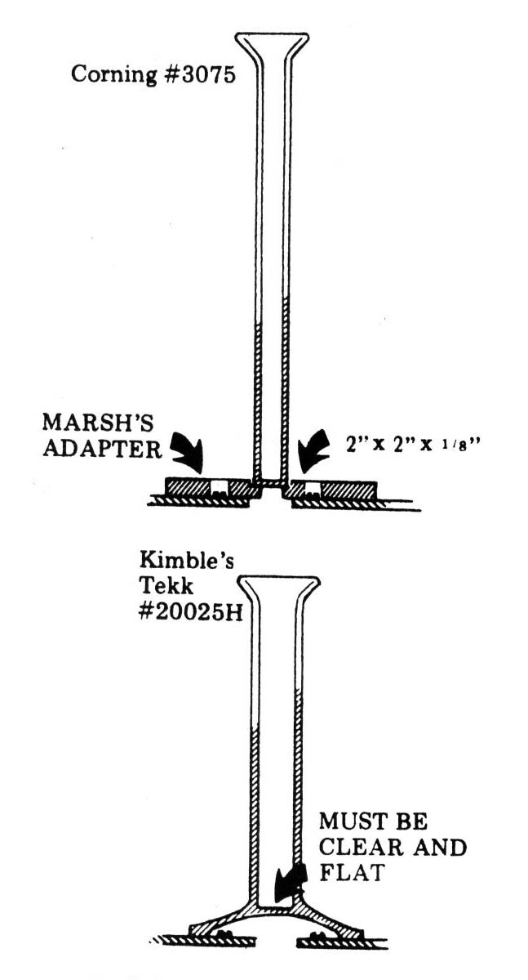
Marsh preferred to use a ml graduated cylinder
such as Corning #3075, with its base removed. (You can
also employ Kimble’s TEKK #20025H.) Note that you
may have to inspect several cylinders to find those with
bases that are relatively flat and clear.

10 ml Cylinders with Fixed Bases

You can sometimes find an all-glass cylinder having
a relatively clear and flat glass bottom. (Try Kimble’s TEKK
#20025K). If the cylinder is not too tall (Some models are),
you can fit it into the polarimeter, centering the base over
the bottom optics, straddling the three screws that hold the
optics in place.

NOTES:

- Plastic cylinders are not suitable since they tend to
depolarize the polarized light.

- Unless the bottom of the fixed base cylinder is clear
and flat, you may find quite a bit of reflected light around
the base, which tends to make viewing difficult.

- The 10 ml cylinders are smaller in diameter than the standard cells. To center such cells in the polarimeter, wrap the jaws of the clamps that hold the cells with electrical tape so that they will be the proper size for the smaller cylinders.

- When students use 10 ml cylinders, caution them that the height, not the volume, of the liquid must be measured (the graduation on a 10 ml cylinder are probably not on centimeter apart).

EXPERIMENT #1 - - The Relationship of Optical Activity to Path Length, A Basic
Length , A Basic Experiment

By Harold M. Gladstone, PhD – Edison, NJ

Method:

- Weigh out 17.1 g of sucrose accurately and make it up into 100 ml if solution. Sucrose has the formula C12H22O11 and a molecular weight of 342; your solution will therefore be 0.5M.

- Using an empty polarimeter, rotate the eyepiece until any light passing through the lower Polaroid is cut off. Rotating first from the right and then from the left, take the average of two or more readings. (This reading corresponds to zero path length.)

- Holding a 15 cm ruler next to the polarimeter tube, pour in the 0.5 sucrose solution until its height reaches about 2 cm. (It is not important to have exactly the right height.) It is important, however, to measure the actual height to the nearest 0.5 mm. Measure at the center of the tube, correct for the thickness of the glass at the bottom of the tube and read to the bottom of the meniscus.

- Repeat the above step for about 4 cm, 6 cm, 8 cm, 10 cm, 12 cm, and 14 cm, measuring both the actual height of the liquid and the angle of rotation of the plane of polarized light with each addition of sucrose solution.

- Record room temperature.

Results:

- Plot a graph of height of liquid (1) vs. optical rotation in degrees (θ).

- Is the relationship between 1 and θ linear? Why?

- From the graph, using the best line through the points, find the θ at exactly 10 cm.

- Using the value found in #3 above, calculate the specific rotation of sucrose.

- Compare your answer above to the literature value and calculate your percent error.

We quote from Dr. Gladstone, “…the time required is less than two hours, including instruction, performance, clean-up, and plotting a graph.”
EXPERIMENT #2 – The Relationship between Optical Activity and Concentration

(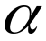) = 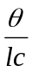

This and the two following experiments were supplied by the Decon Laboratories of Brighton, England

- First prepare a series of known concentrations of a sugar (it can be maltose, dextrose, or ordinary table sugar). Weigh out accurately 2g, 5g, and 10g samples. Working with each sample in turn, dissolve it in distilled water, using less than 45 ml of water. Then add more water until the solution in each case reaches a total volume of 50 ml.

2. Using the polarimeter, first check its zero point. Pour distilled water in the
polarimeter cell to a height of 10 cm and place the cell in the polarimeter. Properly position the light so that you can clearly see the image of the filament in the eyepiece of the polarimeter. Rotate the eyepiece until the image is completely blocked off. Record this extinction point reading as the zero point o

3. Beginning with the most concentrated of the solutions you prepared, pour the liquid
into the polarimeter cell and go through the same process as in step 2. Record the
angular reading corresponding to the extinction point as n.

4. Using a cm scale, measure and note the height of solution in the polarimeter cell.

5. Also note the temperature in °C of you solution. (It is probably the same as room
temperature.)

6. Repeat steps 3 and 4 for each of the other two concentrations, being sure that in
each case you have rinsed the polarimeter cell. Be sure that the outside of the cell is dry each time and that no liquid is spilled on the polarimeter.

Results;
- For each solution, calculate the concentration C in grams per 100 ml of solution.
- Correct each of the readings for the zero point: n-o
- Make a graph of vs c.
- Is the relationship between and c linear?
- What are the units of ?
- From the data obtained on the 10 gm sample calculate
- From the graph find . How does this compare with the value obtained above for the 10 gram sample?

Questions:
- Why is the yellow light used in Polarimetry?
- What would be the effect of using light of longer or shorter wavelength?
- Why are some molecules optically active?
- Why is optical activity dependent upon temperature?

EXPERIMENT #3 – To Study the Rate of Hydrolysis of Sucrose when Catalyzed
by a Dilute Solution of a Strong Acid

- Weigh out approximately 7g of Sucrose (cane sugar) and dissolve in 17 ml of water. Pour the solution into the polarimeter tube.

- At a convenient time (designated zero time) add, with stirring, 10 ml of 6 M hydrochloric acid plus sufficient water to make the total volume 30 ml. Rapidly obtain a reading on the polarimeter for the mixture, noting the elapsed time since mixing.

- At a series of times ( t ) such as 5, 10, 15, 20, 25, 30, 60 and 120 minutes again make a reading on the polarimeter (t). Constant reading shows the end of the reaction ( ).

- Check the zero point of the polarimeter using distilled water.

- Record room temperature.

Results:

- Correct each of the t readings for the zero point t’ = t -

- Draw up a table of your results: t vst’

- Plot a graph of t’ against t as the experiment proceeds.

- Plot a graph of log (- t’) against t. If this is a straight line the reaction of the first order, i.e. it depends only on the concentration of the sucrose (to the first power). The slope of the line is 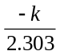 so the velocity constant can be calculated from the curve.

Questions

- What are the units of this velocity constant?

- The reaction is said to be bimolecular. What does this mean? What can you find out about the mechanism of the reaction?

SUGGESTIONS FOR FURTHER EXPERIMENTS

- Study a range of sugars and other substances made into solutions of the same concentration (say 5 g/50 ml of solution) arabinose, fructose, glucose, lactic acid, -methyl glucoside, sucrose, tartaric acid, and xylose.

- Use one of the substances mentioned in the above paragraph for experiment #2, “The Relationship between Optical Activity and Concentration.”

- Use one of the sugars or the ester mentioned above for experiment #3, “To Study the Rate of Hydrolysis of Sucrose when Catalyzed by a Dilute Solution of a Strong Acid.”

- Investigate the effect of varying the concentration of the acid (or varying the acid, keeping the concentration constant) upon the hydrolysis of a sugar.

- Study the effect of substituting sodium hydroxide or yeast in suspension for the acid in a hydrolysis experiment.

- Examine solutions (5 g/50 ml) of D(+) – tartaric acid, L (-)-tartaric acid and meso-tartaric acid, then mix 25 ml each of the first two and examine the new solution.

Introductory Notes by David Marsh for experiments #4 – #6.

Certain substances are able to rotate the direction of vibration of polarized light. Such substances are said to be optically active. The polarimeter is an instrument which is capable of measuring the optical rotation. Clockwise rotation is given a positive (+) sign; counterclockwise rotation is given a negative (-) sign. Certain substances rotate light to a much greater extent than others. Both the direction of rotation and the amount of rotation per gram of solute in a given volume of solution are characteristic properties and can be used to help identify an unknown substance. (Experiment #4 & #5)

When the identity of the solute is known, the polarimeter can be used to determine the concentration of the solution. (Experiment #6)

The Glas-Col polarimeter, employs two Polaroid filters, one under the sample tube and the other in the eyepiece. It can be used to determine the observed rotation to about 1°. (With practice, you may be able to estimate to 0.1°.) More expensive polarimeters use special prisms, monochromatic light, and vernier scales, which allow readings to be made to 0.01°. However, our instrument is much simpler to use than are the precision instruments and it provides you with a good introduction to the subject of Polarimetry. You will find it can give very useful information when you are determining the concentration of a sugar solution, or when you are trying to identify an unknown, for even an approximate value will often be of real help in narrowing your list of possibilities.

To Familiarize yourself with the polarimeter and check its calibration

Fill the polarimeter cell ¾ full with de-mineralized water, dry the outside and then carefully position it in the Glas-Col polarimeter. It should be centered under the eyepiece.

Turn on the light and look through the eyepiece. You will probably see best if your eye is a few inches above the eyepiece. Position the light carefully so that when you look through the eyepiece, you see the filament centered in the lighted area. The filament will disappear when the pointer is at 0° or at 180°. Rotate the eyepiece away from 0° and then turn it back toward 0° while looking at the image of the light bulb filament. Practice turning the dial, and stopping when the light is extinguished, or nearly so. You will probably do best by turning it slightly one way and then the other, finally stopping at what appears to be the darkest point. Empty, clean, and dry the polarimeter cell.

Experiment #4 – Qualitative Polarimetry: Carbohydrates

Introduction: Many different sugars are readily available, some are relatively low in cost and they rotate light to a marked degree. The polarimeter provides a convenient means for comparing the extent to which these different carbohydrates rotate light. The following experiments may be carried out either with standard Glas-Col polarimeter cells, which hold about 35ml, or with a 10 ml cylinder.

- Accurately weigh the sugar (2gm if you are using a 10 ml polarimeter cell, 5 gm if you are using larger cells), and transfer it quantitatively to a volumetric flask, either 10 ml or 25 ml. Dissolve the sample in water and dilute it to the calibration mark.

- Pour the solution into the polarimeter cell, dry the outside, and carefully position the cell in the polarimeter. Turn on the polarimeter light and rotate the eyepiece until the light is extinguished. This will happen near the 0° mark and also near the 180° mark. Choose the reading, which is near which is near the 0° and also near the 180° mark. Choose the reading which is near the 0° mark. With some substances having high rotation, you may notice some secondary color effects. If so, you should choose the darkest point, the point at which there is neither a greenish nor a reddish cast. Make several readings from both directions, average your results, and record the average as the observed rotation. Remember that each line on the scale represents 2°.

- Remove the polarimeter cell and accurately measure in centimeters the solution height from the inside of the base to the bottom of the meniscus. Record the height in centimeters or in decimeters, depending upon the equation you intend to use (see below). Empty, clean and dry the cylinder.

- If you are using 10ml of solution and measuring the cell length in centimeters, you can simplify the calculation as follows:

specific rotation = observed rotation x 100
solution height (cm) x grams of unknown used

specific rotation = observed rotation x ml of solution
solution height (dm) x grams of unknown

- If the dial reading was clockwise from 0°, record the specific rotation as positive; if it was counterclockwise, record it as a negative value.

Experiment #5 – Qualitative polarimetry: Amino Acids

Introduction: The amino acids are interesting because of their importance to living organisms. These are amino acids; they are also the “L” configuration and, with the exception of glycine, they are optically active. From the practical point of view, they are generally more expensive than the carbohydrates, and must be dissolved in the specified reagents if one is going to compare the values obtained with those given in the literature. In general, one should only expect to work with amino acids having large specific rotations.

Choice of Amino Acid: For your initial experiments, you may wish to work with L-cystine, since it is less expensive than some of the others, and it has a relatively large specific rotation.

- Assuming the use of a 10 ml graduated cylinder as the polarimeter cell, dissolve .1 g ;-cystine in 5 ml of 1 M hydrocholoric acid* in a beaker. Transfer to a 10 ml volumetric flask and add additional solvent until the 10 ml mark is reached.

- Proceed as in Experiment #4: “Empty the entire 10ml of the solution into the cylinder, dry the outside, and carefully position it in the polarimeter. Turn on the polarimeter light and rotate the eyepiece until the light is extinguished. This will happen near the 0° and also near the 180° mark. Choose the reading which is near the 0° mark. With some substances having high rotation, you may notice some secondary color effects. If so, you should choose the darkest point, the point at which there is neither a greenish or reddish cast. Make several readings from both directions, average your results and record the average as the observed rotation. Remember that each line on the scale represents 2°.

- “Remove the liquid cell and accurately measure in centimeters, the solution height from the inside of the base to the bottom of the meniscus. Record the height in centimeters or in decimeters, depending upon the equation you intended to use. Empty, clean and dry the cylinder.

- If you are using 10 ml of solution and measuring the cell length in centimeters, you can simplify the calculation as follows:

specific rotation = observed rotation x 100
solution height (cm) x grams of unknown used

specific rotation = observed rotation x ml of solution
solution height (dm) x grams of unknown

- If the dial reading was clockwise from 0°, record the specific rotation as positive; if it was counterclockwise, record it as a negative value.
*When you work with amino acids other than L-cystine, you may have to use a hydrochloric acid solution with a different concentration.

EXPERIMENT #6 – Quantitative Polarimetry

The extent of light rotation is dependent upon the concentration of the optically active substance present. Therefore, the polarimeter can be used to determine the concentration of a solution containing an optically active material. This is done by making up a series of solutions of different known concentration, measuring their observed rotations, plotting a graph and finally, determining the concentration of the unknown material by comparing its observed rotation with the graph.

- If you are using a standard Glas-Col liquid cell, make up 25 ml of a rather concentrated solution of the optically active material and measure its rotation. If you are using a 10 ml graduated cylinder you could, of course, make up a smaller quantity. Record the concentration and the observed rotation.

- The solution is unaffected by its use in the polarimeter and can be diluted to produce a solution of new concentration. Take half of the original solution and dilute with an equal amount of water. Calculate the new concentration and measure its rotation.

- Continue making such dilutions and measuring their rotations until you have at least 5 readings. The last solution will be quite dilute.

- Plot a graph of observed degrees of rotation against concentration.

- Measure the rotation of a solution of unknown concentration and determine its concentration by reference to your Calibration graph.

* The following inverse proportion can be used to determine the concentration of the diluted solution:

Conc. of diluted sol’n = Volume of concentrated sol’n
Conc. of concentrated sol’n Volume of diluted sol’n

or, if you prefer.

Conc. of diluted solution = Vol. of conc. sol’n x conc. of conc. sol’n
Vol. of diluted sol’n

Additional Notes to Marsh’s Experiments

A. The “Student Line” #3076 10 ml graduated cylinders by Pyrex seem to have nice flat bottoms.

B. If you do not wish to use volumetric flasks, satisfactory results can be obtained by dissolving the carefully weighed amount of sugar in 5 or 6 ml of water in a small beaker. This solution is then poured in to the 10 ml graduated cylinder and it is carefully filled to the 10 ml mark and the contents mixed. The cylinder can now be placed in the polarimeter and the observed rotation determined.

C. The specific rotations are given for all the common sugars in Shriner, Fuson, Curtin, Systematic Identification of Organic Compounds, Ed. 5 Wiley p. 341.

D. Shriner, Fuson, Curtin, op cit. p. 265, lists the common - amino acids and specifies solvents and other conditions along with the specific rotations. Since the masses listed are to be dissolved in 100 ml, one would use only one 1/10 of that amount in 10 ml. However, this will often give a small, observed rotation and therefore, you may wish to try dissolving larger amounts. We have found this to be possible in certain cases, and it has given us answers which are closer to the listed specific rotations.

E. The relationship between the observed rotation and the concentration turns out to be linear and therefore, one could determine the concentration of an unknown by merely determining both the observed rotation for a solution of known concentration. Then one could use a direct proportion in order to determine the concentration of the unknown. However, a teacher may feel that it is instructive to have students plot a graph and discover this linear relationship while working on an unknown.

Glas-Col, LLC
711 Hulman Street., P.O. Box 2128, Terre Haute, IN 47802-0128 USA
Phone. (812) 235-6167, Fax. (812) 234-6975
E-mail: pinnacle @glascol.com
www.glascol.com

