A Report on

One-Day Workshop on Reconfigurable Hardware and SEQUEL

Jointly organized by

K.J. SOMAIYA COLLEGE OF ENGINEERING
Vidyavihar, Mumbai-77

And
Virtual Labs (Electronics), IIT Bombay
on
3rd September 2011.

A REPORT

The Department of Electronics Engineering, K.J. Somaiya College of Engineering and Virtual Labs (Electronics), and IIT Bombay organized one day Workshop on Reconfigurable Hardware and SEQUEL on 3rd September 2011.

- Inauguration :

Workshop was inaugurated at 10.30 a.m. in seminar hall in new building by Prof. Dr. M. B. Patil and Mrs. Madhumita Date of Virtual Lab ,EE dept, IIT Bombay. In charge Head of the Dept. Prof. Annu Abraham introduced dignitaries on the Dias to audience and Prof. A. S. Thosar ,I/C principal ,KJSCE welcome them all with flowers.

In this program, K. J. Somaiya College of Engineering was declared as one of the Nodal Centers of Virtual Labs (Electronics) IIT Bombay.

In the presentation Mrs. Madhumita Date pointed out the need of the Virtual Lab in helping students and teachers in understanding the concepts of various experiments in engineering. She also appealed to all participants to use it and gave critical feedback on it.

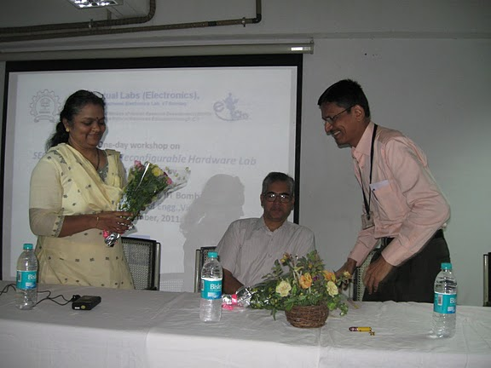

Prof. A. S. Thosar ,I/C principal ,KJSCE welcome all dignitaries with flowers.
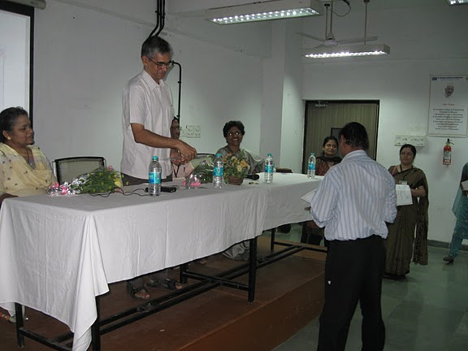

Prof. Dr. M.B. Patil then gave away the certificates to organizing team of 2 Week Workshop on Basic Electronics

Then participants were divided in to 2 groups for CPLD and Sequel sessions. Then for 3 sessions Prof. Dr. M. B. Patil conducted workshop on SEQUEL, a general-purpose simulation package developed at IIT Bombay. 24 participants took part in the SEQUEL workshop. Similarly 17 participants took part in CPLD workshop conducted by Mrs. Madhumita Date and Dev Ghosh and Saurabh Agarwal.
They explained the CPLD board installation, use of Altera Quartus II Development environment and complete process of programming the reconfigurable devices. CPLD boards were used by each participant and had hands on experience on it.

- The general feedback from participants:-

- SEQUEL Workshop

- The open source software was liked by all teachers and 4 students from third year engineering who participated.
- On experimental basis T.E. Engineering students are going to use it for their term work submission of LICD journal report.
- It will prove best teaching aid while teaching various basic subjects in Electronics Engineering
- It was decided that Around 120 students will use the same in this semester.

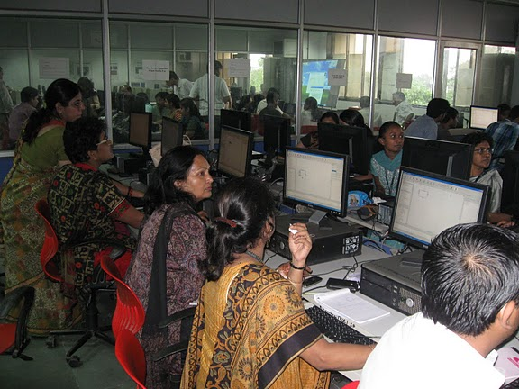
Participants in SEQUEL Workshop.

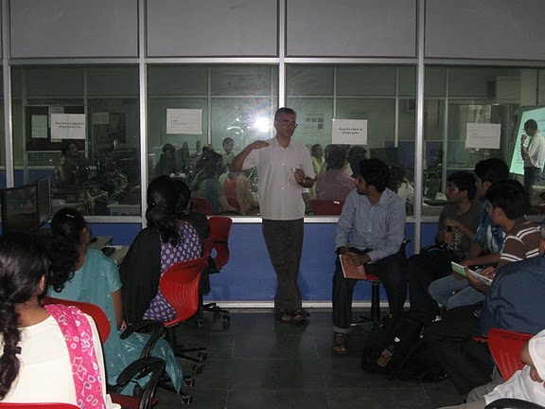

Prof. Dr. M.B.Patil conducting SEQUEL Workshop

- CPLD Workshop
- These CPLD boards are useful for TE students for their digital design project in Electronic Workshop.
- In SE sem IV digital design subject these boards can be used extensively as the students are learning VHDL in the same subject.( 120 students)
- Also ME students are going to use them in course project in subject DSD (18 students).They may require device with more logic cells.

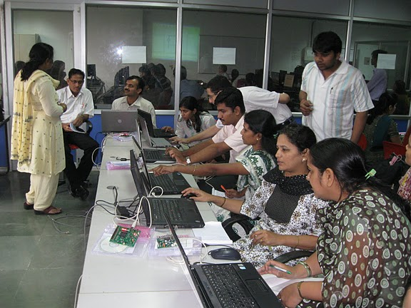

Mrs. Madhumita Date and her team conducting CPLD Workshop.
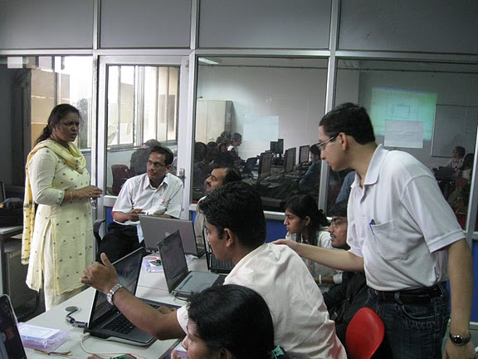

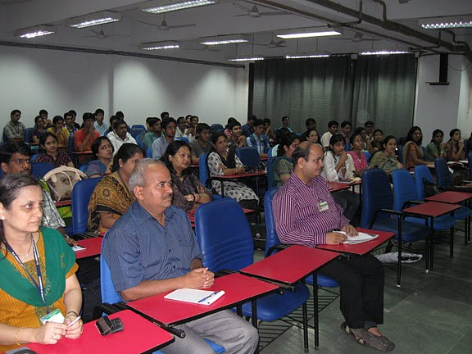

Total Participants in the Workshop were 42 from 14 colleges. Participants from colleges in various cities in Maharashtra like Mumbai, Thane, Pune, Nasik, Shirpur and Sangali were present.

Overall the workshop proved to be very fruitful.

Prof. Milind Marathe and Prof. Arati Phadke
Coordinator,
One-Day Workshop on
Reconfigurable Hardware and SEQUEL.

