Experiment Procedure Documentation

Introduction
This document captures the instructions to integrate this template with your quiz.

Instructions
- Open the quiz-data.json file and change the quiz-title and containers (total number of questions t be displayed in quiz) as per the requirements.
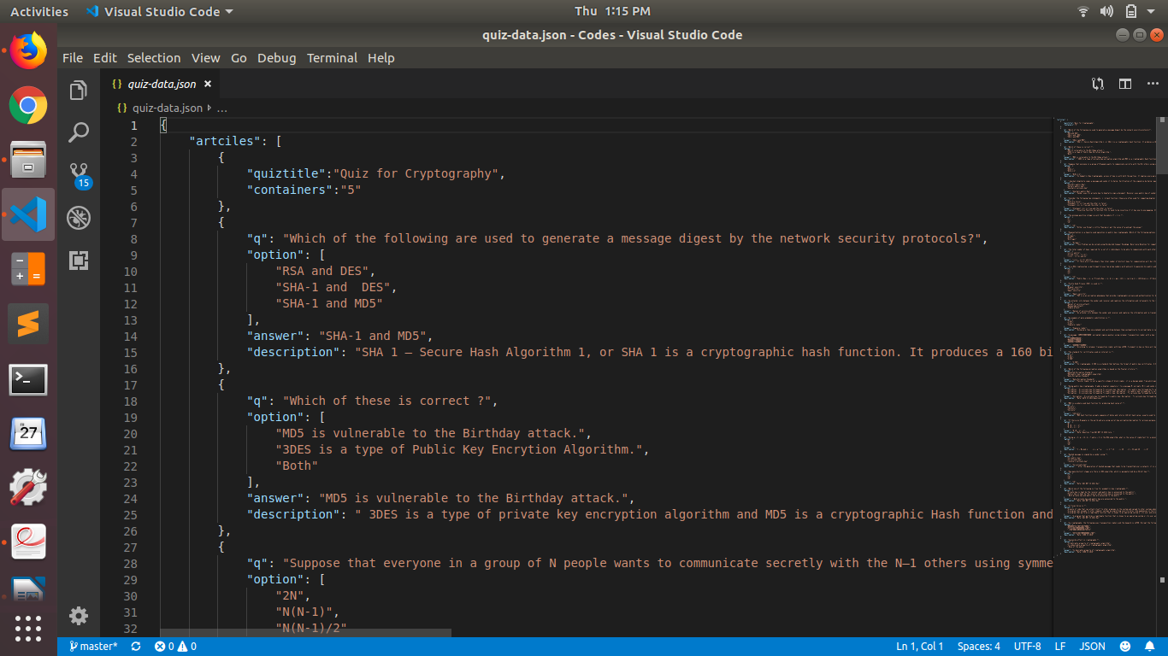
2. After than put the questions ,options ,answer and description in the format same as in above fig. There is no limit on total number of questions you put or on thier respective options. But there should be ony one question and one description.

3. After this, open index.html page
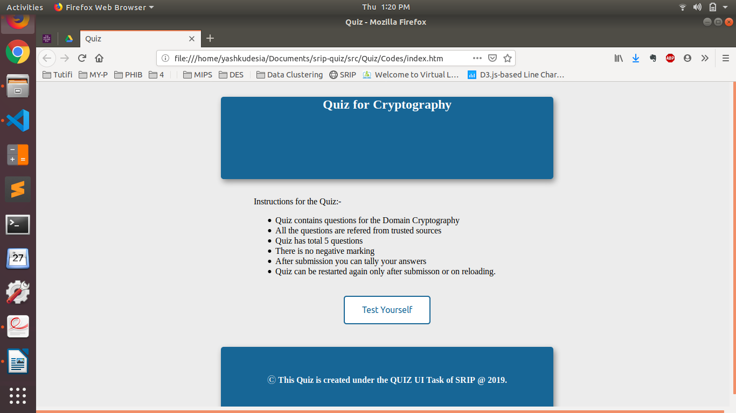
4. After this, attempt all the question and submit the quiz by clicking on Get Score.
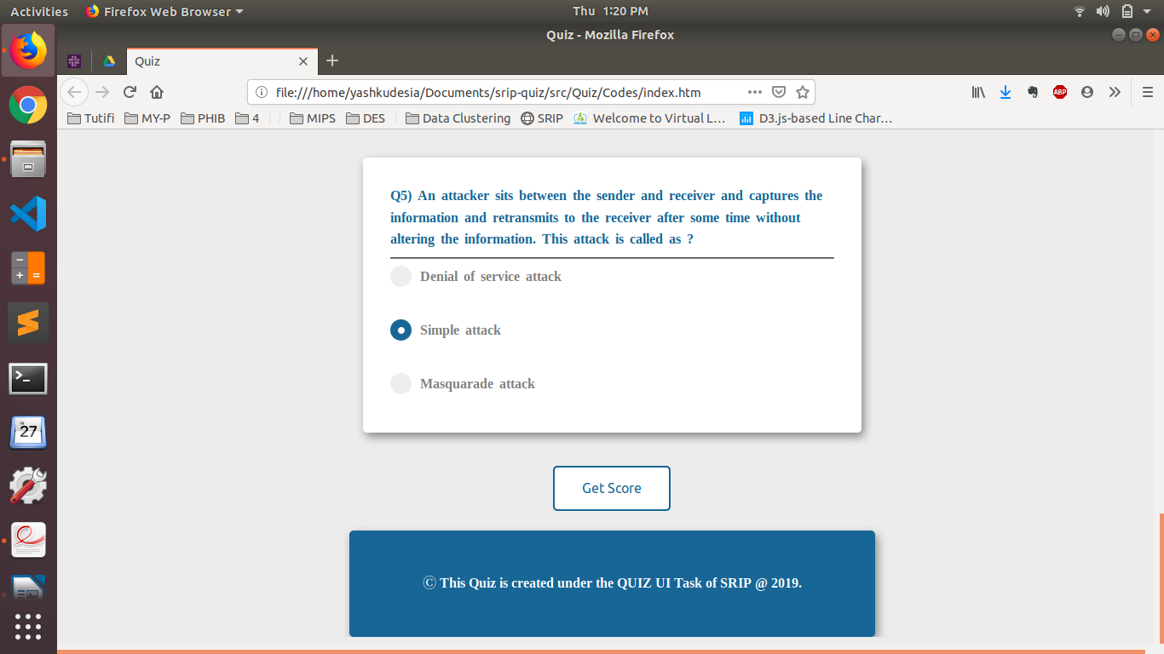
5. After this you can tally your answer & read the description for clarification and your score is in the header.
You can restart the quiz by clicking on Start-Again.

