**QUALITATIVE ANALYSIS OF AMINO ACIDS**

1. Given an unknown solution in a test tube. User needs to identify which amino acid is present in the unknown solution.
2. The materials and the reagents required for doing the tests are shown. [Bunsen burner, water bath, Ninhydrin, Millon’s reagent, sulphanilic acid, Acetic acid – glyoxilic acid reagent, NaOH, NaNO2, Lead acetate solution, Na2CO3 , H2SO4 , Conc. Nitric acid].
3. Click on the ‘Ninhydrin Test’ button to do the Ninhydrin Test. [‘Ninhydrin Test’ shows the presence or absence of amino acid. So it is mandatory before doing any other test.]
4. If amino acid is present enable the combo box (disabled at first) to select the next test to be done.

[Xanthoproteic acid test, Pauly’s Diazo test, Millon’s test, Hopkins cole test and Lead sulphide test.]

1. Allow the user to proceed only if the correct reagent is selected. Else show an alert message “Wrong indicator. Try again.”
2. Click on the reagent to get it in the dropper and click over the test tube to add it into the amino acid solution.
3. Display the test result on completion of each test. Refer Table:1

**Ninhydrin Test:**

1. Add few drops of ninhydrin reagent to the unknown solution.
2. Place the test tube in water bath (automatically shows the clock for 5 minutes and show the animation to play the waterbath).
3. Blue or yellow colored solution [Yellow color indicates the presence of proline and blue color for other amino acids].

**Xanthoproteic acid test:**

1. Add nitric acid solution to the unknown solution (yellow color upon adding the nitric acid solution).
2. Heat the solution over Bunsen burner and cool the solution under tap water. [Show animation]
3. Add NaOH solution to it.
4. No change in color indicates the presence of Cysteine and orange color for other amino acids.

**Pauly’s diazo test:**

1. Show sulphanilic acid, amino acid solution and sodium nitrite solution in an ice box.
2. Add chilled sodium nitrite solution to sulphanilic acid.
3. Add amino acid solution to it.
4. Add sodium carbonate drop wise to it.
5. Red color indicates the presence of Tyrosine and no change in color for other amino acids.

**Millon’s test:**

1. Add Millon’s reagent to the amino acid solution.
2. Heat the test tube over flame and cool under the tap water.[Show animation]
3. Add nitric acid solution to it.
4. Red precipitate indicates the presence of Tyrosine and no change in color for other amino acids.

**Hopkins cole test:**

1. Add acetic acid - glyoxilic acid reagent to the amino acid solution.
2. Add H2SO4 (show adding at the side of the test tube).
3. Purple violet ring formed indicates the presence of Tryptophan and no change in color for other amino acids.

**Lead sulphide test:**

1. Add NaOH solution to the amino acid solution.
2. Heat the solution over Bunsen burner and cool the test tube under tap water.[Show animation]
3. Add lead acetate solution.
4. Black precipitate indicates the presence of Cysteine and no change in color indicates the presence of other amino acids.

|  |  |  |  |
| --- | --- | --- | --- |
| **Tests** | **Tyrosine** | **Tryptophan** | **Cysteine** |
| Ninhydrin test | Blue purple color | Blue purple color | Blue purple color |
| Xanthoproteic acid test | Orange color | Orange color | No color |
| Pauly’s Diazo test | Red color | No color | No color |
| Millon’s test | Red precipitate | No color | No color |
| Hopkins cole test | No color | Purple violet ring is formed | No color |
| Lead sulphide test | No color | No color | Black precipitate |

Table:1

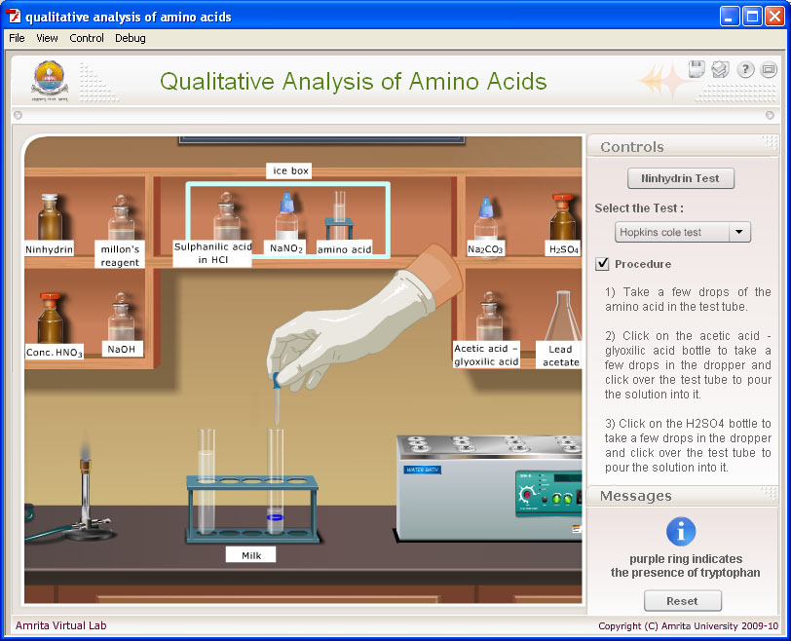

**Modification:**

1. No need of procedure which is shown in the left side.
2. The 6 experiment in this simulation is done in the following order.

* **First** do NINHYDRIN TEST.
* The result is purple color for all 3 amino acid.
* Show the result “PRESENCE OF ALPHA AMINO ACID “ in the left side.
* In the below of this result, show other 5 experiment
* The candidate will select next experiment. If they select Xanthoproteic acid test, Go on with the same and then they can able to do the xanthoproteic acid test. If they click other test,

inactivate it.

* **2** - XANTHOPROTEIC ACID TEST.
* Orange color for Tyrosine and Tryptophan. No color for Cysteine.
* The result is orange color, show “Presence of aromatic amino acid” in the left side. In the case of No orange color, Show absence of Aromatic amino acid”.
* Show other four experiments below, the candidate will pick the next expt from the four tests.

A) For Tyrosine and Tryptophan – Go to Pauly’s Diazo test.If candidate select the experiment other than Pauly’s Diazo test, Show “wrong answer”.

1. For Cysteine – Go to Lead sulphide test. If candidate select the experiment other than Lead sulphide test, Show “wrong answer”.

* **3 (A)** - FOR TYROSINE AND TRYPTOPHAN – PAULY’S DIAZO TEST
* Red color – Show “Presence of Tyrosine or Histidine” ( Show this result for Tyrosine”)
* No red color – “May be tryptophan” ( Show this result for Tryptophan”)
* Show other Three experiments below, the candidate will pick the next expt from the three tests.
* For Tryptophan, Go Hopkins cole test. If candidate select the experiment other than Hopkins cole test, Show “wrong answer”.
* For Tyrosine, Go Millon’s test. If candidate select the experiment other than Millon’s test, Show “wrong answer”.
* **3(B) –** In the case of CYSTEINE – Next is LEAD SULPHIDE TEST
* Black precipitate- Show “presence of Cysteine” and also show the “test completed”
* **4** – For TRYPTOPHAN do “HOPKINS COLE TEST”
* Purple violet ring is formed. Show “ Presence of Tryptophan” and “ Test completed”
* **4** – For TYROSINE do MILLON’S TEST
* Red precipitate is formed. Show “ Presence of Tyrosine” and “ Test completed”