UV-absorbance
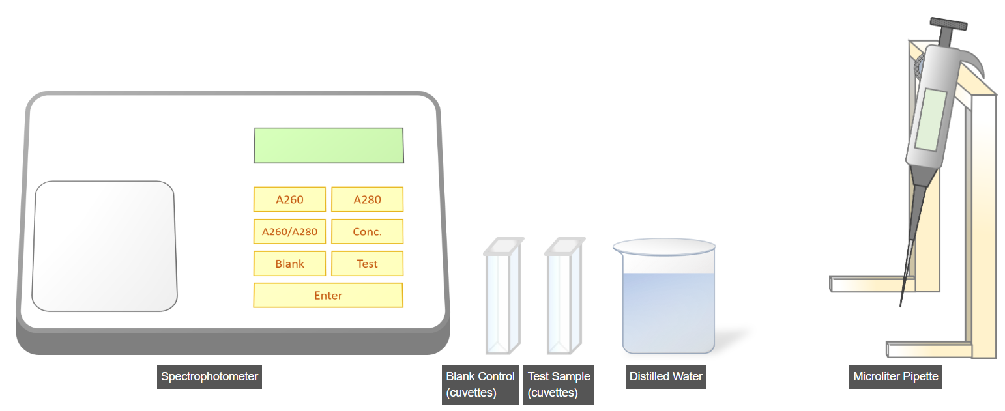
The first step is to prepare a blank sample or control. To do this, click on Microliter Pipette.
Now, click on the pipette's scroll control button to set its reading to 25µl. The maximum capacity of this pipette is 100µl.
Now, click on the beaker containing distilled water to pipette 25µl.
Now, click on the Test Sample cuvettes to transfer 25µl of distilled water into it.
Again click on the beaker containing distilled water to pipette 25µl.
Now, click on the Blank Sample cuvettes to transfer 25µl of distilled water into it.
Now, click on the next step to measure the Blank Sample reading.

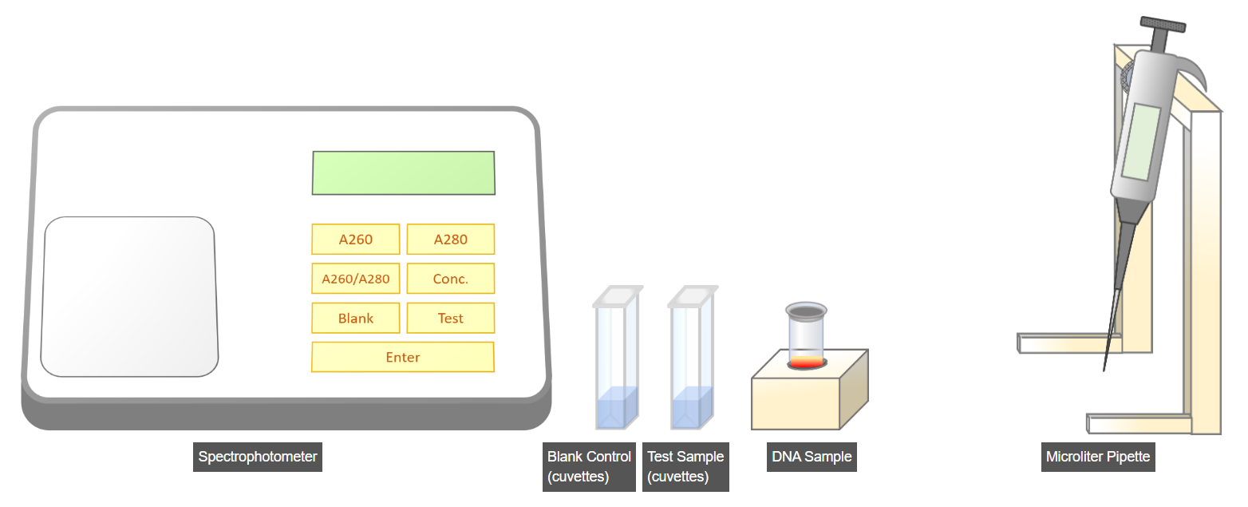

In this step, we zero the blank sample to correct the baseline absorbance from the solvent, ensuring accurate sample absorbance quantification. For this click on the lid of the spectrophotometer to open it.
Now, click on the Blank cuvette to insert it into the spectrophotometer.
Click on spectrophotometer lid to close it.Ensure that the cuvette is inserted properly so that light can pass through it.
Now, click on the blank button to set the machine to blank sample mode. Press Enter to confirm.
Press A260 to take absorbance readings of the blank sample at 260nm.
Press A280 to take absorbance readings of the blank sample at 280nm.
Click on the next step to take a test sample reading.
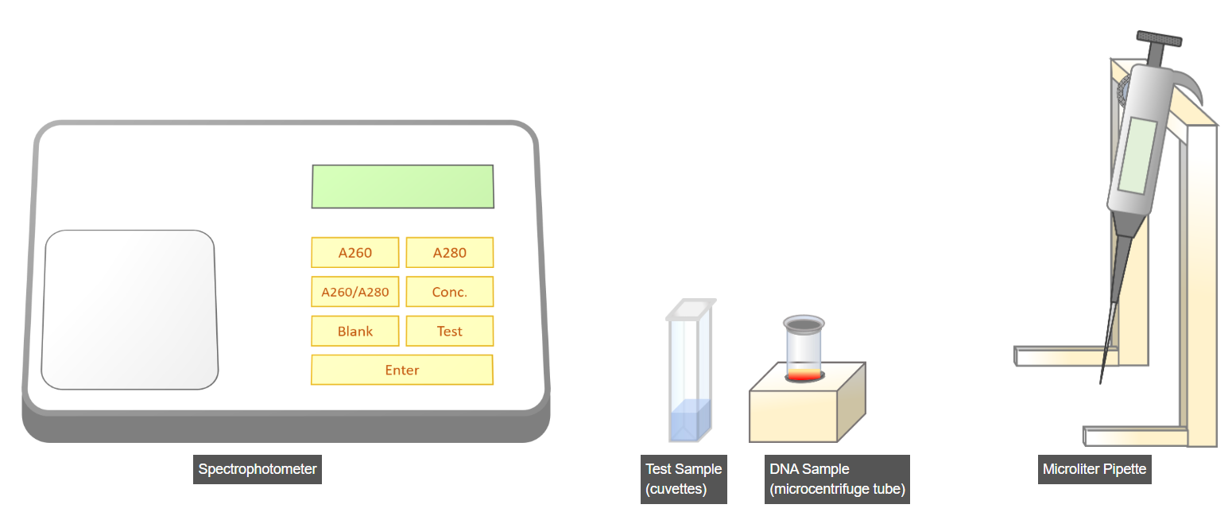
In the final step, we will take DNA sample readings to perform quantitation analysis. For this click on Microliter Pipette.
Now, click on the pipette's scroll control button to set its reading to 25µl.
Now, click on the microcentrifuge tube containing DNA sample to pipette 25µl.
Now, click on the Test Sample cuvettes to transfer 25µl of DNA sample into it.
Now, For this click on the lid of the spectrophotometer to open it.
Now, click on the DNA sample cuvette to insert it into the spectrophotometer.
Again click on spectrophotometer lid to close it.Ensure that the cuvette is inserted properly so that light can pass through it.
Now, click on the Test button to set the machine to test sample mode.Press Enter to confirm.
Press A260 to take absorbance readings of the DNA sample at 260nm.
Press A280 to take absorbance readings of the DNA sample at 280nm.
Press A260/A280 button to calculate the ratio of them.
Press Conc button to calculate concentration of DNA sample.
===============================================================
Agarose-gel-electrophoresis
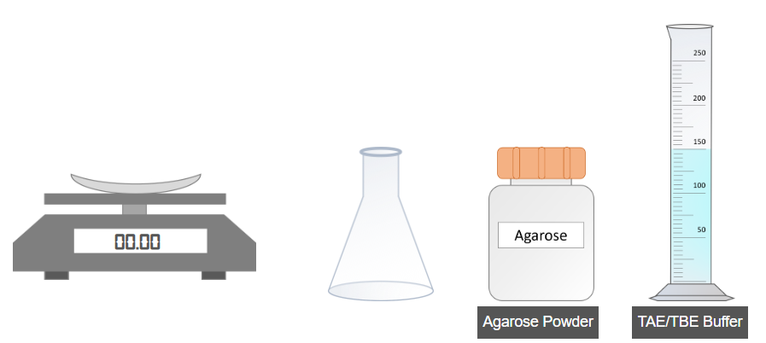
The first part of the experiment is the preparation of agarose gel. For this, click on Agarose Powder to weight 1.5g of it.
Click on 1.5g agarose powder placed on the weight machine to pour it into a blank flask.
Now click on 150ml TAE/TBE buffer solution to pour it into the flask.
Now click on the flask to mix the powder and buffer well.

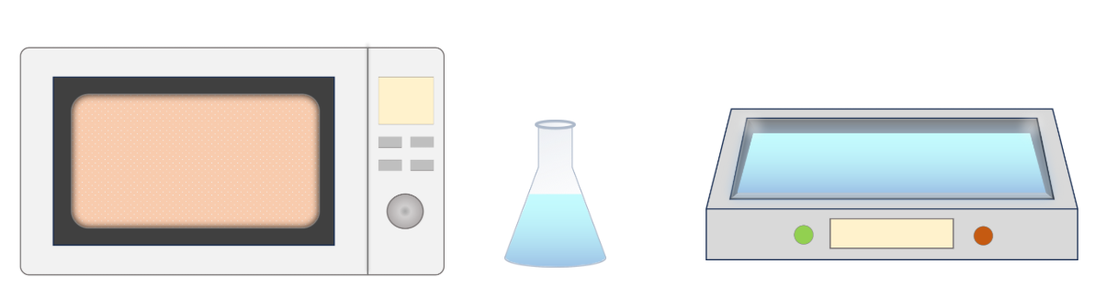
During the preparation of Agarose gel, the next step involves placing the flask containing the mixture into the oven. For this click on flask.
Now, click on the start button of the oven to heat the mixture for maximum up to 3 minutes.
Now, click on the flask placed inside the oven to transfer it into the water cooling system. Before doing so, ensure that the mixture has boiled properly and become transparent.
Now, click on the green start button of the cooling system to cool down the mixture upto 50ºC for 10 minutes.
Now, click on next for further steps.
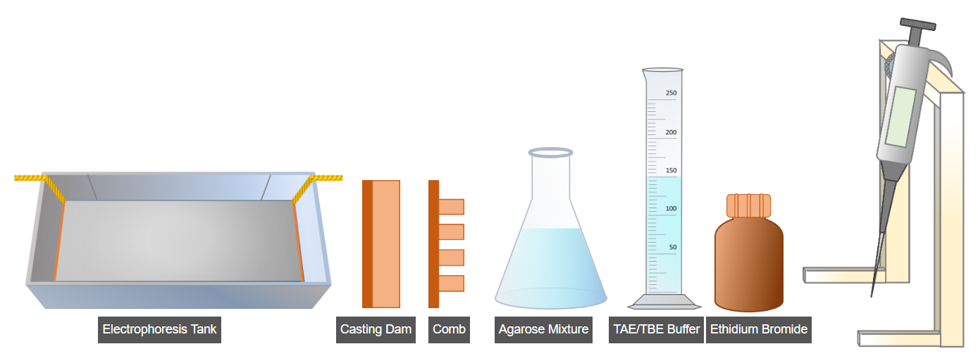
The second part of this experiment is agarose gel formation. For this, click on the casting dam to place it inside the electrophoresis tank.
Now, click on the comb to place it into the electrophoresis tank.
Click on the Microliter Pipette.
Now, click on the scroll wheel of the microliter pipette to set it at 5 microliters.
Now, click on the ethidium bromide to take a 5-microliter sample of it and pour this into the agarose mixture. Caution: Ethidium bromide is a mutagenic compound, handle with appropriate safety measures in a well-ventilated area.
Now click on the agarose mixture flask to mix it well, and pour it into the electrophoresis tank. and let the agarose gel solidify for about 20-30 minutes at room temperature.
Now click on electrophoresis tank to remove the Casting Dam and Comb.
Now, click on the TAE/TBE buffer to pour it into the electrophoresis tank, filling the tank just above the gel.
Now, click 'Next' to proceed to the next part of the experiment.
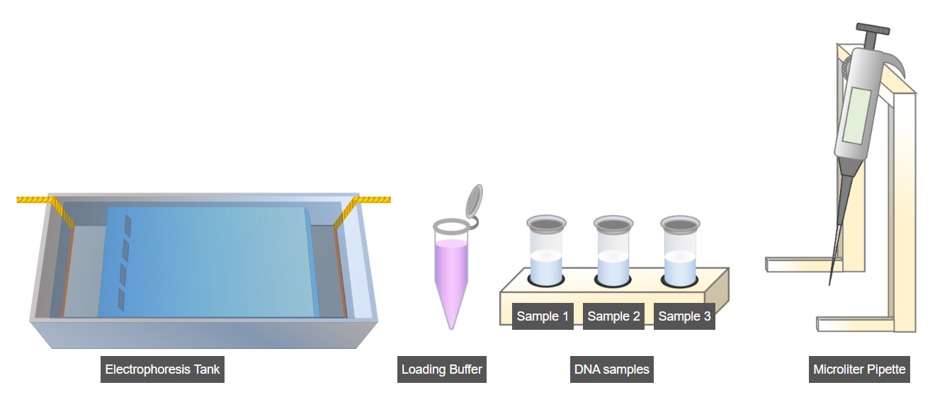
The second part of the experiment involves the preparation of the DNA sample, where loading buffer is added to the DNA sample. For this click on Microliter Pipette.
Now, click on the pipette's scroll control button to set its reading to 100µl.
Now, click on the loading buffer tube to add it to the DNA samples.
lick next to proceed further.
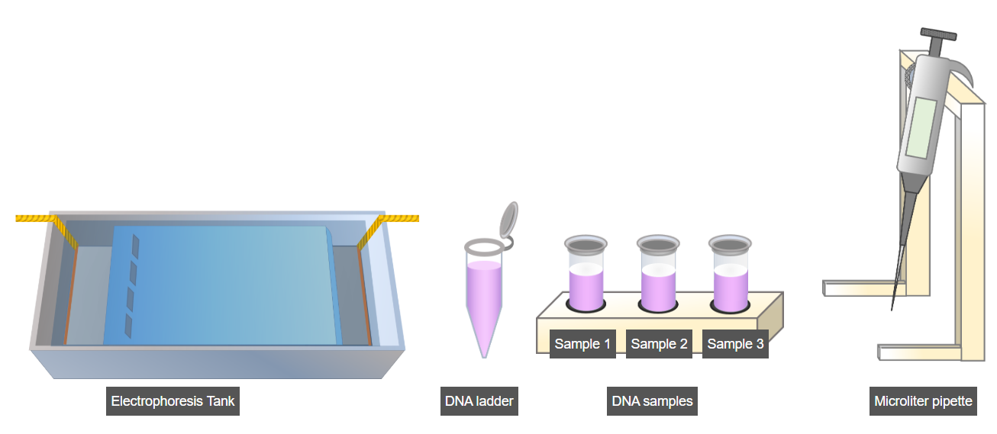
In this part of the experiment, DNA samples are placed inside the agarose gel well.For this click on Microliter Pipette.
Now, click on the pipette's scroll control button to set its reading to 100µl.
Now, click on the DNA ladder and load it into first well of Agarose gel.
Now, click on the DNA sample to load them into other wells of Agarose gel.
Now, click next to proceed further.
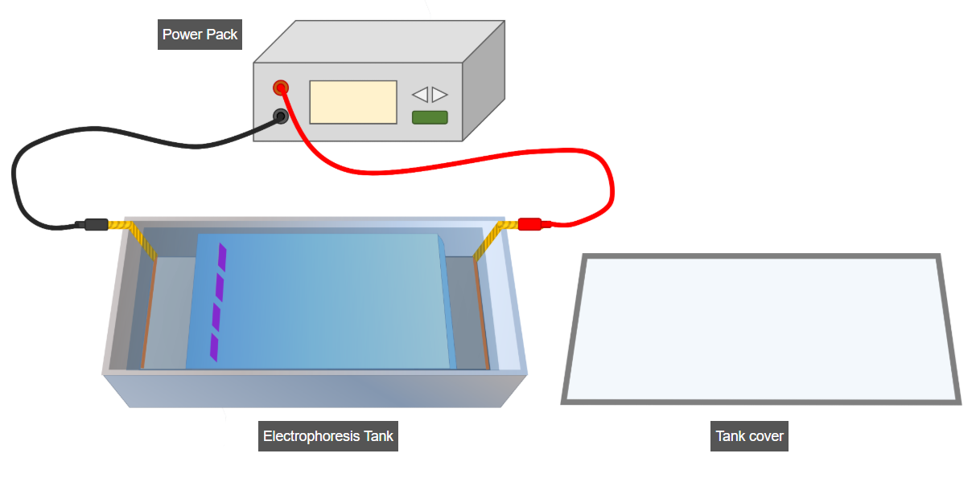
This part of the experiment is called electrophoresis, where a 100V power supply is applied to the agarose gel. For this first click on electrophoresis tank shield to cover it.
Now, click on the green button of Power Pack to supply 100V until the DNA reaches the desired distance, and stop the supply immediately to ensure that the DNA samples do not go out of the gel.
Click on next step for Visualization of result.
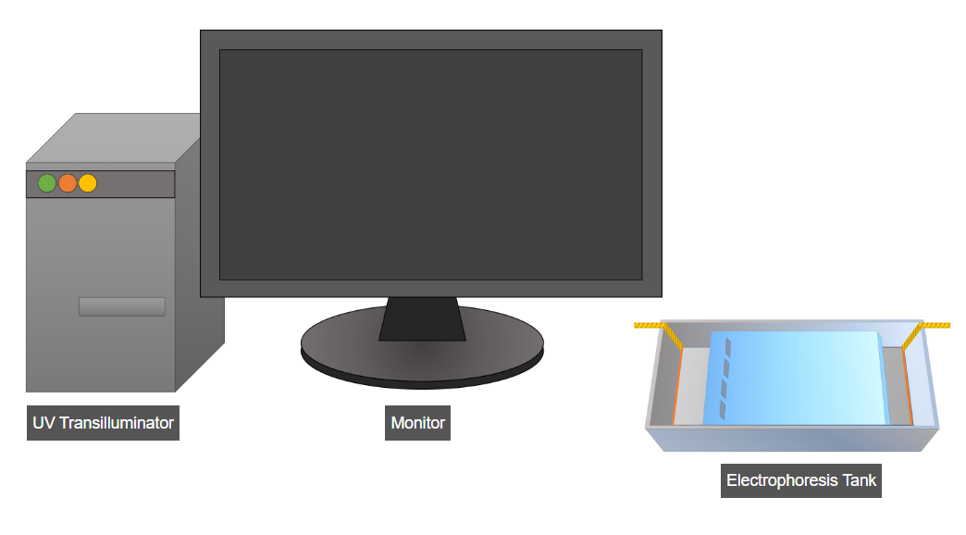
The final part of this experiment involves the visualization of results. For this, click on the UV transilluminator to place the gel inside it and visualize the results of the DNA samples.
Click on the monitor to analyze it in detail.

