bradford-test/
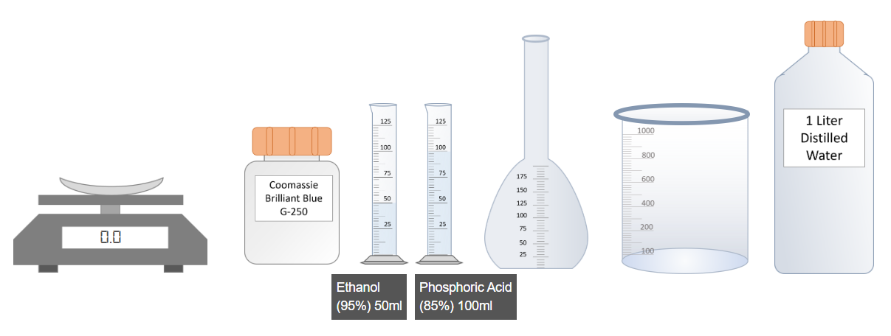
First step is the preparation of Bradford reagent. Click on Coomassie Brilliant Blue G-250 dye to weight 100mg of it.
Click on the measured dye to pour into the flask.
Click on 50ml-Ethanol to pour into the flask.
Click on Phosphoric Acid to pour into the flask
Click on flask to shake it well.
Click on flask to pour into the beaker.
Click on distilled water bottle to pour into the beaker to make 1L reagent.
1L Bradford reagent is prepared for further use. Now click on next step to continue.
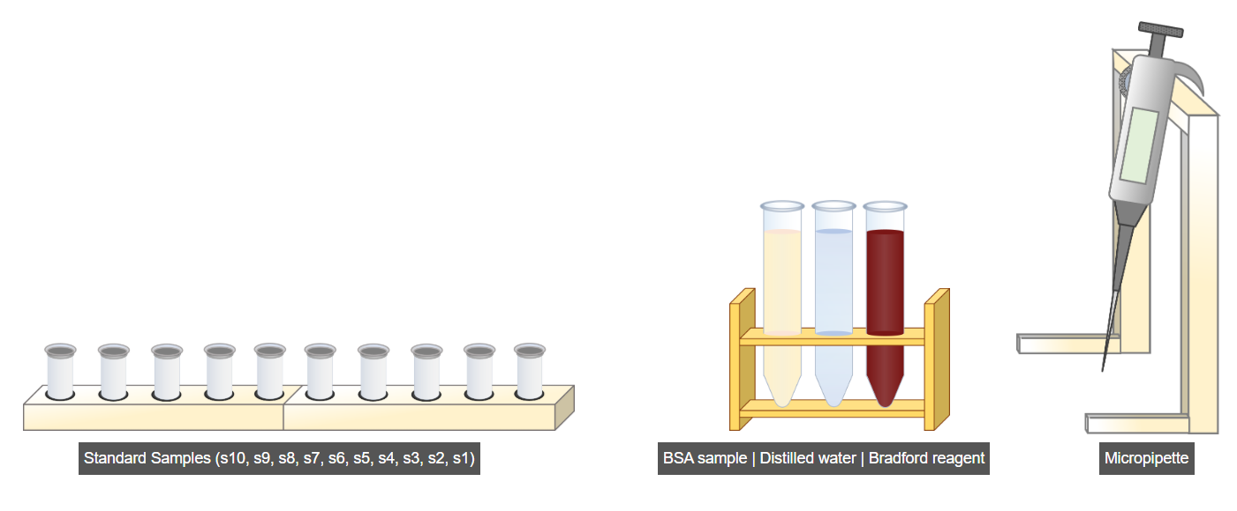
Next step is to prepare the standard samples as given in the table (Open Table). For this click on the standard samples.
Now click on micropipette
Now, click on the micropipette wheel to set its first reading at 50 µl to measure the BSA sample (as per the table).
Now, click on the BSA sample tube.
Now, again click on the micropipette wheel to set its reading at 450 µl to measure distilled water (as per the table).
Now, click on the distilled water tube.
Now, again click on the micropipette wheel to set its reading at 2500µl (2.5ml) to measure Bradford reagent (as per the table).
Now, click on the Bradford reagent tube.
Now, click on the 'Run' button to prepare the rest of the standard samples as per the table.
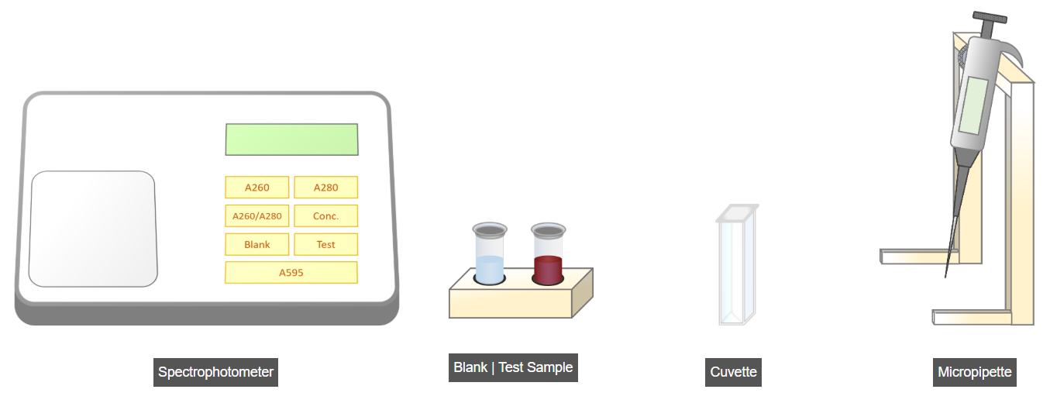
Next step is to measure the absorbance of Blank and Test sample at 595nm using spectrophotometer. For this click on blank sample.
Now click on micropipette to place sample into cuvette.
Now click on Spectrophotometer lid to open it.
Now click on cuvette to read it.
Now click on Blank button on spectrophotometer to set it on blank sample mode.
Now click on A595 button to read absorbance value at 595nm.
Now click Test sample to read it
Now click on micropipette to place sample into cuvette.
Now click on Spectrophotometer lid to open it.
Now click on cuvette to read it.
Now click on Test button on spectrophotometer to set it on Test sample mode.
Now click on A595 button to read absorbance value at 595nm.
Now click on next step to proceed further.
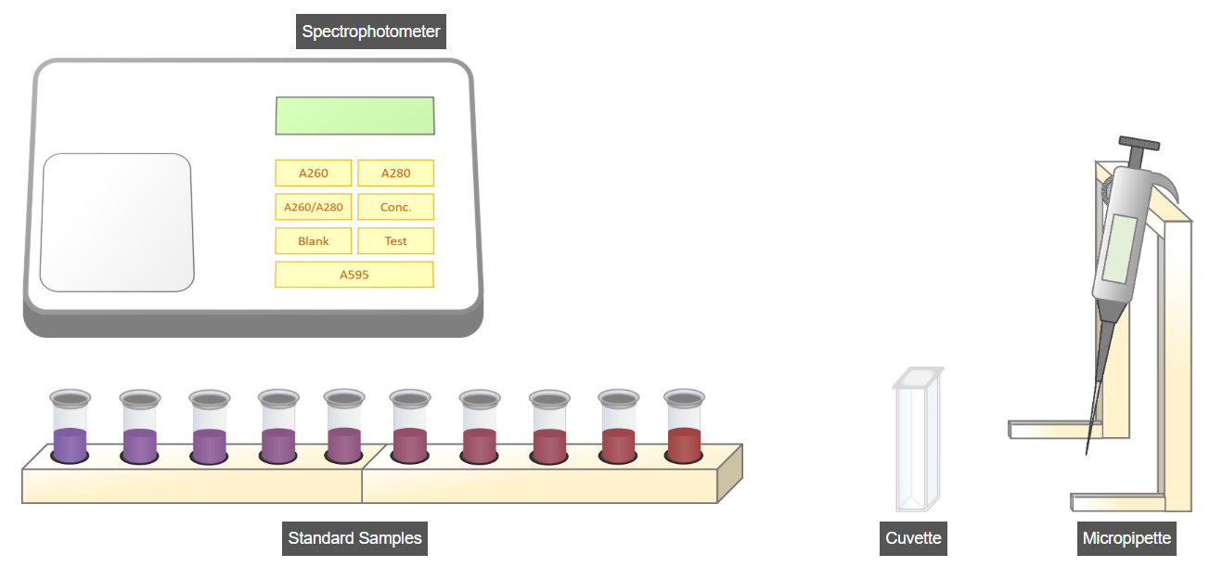
In this step, the same procedure is repeated to measure the absorbance values of the prepared samples at 595 nm. To do this, simply click the Run button.
===================================================================
lowry-test
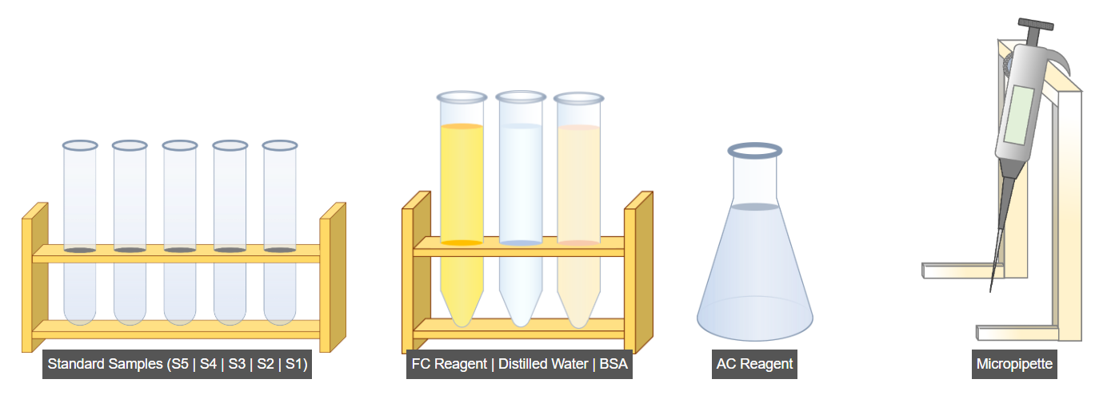
The first step is to prepare the standard samples according to the provided table (See Table). To begin, click on the micropipette.
Next, click on the micropipette wheel to set the initial reading (0.2 ml) according to the table for measuring the BSA solution
Next, click on the BSA solution to measure 0.2 ml of it for the first sample preparation.
Next, Click on the 'Run' button to add the BSA solution to prepare the remaining samples according to the table.
Now, we will use distilled water to prepare our samples. Set the micropipette's initial reading to 0.8 ml as per the table by clicking on the micropipette wheel.
Next, click on the distilled water tube to add 0.8 ml of it for the first sample preparation.
Click on the 'Run' button to add the distilled water to prepare the remaining samples according to the table.
Now, we will use the AC Reagent to prepare our samples. For this, set the micropipette's reading to 4 ml as per the table by clicking on the micropipette wheel.
Next, click on the AC Reagent flask to add 4 ml of it for the first sample preparation.
Click on the 'Run' button to add the AC Reagent to prepare the remaining samples according to the table.
Now, Incubate the samples at room temperature for 10 minutes.
Now, we will use the FC Reagent to prepare our samples. For this, set the micropipette.
click on the micropipette wheel to set it's reading to 0.4 ml as per the table.
Next, click on the FC Reagent tube to add 0.4 ml of it for the first sample preparation.
Click on the 'Run' button to add the FC Reagent to prepare the remaining samples according to the table.
Now, Incubate the samples at room temperature for 15 minutes.
To proceed with the further steps, click on the 'NextStep' button
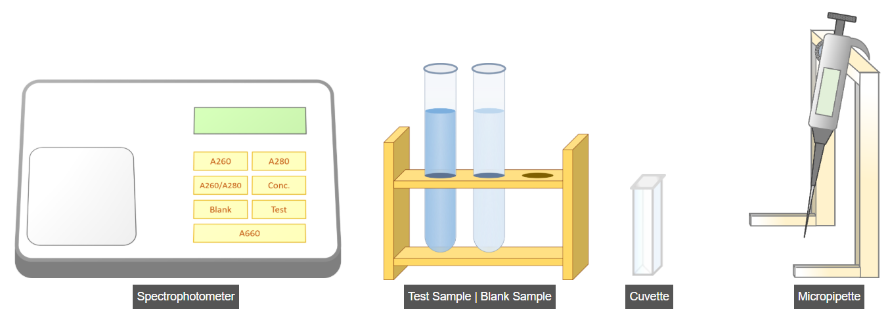
Next step is to measure the absorbance of Blank and Test sample at 660nm using spectrophotometer. For this click on Micropipette.
Now click on micropipette wheel to set its reading to 1ml.
Now click on Blank Sample tube to place 1ml of blank sample into cuvette.
Now click on Spectrophotometer lid to open it.
Now, click on the cuvette to place it into the spectrophotometer.
Now, click on the 'Blank' button on the spectrophotometer to set it on the blank sample mode.
Now, click on the 'A660' button on the spectrophotometer to take the reading at 660 nm.
Next, we need to calculate the test sample reading. To begin, click on the micropipette.
Set the micropipette's reading to 1 ml by clicking on its wheel.
Now click on Test Sample tube to place 1ml of testing sample into cuvette.
Now click on Spectrophotometer lid to open it.
Now, click on the cuvette to place it into the spectrophotometer.
Now, click on the 'Test' button on the spectrophotometer to set it on the test sample mode.
Now, click on the 'A660' button on the spectrophotometer to take the reading at 660 nm.

Now, Click on the 'NextStep' button to proceed with the next steps.
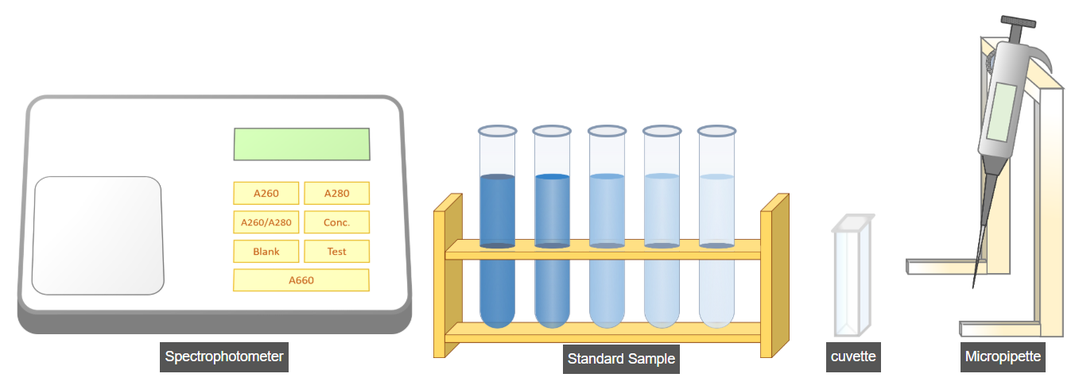
In this step, we will take the readings of the previously prepared standard samples in the same way as the test or blank sample. To do this, click on the Micropipette.
Next, click on micropipette's wheel to set reading value to 1ml.
Now, click on the 'Run' button to take the readings of all prepared standard samples.
Now, click on the 'NextStep' button to calculate the concentration of the test sample
==================================================================
bca-test/
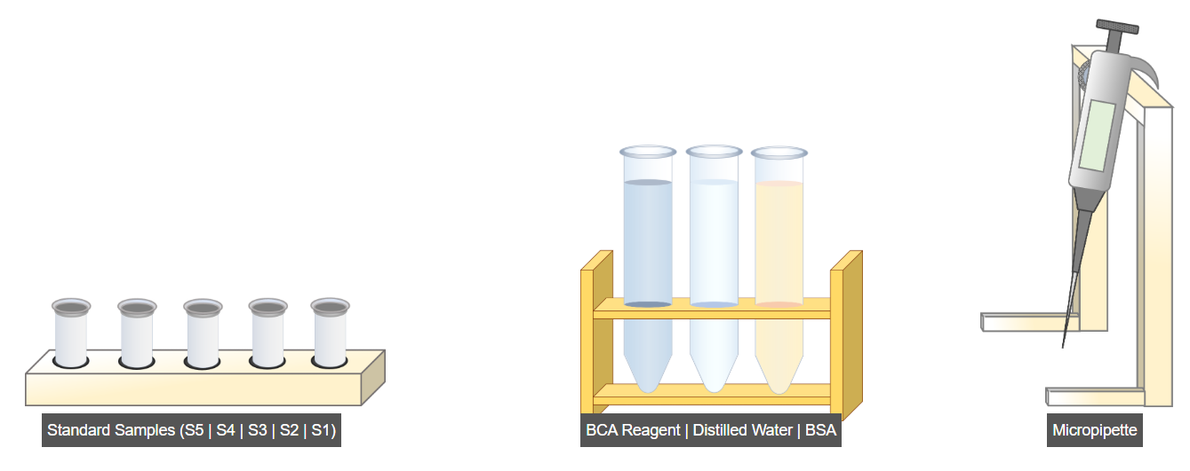
First step is to prepare the standard samples as given in the table (See Table). For this click on the standard samples.
Now click on micropipette.
Now, click on the micropipette wheel to set its first reading at 0.2ml to measure the BSA sample (as per the table).
Now, click on the BSA sample tube.
Now, again click on the micropipette wheel to set its reading at 0.8ml to measure distilled water (as per the table).
Now, click on the distilled water tube.
Now, again click on the micropipette wheel to set its reading at 2ml to measure BCA reagent (as per the table).
Now, click on the BCA reagent tube.
Now click on 'Run' button to prepare remaining standard samples as per the given table.
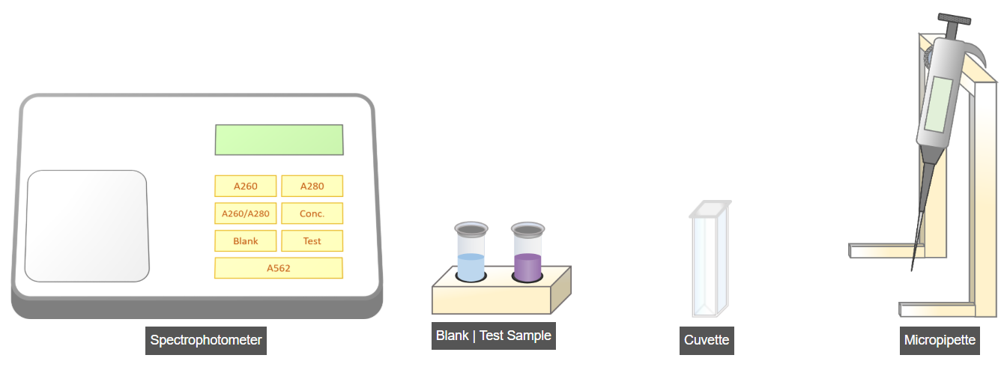
Next step is to measure the absorbance of Blank and Test sample at 562nm using spectrophotometer. For this click on blank sample.
Now click on micropipette to place sample into cuvette.
Now click on Spectrophotometer lid to open it.
Now click on cuvette to read it.
Now click on Blank button on spectrophotometer to set it on blank sample mode.
Now click on A562 button to read absorbance value at 562nm.
Now click Test sample to read it
Now click on micropipette to place sample into cuvette.
Now click on Spectrophotometer lid to open it.
Now click on cuvette to read it.
Now click on Test button on spectrophotometer to set it on Test sample mode.
Now click on A562 button to read absorbance value at 562nm.
Now click on next step to proceed further.
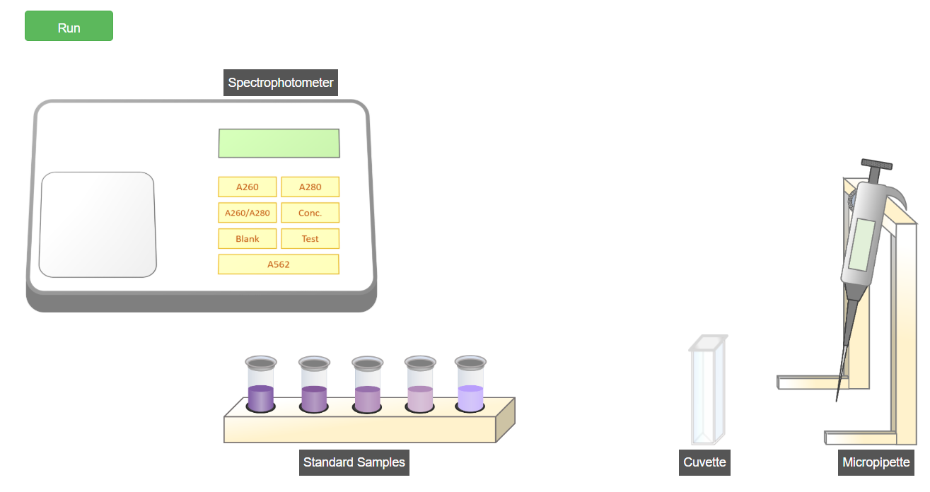
In this step, the same procedure is repeated to measure the absorbance values of the prepared samples at 562 nm. To do this, simply click the Run button.
Click on NextStep to calculate concentration of unknown sample.

