Qualitative analysis of sugars (Molisch test)
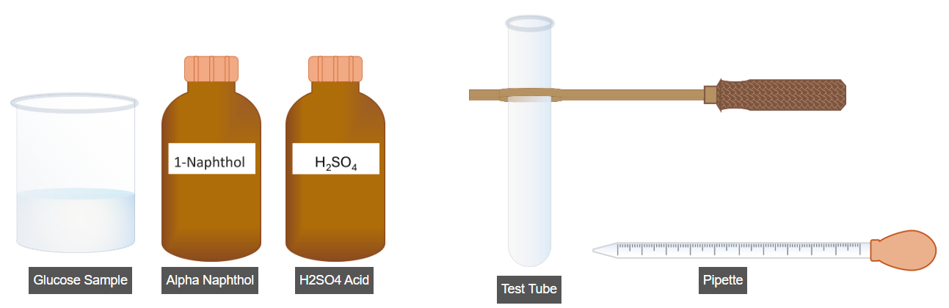
To perform this experiment, pour 5 mL of the glucose sample into the test tube. To do this, click on the pipette tube.
Next, add 2-3 drops of Alpha-Naphthol to the sample. To do this, click on the Alpha-Naphthol bottle.
Now, click on the test tube to mix the solution thoroughly.
Now, click on the sulfuric acid bottle to carefully add 2 mL of it to the solution in the test tube.
Now, check if a purple-colored ring has formed at the junction of the two layers. The appearance of this ring indicates the presence of carbohydrates in the solution.
================================================
Quantitative estimation of reducing sugars (DNS method)
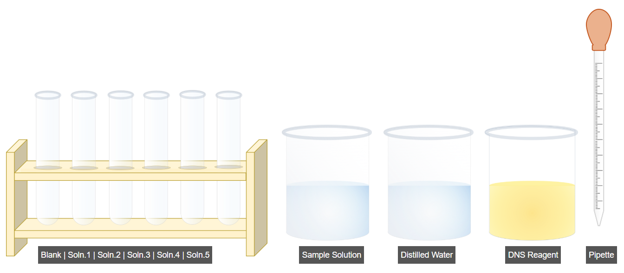
The first step of this experiment is the preparation of the sample solutions (as shown in table). To begin, click on the sample solution beaker to add the solution into the Soln.1 test tube.
Now, click on the Run button to add the solution to the remaining test tubes as specified in the table.
Now, add distilled water to the blank test tube as specified in the table. To do this, click on the distilled water beaker.
Now, click on the Run button to add the distilled water to the remaining test tubes as specified in the table.
The next step is to add DNS reagent to the test tubes to prepare the samples solutions as specified in the table. To do this click on run button.
To proceed further, click on the Next Step button.
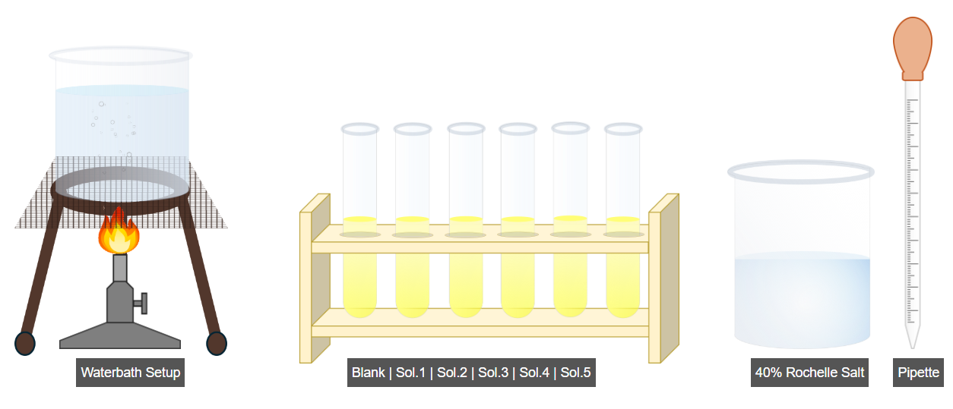
In this step, the samples are boiled for 5-10 minutes to develop color, then cooled to room temperature. For this, click on the test tubes to place them in the boiling water bath.
After, click on the 40% Rochelle Salt solution to add 1ml of it to the test tube sample.
Now, click on the Run button to add 40% Rochelle Salt solution to the remaining test tubes as specified in the table.
To proceed further, click on the next step.
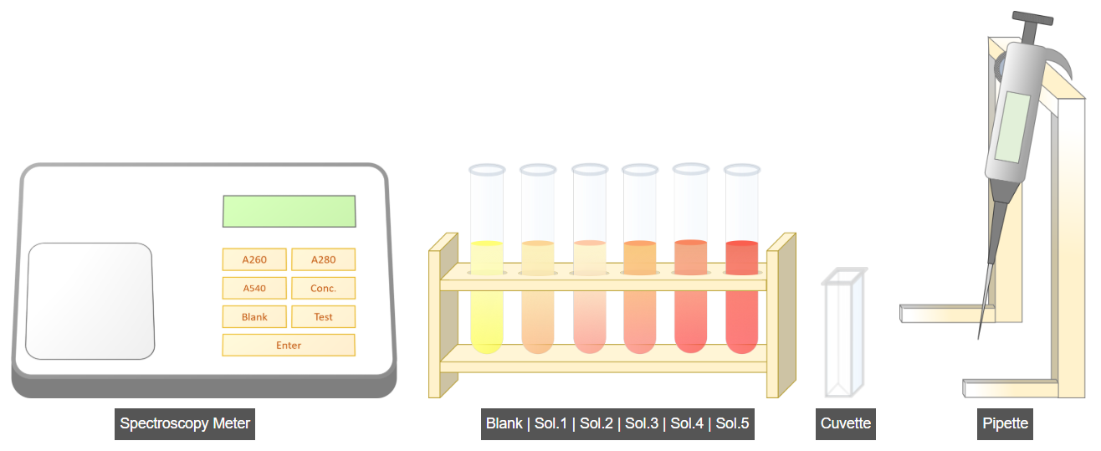
In this step of the experiment, we measure the absorbance of the sample solutions at 540 nm. To do this, click on the micropipette.
Now, click on the micropipette wheel to set the volume to 1 mL.
Now, click on the blank tube to add 1 mL of the solution into the cuvette.
Now, to take the absorbance reading, click on the spectrometer lid to open it and place the test sample inside.
Now, click on the A540 button on the spectrometer to set the absorbance reading to 540 nm.
Now, click on the Blank button on the spectrometer to set it to blank mode.
Now, click on Enter to measure the absorbance reading of the blank sample.
Now, click on the Run button to measure the absorbance readings of the remaining samples in the same way.
To proceed further, click on the next step.
=======================================================
Benedict test for reducing sugars

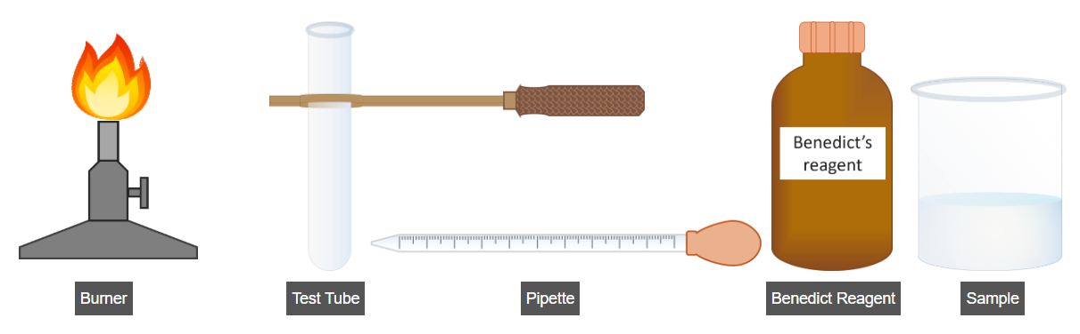
To perform this experiment, add 5mL of Benedict reagent to the test tube. For this, click on the Benedict reagent bottle.
Now, add 5mL of the sample solution to the test tube. To do this, click on the sample beaker.
Now, click on the test tube to mix the solution thoroughly, then place it on the burner to heat the sample over a flame for up to 5 minutes.
Now, click on the Result Analysis button to view the interpretation of results.
=========================================================
Benedict test for non-reducing sugars
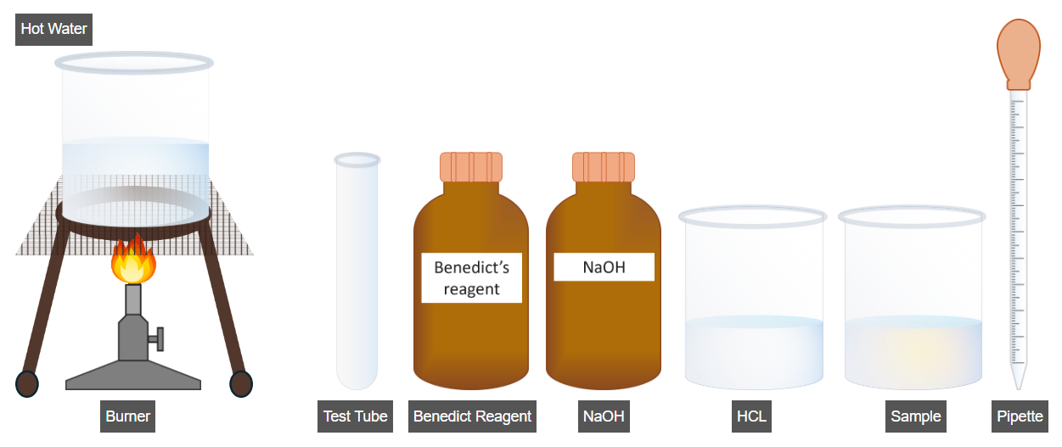
If Benedict test shows no color change, we proceed with the Non-Reducing Sugar test. To begin, click on the sample beaker to add 2mL of the sample solution to the test tube.
Now, add 2mL of HCl solution into test tube. For this, click on the HCl beaker.
Now, click on the test tube to mix the solutions thoroughly and place it in a water bath for 5-10 minutes.
Now, click on the NaOH bottle to add a few drops into the test tube.
Now, click on the Benedict Reagent bottle to add 2ml of it into the test tube.
Now, click on the test tube to mix the solutions thoroughly and place it in a water bath for 3-5 minutes.
Now, click on the Result Analysis button to view the interpretation of results.

