km-vmax-dei-main
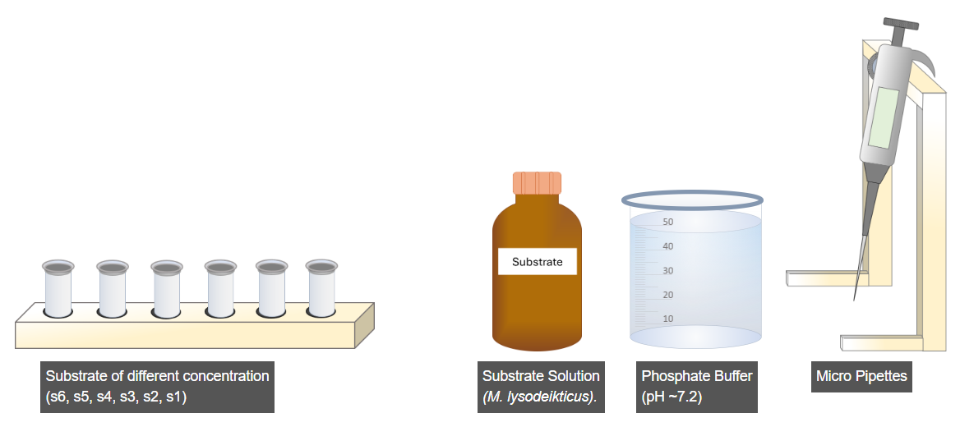
The first step is the preparation of substrate solutions of different concentrations ( See Table ). For this, click on the rack of microcentrifuge tubes.
Now, click on micropipette.
Set the micropipette to 5 µL by clicking on the wheel to measure the substrate.
Now, click on the substrate solution bottle to dispense 5 µL of substrate into the microcentrifuge tubes.
Now set the micropipette to 995 µL by clicking on wheel to measure the buffer solution.
Now, click on the buffer solution beaker to dispense 995 µL of buffer into the microcentrifuge tubes, creating a 1 mL substrate solution with a 0.5 mM concentration (as shown in table).
Now, click on the Run button to generate the remaining substrate samples with different concentrations as per the table.
To proceed further, click on the next step.

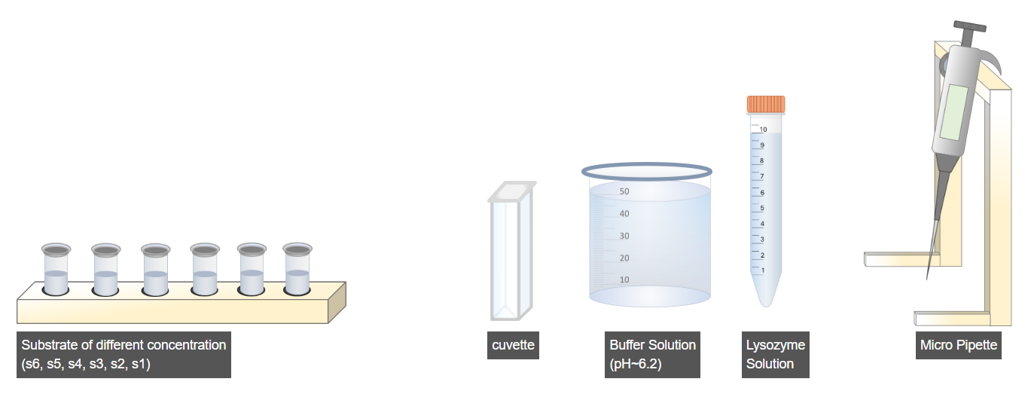
In this part of the experiment, the reaction between the substrate and lysozyme enzyme is performed ( See Table ). For this, click on the Substrate rack.
Now, click on micropipette.
Now, set the reading to 5 µL to measure the substrate by clicking on the micropipette wheel.
Now, click on the microcentrifuge to pour 5 µL of substrate into the cuvette.
Now, set the micropipette reading to 895 µL to measure the buffer solution by clicking on the micropipette wheel.
Now, click on the Buffer Solution flask to pour 895 µL of this solution into the cuvette.
Now, set the micropipette reading to 100 µL to measure the Lysozyme solution by clicking on the micropipette wheel.
Now, click on the Buffer Solution flask to pour 100 µL of Lysozyme solution into the cuvette.
Immediately take the absorbance reading of the prepared sample.
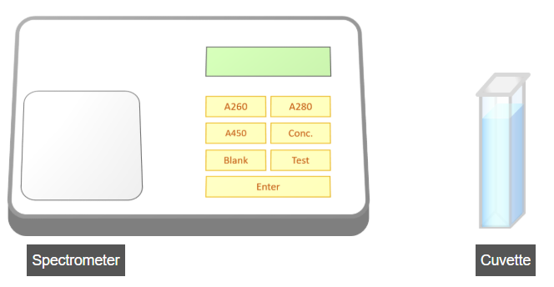
We prepare a mixture of substrate and solutions as described in the previous step(See Table) and begin taking absorbance readings immediately after adding lysozyme. To do this, click on the spectrometer lid to open it.
Now, click on the micro cuvette to measure its absorbance reading.
Now, click the test button on the spectrometer to set it to test reading mode.
Now, click the 'A450' button to take an absorbance reading at 450 nm. Note down the reading every 30 seconds.
Click on Next Step to perform various enzyme kinetics analyses.

