S.No. | Name of the Equipment | Image | Symbol | Function
1. | Resistor | 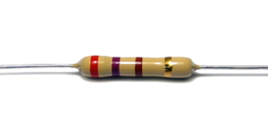 | 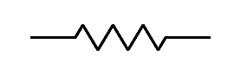 | To control the flow of current to other components in a circuit.
2. | Capacitor | 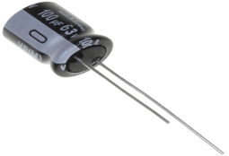 | 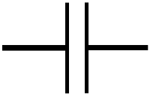 | To store the electrical energy and give this energy again to the circuit when necessary.
3. | Inductor | 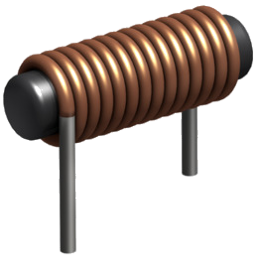 | 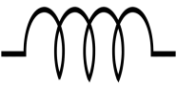 | To block AC while allowing DC to pass.
4. | Voltmeter | 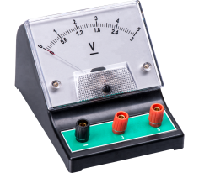 | 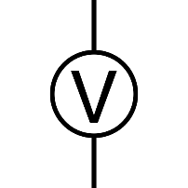 | An instrument used for measuring electrical potential difference between two points in an electric circuit.
5. | Ammeter | 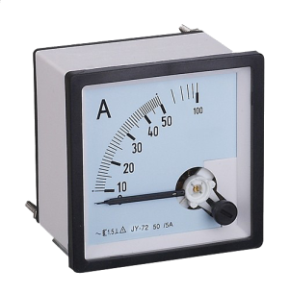 | 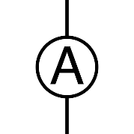 | An instrument used for measuring electric current in units of amperes.
6. | Relay | 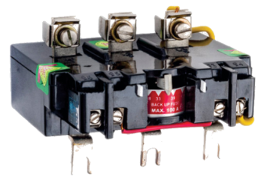 | 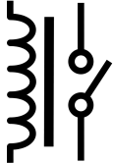 | Relays are switches that open and close circuits electromechanically or electronically.
7. | Circuit Breaker | 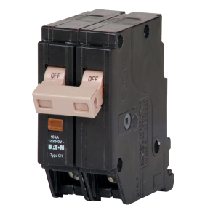 |  | To interrupt the current flow after a fault is detected.
8. | Auto Transformer | 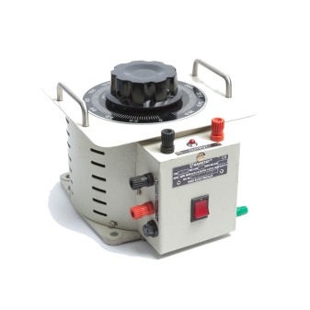 | 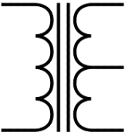 | It is used to start induction motors,regulate the voltage of transmission lines,transform voltages when the primary to secondary ratio is close to unity.
9. | DC Motor | 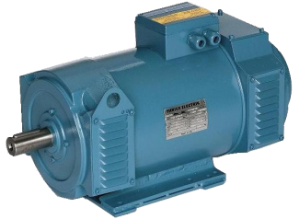 | 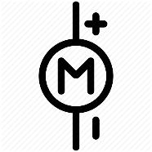 | A DC motor is any of a class of rotary electrical machines that converts direct current electrical energy into mechanical energy.
10. | Slip Ring Induction Motor | 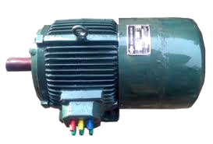 | 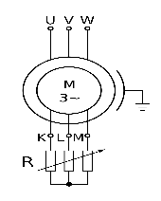 | Generally employed where load requires high starting torque or good speed control.
11. | Squirrel cage Induction Motor | 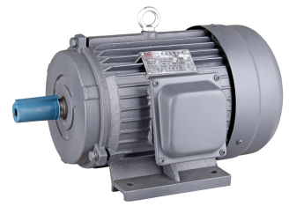 | 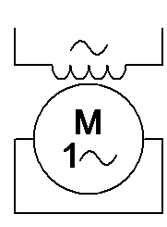 | It functions on the principle of electromagnetism.The interaction of the magnetic fields produced by the stator and rotor windings produces a torque on the squirrel cage rotor.
12. | Rheostat | 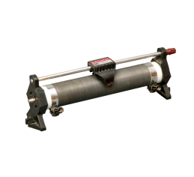 | 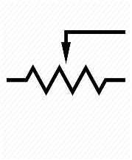 | It is a variable resistor. By changing the resistance you can control the current flowing through it.

