Familiarization with the Microwave Laboratory Apparatus
S.No. | Name of the Equipment | Image | Symbol | Function
1 | Circulator | 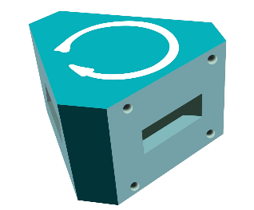 | 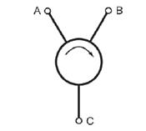 | It transports radio frequency or microwave signals from one port to another.
2 | Isolator | 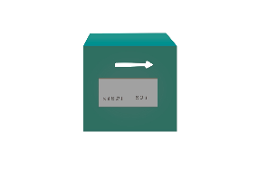 | 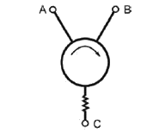 | It transmits microwave or radio frequency power in one direction only. It is used to shield equipment on its input side, from the effects of conditions on its output side.
3 | Attenuator | 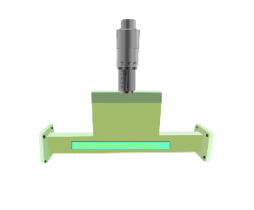 | 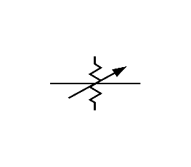 | It decreases the strength of the input signal either continuously or step by step without appreciable signal distortion while substantially maintaining constant impedance match
4 | Magic Tee | 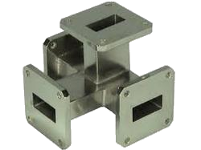 | 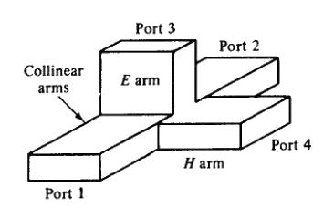 | The magic-tee can be used as a power combiner or divider, depending on the needs of the application.
5 | Directional Coupler | 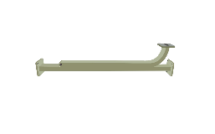 | 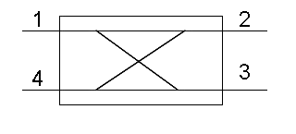 | The basic function of a directional coupler is to operate on an input so that two output signals are available.
6 | Horn Antenna | 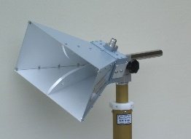 | 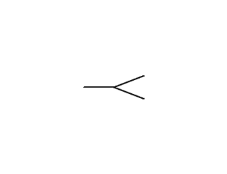 | A horn antenna is used to transmit radio waves from a waveguide (a metal pipe used to carry radio waves) out into space, or collect radio waves into a waveguide for reception.
7 | H-Plane Tee | 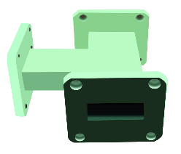 | 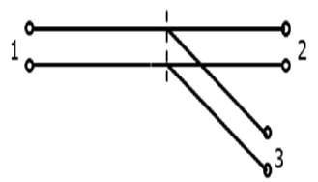 | It is used to either divide or combine power in a waveguide system. It is a two way in-phase power divider/combiner i.e it is additive in nature. When two input signals are fed to port 1 & 2, the output at port 3 is in phase and additive and when the input signal is fed to port 3, the signal is split in to two equal parts that are in-phase at port 1 & 2.
8 | E-Plane Tee | 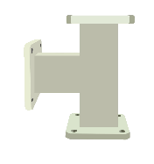 | 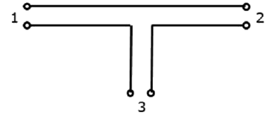 | It is similar to a power divider.  The outputs we get in this type of tee are 180° out of phase with each other, irrespective of from which port the input is fed.
9 | Frequency Meter | 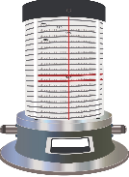 | 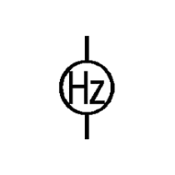 | A frequency meter is an instrument that displays the frequency of a periodic electrical signal.
10 | Pin Modulator | 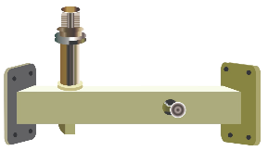 | 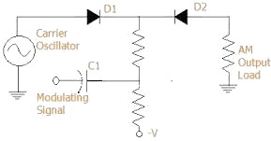 | sIt accepts a low frequency (base band) signal that modulates the output of e.g. a generator, typically in amplitude, frequency or phase. Its use is that this is the signal you are actually interested in. The high frequency signal is just a carrier: without modulation it is useless.

