phosphate-carbonate-bicarbonate
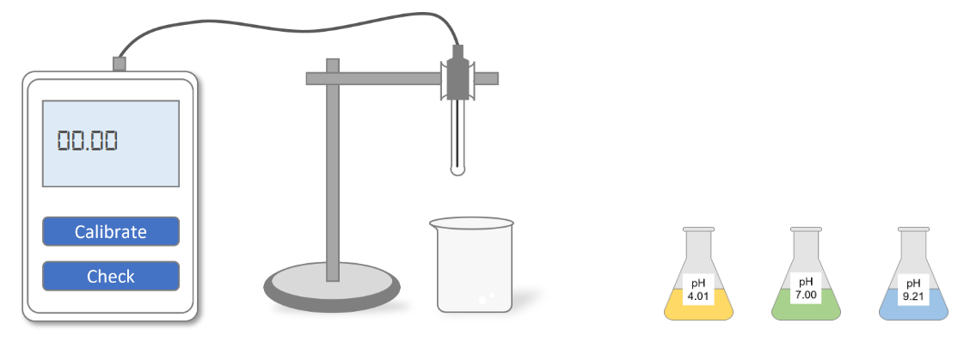

First Step is calibration of the pH meter. Click on pH 4.01 flask.
Click on pH meter glass electrode.
Click on Calibrate button of meter.
Meter is calibrated to pH value 4.01. Now click on flask to empty it.
Repeat same steps for pH 7.0 and pH 9.21
First step is completed. Now click on next for second step.

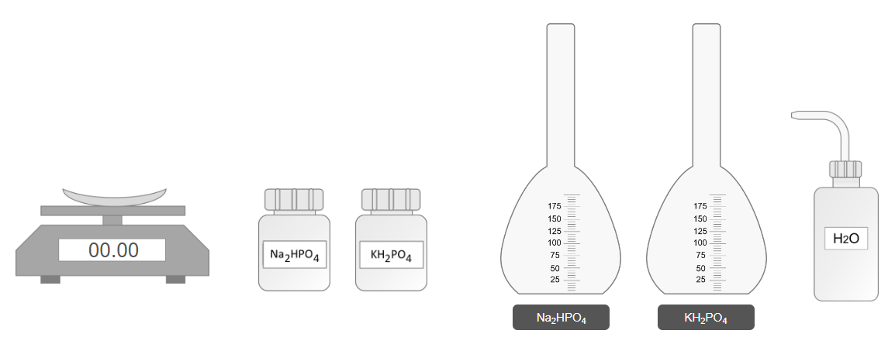
In the second step we generate two 100ml solution of 1.42gm of Na2HPO4 and 1.36gm of KH2PO4.
To start second step click on Na2HPO4 bottle.
Click on the chemical compound placed on weight machine.
Click on water bottle to fill up the flask upto 100ml.
Click on Na₂HPO₄ solution to shake it well.
Repeat same steps again to make 100ml KH₂PO₄ solution.
Both solutions have been made. Now click on next for third step.
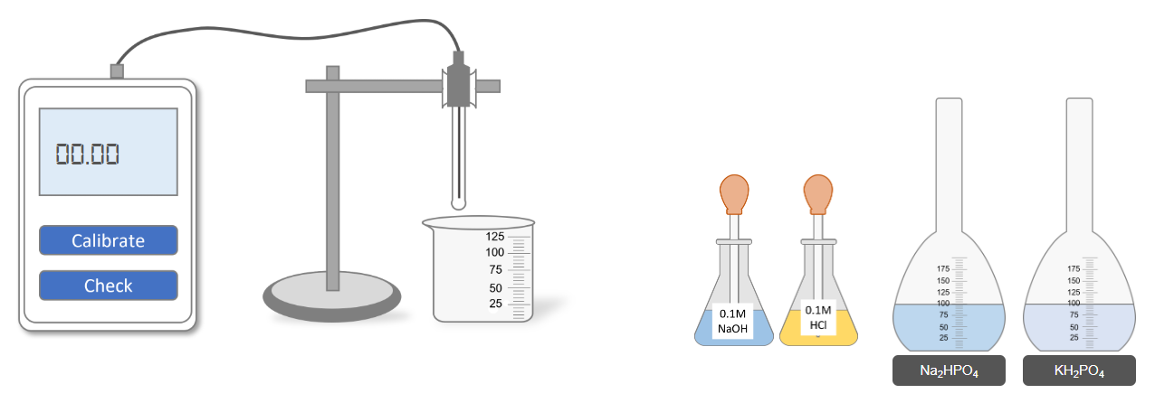
In the last step we measure the pH value of solutions. For this click on Na₂HPO₄ solution.
Now click on KH₂PO₄ solution.
Now click on pH glass electrode meter.
Now click on check button of pH meter and note the pH value.
If pH value is less than 7.2, click on NaOH solution and pore few drop of it into target solution. OR if pH value is greater than 7.2, click on HCL solution and pore few drop of it into target solution.
Now click on check button of pH meter and note the pH value again.

