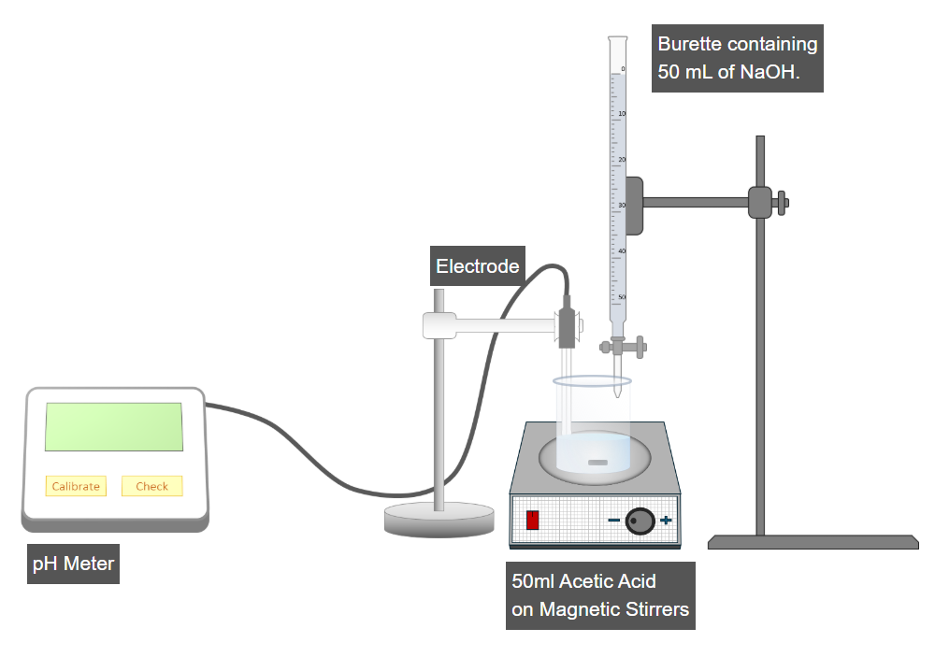
To perform this experiment, we first need to calibrate the pH meter. Click on the Calibrate button of the pH meter to perform the calibration operation.
Now, click the check button on the pH meter to measure the pH value of acetic acid.
Now, add 2 mL of NaOH to the beaker by clicking the burette valve.
Now, turn on the magnetic stirrer by clicking the red button to mix the weak acid and strong base effectively.
Note the new pH reading.
Again, click on the burette valve to add 2mL of NaOH to the beaker and note the pH reading.
Repeat the incremental addition of 2 mL of NaOH to the beaker, recording the pH value of the mixture up to 25 times.
Now, click 'Next Step' to calculate the pKa value

