Theory
The circuit diagram of push-pull converter is given in Fig. 1.
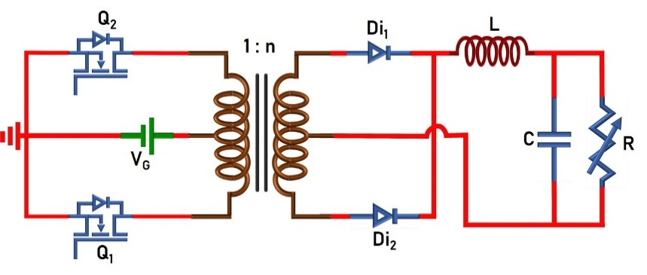
Fig. 1. Circuit Diagram of Push-pull Converter.
The switches (Q₁ and Q₂: ON/OFF-state) are turned-ON/OFF using 180º phase shifted PWM signals. The converter operation can easily be understood from the following equivalent circuits. Brief mathematical analysis is given below.
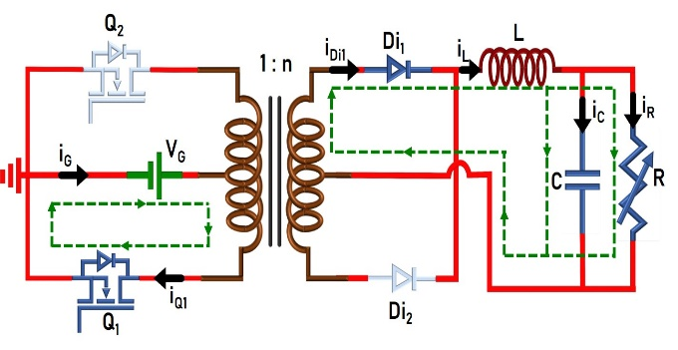 | 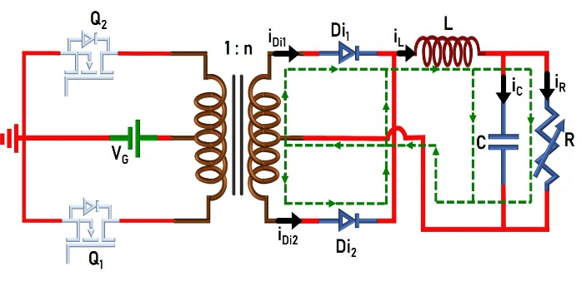
Fig. 2(a). Circuit in mode-I (Q₁- ON, Q₂- OFF). | Fig. 2(b). Circuit in mode-II, IV (Q₁- OFF, Q₂- OFF).
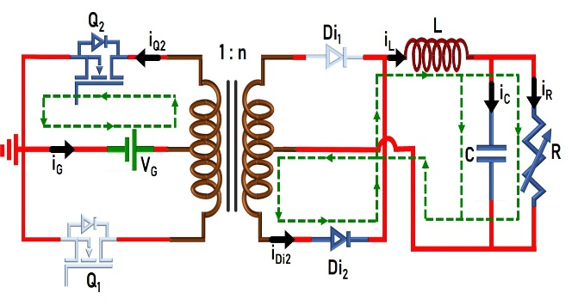
Fig. 2(c). Circuit in mode-III (Q₁- OFF, Q₂- ON).
- Voltage conversion ratio or Voltage gain:
Voltage across inductor L:
Since the frequency of inductor current/voltage is ‘T_{S}/2’, only Mode-I and Mode-II or Mode-III and Mode-IV is sufficient to formulate the voltage gain:

Mode-I:
..(1)

where n=N_{s}/N_{p}.

Mode-II:
..(2)

Applying ‘volt-sec’ balance across the inductor (eqn. 1 and 2)

..(3)

Solving eqn. 3 gives,

..(4)

- Average current through the inductor:
Current through capacitor C:
Since the frequency of both the inductor and capacitor currents is ‘T_{S}/2’, only Mode-I and Mode-II is considered.

Mode-I:
..(5)

Mode-II:
..(6)

Applying ‘Charge-sec’ balance to the capacitor (eqn. 5 and 6)

..(7)

Solving eqn. 7 gives,

..(8)

Therefore, average inductor current is equal to load current.

- Power balance under ideal condition (neglecting losses in the converter):
In ideal conditions, the input power is equal to the output power. Hence,

..(9)

..(10)

Substituting eqn. 4 in 10,

..(11)

- Inductor current ripple:
From eqn. 1,

..(12)

..(13)

Therefore, the inductor ripple current is,

..(14)
- Current through various components:
The current through various components can easily be identified from Fig. 3.

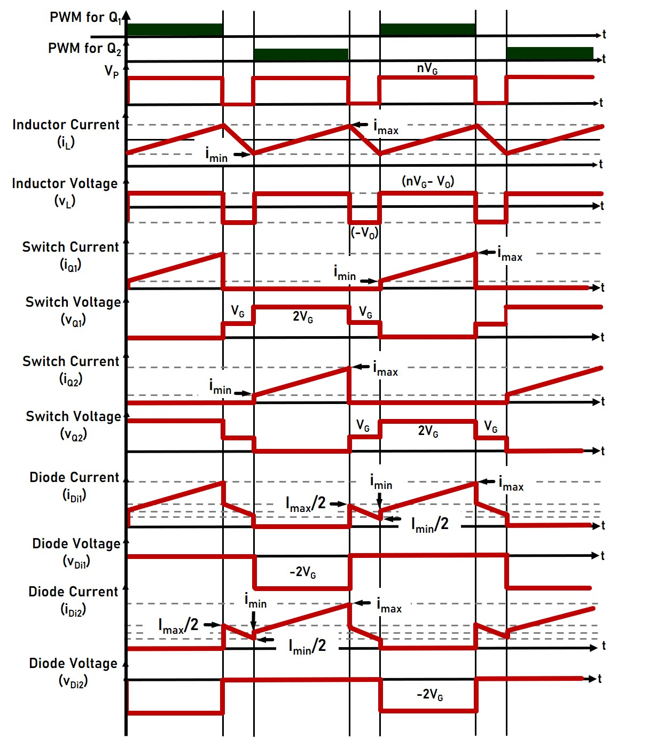
Fig. 3. Circuit Diagram of Push-pull Converter.
 | Mode-I  (DT_{S}/2) |  | Mode-II  ((1-D)T_{S}) |  | Mode-III  (DT_{S}/2) |  | Average Current
 | i_{min} | i_{max} | i_{min} | i_{max} | i_{min} | i_{max} | I_{avg}
i_{L}
i_{C}
i_{Q1}
i_{Q2}
i_{Di1}
i_{Di2}

- Voltage and current stress of various components:

 | Voltage stress | Current stress
Inductor (L)
Capacitor (C)
Switches (Q₁, Q₂)
Diodes (Di₁, Di₂)

- Efficiency analysis:
$\% Efficiency= \frac{Power delivered to the load}{Power drawn from the source}x100$ ..(15)

..(16)
Power losses occurring in various components are given below:

Power loss in inductor:

..(17)

Power loss in capacitor:

..(18)

Power loss in switches:

..(19)

..(20)

Power loss in diodes:

..(21)

..(22)

Total power loss:

..(23)

- Effect of non-idealities on voltage gain expression:
Power losses occurring in various components are given below:

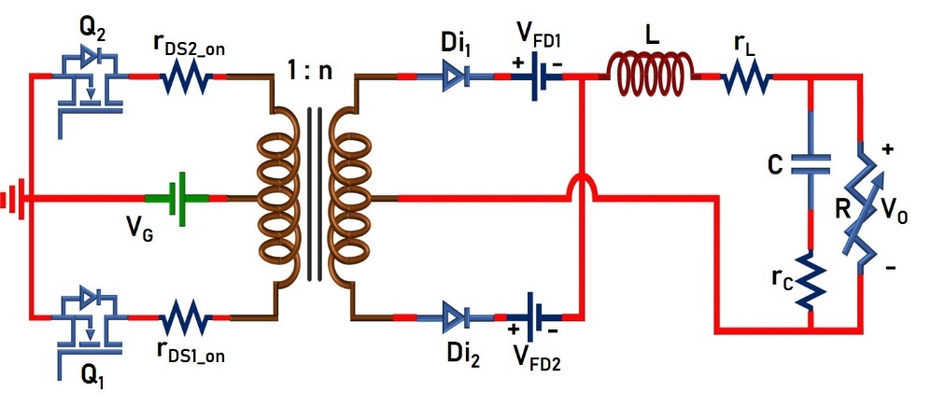
Fig. 4. Circuit Diagram of Push-pull Converter with non-idealities.
Voltage across inductor L:
Since the frequency of inductor voltage is T_{S}/2, only Mode-I and Mode-II or Mode-III and Mode-IV will be taken:

Mode-I:
..(24)

Mode-II:
..(25)

Applying Volt-sec balance across the inductor (eqn. 24 and 25),

..(26)

Substituting, and solving the above equation gives,

..(27)

