Theory

The circuit diagram of push-pull converter is given in Fig. 1.

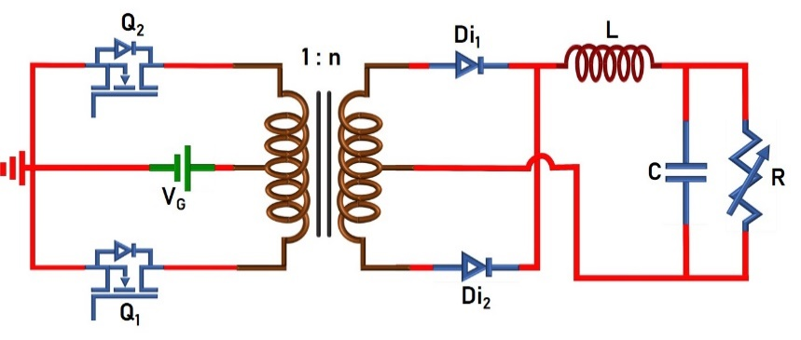

Fig. 1. Circuit Diagram of Push-pull Converter.

The switches (Q1 and Q2: ON/OFF-state) are turned-ON/OFF using 180o phase shifted PWM signals. The converter operation can easily be understood from the following equivalent circuits. Brief mathematical analysis is given below.

|  |  |
| --- | --- |
|  |  |
| Fig. 2(a). Circuit in mode-I (Q1- ON, Q2- OFF). | Fig. 2(b). Circuit in mode-II, IV (Q1- OFF, Q2- OFF). |
|  | |
| Fig. 2(c). Circuit in mode-III (Q1- OFF, Q2- ON). | |

1. Voltage conversion ratio or Voltage gain:

Voltage across inductor L:

Since the frequency of inductor current/voltage is ‘TS/2’, only Mode-I and Mode-II or Mode-III and Mode-IV is sufficient to formulate the voltage gain:

Mode-I:

 ..(1)

where n=Ns/Np.

Mode-II:

 ..(2)

Applying ‘volt-sec’ balance across the inductor (eqn. 1 and 2)

 ..(3)

Solving eqn. 3 gives,

 ..(4)

1. **Average current through the inductor:**

Current through capacitor C:

Since the frequency of both the inductor and capacitor currents is ‘TS/2’, only Mode-I and Mode-II is considered.

Mode-I:

 ..(5)

Mode-II:

 ..(6)

Applying ‘Charge-sec’ balance to the capacitor (eqn. 5 and 6)

 ..(7)

Solving eqn. 7 gives,

 ..(8)

Therefore, average inductor current is equal to load current.

1. **Power balance under ideal condition (neglecting losses in the converter):**

In ideal conditions, the input power is equal to the output power. Hence,

 ..(9)

 ..(10)

Substituting eqn. 4 in 10,

 ..(11)

1. **Inductor current ripple:**

From eqn. 1,

 ..(12)

 ..(13)

Therefore, the inductor ripple current is,

 ..(14)

1. **Current through various components:**

The current through various components can easily be identified from Fig. 3.

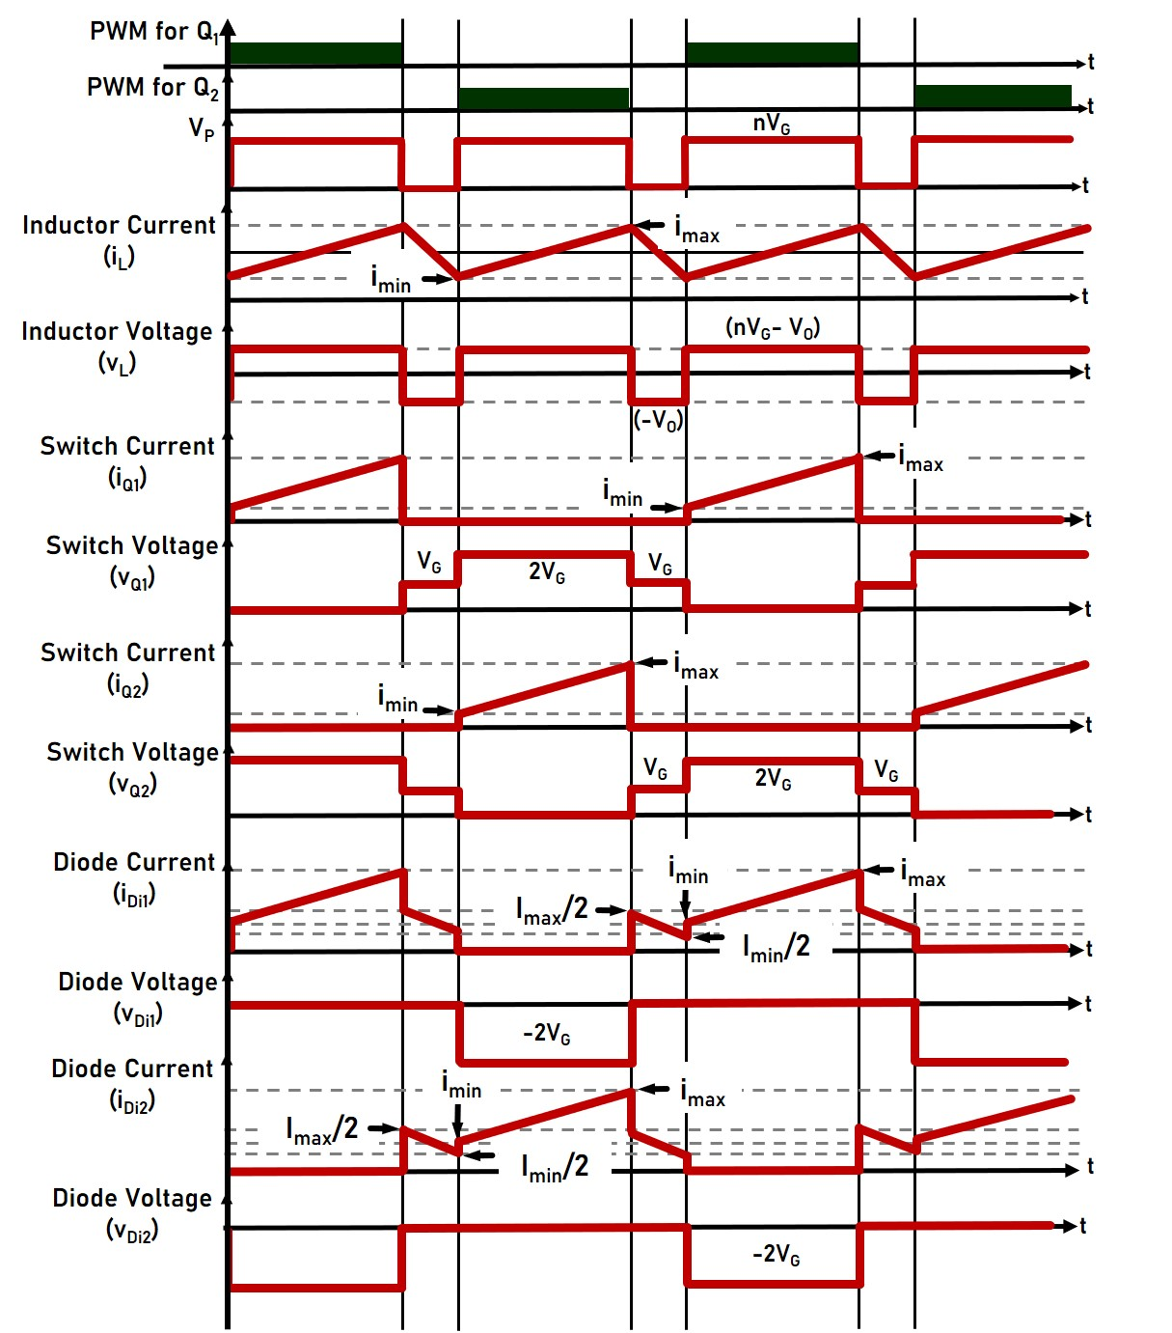

Fig. 3. Circuit Diagram of Push-pull Converter.

|  |  |  |  |  |  |  |  |
| --- | --- | --- | --- | --- | --- | --- | --- |
|  | Mode-I  (DTS/2) | | Mode-II  ((1-D)TS) | | Mode-III  (DTS/2) | | Average Current |
|  | imin | imax | imin | imax | imin | imax | Iavg |
| iL |  |  |  |  |  |  |  |
| iC |  |  |  |  |  |  |  |
| iQ1 |  |  |  |  |  |  |  |
| iQ2 |  |  |  |  |  |  |  |
| iDi1 |  |  |  |  |  |  |  |
| iDi2 |  |  |  |  |  |  |  |

1. **Voltage and current stress of various components:**

|  |  |  |
| --- | --- | --- |
|  | Voltage stress | Current stress |
| Inductor (L) |  |  |
| Capacitor (C) |  |  |
| Switches (Q1, Q2) |  |  |
| Diodes (Di1, Di2) |  |  |

1. **Efficiency analysis:**

$\% Efficiency= \frac{Power delivered to the load}{Power drawn from the source}x100$..(15)

 ..(16)

Power losses occurring in various components are given below:

Power loss in inductor:

 ..(17)

Power loss in capacitor:

 ..(18)

Power loss in switches:

 ..(19)

 ..(20)

Power loss in diodes:

 ..(21)

 ..(22)

Total power loss:

 ..(23)

1. **Effect of non-idealities on voltage gain expression:**

Power losses occurring in various components are given below:

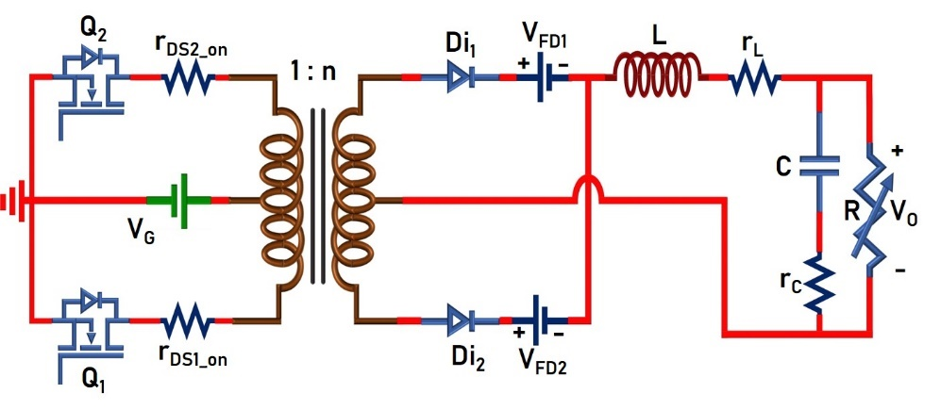

Fig. 4. Circuit Diagram of Push-pull Converter with non-idealities.

Voltage across inductor L:

Since the frequency of inductor voltage is TS/2, only Mode-I and Mode-II or Mode-III and Mode-IV will be taken:

Mode-I:

 ..(24)

Mode-II:

 ..(25)

Applying Volt-sec balance across the inductor (eqn. 24 and 25),

 ..(26)

Substituting,  and solving the above equation gives,

 ..(27)