**Worked example**

For an infinitely long string, consider giving the string zero initial displacement $u\left(x,0\right)=0$ and initial velocity $u_{t}\left(x,0\right)=g\left(x\right).$ suppose

$$g\left(x\right)=\left\{\begin{aligned}\cos^{2}\left(\frac{π}{2}x\right), -1≤x≤1 \\ 0, otherwise \end{aligned}\right.$$

The initial conditions have the form considered above for $F\left(x\right)=0$ and $G\left(x\right)=\cos^{2}\left(\frac{π}{2}x\right)$.

Step 1. D’Alembert’s solution equation (3.1) becomes

$$u\left(x,t\right)= \frac{1}{2}\int_{x-t}^{x+t}{g\left(s\right)ds}$$

Step 2. The regions are the same as those in equation (3.3) and are plotted in Figure 12 above.

Step 3. Determine $u\left(x,t\right)$ in each region. From equation (3.4), we have

$$u\left(x,t\right)=\left\{\begin{aligned}\frac{1}{2}\int_{x-t}^{x+t}{G\left(s\right)ds,} (x,t)∈R_{1} \\ \frac{1}{2} \int_{x-t}^{1}{G\left(s\right)ds,} (x,t)∈R_{2} \\ \frac{1}{2} \int_{-1}^{x+t}{G\left(s\right)ds,} (x,t)∈R_{3} \\ \frac{1}{2} \int_{-1}^{1}{G\left(s\right)ds,} (x,t)∈R_{4} \\ 0 \left(x,t\right)∈R_{5},R_{6}\end{aligned}\right.$$

Note that

$$\int_{a}^{b}{\cos^{2}\left(\frac{π}{2}x\right)dx=}\int_{a}^{b}{\frac{1}{2}}\left(1+\cos\left(πx\right)\right)dx= \frac{b-a}{2}+\frac{\sin\left(πb\right)-\sin{(πa)}}{2π}$$

Thus

$$\int_{x-t}^{x+t}{G\left(s\right)ds}=t+\frac{\sin\left(π(x+t)\right)-\sin{(π(x-t))}}{2π}=t+ \frac{1}{π}\cos{(πx)}\sin{(πt)}$$

$$\int_{x-t}^{1}{G\left(s\right)ds}=\frac{1-(x-t)}{2}-\frac{\sin{(π(x-t))}}{2π}$$

$$\int_{-1}^{x+t}{G\left(s\right)ds}=\frac{1+x+t}{2}+\frac{\sin{(π(x+t))}}{2π}$$

$$\int_{-1}^{1}{G\left(s\right)ds}=1$$

Thus

$$u\left(x,t\right)=\left\{\begin{aligned}\frac{t}{2}+ \frac{1}{2π}\sin\left(πt\right)\cos{(πx)}, (x,t)∈R_{1} \\ \frac{1-(x-t)}{4}-\frac{\sin{(π(x-t))}}{4π}, (x,t)∈R_{2} \\ \frac{1+x+t}{4}+\frac{\sin{(π(x+t))}}{4π}, (x,t)∈R_{3} \\ \frac{1}{2}, (x,t)∈R_{4} \\ 0, (x,t)∈R_{5},R_{6}\end{aligned} (3.9)\right.$$

Step 4. We consider early, intermediate and later times, $t =1/2, 1, 2.$ At $t =1/2,$ the regions $R_{n}$ are given by equation (3.5), (3.6) and (3.9) becomes

$$u\left(x,\frac{1}{2}\right)=\left\{\begin{aligned}\frac{1}{4}+ \frac{\cos{(πx)}}{2π}, -\frac{1}{2}≤x≤\frac{1}{2} \\ \frac{1}{4}\left(\frac{3}{2}-x\right)+\frac{\cos{(πx)}}{4π}, \frac{1}{2}≤x≤\frac{3}{2} \\ \frac{1}{4}\left(\frac{3}{2}+x\right)+\frac{\cos{(πx)}}{4π}, -\frac{3}{2}≤x≤-\frac{1}{2} \\ \\ 0 ׀x׀≥\frac{3}{2}\end{aligned}\right.$$

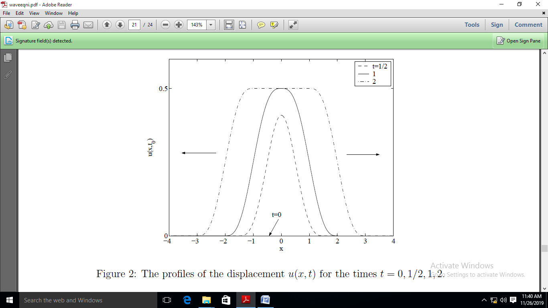

**Figure 13** The profiles of the displacement $u(x, t)$ for the times $t =0, 1/2, 1, 2.$

At $t =1,$ the regions $R_{n}$ are given by equation (3.7) and (3.9) becomes

$$u\left(x,1\right)=\left\{\begin{aligned}\frac{2-x}{4}+ \frac{\sin{(πx)}}{4π}, 0≤x≤2 \\ \frac{2+x}{4}- \frac{\sin\left(πx\right)}{4π}, -2≤x≤0 \\ 0 ׀x׀≥2 \end{aligned}\right.$$

At $t =2,$ the regions $R_{n}$ are given by equation (3.8) and (3.9) becomes

$$u\left(x,2\right)=\left\{\begin{aligned}\begin{aligned}\frac{3-x}{4}-\frac{\sin\left(πx\right)}{4π}, 1≤x≤3 \\ \frac{3+x}{4}+ \frac{\sin\left(πx\right)}{4π}, -3≤x≤-1 \\ \\ \frac{1}{2} -1≤x≤1 \\ 0 ׀x׀≥3 \end{aligned} \\ \end{aligned}\right.$$

In Figure 13, the profiles of the displacement $u(x, t)$ are plotted for the times $t = 0, 1/2, 1, 2.$

**The various possible cases**

For convenience, let's define the reflection and transmission coefficients as

$$R≡\frac{v_{2}-v_{1}}{v_{2}+v_{1}} and T≡\frac{{2v}_{2}}{v_{2}+v_{1}} (4.13)$$

With these definitions, we can write the reflected and transmitted waves in Eqs. (4.10) and (4.12) as

$$ψ_{r}\left(x,t\right)=Rψ_{i}\left(-x,t\right)$$

$${ ψ}_{t}\left(x,t\right)=Tψ_{i}\left(\left({v_{1}}/{v_{2}}\right)x,t\right) (4.14)$$

*R* and *T* are the amplitudes of $ψ_{r}$ and $ψ_{t}$ relative to $ψ_{i}$. Note that 1 + *R* = *T* always. This is just the statement of continuity of the wave at $x = 0.$

Since $v=\sqrt{T/μ}$, and since the tension *T* is uniform throughout the string, we have $v_{1}∝1/{\sqrt{μ_{1}}}$ and $v_{2}∝1/{\sqrt{μ_{2}}}.$ so we can alternatively write *R* and *T* in the terms of the densities on either side of $x = 0:$

$$R≡\frac{\sqrt{μ_{1}}-\sqrt{μ_{2}}}{\sqrt{μ_{1}}+\sqrt{μ_{2}}} and T≡\frac{2\sqrt{μ_{1}}}{\sqrt{μ_{1}}+\sqrt{μ_{2}}} (4.15)$$

**There are various cases to consider:**

* BRICK WALL ON RIGHT: $μ_{2}=∞\left(v_{2}=0\right)⇒R = -1, T =0.$ Nothing is transmitted, since $T = 0.$ And the reflected wave has the same size as the incident wave, but is inverted due to the $R = -1$ value. This is shown in Fig. 19.

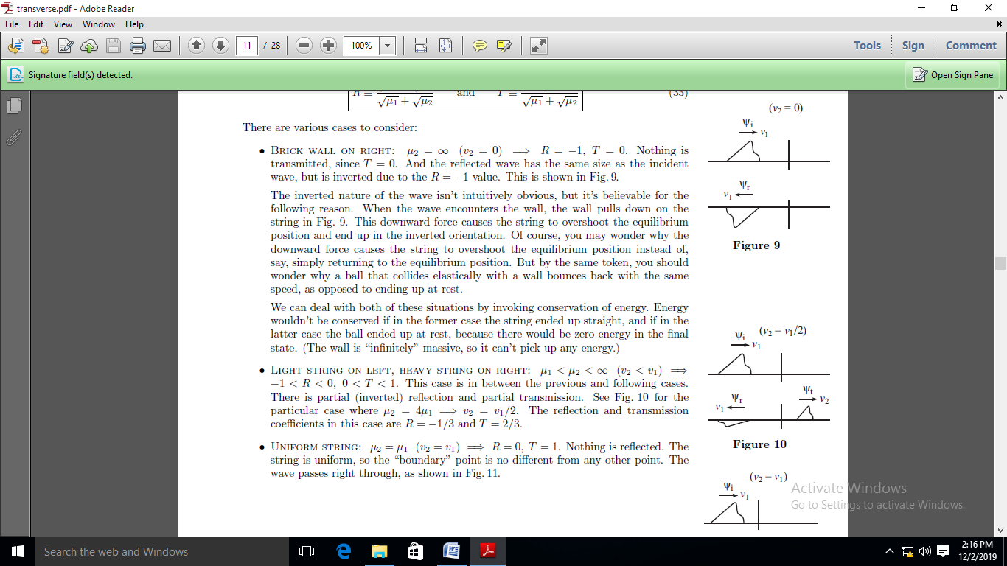

**Figure 19.**

The inverted nature of the wave isn't intuitively obvious, but it's believable for the following reason. When the wave encounters the wall, the wall pulls down on the string in Fig. 19. This downward force causes the string to overshoot the equilibrium position and end up in the inverted orientation. Of course, you may wonder why the downward force causes the string to overshoot the equilibrium position instead of, say, simply returning to the equilibrium position. But by the same token, you should wonder why a ball that collides elastically with a wall bounces back with the same speed, as opposed to ending up at rest.

We can deal with both of these situations by invoking conservation of energy. Energy wouldn't be conserved if in the former case the string ended up straight, and if in the latter case the ball ended up at rest, because there would be zero energy in the final state. (The wall is “infinitely" massive, so it can't pick up any energy.)

* LIGHT STRING ON LEFT, HEAVY STRING ON RIGHT: $μ_{1}<μ_{2}<∞ \left(v_{2}{<v}_{1}\right) ⇒ -1<R<0, 0<T<1.$ This case is in between the previous and following cases.There is partial (inverted) reflection and partial transmission. See Fig. 20 for the particular case where $μ_{2}=4μ_{1}⇒v_{2}{=v}_{1}/2$. The reflection and transmission coefficients in this case are $R = -1/3$ and $T = 2/3.$



**Figure 20.**

* UNIFORM STRING: $μ_{2}=μ_{1}\left(v_{2}{=v}_{1}\right)⇒R=0,T=1.$ Nothing is reflected. The string is uniform, so the “boundary" point is no different from any other point. The wave passes right through, as shown in Fig. 21.

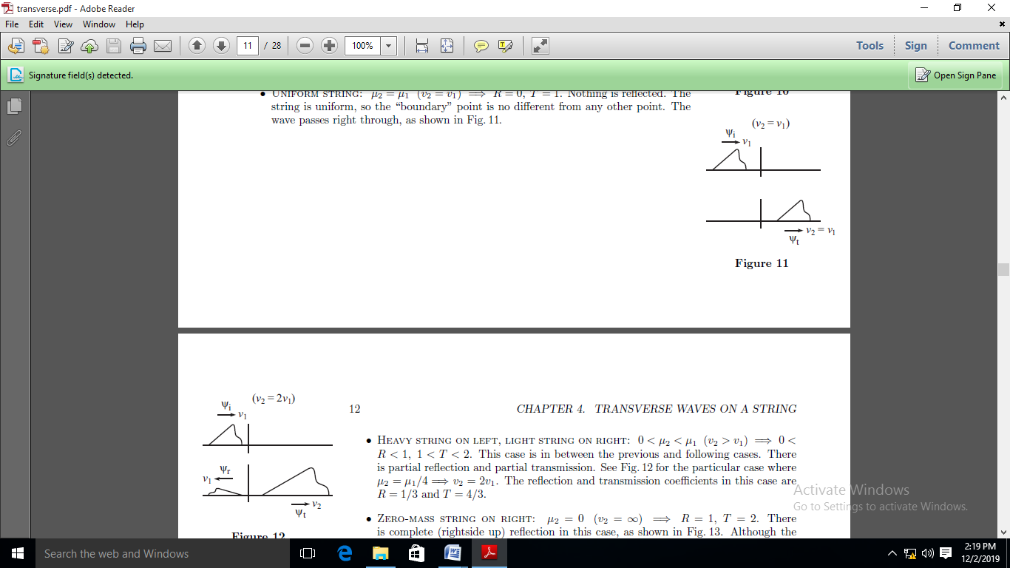

**Figure 21.**

* HEAVY STRING ON LEFT, LIGHT STRING ON RIGHT: $0<μ_{2}<μ_{1}\left(v_{2}{>v}_{1}\right)⇒0<R<1, 1<T<2.$ This case is in between the previous and following cases. Thereis partial reflection and partial transmission. See Fig. 22 for the particular case where $μ_{2}={μ_{1}}/4⇒v_{2}=2v_{1}.$ The reflection and transmission coefficients in this case are $R=1/3 and T=4/3.$

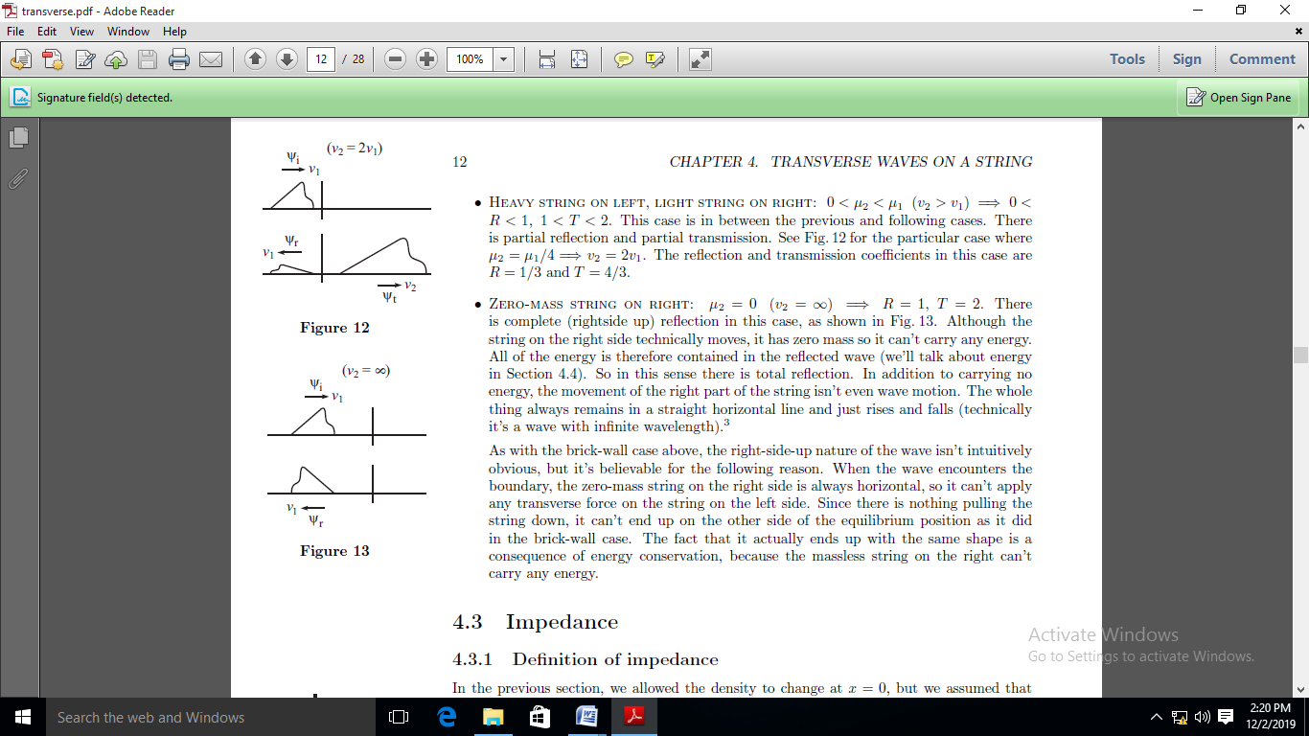

**Figure 22.**

* ZERO-MASS STRING ON RIGHT: $μ_{2}=0 \left(v_{2}=∞\right)⇒R=1,T=2.$ There is complete (right side up) reflection in this case, as shown in Fig. 23. Although the string on the right side technically moves, it has zero mass so it can't carry any energy. So in this sense there is total reflection. In addition to carrying no energy, the movement of the right part of the string isn't even wave motion. The whole thing always remains in a straight horizontal line and just rises and falls (technically it's a wave with infinite wavelength).



**Figure 23.**

As with the brick-wall case above, the right-side-up nature of the wave isn't intuitively obvious, but it's believable for the following reason. When the wave encounters the boundary, the zero-mass string on the right side is always horizontal, so it can't apply any transverse force on the string on the left side. Since there is nothing pulling the string down, it can't end up on the other side of the equilibrium position as it did in the brick-wall case. The fact that it actually ends up with the same shape is a consequence of energy conservation, because the mass less string on the right can't carry any energy.