**Development of Virtual lab :Round 1 (R1) - Template (Worksheet)**

|  |
| --- |
| **Name of Faculty:** Dr Ashutosh Tiwari  **Institute: Rajkiya Engineering College Banda**  **Email ID** (as submitted in the registration form)**: ashutosh.tiwari0885@gmail.com**  **Discipline to which the Lab belongs: Physics**  **Name of the Lab: Basics of Physics**  **Name of experiment: Verification of Stefan’s law**  (only one Experiment per worksheet. for submitting more than one experiments, please fill up another worksheet)**:**  **Kindly Refer these documents before filling the worksheet**   1. **Guidelines :**     1. **Handout for R1 Overall Summary :** [**http://bit.ly/Vlabs-Dev_Handout_Summary_R1**](http://bit.ly/Vlabs-Dev_Handout_Summary_R1)    2. **Handout R1 for topics 1 & 2 :** [**http://bit.ly/Vlabs-Dev_Handout_1_R1**](http://bit.ly/Vlabs-Dev_Handout_1_R1)    3. **Handout R1 for topics 3 & 4:** [**http://bit.ly/Vlabs-Dev_Handout2_R1**](http://bit.ly/Vlabs-Dev_Handout2_R1)    4. **Presentation on Learning Objectives:** [**http://bit.ly/Vlabs-Dev_LO-ppt**](http://bit.ly/Vlabs-Dev_LO-ppt) 2. **Samples of R1**    1. **Fluid-Mechanics: :** [**http://bit.ly/Fluid-Mech_R1_Sample**](http://bit.ly/Fluid-Mech_R1_Sample)    2. **Digital-Electronics-Lab:** [**http://bit.ly/Digital_elec_R1_Sample**](http://bit.ly/Digital_elec_R1_Sample)    3. **Numerical-Methods-Lab:** [**http://bit.ly/Numerical-Method_R1_Sample**](http://bit.ly/Numerical-Method_R1_Sample) |
|  |

**1.1 FOCUS AREA: Engineering Physics**

**1.2 About the Experiment:** For black bodies, Stefan’s law is

E = σ (T4-T04) (1)

Where E is the net amount of radiation emitted per second per unit area by a body at temperature T and surrounded by another body at temperature T0. σ is called Stefan’s constant. A similar relation can also hold for bodies that are not black. In such case, we can write

P = C (Tα -T0α) (2)

Where, P is the total power emitted by a body at temperature T surrounded by another at temperature T0, α is a power quite closed to 4 and C is some constant depending on the material and area of such a body. Further the relation can be put as

P = C Tα (1-T0α/ Tα) (3)

If T>> T0 (e.g., T = 1500K, and T0 ≈ 300K), we can write

P = C Tα (4)

Or

Log10P = αLog10T + Log10C (5)

The graph between Log10P and Log10T should be a straight line whose slope gives α.

**1.3 Learning Objectives:**

|  |  |  |  |
| --- | --- | --- | --- |
| **S.No.** | **Learning Objective** | **Cognitive Level** | **Action Verb** |
| 1 | **Identify** the relation between rate of Energy emitted by any body and its temperature if the temperature of the body is large as compared to surroundings. | Recall | Identify |
| 2. | **Describe** the methodology to vary the temperature of the body and to observe the variation in rate of energy emitted by the body. | Understand | describe |
| 3. | **Predict** the variation of temperature of the body with rate of energy emission by plotting a graph between log P and log T. | Apply | predict |
| 4. | **Examine** the slope of plotted graph and compare the slope with the standard value. | Analyse | examine |
| 5. | **Conclude** the relation between Temperature of the Filament and the rate of Energy Emission. | Evaluate | Conclude |

**2. Instructional Strategy**

Expository Method

**2.1 Instructional Strategy:**

Figure : Steps of the completion of the project

**2.3 Description of sections:**

**Experimental setup:**

In order to verify Stefan’s law the experimental set up is as shown in Figure 3, with the help of this setup we have to measure the following two parameters:

1. Power radiated P: We use in this experiment tungsten bulb as the radiating body and in the steady state the electrical power V.I should be equal to the radiation power P (neglecting power lost in the leads and through the gas in the bulb).
2. Temperature of the radiating body, T: In our experiment we need measure the temperature of tungsten filament. This is achieved by measuring the resistance of filament, Rt and then using the relation

Rt = R0 (1+ αt + βt2) (6)

With α and β being known for tungsten, we can find temperature of the filament. One serious limitation arises in the measurement of R0 (resistance of filament at 0°C or 273K, one can write R0 or R273). At very small current, V/I ratio will give filament resistance as well as lead resistance. In order to calculate R0 then we measure the resistance (Rg) at the stage when the filament first starts glowing and temperature at this stage is approximately 800K. At this temperature contribution of lead resistance becomes smaller by a factor of 4 as compared with that at 273K. Therefore measurement of Rg (=R800) and using the computed factor, R800/R273, a more accurate value of R273 (=R0) is found.

1. With different increasing and decreasing values of current, we adjust such that the bulb glows each time. Then for value of V and I, ratio V/I is found which gives Rg. This is the filament resistance at 800K. From Rt/R0 vs. T graph, we note that

Rt/R0 = R800/R273 = 3.9 (7)

Therefore, R800/3.9 = R273

Or

Rg/3.9 = R0 (8)

1. Now filament current I is increased from a value below glow stage to values high enough to get dazzling white light, measuring voltage V across bulb every time. From these V and I values, we deduce power P (=VI) and Rt (=V/I). From Rt using the value R0 (or Rg /3.9) or R273K , we deduce the temperature T of the filament and obtain a graph in Log10P against Log10T.
2. Value of temperature for a particular Rt/R0 can be calculated from the linear fit relation

T= (-2.613)*( Rt/R0)^2 + 85.78* (Rt/R0) + 434.8 (9)

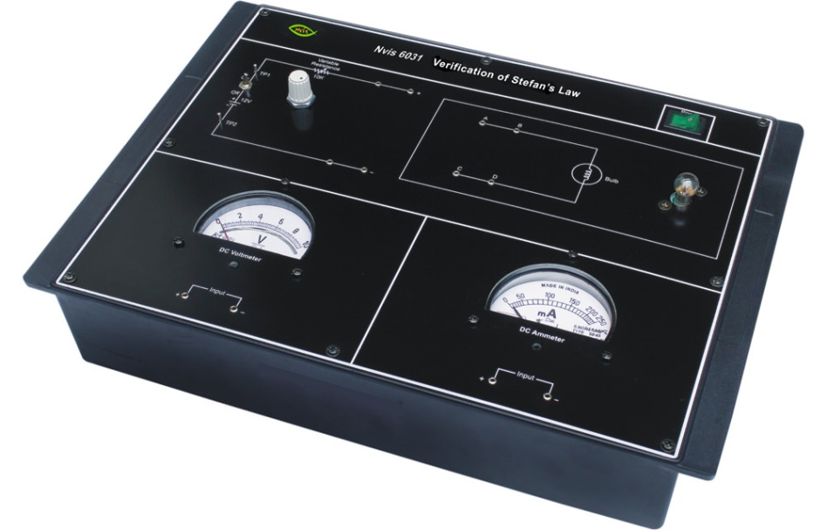

Figure 2: Stefan’s law verification apparatus (http://www.nvistech.com/technical-training/physics/verification-of-stefans-law)

**Observations:**

**Table 1: Readings for determination of the filament resistance (Rg) at temperature T= 800K:**

|  |  |  |  |  |  |  |  |
| --- | --- | --- | --- | --- | --- | --- | --- |
| S.No. | Current Increasing | | | Current Decreasing | | | Mean Rg/3.9 |
| Voltage V volts | Current I amp. | Rg=V/I Ohms | Voltage V volts | Current I amp. | Rg=V/I Ohms |  |
| 1 |  |  |  |  |  |  |  |
| 2 |  |  |  |  |  |  |  |
| 3 |  |  |  |  |  |  |  |
| 4 |  |  |  |  |  |  |  |
| 5 |  |  |  |  |  |  |  |
| 6 |  |  |  |  |  |  |  |
| 7 |  |  |  |  |  |  |  |
| 8 |  |  |  |  |  |  |  |
| 9 |  |  |  |  |  |  |  |
| 10 |  |  |  |  |  |  |  |
| 11 |  |  |  |  |  |  |  |
| 12 |  |  |  |  |  |  |  |
| 13 |  |  |  |  |  |  |  |
| 14 |  |  |  |  |  |  |  |
| 15 |  |  |  |  |  |  |  |
|  | | | | | | | **Mean Ro=** |

**Table 2: Determination of Power P for different temperature T:**

|  |  |  |  |  |  |  |  |  |
| --- | --- | --- | --- | --- | --- | --- | --- | --- |
| **S. No.** | **Voltage V volts** | **Current I amp.** | **Rt=V/I Ohms** | **Rt/Ro** | **Temperature corresponding to Rt/Ro From eq 9.** | **Log10T** | **Power P = V I**  **Volts** | **Log10P** |
| 1 |  |  |  |  |  |  |  |  |
| 2 |  |  |  |  |  |  |  |  |
| 3 |  |  |  |  |  |  |  |  |
| 4 |  |  |  |  |  |  |  |  |
| 5 |  |  |  |  |  |  |  |  |
| 6 |  |  |  |  |  |  |  |  |
| 7 |  |  |  |  |  |  |  |  |
| 8 |  |  |  |  |  |  |  |  |
| 9 |  |  |  |  |  |  |  |  |
| 10 |  |  |  |  |  |  |  |  |
| 11 |  |  |  |  |  |  |  |  |
| 12 |  |  |  |  |  |  |  |  |
| 13 |  |  |  |  |  |  |  |  |
| 14 |  |  |  |  |  |  |  |  |
| 15 |  |  |  |  |  |  |  |  |

**Result:**

Plot the graph as log10P vs. log10T will be straight line.

**Calculations:**

Slope of the straight line log10P vs. log10T gives the value of α.

**2.2 Assessment Method:**

**Quiz will be taken for evaluation (Example given below)**

**Pre Test**

1. The plot of Log P Vs log T for anybody is at a temperature larger than the temperature of the surroundings will be:

a) Straight line b) parabolic c) hyperbolic d) elliptical

2. The slope of the standard plot between Log P Vs log T for anybody is at a temperature larger than the temperature of the surroundings is:

a) 4.2 b) 4.0 c) 4.8 d) 5.0

**Post Test**

3. The value of the current in the filament at T=800 K when applied potential difference is 5V:

a) 0.2 A b) 0.4 A c) 0.6A d) 0.8A

4. Resistance of any conductor _______________ with increase in temperature.

a) Increases b) decreases c) remains constant d) none of these

5. Keeping Temperature constant how the rate of energy emission from any body depends on increasing its surface area?

a) Increases b) decreases c) remains constant d) none of these

**3. Task & Assessment Questions**

Complete the following table with details of the various tasks and assessment questions you will give to the students.

|  |  |  |  |
| --- | --- | --- | --- |
| **SrNo.** | **Learning Objective to be met**  (choose anyone from you declared above) | **Tasks to be performed by the students** | **Assessment questions aligned to the task** |
| **1** | Student will **identify** the relation between rate of Energy emitted by any body and its temperature if the temperature of the body is large as compared to surroundings. | Student will complete introduction. He will be given 4 images for Stefan’s law and will choose correct image from them. | 1. Choose the correct image for the plot between LogP and LogT which verifies stefan’s Law from images figure givben below:  (FIGURE 3 will be placed)   1. Image 1 b)Image 2   c)Image 3 d)Image4  2. Relation between rate of Energy Emission from any blackbody with its absolute Temperature according to Stefan’s Law is:  a) $E∝T^{3}$ b) $E∝T^{2}$ c) $E∝T^{4}$ d) $E∝T^{5}$ |
| **2** | To enable the student to **describe** the methodology to vary the temperature of the body and to observe the variation in rate of energy emitted by the body. |  | Choose the image which shows the correct order of the procedure to be followed in this experiment:  (FIGURE 4 will be placed)  a) Image 1 b) Image 2  c) Image 3 d) Image 4 |
| **3** | Student will be able to **predict** the variation of temperature of the body with rate of energy emission by plotting a graph between log P and log T. | Student will start making circuit connections followed by taking observations for Power Radiated by the filament and the resistance of the filament by varying the potential difference applied. | The plot of Log P Vs log T for anybody is at a temperature larger than the temperature of the surroundings will be:  a) Straight line with positive slope and positive intercept  b) Straight line with negative slope positive intercept  c) Straight line with negative slope negative intercept d) Straight line with positive slope negative intercept |
| **4** | Student will **examine** the slope of plotted graph and will compare the slope with the standard value. | Student will take observations for resistance at different temperatures and calculate values of P and plot graph between log P and Log T | The value of the current in the filament at T=800 K when applied potential difference is 5V:  a) 0.2 A b) 0.4 Ac) 0.6A d) 0.8A |
| **5** | Conclude the relation between Temperature of the Filament and the Rate of Energy Emission. | Students will calculate slope of the plotted graph between log P and Log T and conclude that it is coming close to 4. | The slope of the standard plot between Log P Vs log T for anybody is at a temperature larger than the temperature of the surroundings is:  a) 4.2 b) 4.0  c) 4.8 d) 5.0 |

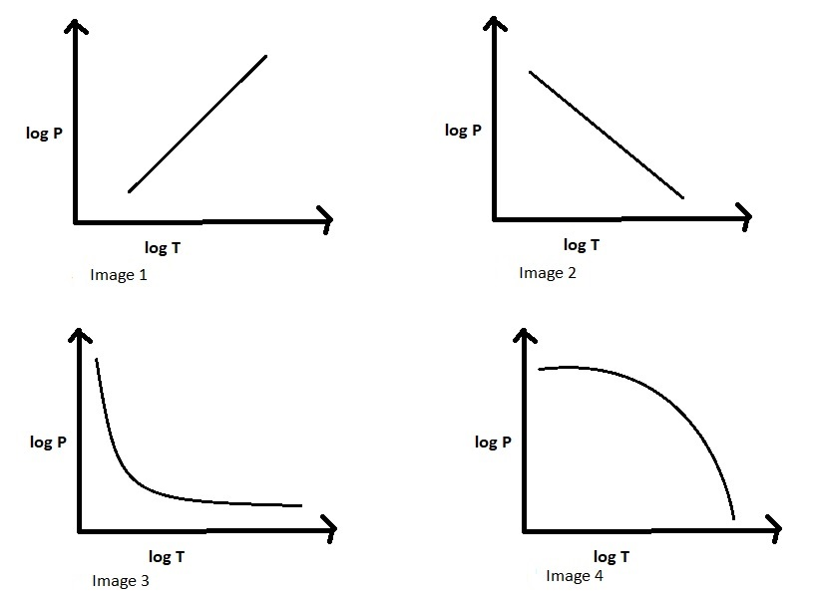

Figure Image for assessment question for the task 1.

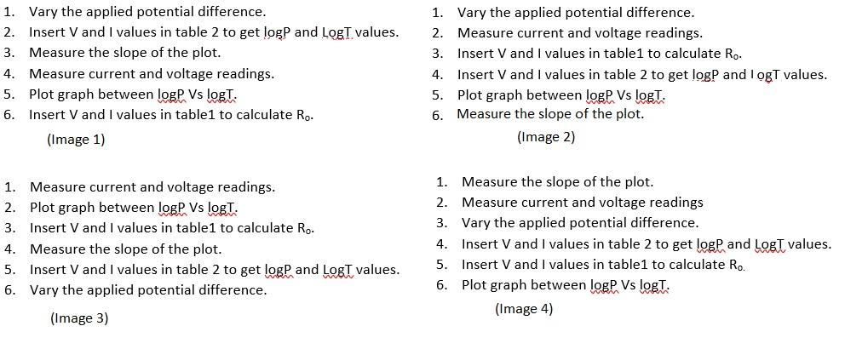

Figure Image for the assessment question for Task2.

**4. Simulator Interactions**

**Complete the following table giving the details of the Simulator interactions.**

|  |  |  |
| --- | --- | --- |
| **What students will do?** | **What Simulator will do?** | **Purpose of the task** |
| Student will make the connections to complete the circuit for the experimental verification of Stefan’s Law. | Simulator will allow him to make connections and will alert him in case of wrong connections made. | Student will be able to recall the basics of the lab |
| Student will slide the power button of the simulator to ON position | Simulator will show the green light indicating that the simulator is ready for use. | To initiate the simulator |
| Student will choose the desired voltage from the voltmeter and gradually increase the voltage | Simulator will show the corresponding current in the ammeter | To find the current in the filament corresponding to the potential difference applied. |
| Student will insert the current corresponding to each potential difference applied and mention these values in the table 1. | Simulator will fetch the corresponding current and potential difference data and calculate power dissipated in the filament in form of heat through the filament and the resistance of the changing resistance of the filament. | To get the power values and the resistance values with respect to the changing temperature of the filament. |
| Student will insert all the resistance values all the values in the table 2. | Simulator will show temperature corresponding to each resistance value | To get the temperature values corresponding to changing filament resistance |
| Student will press the draw Graph button | Simulator will show plot between LogP and Log T | To plot graph between LogP and Log T |
| Student will choose any two points on the graph and press the calculate slope button | Slope of the graph will be calculated. | Student will note the value of the slope and calculate the percentage error with the standard value. |
| Student will change the heat method and the heating body and will repeat the experiment | Simulator will show plot between LogP and Log T and slope of the graph will be calculated | Student will note the value of the slope and calculate the percentage error with the standard value. |