# *A PROJECT REPORT ON*

ECONOMIC LOAD DISATCH

IN THE PARTIAL FULFILMENT OF THE REQUIRMENT FOR THE DEGREE OF

BACHELOR OF TECHNOLOGY

In

ELECTRICAL AND ELECTRONICS ENGINEERING

By

ARSH GUPTA

ABHISHEK RISHI

GURYARI PASWAN

SAKSHI SAENA

SANJANA SINGH

Under the guidance of

Prof. ASHISH SAINI



TABLE OF CONTENT

* Certificate 3
* Abstract 4
* Declaration 5
* Acknowledgement 6
* Project overview 7

1. Introduction 8

* Block Diagram and Description 10

1. Block diagram of load dispatch centre 11
2. Generator Operating Cost Curves 13
3. Objective Function 16
4. System Constraints 17

* Methods to solve ELD problem 20

1. Lambda Iteration Method 21
2. Algorithm 22
3. Flowchart 23
4. Matlab Code 24
5. Results 26
6. Particle Swarm Optimization 27
7. Introduction 28
8. PSO Parameters 30

* Bibliography

## CERTIFICATE

This is to certify that Project Report entitled “ECONOMIC LOAD DISPATCH USING PARTICLE SWARM OPTIMIZATION” that is submitted by ARSH GUPTA, ABHISHEK RISHI, GURPYARI PASWAN, SAKSHI SAXENA, SANJANA SINGH in partial fulfillment of the requirement for the award of the degree B.Tech in Department of ELECTRICAL of Dayalbagh Educatonal Institute, is a record of the student own work carried out by him under my own supervision. The matter embodies in thesis is original and has not been submitted for the award of any other degree.

Date: Project guide:

(Prof. ASHISH SAINI)

## ABSTRACT

In practical situations and under normal operating conditions, the generating capacity of power

plants is more than the total losses and load demand. Also, power plants have different fuel costs and are not the same distance from the load centers. Hence the need for developing improved methods of economic dispatch of generated power from mostly remote locations to major load centers in the urban cities.

Most methods adopted for optimal dispatch are either cumbersome in their computational approaches. This work proposes a fast and easy to use MATLAB syntax to aid in solving economic dispatch problems. The software component proposed in this work will try to estimate the optimal value of real power to be generated with the least possible fuel cost. This will be based on the assumption of equal incremental cost and the result compared to algorithm simulation.

DECLARATION

I hereby declare that this submission is own work and that, to the best of my knowledge and belief, it contains no material previously published or written by another person nor material which to a substantial extend has been accepted for the award of the award of any other degree or diploma of the university or other institute of the higher leaning except where due acknowledgement has been made in the text.

Signature:

Name:

Roll No.:

Date:

## ACKNOWLEDGEMENT

First and foremost, I am deeply indebted to my mentor Prof. ASHISH SAINI who inspiration has been unfailingly available to me at all stages of my training. This has fueled my enthusiasm even further and encouraged me to boldly step into what was a totally dark and unexplored expanse before me.

In course of present work it has been my privilege to receive help and assistance of my friends. I take great pleasure in acknowledge my debt to them.

I wish to thank my parents for their undivided support and interest who inspired me and encouraged me to go my own way, without whom I would be unable to complete my project. At last but not the least I want to thank my friends who appreciated me for my work and motivated me and finally to God who made all the things possible.

Signature:

Name:

Roll no.

Date:

**CHAPTER :- 1**

**Project Overview**

1. **introduction of project**
   1. **Project Definition:**

Project title is “**ECONOMIC LOAD DISATCH USING PARTICLE SWARM OPTIMIZATION** “.

The main aim of electric power utilities is to provide high-quality. Reliable power supply to the consumers at the lowest possible cost while operating to meet the limits and constraints imposed on the generating units. This formulates the economic load dispatch (ELD) problem for finding the optimal combination of the output power of all the online generating units that minimizes the total fuel cost, while satisfying an equality constraint and a set of inequality constraints. As the cost of power generation is exorbitant, an optimum dispatch results in economy.

**Problem statement:**

The primary objective of economic load dispatch problem is to minimize the total fuel cost while fulfilling the operational constraints of power system. In economic load dispatch problem allocation of optimal power generation among the different generating units at minimum possible cost is done in such a way so as to meet demand constraint and generating constant.

* 1. **Project overview**

• Practically, the real world input and output characteristics of the generating units are highly nonlinear, and discrete in nature owing to prohibited operating zones. Thus the resultant ELD is a challenging non-convex optimization problem, which is difficult to solve using the traditional methods. In a practical power system, the power plants are not located at the same distance from the centre of loads and their fuel costs are different. Also under normal operating conditions, the generating capacity is more than the total load demand and losses. Thus there are many options for scheduling the generation. With large interconnection of electrical networks, the energy crisis in the world and continuous rise in prices, it is very essential to reduce the running charges of electrical energy .i.e. reduce the fuel consumption for meeting a particular demand. In an interconnected power system, the objective is to find the real and reactive power scheduling of each power plant in such a way as to minimize the operating cost. This means that the generators real and reactive powers are allowed to vary within certain limits so as to meet a particular load demand with minimum fuel cost. This is called the optimal power flow (OPF) problem. The OPF is used to optimize the power flow solution of large scale power system. This is done by minimizing selected objective functions.

• While maintaining an acceptable system performance in terms of generator capability limits and output of the compensating devices. The objective functions, also known as cost functions may present economic costs, system security or other objectives. Efficient reactive power planning enhances operation as well as system security.

In this project our aim was to find optimal solution to the Economic dispatch including losses and generating limits .There are several methods to solve Economic load dispatch problem. Hence we considered one of the conventional methods i.e. lambda iterative method and one of the Artificial Intelligence methods i.e. Particle Swarm Optimization. Lambda iterative method was done by considering a specific lambda value and co-ordination equations were derived. From this equation we got a solution in which inequality constraints imposed on generation of each plant and equality condition were satisfied. Particle Swarm Optimization is also used to solve the same problem. In this method various steps involved are Initialization, Evaluation etc. Through all the above process the optimal solution was derived .

.

**CHAPTER :- 2**

**BLOCK DIAGRAM AND ITS DESCRIPTION**

**2.1 Basic Block Diagram**

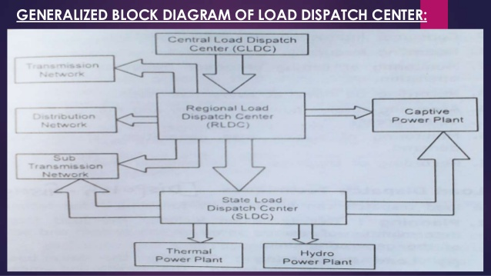

Fig. 2.1 Basic Block Diagram

**2.1 DESCRIPTION**

**Economic Load Dispatch - Thermal Stations**

A power system is a mix of different type of generations, out of which thermal, hydro and nuclear power generations contribute the active share. However, economic operation has conveniently been considered by proper scheduling of thermal or hydrogenation only. As for the safety of nuclear station, these types of stations are required to run at its base loads only and there is a little scope for the schedule of nuclear plants in practice. Economy of operation is most significant in case of thermal stations, as the variable costs are much higher compared to other type of generations. This can be considered by looking at various costs of different stations.

|  |  |  |  |
| --- | --- | --- | --- |
| Cost | Thermal  Stations | Hydro  stations | Nuclear  Stations |
| Fixed costs | 20% | 75% | 70% |
| Fuel cost | 70% | 0% | 20% |
| Other operational costs | 10% | 25% | 10% |

**Various Costs of different Stations**

Obviously the cost of fuel form the major portion of all variable costs and the purpose of economic operation is to reduce the cost of fuel. This is a static optimization problem. This project deals with the economic load dispatch of the thermal plants.

2.2 **Generator Operating Cost Curves**

The major component of the generator operating cost is the fuel input/hour, while maintenance contributes only to a small extent. The fuel cost is meaningful in case of thermal and nuclear stations.

The different operating cost curves are:

1. Input output curve.
2. Incremental fuel cost curve.

**Input Output Curve**

Power plants consisting of several generating units are constructed investing huge amount of money. Fuel cost, staff salary, interest and depreciation charges and maintenance cost are some of the components of operating cost. Fuel cost is the major portion of operating cost and it can be controlled. Therefore, we shall consider the fuel cost alone for further consideration.

To get different output power, we need to vary the fuel input. Fuel input can be measured in Tonnes / hour or Millions of Btu / hour. Knowing the cost of the fuel, in terms of Rs. / Tonne or Rs. / Millions of Btu, input to the generating unit can be expressed as Rs / hour. Let Ci Rs / h be the input cost to generate a power of Pi MW in unit i. Fig.1 shows a typical input – output curve of a generating unit. For each generating unit there shall be a minimum and a maximum power generated as Pi min and Pi max.

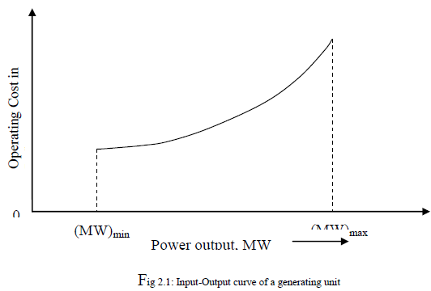

If the input-output curve of unit i is quadratic, we can write

**Fi= ai*P2gi + bi*Pgi + ci**

A power plant may have several generator units. If the input-output characteristic of different generator units are identical, then the generating units can be equally loaded. But generating units will generally have different input-output characteristic. This means that, for particular input cost, the generator power Pi will be different for different generating units in a plant.

**INCREMENTAL COST CURVE**

As we shall see, the criterion for distribution of the load between any two units is based on whether increasing the generation of one unit, and decreasing the generation of the other unit by the same amount results in

an increase or decrease in total cost. This can be obtained if we can

calculate the change in input cost ΔCi for a small change in power ΔPi.

Since

**dCi/dPi= ΔCi/ ΔPi.**

we can write

**ΔCi = (dCi/dPi)* ΔPi.**

Thus while deciding the optimal scheduling, we are concerned with dFi/dPi , INCREMENTAL COST (IC) which is determined by the slopes of the input output curves. Thus the incremental cost curve is the plot of dFi/dPi versus Pi. The dimension of dFi/dPi is Rs / MWh.

The unit that has the input – output relation as

**Fi= ai*P^2gi + bi*Pgi + ci**

has incremental cost (IC) as

**ICi= dFi/dPi = 2aPgi+b**

Here a,b,c are constants.

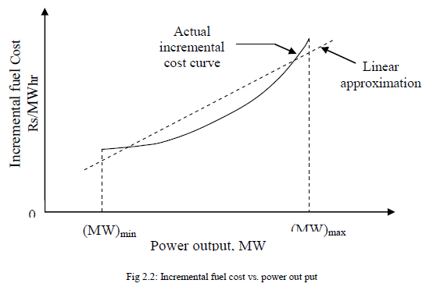

**The formulation of ELD problem can be done as follows-**

**1.** **Objective function**

The ELD problem can be formulated by single quadratic function which is given by following equation

**Ng**

**F(gi) = Σ Fi (Pgi) ……(1)**

**0**

Where,

**F(gi) =Total fuel cost ($/h)**

**Fi (Pgi) = Fuel cost of ith generator ($/h)**

**Ng = Number of generator**

The fuel cost of ith generator can be expressed as,

**Fi (Pgi) = ai*P2gi + bi*Pgi + ci ……(2)**

Where,

**ai, bi and ci = Fuel cost coefficients of ith generator**

From equation (1) and (2),

**Fi (Pgi) = Σ (ai*P2gi + bi*Pgi + ci) …….(3)**

**2.** **System Constraints**

There are two types of constraints in ELD problem:

**2.1 Equality Constraint (Power balance constraint)**

The cost function is not affected by reactive power but it is affected by real power. According to this constraint summation of real power of all the generating unit must be equal to the total real power demand on the system plus power transmission loss. This constraint is also known as power balance constraint.

Ng

**Σ Pgi = Pd+Pl**

0

Where,

**Pgi = Real power generation of ith generator**

**Pd = Total real power demand**

**Pl = Power transmission loss**

**2.2 Inequality Constraint**

Inequality constraints for the generating unit can be given as follows:

**Min Max**

**Pgi <= Pgi <= Pgi**

Where,

**Pgi = Real power generation of ith generator**

**Pgimin = minimum limit of power generation of ith generator .**

**Pgi max = maximum limit of power generation of ith generator**

Transmission loss can be expressed as a function of generator power through B-coefficients. The simplest form of loss equation using B-coefficients is given by

**Pl = ∑ Ng ∑Ng Pgi Bij Pgj MW …… (6)**

**i=0 j=0**

Where,

**Pgi , Pgj = Real power generation at the ith and jth buses, respectively**

**Bij = Loss coefficients**

For this constraint based optimization problem we use Lagrangian multiplier. So the augmented cost function is given by

Ng

**L(Pgi , λ ) = Fi (Pgi) + λ [Pd+ Pl - ∑ (Pgi) ]** **……(7)**

i=0

Where **λ is the Lagrangian multiplier.**

The necessary condition for optimization problem is given by equation (8)

**∂ L(Pgi,λ) = 0 , …….(8)**

**∂ Pgi (i= 1, 2,……Ng)**

**∂ F(Pgi) + λ( ∂Pl  - 1) = 0 , ….(9)**

**∂ Pgi ∂Pgi**

Equation (9) can be written as

**∂ F(Pgi)= λ(1- ∂ Pl) , (i=1, 2…Ng) ……(10)**

**∂ Pgi ∂ Pgi**

Where,

**∂ F(Pgi) =Incremental cost of the ith generator ($/MWh)**

**∂ Pgi**

**∂ Pl=Incremental transmission loss (ITL) of ith generator.**

**∂ Pgi**

**The above equation is called as coordination equation**.

Furthermore,

**∂ L(Pgi,λ) = PD + PL - ΣNG (Pgi)=0 ……(11)**

**∂ λ i=0**

By differentiating equation (6) with respect to Pgi ,

**∂ (PL) = ΣNG (2BijPgi)=0 ……..(12)**

**∂ Pgi j=0**

The incremental cost of ith generator can be obtained by differentiating equation (3) with respect to Pgi

**∂ F(Pgi) =2ai Pgi + bi …….(13)**

**∂ Pgi**

With the help of equation (12) & (13), equation (10) can be written as

**2aiPgi+bi = λ[1-ΣNg (2BijPgj)]**

**j=0**  **..........(14)**

By arranging equation (14)

**2(ai+λBii)Pgi = λ(1- ΣNG (2BijPgj) )**

**J=0,j≠i**  **………(15)**

The value of Pgi can be formulated as

**Pgi = λ(1- ΣNg j=0,j≠i (2BijPgj)) – bi , (i=1, 2…Ng)**

**2(ai + λBii) ……..(16)**

**If λ is known then generator real power can be obtained by equation (16).**

**CHAPTER :- 3**

**METHODS TO SOLVE ELD PROBLEM**

**LAMBDA ITERATION METHOD**

Lambda iteration method is more conventional to deal with the minimization of cost of generating the power at any demand. For more number of units, the Lambda iteration method is more accurate and incremental cost curves of all units are stored in memory.

Algorithm for Economic Dispatch

**STEP 1:** Initialization:

Input data such as; number of plants, total load demand, generator limits, cost curve coefficients, iteration limit and tolerance.

**STEP 2:** Start counter.

**STEP 3:** Calculate power value for each plant using Equation 15.

**STEP 4:** Check if iteration limits is exceeded.

If yes, inform user of non-convergence and stop.

Else, go to step 5.

**STEP 5:** Check if Power value for plant is less then set limit.

If yes, set power value to lower limit, increment counter and go to 4.

Else, go to 6.

**STEP 6:**Check if Power value for plant is more than set limit.

If yes, set power value to upper limit, increment counter and go to 4.

Else go to 7.

**STEP 7:** Sum up Power for all plants and calculate the power loss using Equation .

**STEP 8:** Calculate net power from Equation 17.

**STEP 9:** If absolute value for net power is less than set tolerance level,

Display calculated power value, incremental cost value and stop.

**STEP 10:** If net power is greater than zero,

Reduce the value of the incremental cost, increment counter and go to 4.

Else, increase the value of the incremental cost, increment counter and go to 4

FLOWCHART



**MATLAB CODE FOR LAMBDA ITERATION METHOD**

%N = iteration count limit

%e = iteration tolerance

%lamda = Lagrange multiplier (Lambda)

%del_lamda = change in lambda

%PD = Power Demand

%Pmin & Pmax = minimum and maximum power limits

n=1; lamda=0; del_lamda=0; e=0.01; P=0 ;N=1; PD=0;

Psum=0;

m=input('Input total number of thermal unit:');

for k=1:m

disp('plant')

disp(k)

Pmin(k)=input('insert minimum power:');

Pmax(k)=input('insert maximum power:');

end

disp('Input cost coefficients per plant in the form below:')

disp('[alpha1 beta1 gamma1;alpha2 beta2 gamma2;...]')

C=input('Insert Cost Coefficients:');

for k=1:m

P(k)=(lamda-C(k,2))/(2*C(k,3));

disp(P(k))

if P(k)<Pmin(k)

P(k)=Pmin(k);

elseif P(k)>Pmax(k)

P(k)=Pmax(k);

end

Psum=Psum+P(k);

end

if n>N

disp('Solution non-convergence');

disp('Number of Iterations:')

disp(n-1)

else Pnet=Psum-PD;

del_lamda=abs(Pnet)/P(k);

if abs(Pnet)<e

disp('final value for lamda:')

disp(lamda)

disp('Power for plants 1 to m:')

disp(P)

disp('number of iterations:')

disp(n)

disp('iteration tolerance:')

disp(e)

elseif Pnet>0

lamda=lamda-del_lamda;

else

lamda=lamda+del_lamda;

end

end

Psum=0;

%n=n+1;

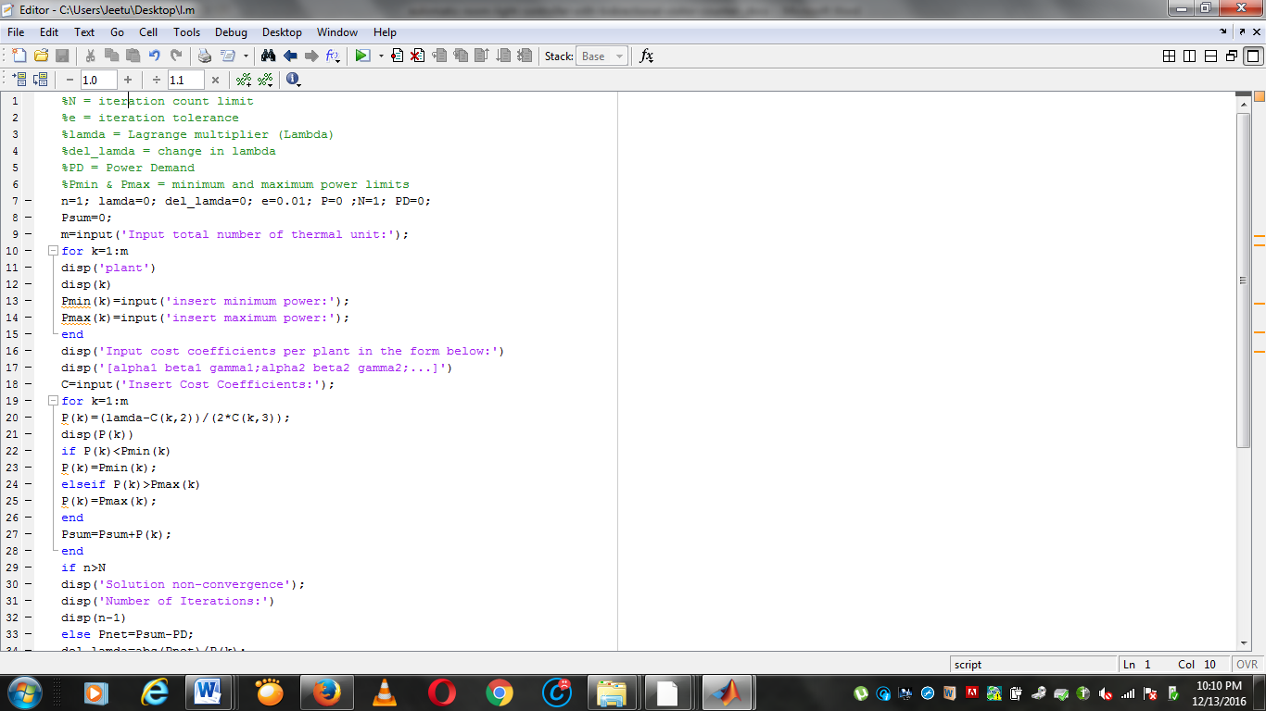

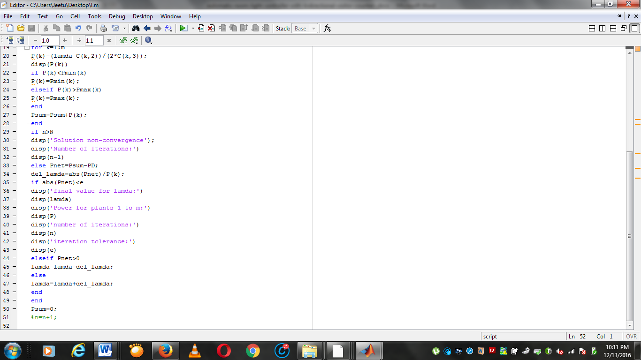

**RESULTS**

Two generating units considered

F1 = 0.004P12+ 9.2P1+ 420

F2= 0.0029P22+ 8.5P2 + 350

The unit operating ranges are-

100 MW ≤ P1 ≤ 200 MW

150 MW ≤ P2 ≤ 500 MW

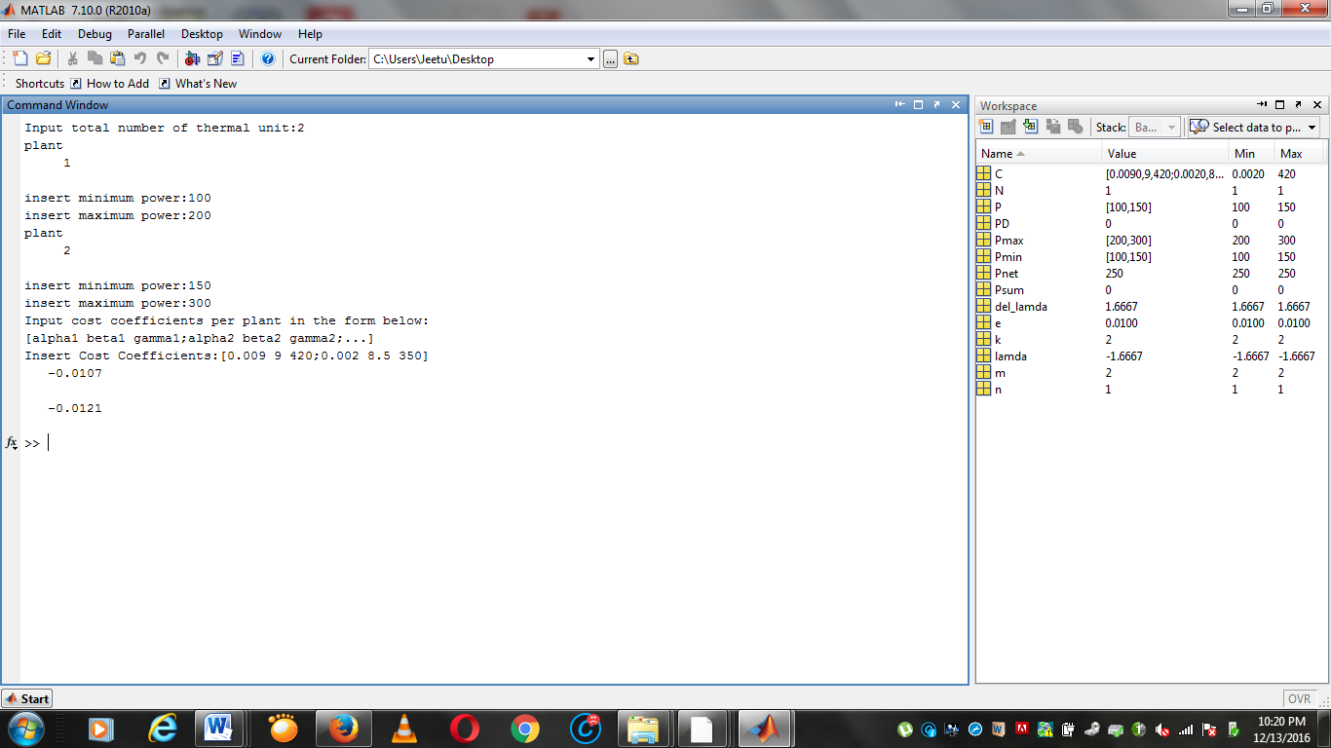

**PARTICLE SWARM OPTIMIZATION**

The PSO has been proposed by Eberhart and Kennedy in 1995, subsequently developed in thousands of scientific papers, and applied to many diverse problems, for instance neural networks training, data mining, signal processing, and optimal design of experiments.

PSO is a swarm intelligence meta-heuristic inspired by the group behavior of animals, for example bird flocks or fish schools. Similarly to genetic algorithms (GAs), it is a population-based method, that is, it represents the state of the algorithm by a population, which is iteratively modified until a termination criterion is satisfied. In PSO algorithms, the population P={p1,…,pn} of the feasible solutions is often called a swarm. The feasible solutions p1,…,pn are called particles. The PSO method views the set Rn of feasible solutions as a“space” where the particles “move”. For solving practical problems, the number of particles is usually chosen between 10 and 50.

Reynolds proposed a behavioral model in which each agent follows three rules:

Separation. :Each agent tries to move away from its neighbors if they are too close.

Alignment. :Each agent steers towards the average heading of its neighbors.

Cohesion. : Each agent tries to go towards the average position of its neighbors

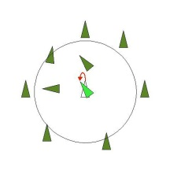 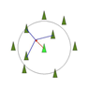 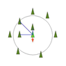

ALIGNMENT SEPERATION COHESION

**PSO CONTROL PARAMETERS**

* **Number of Particles :** The typical range of the number of particles is 20-40.Actually for most of the problems 10 particles is large enough to get good results. For some difficult or special problems, one can try 100 or 200 particles as well.
* **Dimension of Particles:** Dimension of particles is determined by the problem to be optimized.
* **Maximum Velocity :** Vmax determines the maximum change that one particle can take during each iteration.
* **Acceleration Constants :**The acceleration coefficients should be set sufficiently high. Higher acceleration coefficients result in less stable systems in which the velocity has a tendency to explode. To fix this, the velocity Vi is usually kept within the range of [Vmax,Vmax]. However, other settings were also used in different papers.
* **Stopping Condition :**The maximum numbers of iterations that PSO executes or the minimum error requirement are the stopping conditions.
* **Inertia Weight :**The weight factor W in equation is given by,

**W = Wmax- Wmax-Wmin * iter**

**Iter max**

Suitable selection of inertia weight in above equation provides a balance between global and local explorations, thus requiring less number of iterations on an average to find a sufficient optimal solution. As originally developed, inertia weight often decreases linearly from about 0.9 to 0.4 during a run.

**BIBLIOGRAPHY**

1. Ashfaq Husain, “Electrical Power System”, CBS Publishers and Distributors, Fifth Edition (2007).
2. C.L. Wadhwa, “Electrical power system”, 5th Edition,load dispatch, (2009).
3. S. Sivanagaraju, G. Sreenivasan, “Power System Operation and control”. (2011).
4. D.P. Kothari, J.S. Dhillon, “Power System Optimization”, PHI, Second Edition (2010).

* [**http://www.iosrjournals.org/iosr-jeee/Papers/Vol7-issue1/H0714954.pdf?id=5802**](http://www.iosrjournals.org/iosr-jeee/Papers/Vol7-issue1/H0714954.pdf?id=5802)
* [**https://www.google.co.in/search?site=&source=hp&q=Advantages+of+particle+swarm+optimazation+over+lamda+iteration+method&oq=Advantages+of+particle+swarm+optimazation+over+lamda+iteration+method&gs_l=hp.3...1549.39734.0.39950.70.61.0.0.0.0.1468.1468.7-1.1.0....0...1.1.64.hp..69.0.0.0.ZoYET2jvPOU**](https://www.google.co.in/search?site=&source=hp&q=Advantages+of+particle+swarm+optimazation+over+lamda+iteration+method&oq=Advantages+of+particle+swarm+optimazation+over+lamda+iteration+method&gs_l=hp.3...1549.39734.0.39950.70.61.0.0.0.0.1468.1468.7-1.1.0....0...1.1.64.hp..69.0.0.0.ZoYET2jvPOU)
* [**http://matlabproject.ir/form/files/265405.pdf**](http://matlabproject.ir/form/files/265405.pdf)
* [**http://souhil-mouassa.e-monsite.com/medias/files/an-efficient-particle-swarm-optimization-technique-to-solve.pdf**](http://souhil-mouassa.e-monsite.com/medias/files/an-efficient-particle-swarm-optimization-technique-to-solve.pdf)