1. Read an 8 bit grayscale image and generate the image of 7 bit, 6 bit, 5 bit, 4 bit, 3 bit, 2 bit and 1 bit image.

Input Image (8 bit):

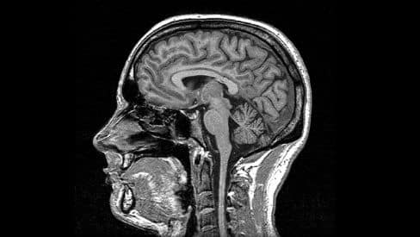
Output Images:

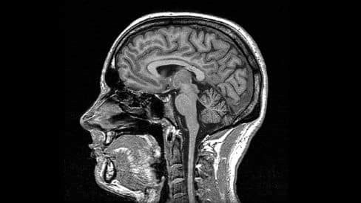 | 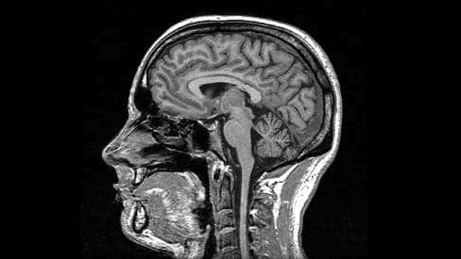
7 – bit | 6 – bit
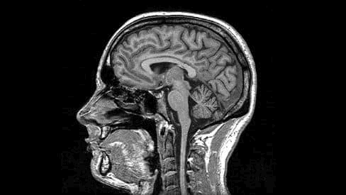 | 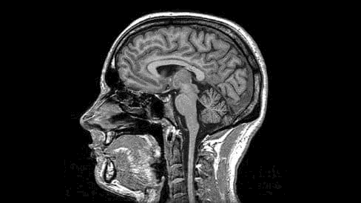
5 – bit | 4 – bit
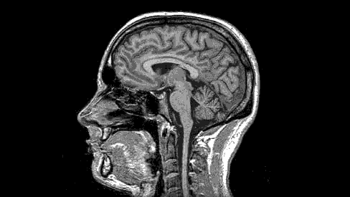 | 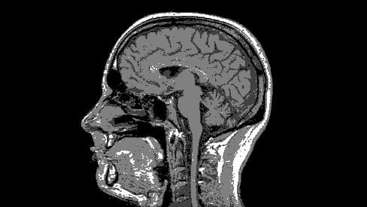
3 – bit | 2 -bit
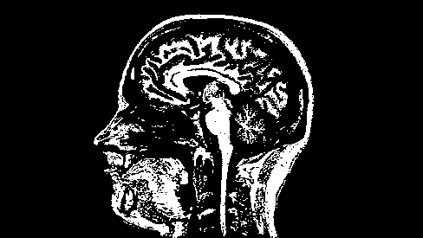
1 – bit

Conclusion :
We can see that as the number of bits reduces, the number of discrete intensity levels in the image decreases. Due to this minute details of the original image is lost . Thus we can conclude that as the number of bits is reduced, quality of the image decreases.

