2. Read a grayscale image and perform the Zooming and Shrinking operation on it. Consider the Zooming factor as 2 and shrinking factor as 0.5

Input Image:
Resolution: 488 x 275

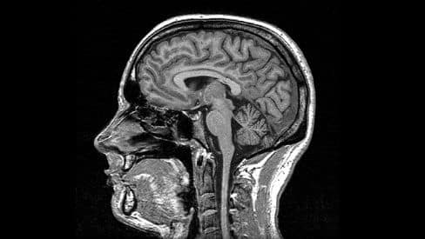
Zoomed Image:
Resolution: 976 x 550 (2x)

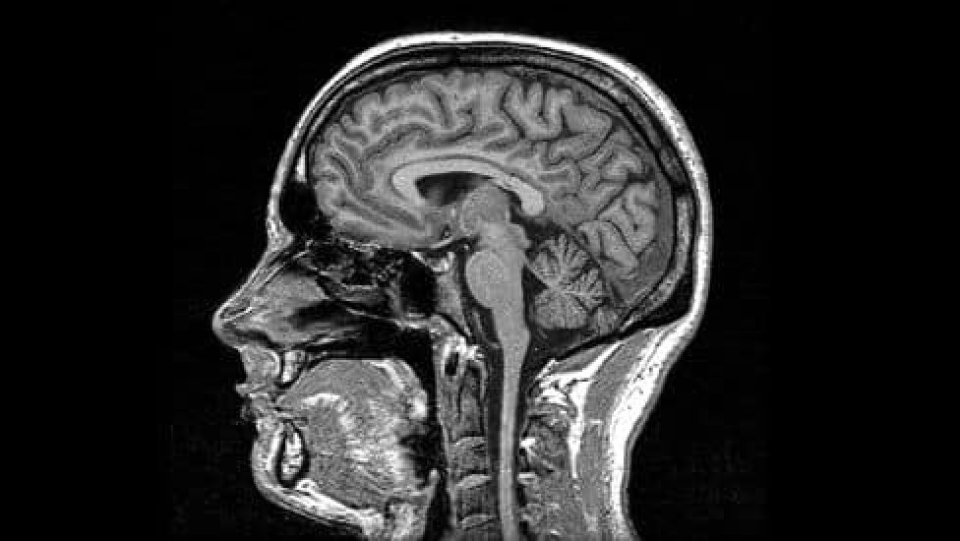

Shrinked Image:
Resolution: 244 x 137 (0.5x)

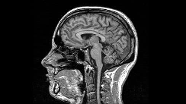

Conclusion:

