4. Read a low contrast grayscale image, implement and demonstrate the Histogram
Equalization code for enhancing the low contrast image.

Input Image:

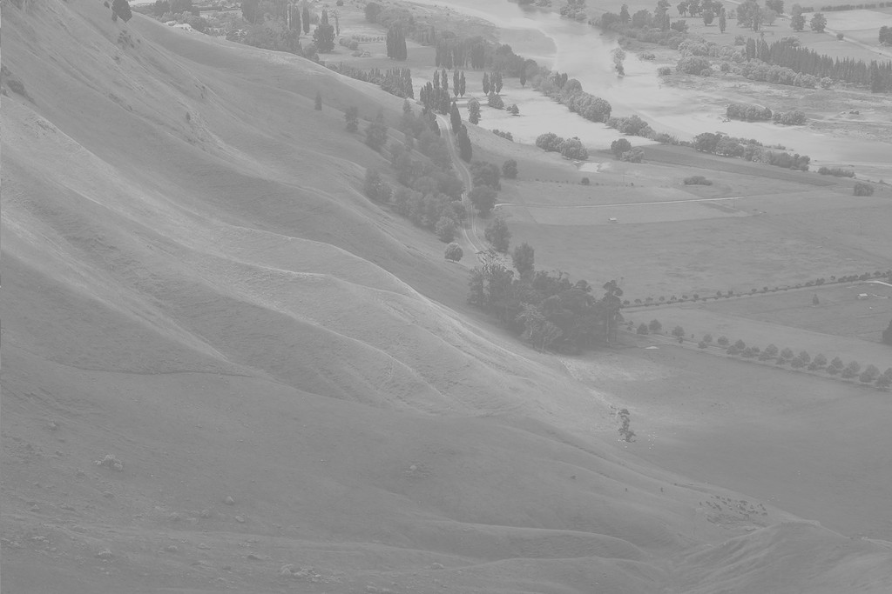
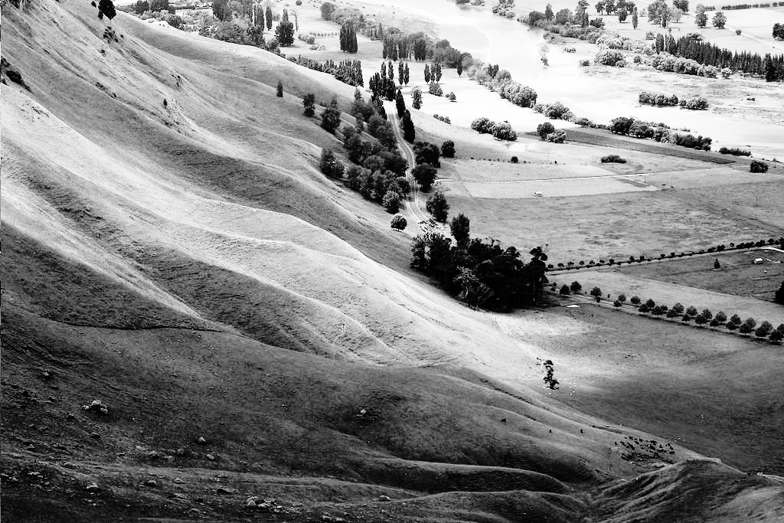
Output Image:

