5. Read a grayscale image, implement and demonstrate the Edge detector of an image using Laplacian Edge Detector.

Input Image | Output Image
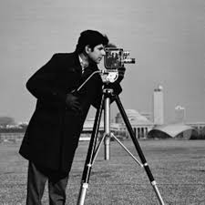 | 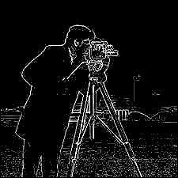
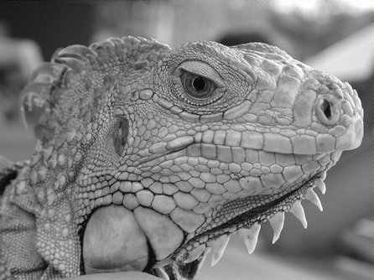 | 