Debugging AGC
with
Code::Blocks

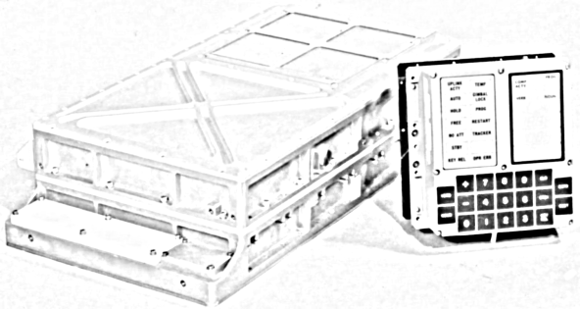

Written by Onno Hommes
May 23rd 2008

Table of Contents
1 Introduction 3
2 Requirements 4
2.1 The Virtual AGC software. 4
2.2 Code::Blocks 4
2.3 Patches for yaAGC 4
3 Install 5
3.1 Install Packages 5
3.2 Patch yaAGC 5
3.2.1 Act like a GNU Debugger 5
3.2.2 Virtual Linear Addressing 5
3.2.3 Sources or Binary 6
3.3 Install Scripts 7
4 Configuration 8
4.1 Configure Syntax Highlighting 8
4.2 Configure AGC yaYUL Compiler 8
4.3 Configure Auxiliary Tools 9
5 Project Setup 10
5.1 Creating an Empty Project 10
5.2 Adding Sources 10
5.3 External Makefile 10
5.4 Integrated Build Approach 11
5.4.1 Picking the main source file 11
5.4.2 Adding the Build Command 11
5.4.3 Post Build Steps 12
6 Debugging 13

Introduction
This document is intended to explain how to setup visual debugging for the [1] Virtual AGC with the cross platform IDE Code::Blocks. The Virtual AGC is a simulation of the original Apollo Guidance Computer and is able to run the original Command Module code as well as the original Lunar Module code. Before starting commencing with this document the reader is advised to first familiarize them selves with the basics of the Virtual AGC before continuing. This document will take you from the required software to a visual debugging session running some example code named Lemon. For the historians under us Lemon was a proposed name for the Lunar Module code but for obvious reasons not accepted at MIT at the time. The Lemon program is quite small and allows you to get a basic understanding of the AGC assembler code and how to interact with the DSKY (i.e. the interface the astronauts used during flight).
The first chapter lists and explains the required software. The second chapter discusses the install and patching of the required software (note only the yaAGC requirs a patch to behave like the GNU debugger gdb). Instead of patching, this documentation bundle also comes with binaries for Linux and Windows. Chapter 4 outlines the configuration of the new debugger for the Code::Blocks IDE.
The last two chapters focus on the Project setup in Code::Blocks and the actual debugging of the Lemon program code. The project setup will use two methods for compiling the code. One is the external custom makefile the other method is the fully integrated Code::Blocks approach.
The documentation will focus on a setup in Linux but once familiar with Code::Blocks setting this up for Windows shouldn't be difficult. The main requirement is that you work with the patched yaAGC and that you have a yaYUL that generates the symbol file for the AGC core ropes image.
Where appropriate this manual will show screen captures of Code::Blocks running on a KDE environment patched with the Edge look and feel.
This document is part of a project to make the Virtual AGC software behave like a GNU debugger to allow visual debuggers to interact with the AGC emulation environment. Tested working debug environments are Emacs, KDbg and Code::Blocks.

Requirements
The following software packages must be installed on your system: Virtual AGC Software, Code::Blocks and the patches to the Virtual AGC to make the AGC simulator behave like gdb. As much as possible an effort is made to use the standard distribution of all the required software.

The Virtual AGC software.
At a minimum your must have the pre-compiled binaries and be able to run the basic simulations (i.e. DSKY with AGC interaction) in this environment. The version you must use is the usually the latest. However the work outlined here is based on the April 22 2007 package provided for the Virtual AGC environment.
Visit the Virtual AGC website at: http://www.ibiblio.org/apollo/index.html

Code::Blocks
Code::Blocks is an advanced cross platform IDE that runs on Linux, Windows and Mac OS X. The IDE use the wxWidgets to be able to port to these respective targets. Download the latest version for your platform. The version of Code::Blocks used for this manual is version 8.02.

Patches for yaAGC
As of today the current version of the AGC simulation does not yet contain the patches required to have the AGC emulator behave like a gdb environment. Either apply the code patches yourself or take the binaries provided for your platform.

Install
This chapter outlines the steps to install the third party software of the Virtual AGC, Code::Blocks and the patches for the Virtual AGC. Currently only the AGC itself is supported and not the AGS.

Install Packages
Install both the Virtual AGC and Code::Blocks software first as is recommended for these packages respectively. Please follow the appropriate directions for your platform. Test if if the Virtual AGC is properly functioning by using either Colossus249 or Luminary131. At a minimum you should be able to interact with the AGC through the proprietary interface in debug mode as well as in full running mode with the DSKY (using some verbs and nouns). When in debug mode you should see something like:

Apollo Guidance Computer simulation, ver. 20070305, built Dec 18 2007 19:32:56
(c)2003-2005,2007 Ronald S. Burkey.
Refer to http://www.ibiblio.org/apollo/index.html for additional information.
Stepped.
ACC=000000 L=000000 Q=000000 EB=000000(E0) FB=000000(00) Z=004000 BB=000000
ARUPT=000000 LRUPT=000000 QRUPT=000000 ZRUPT=000000 BBRUPT=000000 BRUPT=00000 CHAN07=00000
CYR=000000 SR=000000 CYL=000000 EDOP=000000 Realtime=1/100
Index=00000 Extend=0 Interrupts=0 OverflowAQ=00 ISR=0 Cycles=0/85333
Source file = INTERRUPT_LEAD_INS.s:41
04000 00004 INHINT # GO
>

Test if Code::Blocks is installed properly by launching it.

Patch yaAGC
Why patch yaAGC?

Act like a GNU Debugger
In order to operate with existing Graphical debuggers like Code::Blocks or KDbg the yaAGC program has to behave like the GNU debugger gdb. Since the project is still ongoing currently only the command line interface of the GDB/MI is implemented. When the full gdb machine interface is implemented then yaAGC will be able to run even with Eclipse. So to answer the question yaAGC must behave like gdb. The patch includes replacing proprietary command behavior with gdb behavior and new commands where added to allow proper functioning for Visual debuggers for gdb.

Virtual Linear Addressing
The memory model of the AGC uses banked memory much like an S12 from Freescale today. However to make things easier to work with in the gdb environment the patch enables virtual linear addressing. This is actual nothing new; During the Apollo program the MIT engineers already had linear programming for their interpreter that was running inside the AGC. The virtual memory model that is implemented is documented in the Hugh Blair-Smith AGC4 memo #9 from 1965. The memory model as implemented can be accessed in yaAGC command line using the gdb command: info target

Sources or Binary
You can either replace yaAGC with the binary provided with this distribution or copy the sources and makefiles from this distribution to the yaAGC folder. The makefiles where changed to add the new GDB/MI capability and to allow for compilation according to the original implementation or for the new GDB/MI interface. To get GDB/MI enabled the compiler must have GDBMI defined. After the sources are placed in the proper spot recompile the yaAGC. Once completed one can test the new binary with an existing core-ropes image in debug mode.
For example:
yaAGC --core=Colossus249.bin --debug --fullname
Notice that this patch will try to load the symbol file if not specified by assuming the symbol file to be named Colossus249.symtab for the previous example. This attempt will only be made if the option --debug is passed. Once at the command prompt type you notice the new (agc) prompt. Try: info target to see the linear memory model. You should see something like:

Apollo Guidance Computer simulation, ver. , built May 16 2008 20:06:54
Copyright (C) 2003-2005,2007 Ronald S. Burkey.
yaAGC is free software, covered by the GNU General Public License, and you are
welcome to change it and/or distribute copies of it under certain conditions.
Refer to http://www.ibiblio.org/apollo/index.html for additional information.
▒▒/u01/Code/VirtualAGC/Colossus249/INTERRUPT_LEAD_INS.s:41:41:beg:0x0800
(agc) info target
Symbols from "Colossus249.symtab".
Local exec file:
file type ropes-agc.
Entry point: 0x0800
0x0000 - 0x02ff is .unswitched_eraseable
0x0300 - 0x07ff is .switched_eraseable
0x0800 - 0x0fff is .fixed_fixed
0x1000 - 0x17ff is .common_fixed
0x1800 - 0x1fff is .fixed_fixed
0x2000 - 0x6fff is .common_fixed
0x7000 - 0x9fff is .super_bank
(agc)

Install Scripts
The scripts provided for Code::Blocks act as an invocation bridge to remedy any differences of invocation with regards to a regular gdb session. The three scripts for Code::Blocks can be found in the codeblocks/script folder of this distribution:

agc-yul For AGC assembler compilation
agc-lnk For AGC linking (just a command sink)
agc-gdb For AGC debugging

Copy the three scripts to the /usr/bin directory in your Linux install and make sure they have execution permissions (i.e. chmod 755 ). If you do not have yaAGC and yaYUL in your path you may want to adjust the location in these applicable scripts.

Configuration
Now that all the software is installed it is necessary to configure the AGC tools for use in Code::Blocks. The configuration covers three sections: Source Highlighting, Compiler Tool set and auxiliary tools (e.g. yaDSKY).

Configure Syntax Highlighting
The syntax highlighting provided by this distribution is just a basic setup and based on a Makefile lexer. Code::Blocks uses Scintilla source editing and to create a real AGC lexer would require patching the Code::Blocks lexer from Scintella. However since the Makefile lexer is close enough (it allows for keyword specification and color settings and the comment style matches with the AGC code it is easier to just create a simple derivative of the Makefile lexer. An example is provided with this distribution. Just copy the two files lexer_agc.xml and lexer_agc.sample to the lexers directory in the Code:Blocks install (e.g. /usr/share/codeblocks/lexers). Either adjust the settings later in the GUI of Code:Blocks or edit the xml file by hand if you prefer different colors. This example lexer enables comment folding as well as enable comment block selection. After this configuration you will be able to open ".s" AGC assembly files and also apply AGC source filtering in File Dialogs.

Configure AGC yaYUL Compiler
To enable the AGC tools in Code::Blocks you must add a new compiler tool-set. To do this select the "Compiler and debugger..." menu option from the Settings menu. This will launch a dialog for configuring and/or adding new compiler tools. While in the global compiler settings section select the GNU GCC Compiler tool set.
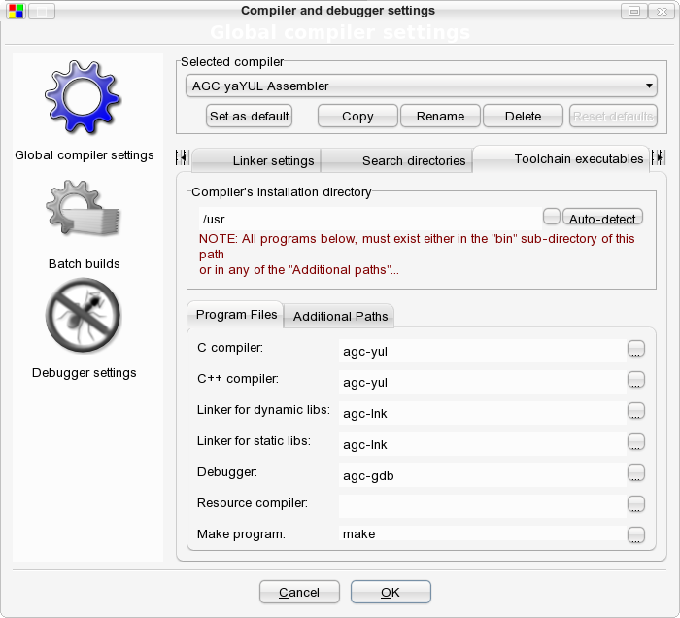

Then select copy and provide the new compiler/assembler tool set name:
AGC yaYUL Assembler
Thereafter make sure all compiler flags are cleared and move to the "Toolchain executables" tab. Make sure the compilers installation directory is "/usr" and add the installed scripts as the respective compiler, linker and debugger. This means setting the compiler values to agc-yul, the linker entries to agc-lnk and the debugger to agc-gdb and leave the make program set to make (see earlier screen capture). Thereafter select the debugger settings section and make sure only the "Do not run debuggee" and "Display debugger's log" are set. Although the last setting is optional if you want to see the interaction between Code::Blocks and yaAGC. Click "Ok" and confirm and store the new assembler settings. The AGC yaYUL Assembler and yaAGC debugger are now available to be used by projects.

Configure Auxiliary Tools
Although many additional tools can be configured in this section only the yaDSKY is demonstrated to be added. From the "Tools" menu select configure tools. On the presented dialog click the "Add" button to bring up another dialog in which you can specify the parameters for the DSKY.
For example use:
Name: DSKY
Executable: /u01/Code/VirtualAGC/yaDSKY/src/yadsky
Parameters: --half-size --port=19797 --cfg=/u01/Code/VirtualAGC/yaDSKY/src/CM.ini
Launch option: Launch tool visible (without output redirecting)
It is important to specify the correct location of the configuration "ini" file. For more information about yaDSKY see the Virtual AGC website. To launch the DSKY tool just select the respective option on the Tools menu.

Project Setup
Now that the YUL assembler is added and the AGC assembler sources are recognized it is time to pick which build approach to take. In Code::Blocks you can either use an external Makefile or use the fully integrated tools. This chapter describes both and allows both settings to be applied at the same time. When describing the integrated tool approach it will be explained how to switch between the two (if you get bored seeing the same build messages). However despite the approach the first thing that must be done is setting up a project with the sources to be edited and debugged.

Creating an Empty Project
To create a project in Code::Block from the file menu select new-> project menu option. This will bring up the template selection form. From this for select the "Empty Project" template. Provide the following information:
Title: "Lemon"
Folder: "<your_path_to>/lemon
Project Filename: Lemon.cbp
Resulting Filename: <your_path_to>/lemon/Lemon.cbp

Notice that since we already have a lemon folder that we don't need a new project folder inside the lemon folder (i.e. check the auto-generated path for resulting file name). Select "Next" to move to the next dialog. From this next dialog pick for obvious reasons the AGC yaYUL Assembler as the compiler setting and only enable the Debug build (leaving the defaults for output dir and objects output dir). Select "Finish" and you should have an empty project in the project manager view.

Adding Sources
To add the source right-click on the "Lemon" project and select the option add files. This will bring up a file selection dialog. Navigate to the source "src" directory and select the YUL Assembler files (note: you can use the file filter to only show AGC Assembler files). Click "Add" and now the selected files should be visible as ASM Sources in your project under "src".

External Makefile
The setup of the external makefile is very easy; Just right click on the project "Lemon" and bring up the main project properties and on the "Project Settings" dialog select the custom makefile option and commit the change by pressing the "Ok" button. If you have multiple projects added in Code::Blocks make sure to first activate the respective project (i.e. right click on the project and select "Activate Project") before click the build icon on the toolbar.
A successful build should look like this:
mkdir -p bin/Debug
make -C src
make[1]: Entering directory `/home/ohommes/Code/AGC/DebugAGC/lemon/src'
yaYUL LEMON.s > ../bin/Debug/Lemon.lst
mv LEMON.s.bin ../bin/Debug/Lemon.bin
mv LEMON.s.symtab ../bin/Debug/Lemon.symtab
make[1]: Leaving directory `/home/ohommes/Code/AGC/DebugAGC/lemon/src'
Process terminated with status 0 (0 minutes, 0 seconds)
0 errors, 0 warnings

Nothing special it just ran the normal makefile provided with the distribution. Feel free to change it anyway you see fit. If everything is successful you can move forward to chapter 6 or continue setting up an integrated build; building without the makefile.

Integrated Build Approach
Setting up for an integrated build takes several steps. First you need to pick the main source file for YUL to process and you need to specify the build command to use. and when this is done you must provide the post build steps.

Picking the main source file
Bring up the project properties dialog and make sure the custom Makefile option is not selected. Then select the "Build targets" tab. In the build target files selection window first un-select all sources (just use the toggle checkmarks button). Then select only the Lemon.s source file.

Adding the Build Command
With the 'Lemon.s" Source file selected in the "Build targets" tab press the "selected file properties" button to bring up the file properties dialog. On this dialog select the "Advanced" tab. On this dialog confirm that the AGC yaYUL assembler is selected and that the check box "Use custom command to build this file" is selected. Provide the following as the custom command:
$compiler $file_dir $file_name.$file_ext
Then close all dialogs positively confirming the changes.

Post Build Steps
Now you can already compile the core-ropes image however for the debugging to happen successfully you need some post build steps to be setup.
To start right click on the project "Lemon" and pick the build options menu option (not the properties). Then select the "pre/post build steps" tab for the Debug build and add the following as you post build steps:

mv -f src/LEMON.s.bin bin/Debug/Lemon.bin
mv -f src/LEMON.s.symtab bin/Debug/Lemon.symtab
mv -f src/LEMON.s.lst bin/Debug/Lemon.lst

It is also a good idea to activate always execute this even if target is up to date. Close all dialogs positively confirming the changes. Now try a build by click the build icon. The output should look like the following:

-------------- Build: Debug in Lemon ---------------
Compiling: src/LEMON.s
Linking executable: bin/Debug/Lemon
Awaiting bin/Debug/Lemon.bin
Running target post-build steps
mv -f src/LEMON.s.bin bin/Debug/Lemon.bin
mv -f src/LEMON.s.symtab bin/Debug/Lemon.symtab
mv -f src/LEMON.s.lst bin/Debug/Lemon.lst
Process terminated with status 0 (0 minutes, 0 seconds)
0 errors, 0 warnings

If the build runs without any errors move on to chapter 6 for debugging.

Debugging
The best way to start a debugging session is to just use step into from the debug menu or debug toolbar. This will bring you into debug mode and stopped at the first op code. Place your breakpoints or just use F7 to step through the code. To get rid of the terminal window change the build type in the build options from Console to GUI when you are not in debugging mode.
Now just start getting familiar with the Code::Blocks IDE, bring up watches, CPU registers, memory regions, etc. Also try running the AGC code (without breakpoints) and bring up the DSKY from the tools menu. If everything works okay with the Lemon program it should flash the Comp Activity light. To start debugging just hit the stop button once and you will be placed at the current point of execution. Resume execution or debug from that point.
Enjoy!

